Additional file 1

Gold Nanoparticle-Quantum Dot Fluorescent Nanohybrid: Application for Localized Surface Plasmon Resonance-induced Molecular Beacon Ultrasensitive DNA Detection

Oluwasesan Adegoke,¹ Enoch Y. Park^{1,2,}

E-mail addresses:
adegoke.sesan@mailbox.co.za (OA),
park.enoch@shizuoka.ac.jp (EYP)

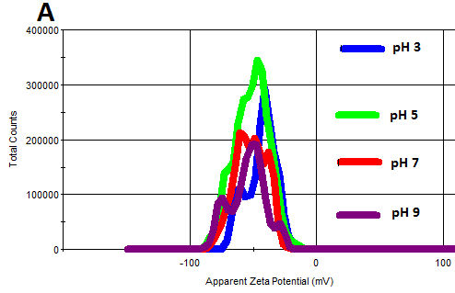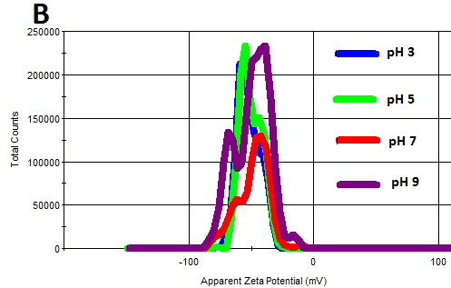

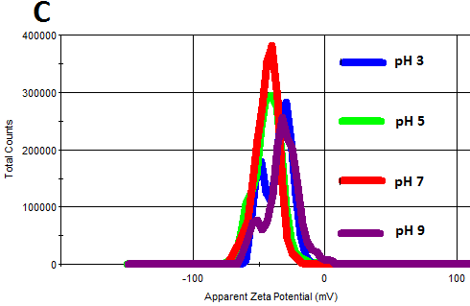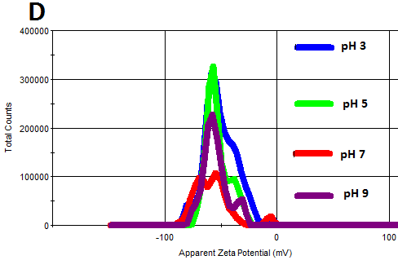

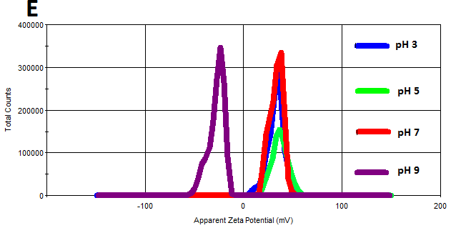

Figure S1. Overlay of the ZP curves of (A) TGA-AuNPs, (B) MPA-AuNPs, (C) _{L}-cysteine-AuNPs, (D) GSH-AuNPs and (E) cysteamine-AuNPs at pH 3, pH 5, pH 7 and pH 9.

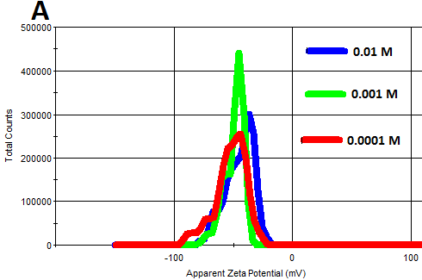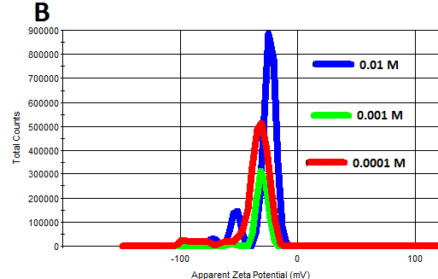

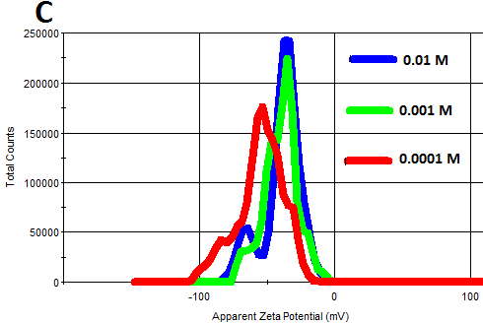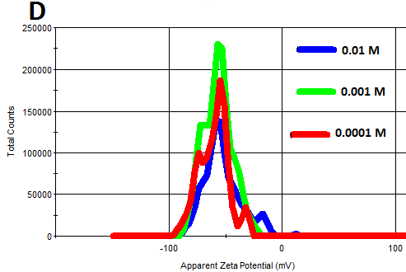
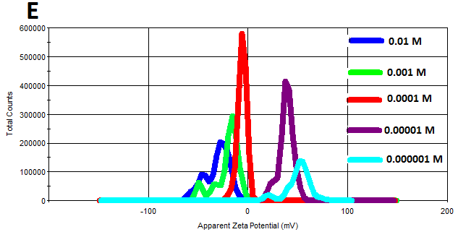

Figure S2. Overlay of the ZP curves of (A) TGA-AuNPs, (B) MPA-AuNPs, (C) _{L}-cysteine-AuNPs and (D) GSH-AuNPs and (E) cysteamine-AuNPs at different ionic strength of 0.01 M, 0.001 M and 0.0001 M.

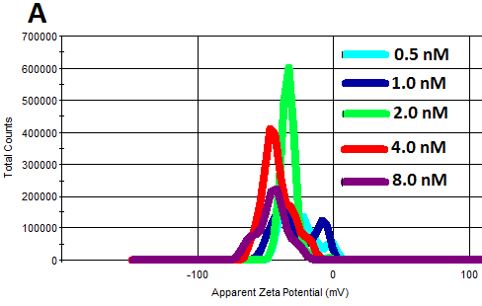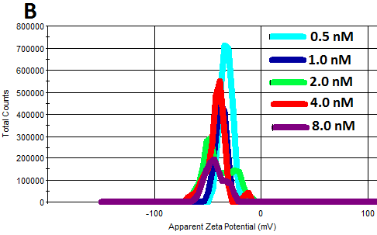

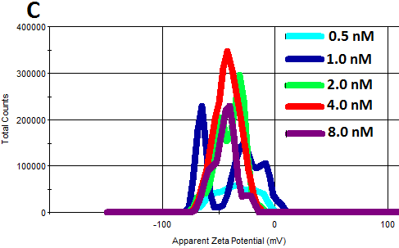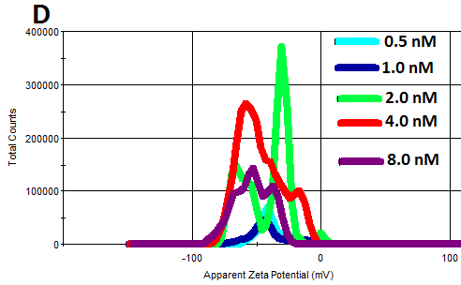
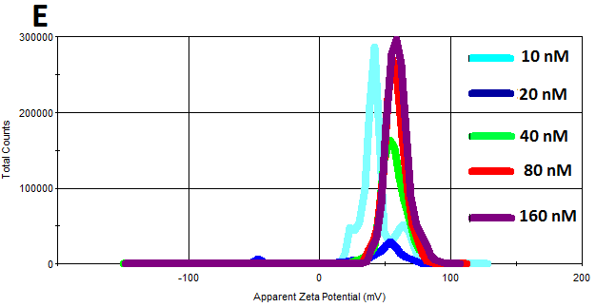

Figure S3. Overlay of the ZP curves of (A) TGA-AuNPs, (B) MPA-AuNPs, (C) _{L}-cysteine-AuNPs (D) GSH-AuNPs and (E) cysteamine-AuNP at different NP concentration.

The DLS plot for the SiO₂-Qdots as shown in Figure S4A exhibit a hydrodynamic particle size value of 52.2 nm which is well below 100 nm. This imply that the SiO₂-Qdots is monodisperse and unagglomerated. The corresponding ZP charge as determined from the ZP plot (Figure S4B) was –38.0±5.3 mV, thus indicating a high colloidal stability of the SiO₂-Qdots. ZP was also employed to probe the colloidal stability of the AuNP-SiO₂-Qdots nanohybrid and the AuNP-SiO₂-Qdots-MB biosensor. The ZP are shown in Figure S4C and D respectively. The values obtained are –34.5±3.9 mV for AuNP-SiO₂-Qdots and –38.5±4.4 mV for AuNP-SiO₂-Qdots-MB. The ZP charge values obtained indicate that high colloidal stability was retained by the nanohybrid and the biosensor conjugate.

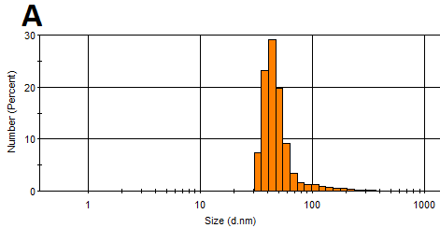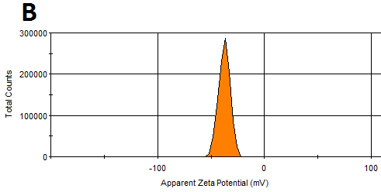
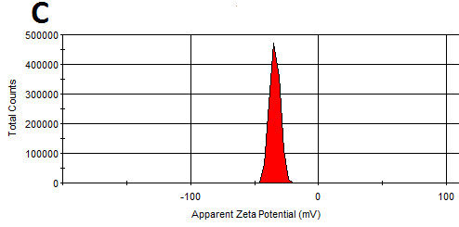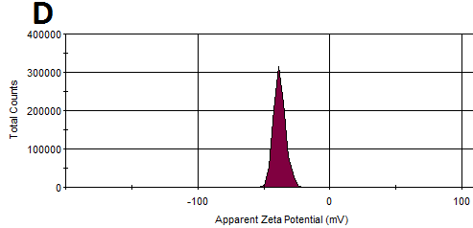

Figure S4. DLS and ZP plot for SiO₂-capped CdZnSeS/ZnSe_{1.0}S_{1.3} Qdots (A and B) and ZP plot for SiO₂-Qdots-AuNP (C) and SiO₂-Qdots-AuNP-MB (D).

Correspondence: park.enoch@shizuoka.ac.jp (EYP). ¹ Laboratory of Biotechnology, Research Institute of Green Science and Technology, Shizuoka University, 836 Ohya, Suruga-ku, Shizuoka 422-8529, Japan ² Laboratory of Biotechnology, Department of Bioscience, Graduate School of Science and Technology, Shizuoka University, 836 Ohya, Suruga-ku, Shizuoka 422-8529, Japan

