Fast synthesis of Pt nanocrystals and Pt/microporous La₂O₃ materials using acoustic levitation
Yinkai Yu, Shaohua Qu, Duyang Zang, Liuding Wang and Hongjing Wu *
Key Laboratory of Space Applied Physics and Chemistry of Ministry of Education, Department of Applied Physics, School of Sciences, Northwestern Polytechnical University, Xi’an 710072, P. R. China;
* Correspondence: wuhongjing@mail.nwpu.edu.cn; Tel.: +86-029-88431664
Fig. S1 HAADF-STEM images of Pt clusters prepared by the acoustic levitation (0.5 g L⁻¹).
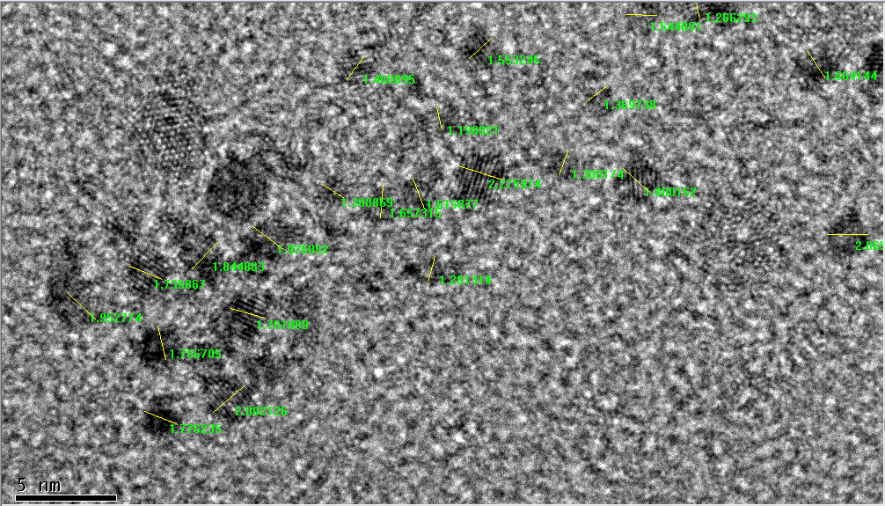
Fig. S2 The average diameter analysis procedure of Pt nanocrystals (0.00625 g L⁻¹).

