Additional file 1

Effect of Zinc Acetate Concentration on Optimization of Photocatalytic Activity of p-Co₃O₄/n-ZnO Heterostructures
Hongyan Xuª, Mingliang Shiª, Caiqin Liangª, Siyan Wangª, Chengkai Xiaª, Chenyang Xue^{b}, Zhenyin Hai^{c}, Serge Zhuiykov^{*a,c}

ª School of Materials Science and Engineering, North University of China, Taiyuan 030051, P.R. China
^{b} Key Laboratory of Instrumentation Science and Dynamic Measurement of Ministry of Education, North University of China, Taiyuan 030051, P.R. China
^{c} Ghent University Global Campus, Department of Applied Analytical & Physical Chemistry, 119 Songdomunhwa-ro, Yeonsu-gu, Incheon 21985, South Korea

* - corresponding author; e-mail: serge.zhuiykov@ugent.be (S. Zhuiykov)

Figure S1. Nitrogen adsorption–desorption isotherms of (a) Co₃O₄, (b) Co₃O₄/ZnO-5, (c) Co₃O₄/ZnO-15, (d) Co₃O₄/ZnO-25, (e) Co₃O₄/ZnO-35, (f) Co₃O₄/ZnO-45 and (g) Co₃O₄/ZnO-55.

Figure S2. Irradiation time dependent UV-vis absorbance spectra of MO aqueous solution in the presence ZnO.

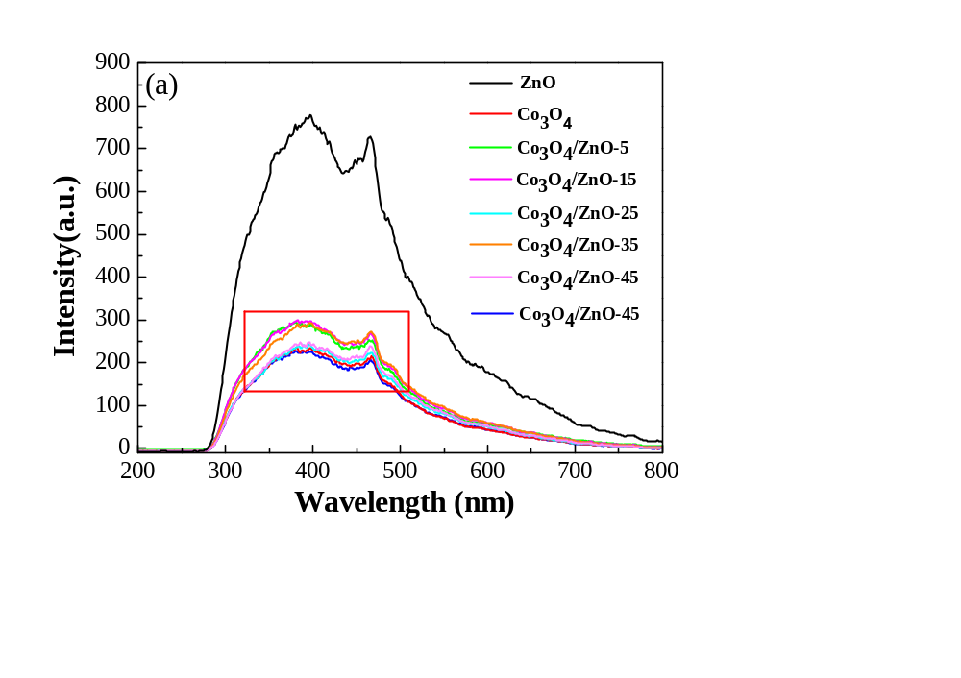

Figure S3. PL spectra of (a) ZnO, Co₃O₄ and Co₃O₄/ZnO heterostructures, and (b) the magnification of the square in (a).

Figure S4. FTIR spectra of Co₃O₄ and Co₃O₄/ZnO heterostructures after 72 h degradation of MO.

