Supporting Information for
Improved cycling stability of LiCoO₂ at 4.5 V via surface modification of electrodes with conductive amorphous LLTO thin film
Shipai Song¹, Xiang Peng¹, Kai Huang¹, Hao Zhang¹, Fang Wu¹, Yong Xiang^{1,2}, and Xiaokun Zhang^{1*}
¹ School of Materials and Energy and ²Advanced Energy Research Institute, University of Electronic Science and Technology of China, Chengdu, Sichuan 611731, China
*Corresponding author e-mail: zxk@uestc.edu.cn

The LLTO thin films were deposited on the silicon wafer and the thickness of LLTO films were determined using a ME-L (EOPTICS) profilometer.
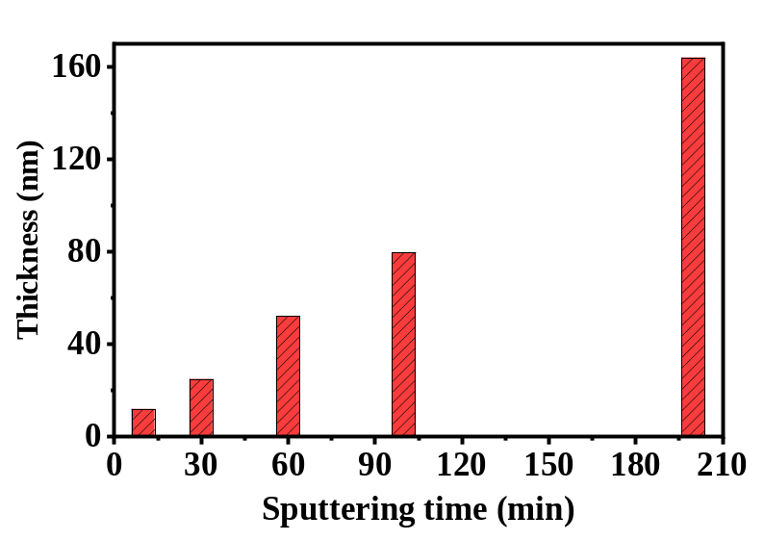
Figure S1. The thickness of the LLTO thin films with the different deposition time.

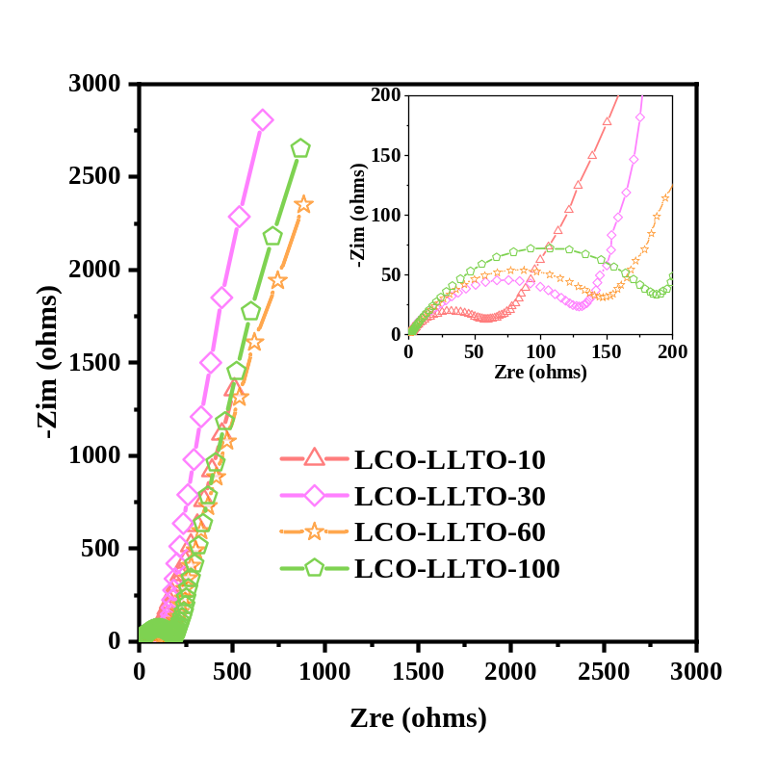
Figure S2. Electrochemical impedance spectra of the as-assembled testing cells with LCO-LLTO-10, LCO-LLTO-30, LCO-LLTO-60, and LCO-LLTO-100.

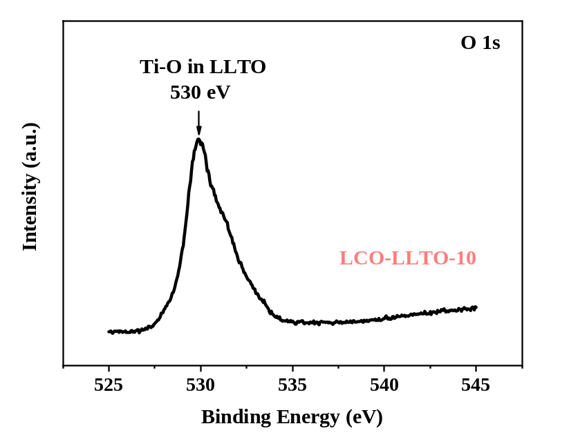
Figure S3. O 1s spectrum of LCO-LLTO-10 after 100 cycles.

