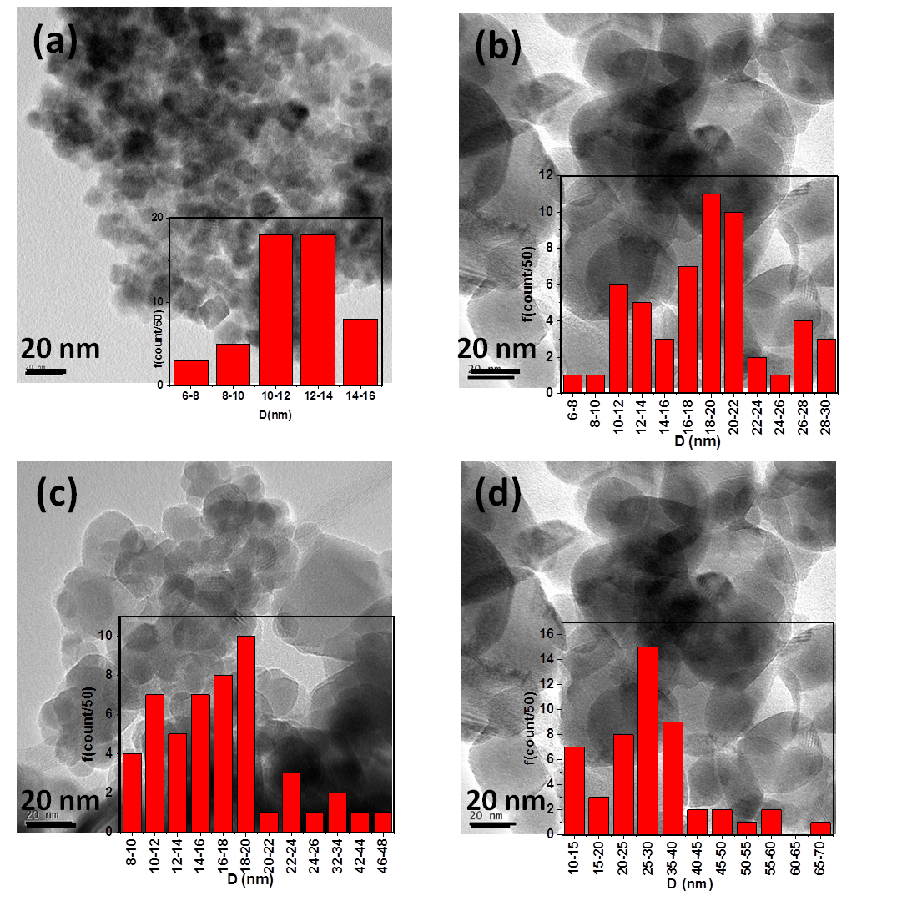

Fig. S1 TEM images of the Sn_{x}Fe_{3-2x/3}O₄ samples with x = a: 0.000, b: 0.045, c: 0.090, d: 0.150 (The scale length = 20nm, insight: size distribution histogram of prepared nanoparticles.

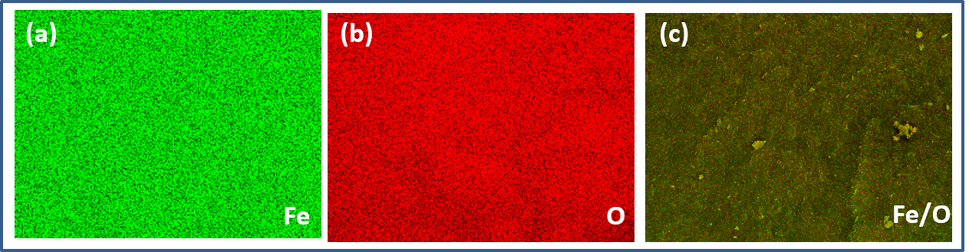

Fig. S2 SEM/EDS X-ray elemental mapping of (a) Fe (green) (b) O (red) and (c) green/red overlay for pure Fe₃O₄ nanoparticles.

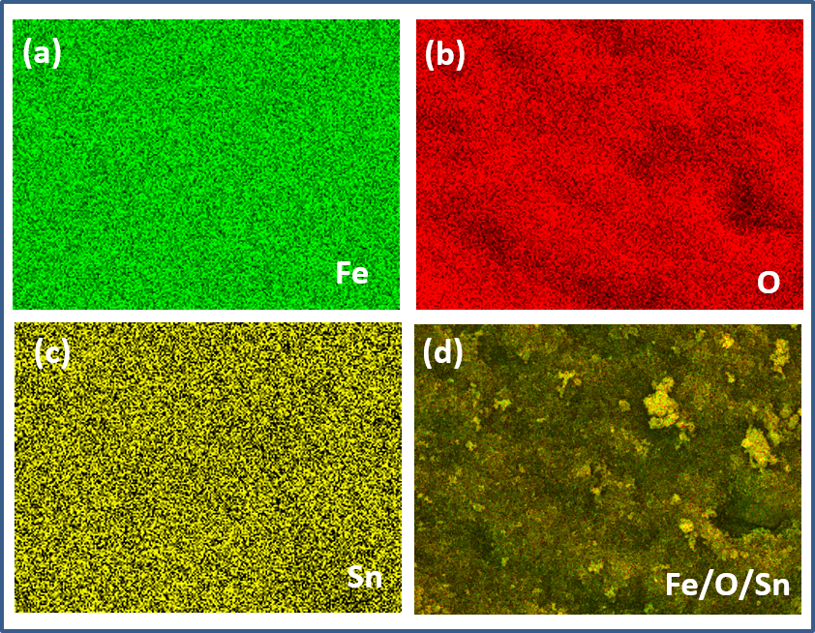

Fig. S3 SEM/EDS X-ray elemental mapping of (a) Fe (green) (b) O (red) (c) Sn (yellow) and (d) green/red/yellow overlay.

