Fig. S1.
Fig. S1 Tg inhibits MWCNTs-induced NO accumulation. 3-day-old tomato seedlings were treated with distilled water and 5 mg/mL MWCNTs with or without 20 µM tungstate (Tg). The NO signal was analyzed by LSCM (A) and EPR (B) after treated for 24 h. Scale bar = 0.1 mm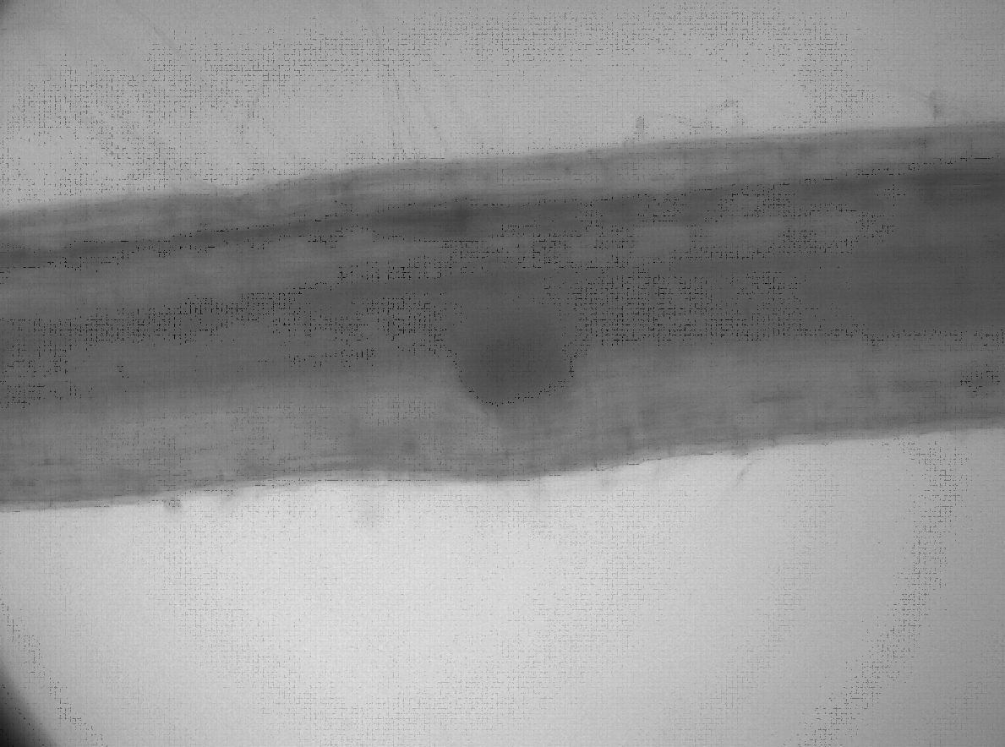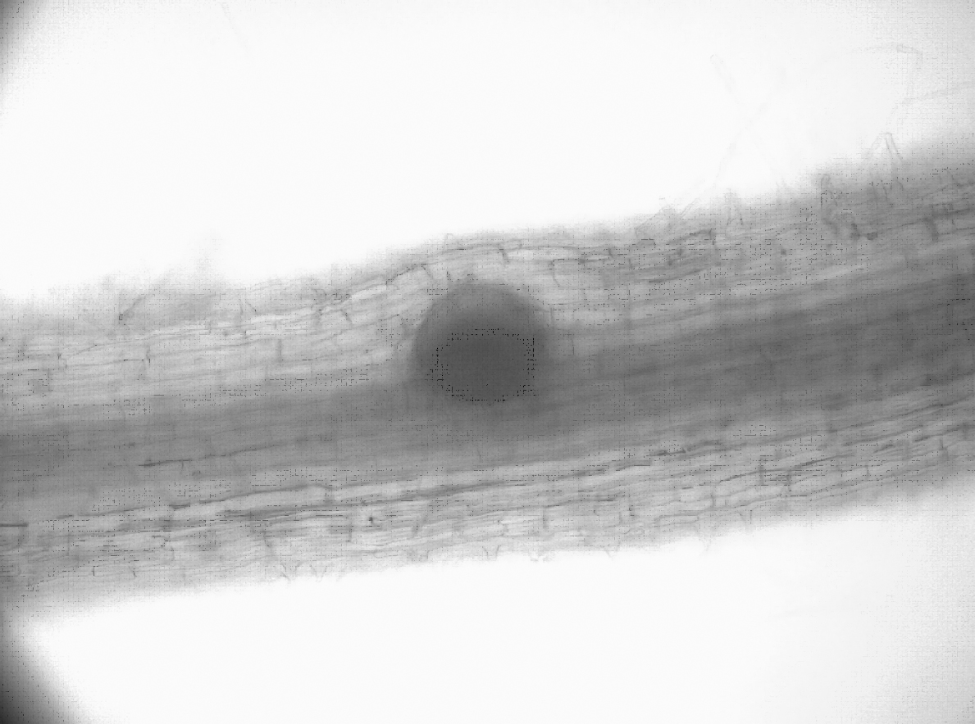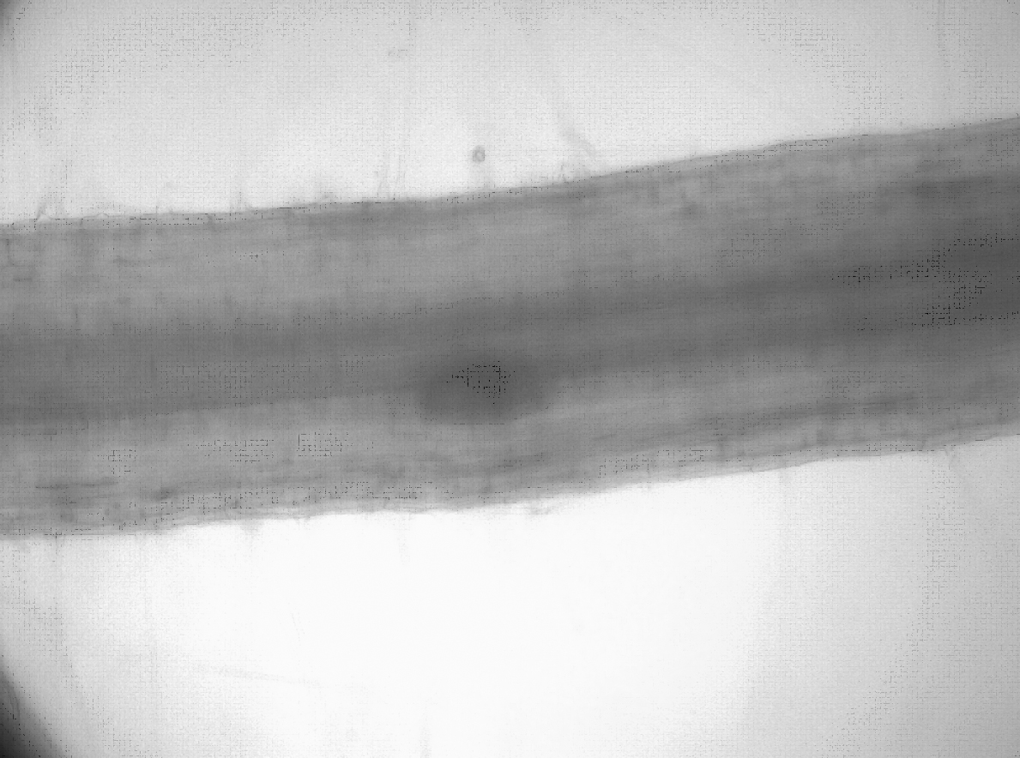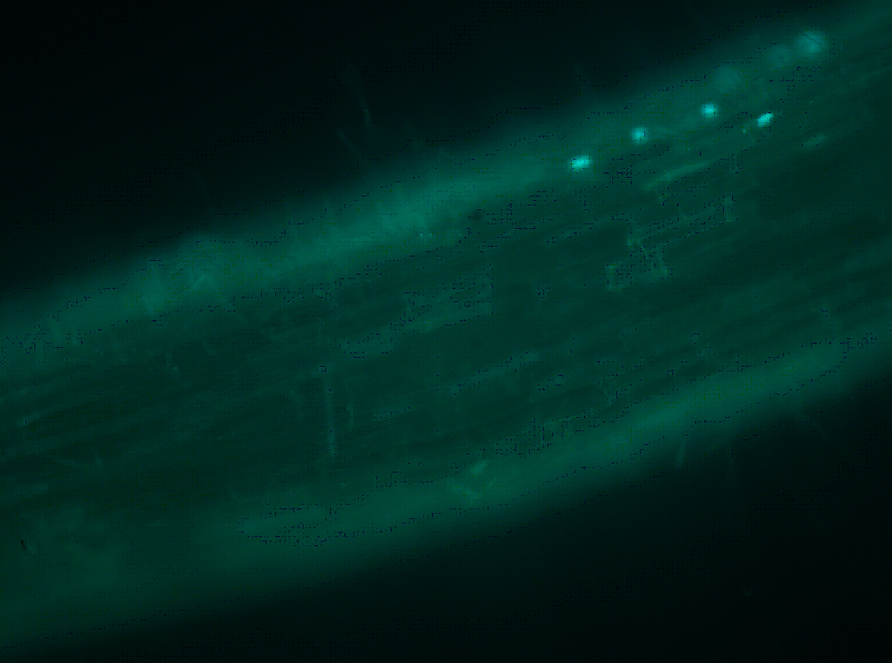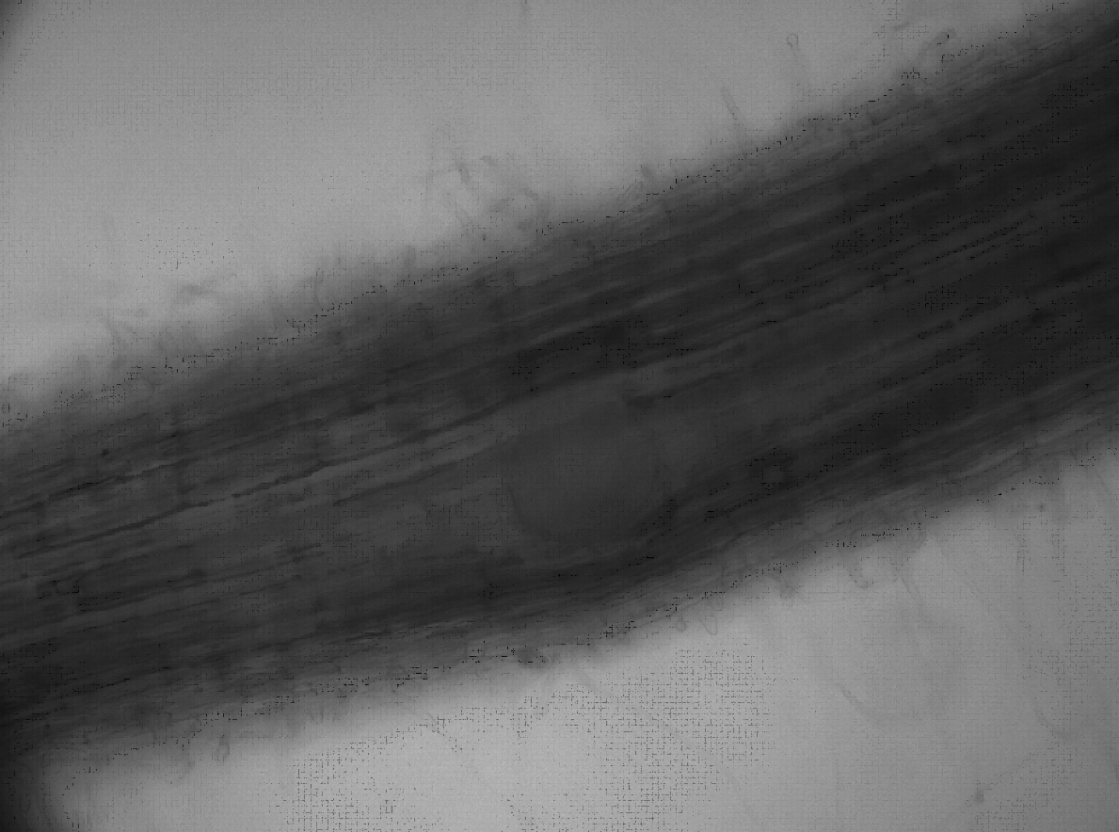.
Con
MWCNTs
Con Tg
a
Con Tg
b

