Supporting information
Thermodynamics controlled sharp transformation from InP to GaP nanowires via introducing trace amount of Gallium.
Zhenzhen Tian¹, Xiaoming Yuan¹*, Ziran Zhang¹, Wuao Jia¹, Jian Zhou², Han Huang¹, Jianqiao Meng¹, Jun He¹*, Yong Du³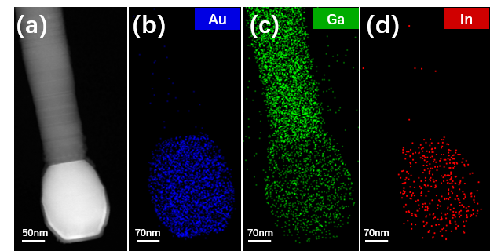
Figure S1. (a) HAADF image of a GaP nanowire. EDX mapping of (a). (b) Au, (c) Ga element and (d) In element. From the brightness contrast and the EDX mapping, it seems there exists a Au-rich layer at the top surface .

