Supporting Information

Multimodal imaging and photothermal/chemodynamic therapy of cervical cancer using GSH-responsive MoS₂@MnO2 theranostic nanoparticles

Runrun Shao¹, Xiaofang Qiao², Linlin Cao², Jianliang Man¹, Lingyun Guo¹,Lanlan Li¹,Wen Liu¹,Lihong Li¹,Bin Wang¹, Lixia Guo¹, Sufang Ma¹, Boye Zhang¹, Haojiang Wang¹, and Lili Yan¹*

¹College of Basic Medicine University, Shanxi Medical Univerity, Taiyuan, 030000, P. R. China.
²Henan Center For Drug Evaluation and Inspection, Henan, 450000, P. R. China.

Supplementary Figures

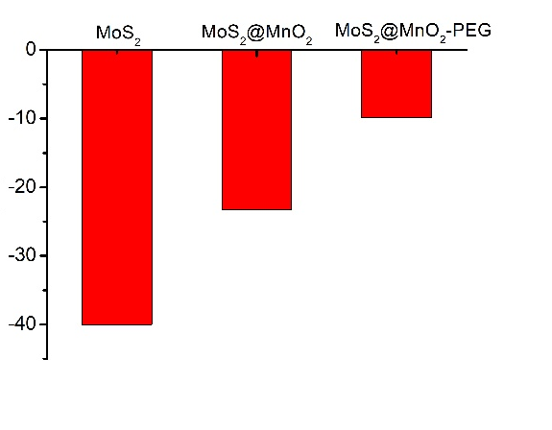
Figure S1.The Zeta potential of MoS₂, MoS₂@MnO₂, and MoS₂@MnO₂-PEG.

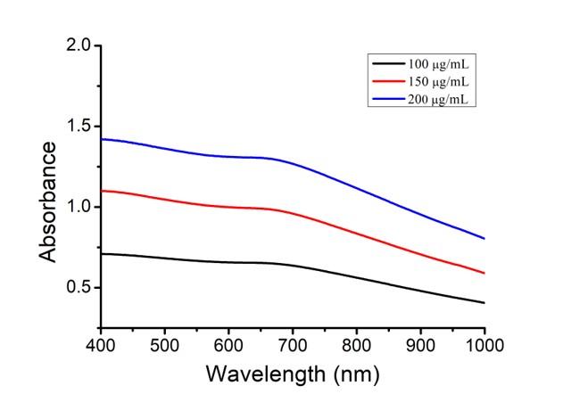
Figure S2.UV absorption MoS₂@MnO₂ at different concentrations
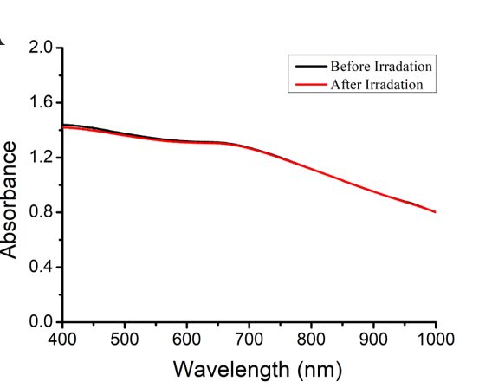
Figure S3.The photostability of MoS₂@MnO₂.

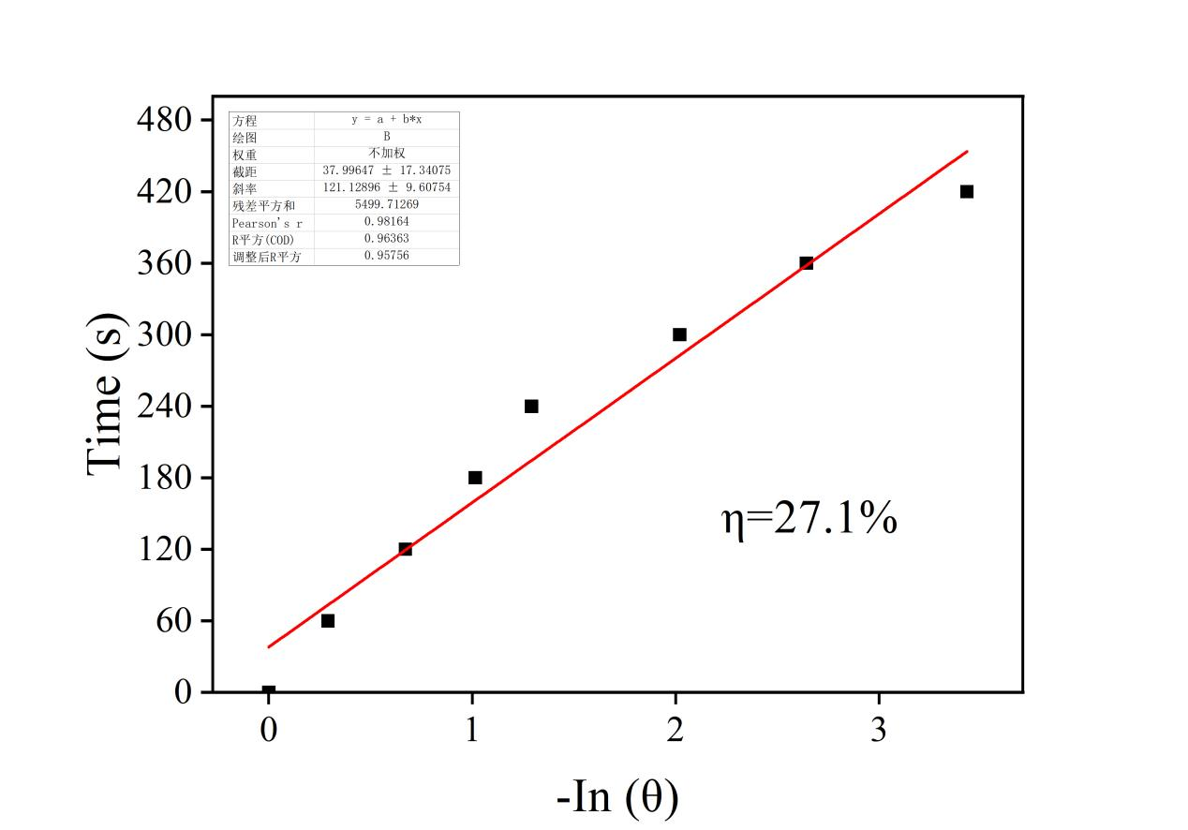
Figure S4. Plot of the cooling time as a function of the negative natural logarithm of the temperature driving force and photothermal conversion efficiency (η).
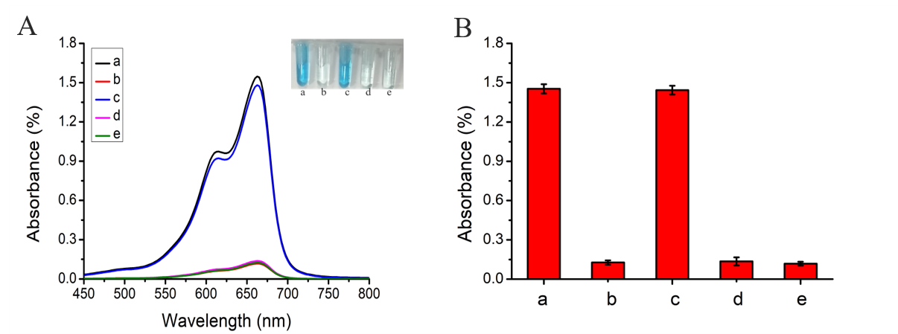
Figure S5. (A) Add different traps to detect the type of reactive oxygen species; (B) UV-Vis chart. where (a：MB；b：MB+MoS₂@MnO₂-PEG+H₂O₂+HCO₃⁻+1.0 mM GSH；c：MB+MoS₂@MnO₂-PEG+H₂O₂+HCO₃⁻+1.0 mM GSH+IPA；d：MB+MoS₂@MnO₂-PEG+H₂O₂+ HCO₃⁻+1.0 mM GSH+PBQ；e：MB+MoS₂@MnO₂-PEG+H₂O₂+HCO₃⁻+1.0 mM GSH+NaN₃））。

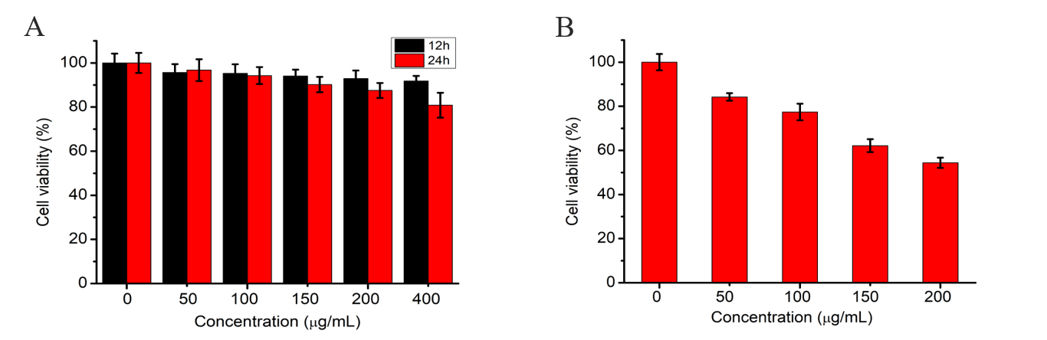
Figure S6.(A) Effects of different concentrations of MoS₂@MnO₂-PEG on HcerEpic cell viability;
- Effect of different concentrations of MoS₂@MnO₂-PEG on HeLa cell viability.

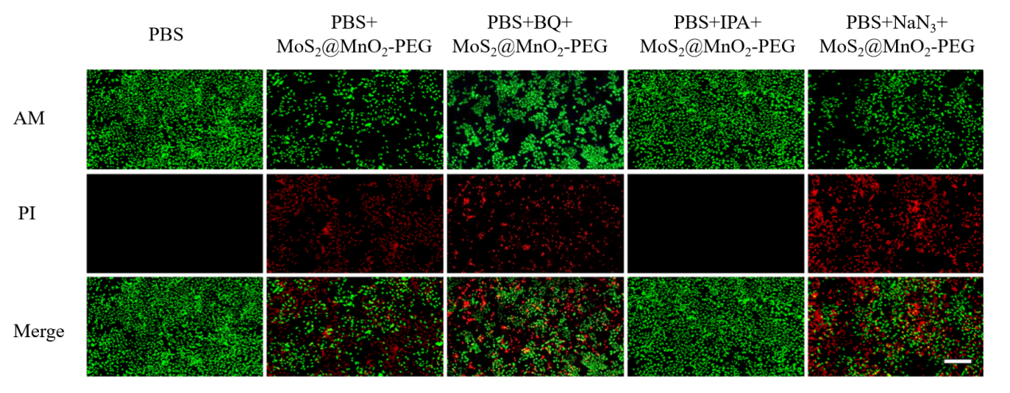
Figure S7.Calcein-AM/PI staining observation method to verify the type of reactive oxygen species that trigger apoptosis (scale bar : 100 μm)

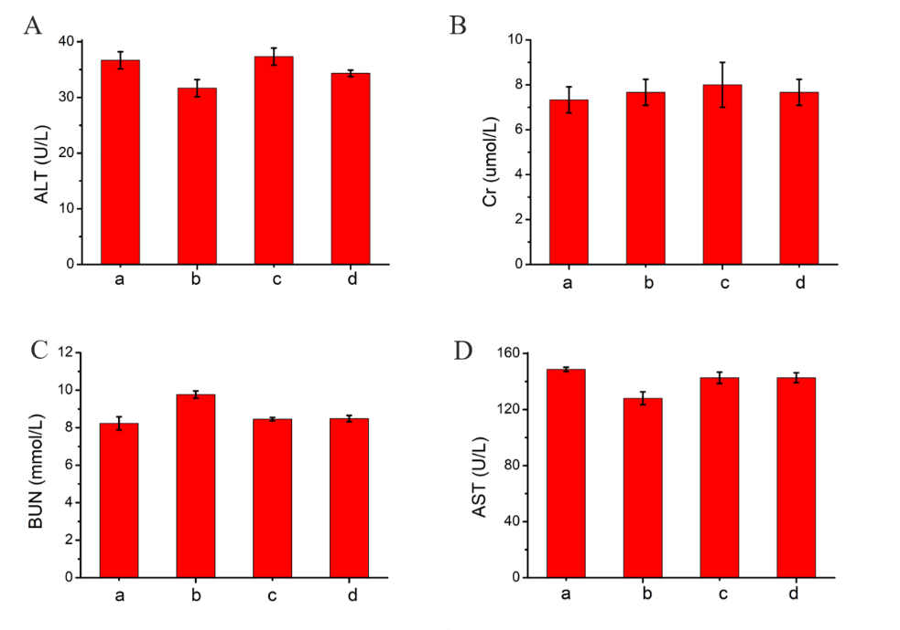
Figure S8.Statistical chart of serum biochemical indexes in nude mice. (A) alanine aminotransferase (ALT); (B) creatinine (Cr); (C) urea nitrogen (BUN); (D) Aspartate aminotransferase (AST). (a：PBS；b：PBS+Laser；c：MoS₂@MnO₂-PEG；d：MoS₂@MnO₂-PEG+Laser)。

