SUPPORTING INFORMATION
Durable Anti-Fog Micro-Nano Structures Fabricated by Laser Ablation of Aluminum Film on Resin/Glass
Hongtao Cui*, Chao Teng, Xinyi Xie, Xiaowen Qi
Department of Materials Science, School of Civil Engineering, Qingdao University of Technology, Qingdao 266520, China
Correspondence*: cuihongtao88@gmail.com

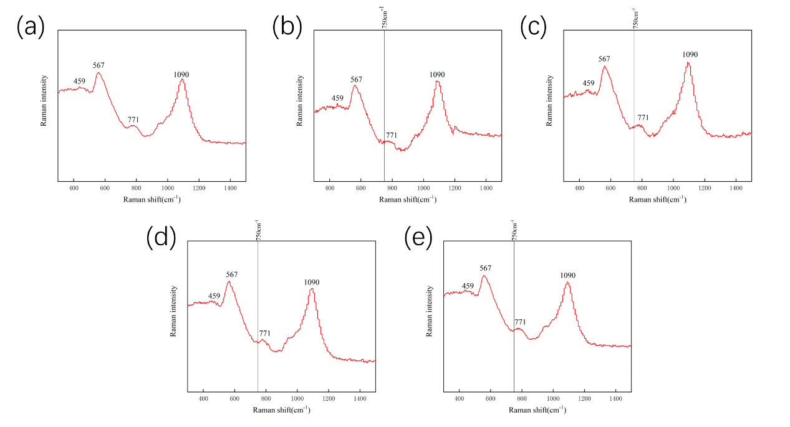
Fig.S1 Raman spectroscopy of unprocessed and processed glass with different scan rates. (a) reference (b) 2 m/s (c) 4 m/s (d) 5m/s (e) 6m/s

