Supporting Information
Ultra-fast photocatalytic degradation of Rhodamine B exploiting oleate-stabilized zinc oxide nanoparticles
Nicolò Maria Percivalleª, Marco Carofiglio^{a,¥}, Simelys Hernándezª,*, Valentina Caudaª,*
ª Department of Applied Science and Technology, Politecnico di Torino, Corso Duca degli Abruzzi 24, 10129 Turin Italy
¥ Present address: Department of Molecular Biochemistry and Pharmacology, Istituto di Ricerche Farmacologiche Mario Negri IRCCS, Via Mario Negri 2, 20156 Milan, Italy

Calibration curves
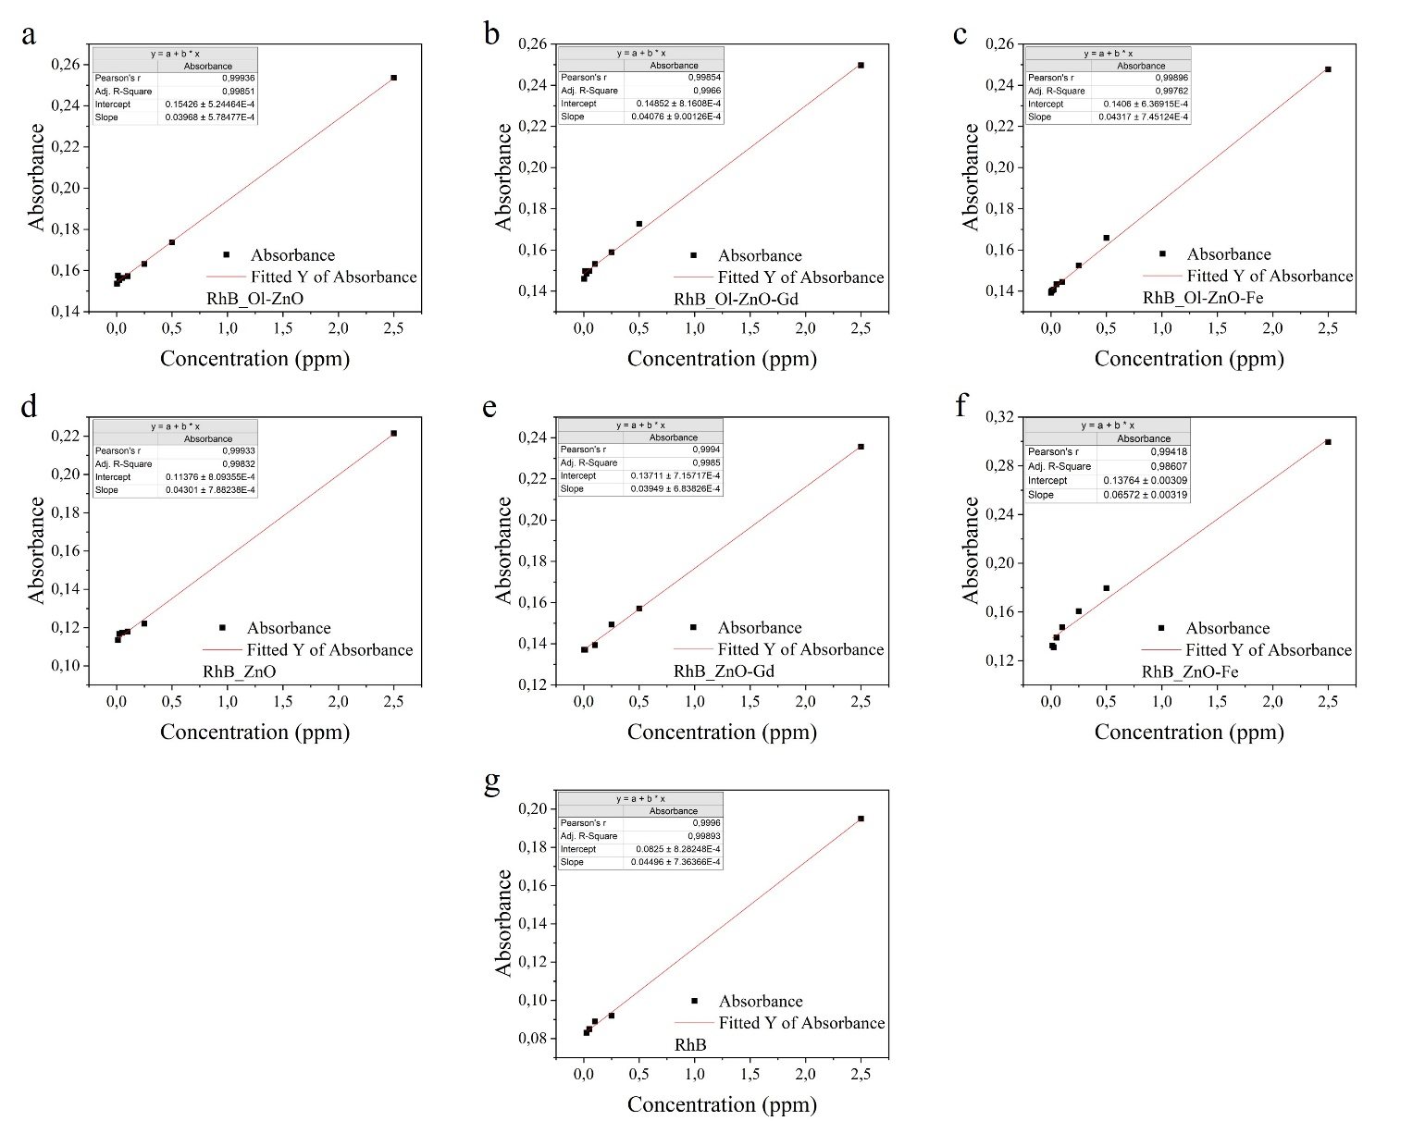
Fig. S1. Calibration curves of the different catalysts in the RhB solution: (a) Ol-ZnO, (b) Ol-ZnO-Gd, (c) Ol-ZnO-Fe, (d) ZnO, (e) ZnO-Gd, and (f) ZnO-Fe. (g) Calibration curve of RhB in double distilled water alone, without any catalyst in the solution.

Characterization of the nanocrystals synthesized without oleic acid
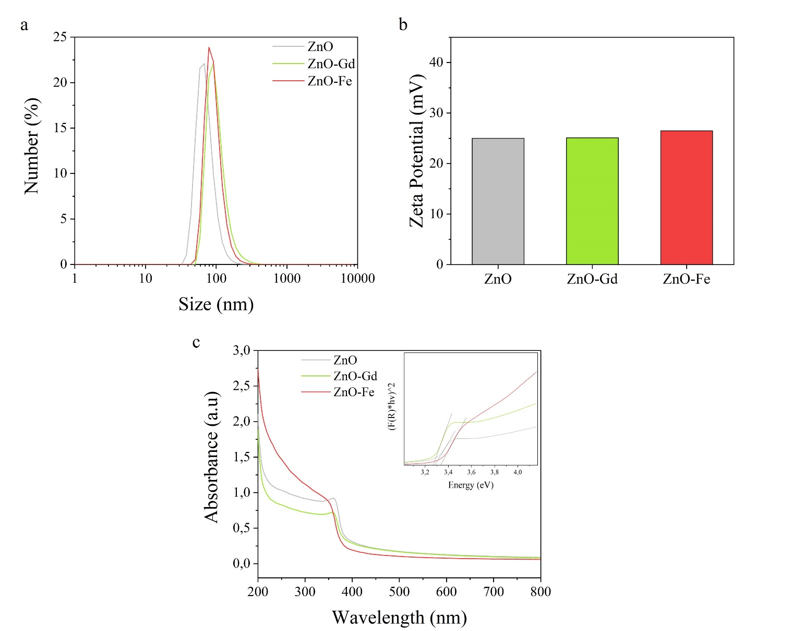
Fig. S2. Characterization of ZnO, ZnO-Gd, and ZnO-Fe nanocrystals: (a) DLS measurements, (b) Z-potential values of the NCs at the pH conditions of the photodegradation experiment (pH = 5.8), and (c) UV-visible spectra with the Tauc’s plots for the evaluation of the optical band gaps (Eg) represented in the upper right square.

