Supporting Information
Bioinspired Fe₃O₄@Ag@ Indocyanine Green / Adenosine triphosphate nanoenzyme in Synergistic Antibacterial Performance

Dongmei Hu,‡^{1, 2} Qing Wu,‡^{1, 2}Yujun Yang,³ Yan Wang,^{1, 2} Yanhao Li,^{1,2} Haixiang Chen,^{1, 2} Liang Tang,^{1, 2} Xiang Mao*^{1, 2} and Zhenyu Wang*^{1, 2}
1. College of Biomedical Engineering, Chongqing Medical University, Chongqing 400016, P. R. China.
2. State Key Laboratory of Ultrasound in Medicine and Engineering College of Biomedical Engineering, Chongqing Medical University, Chongqing 400016, P. R. China.
3. Key Laboratory of Laboratory Medical Diagnostics, Ministry of Education, Department of Laboratory Medicine, Chongqing Medical Laboratory Microfluidics and SPRi Engineering Research Center, Chongqing Medical University, Chongqing 400016, P. R. China.

Corresponding Author:
Xiang Mao: maox@cqmu.edu.cn; Zhenyu Wang: wangzhenyu@cqmu.edu.cn

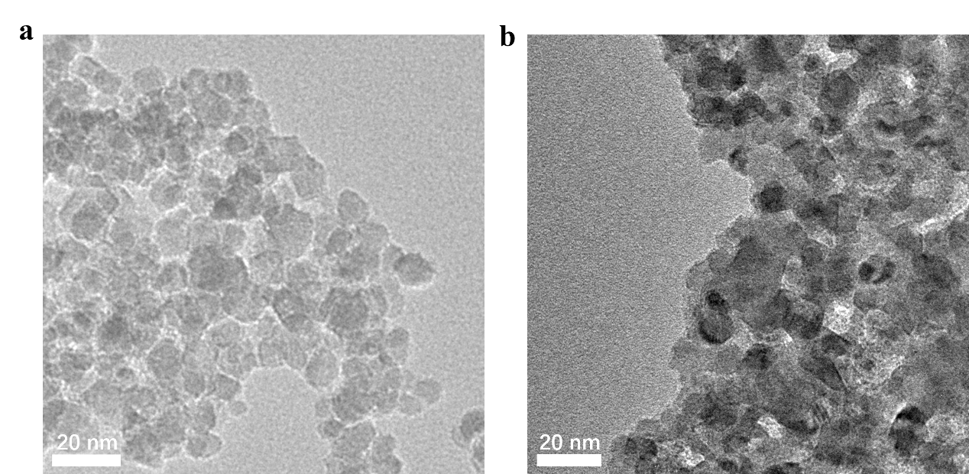
Fig S1. TEM images of (a) Fe₃O₄ and (b)Ag

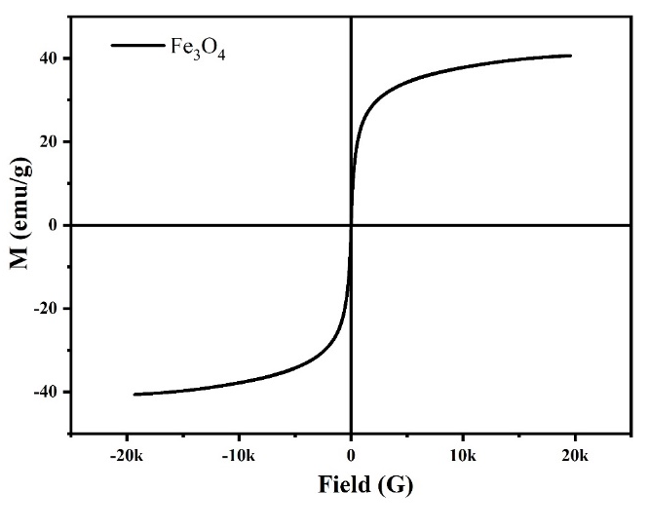
Fig S2. Magnetic properties of Fe₃O₄.

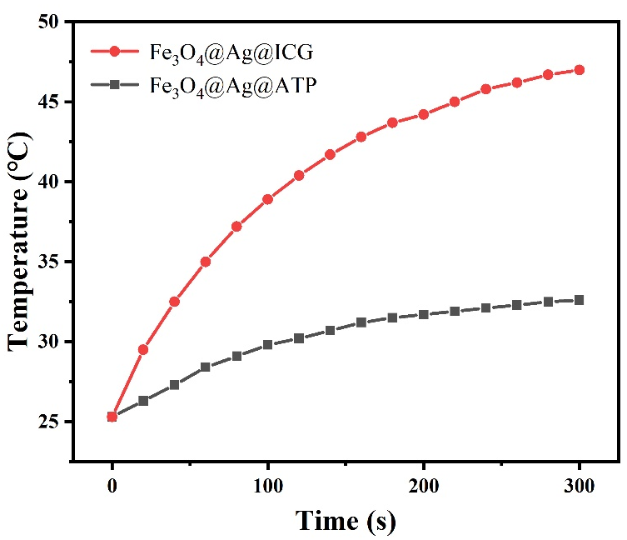
Fig S3. Temperature changes of Fe₃O₄@Ag@ATP and Fe₃O₄@Ag@ICG (200 µg/mL) under 808 nm NIR laser irradiation (1.0 W /cm²).

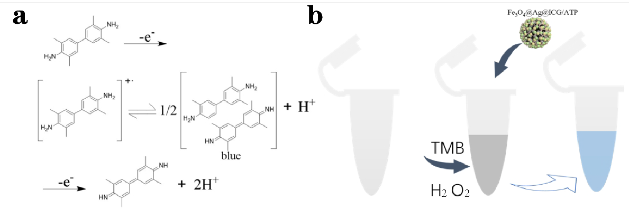
Fig S4. (a) The oxidation mechanism of TMB；(b) TMB reacts with Fe₃O₄@Ag@ICG@ATP and H₂O₂ to lose a single electron to produce a blue product.

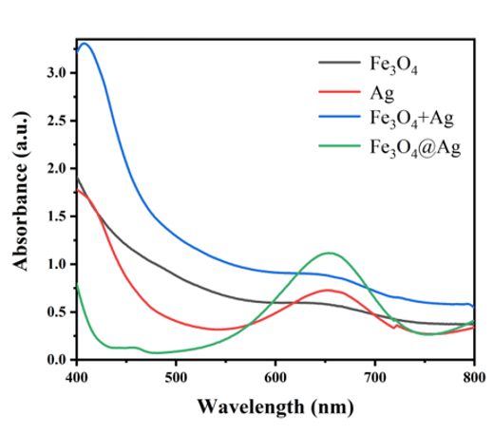
Fig S5. UV-vis spectra of TMB catalyzed by the Fe₃O₄, Ag, Fe₃O₄ + Ag, and Fe₃O₄@Ag structures in the presence of H₂O₂

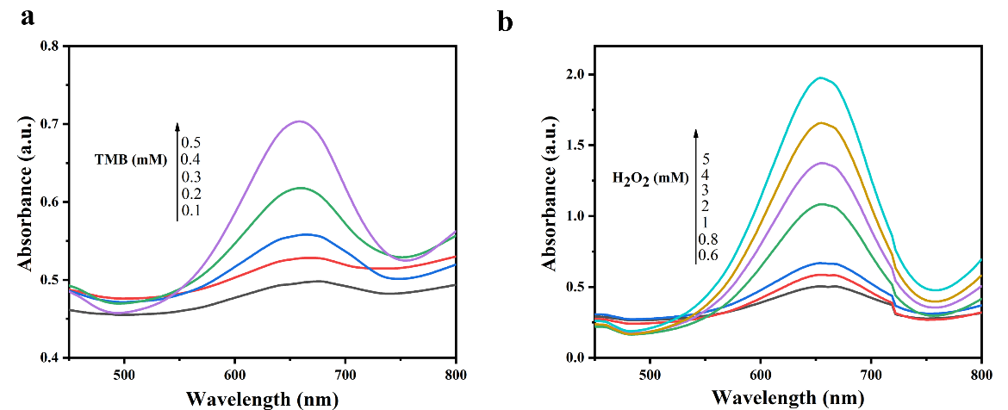
Fig S6. (a) UV-Vis absorption spectra of different TMB concentration solutions of Fe₃O₄@Ag@ICG/ATP. (b) UV-Vis absorption spectra of different H₂O₂ concentration solutions of Fe₃O₄@Ag@ICG/ATP.

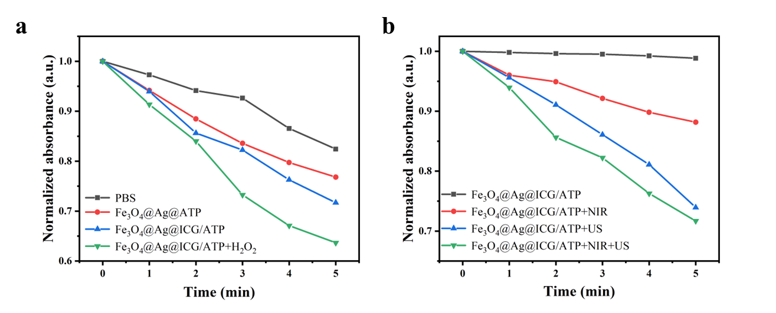
Fig S7. (a) Normalized absorbances (417 nm) of PBS, Fe₃O₄@Ag@ATP, Fe₃O₄@Ag@ICG/ATP, Fe₃O₄@Ag@ICG/ATP+ H₂O₂ reacting with DPBF under both NIR and US irradiation for 5 min. (b) Normalized absorbances (417 nm) of Fe₃O₄@Ag@ICG/ATP reacting with DPBF under US irradiation, under NIR irradiation, under both NIR and US irradiation for 5 min.

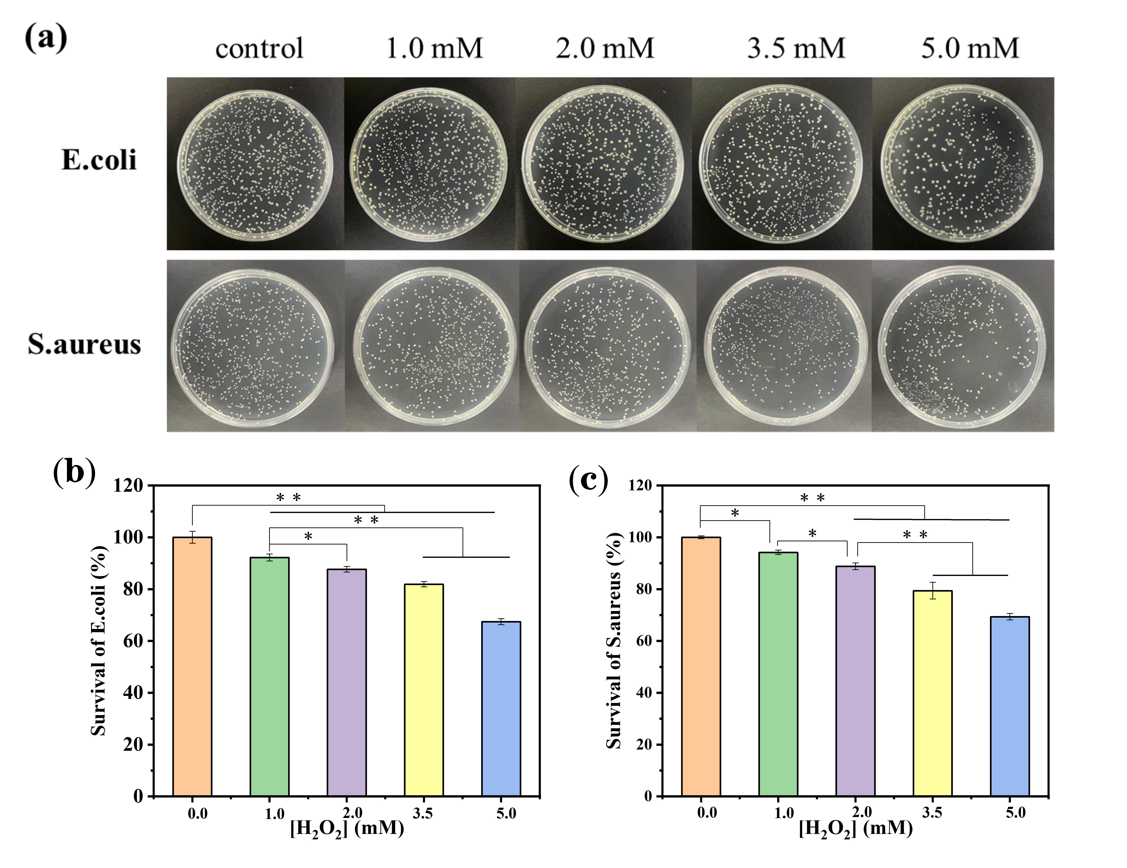
Fig S8. (a) The pictures of E. coli and S. aureus colonies on agar plates after treatments with different concentrations of H₂O₂. The corresponding viabilities of (b) E. coli and (c) S. aureus from the data in (a). The data are expressed as means ± SD (n = 3). *p<0.05, *p<0.01.

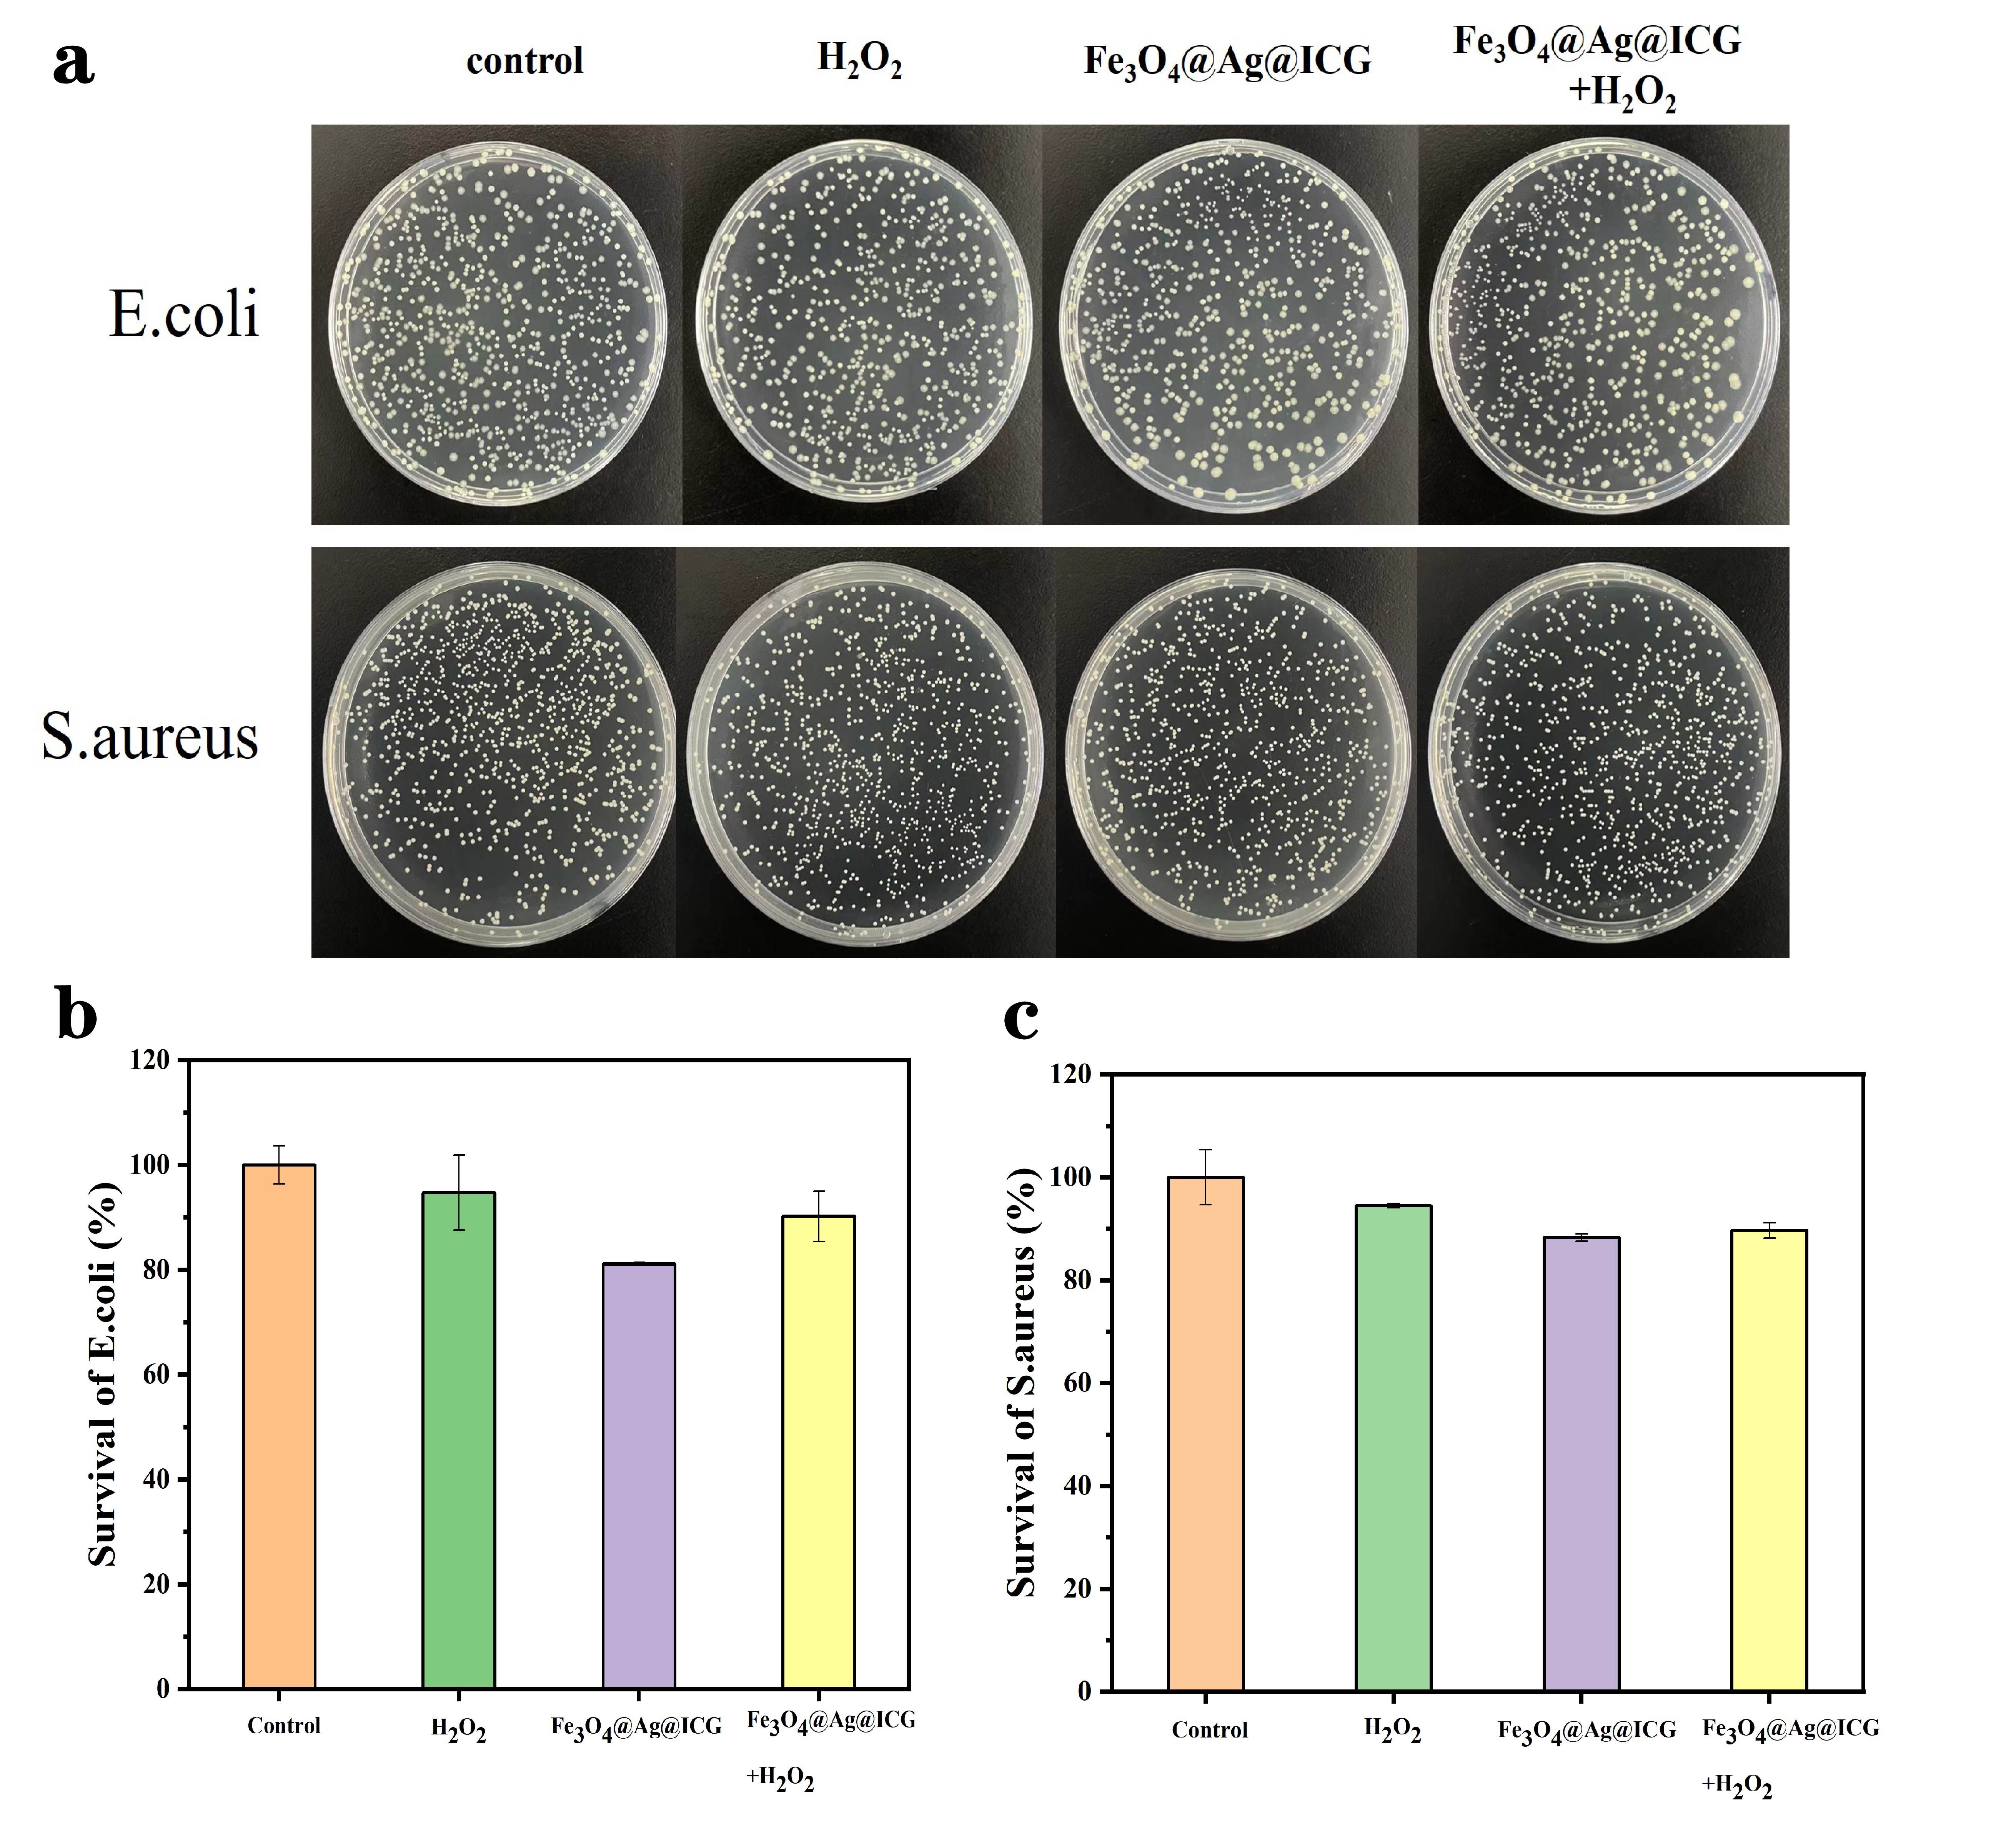
Fig S9.(a) The pictures of E. coli and S. aureus colonies on agar plates after different treatments. The corresponding viabilities of (b) E. coli and (c) S. aureus from the data in (a). The data are expressed as means ± SD (n = 3).
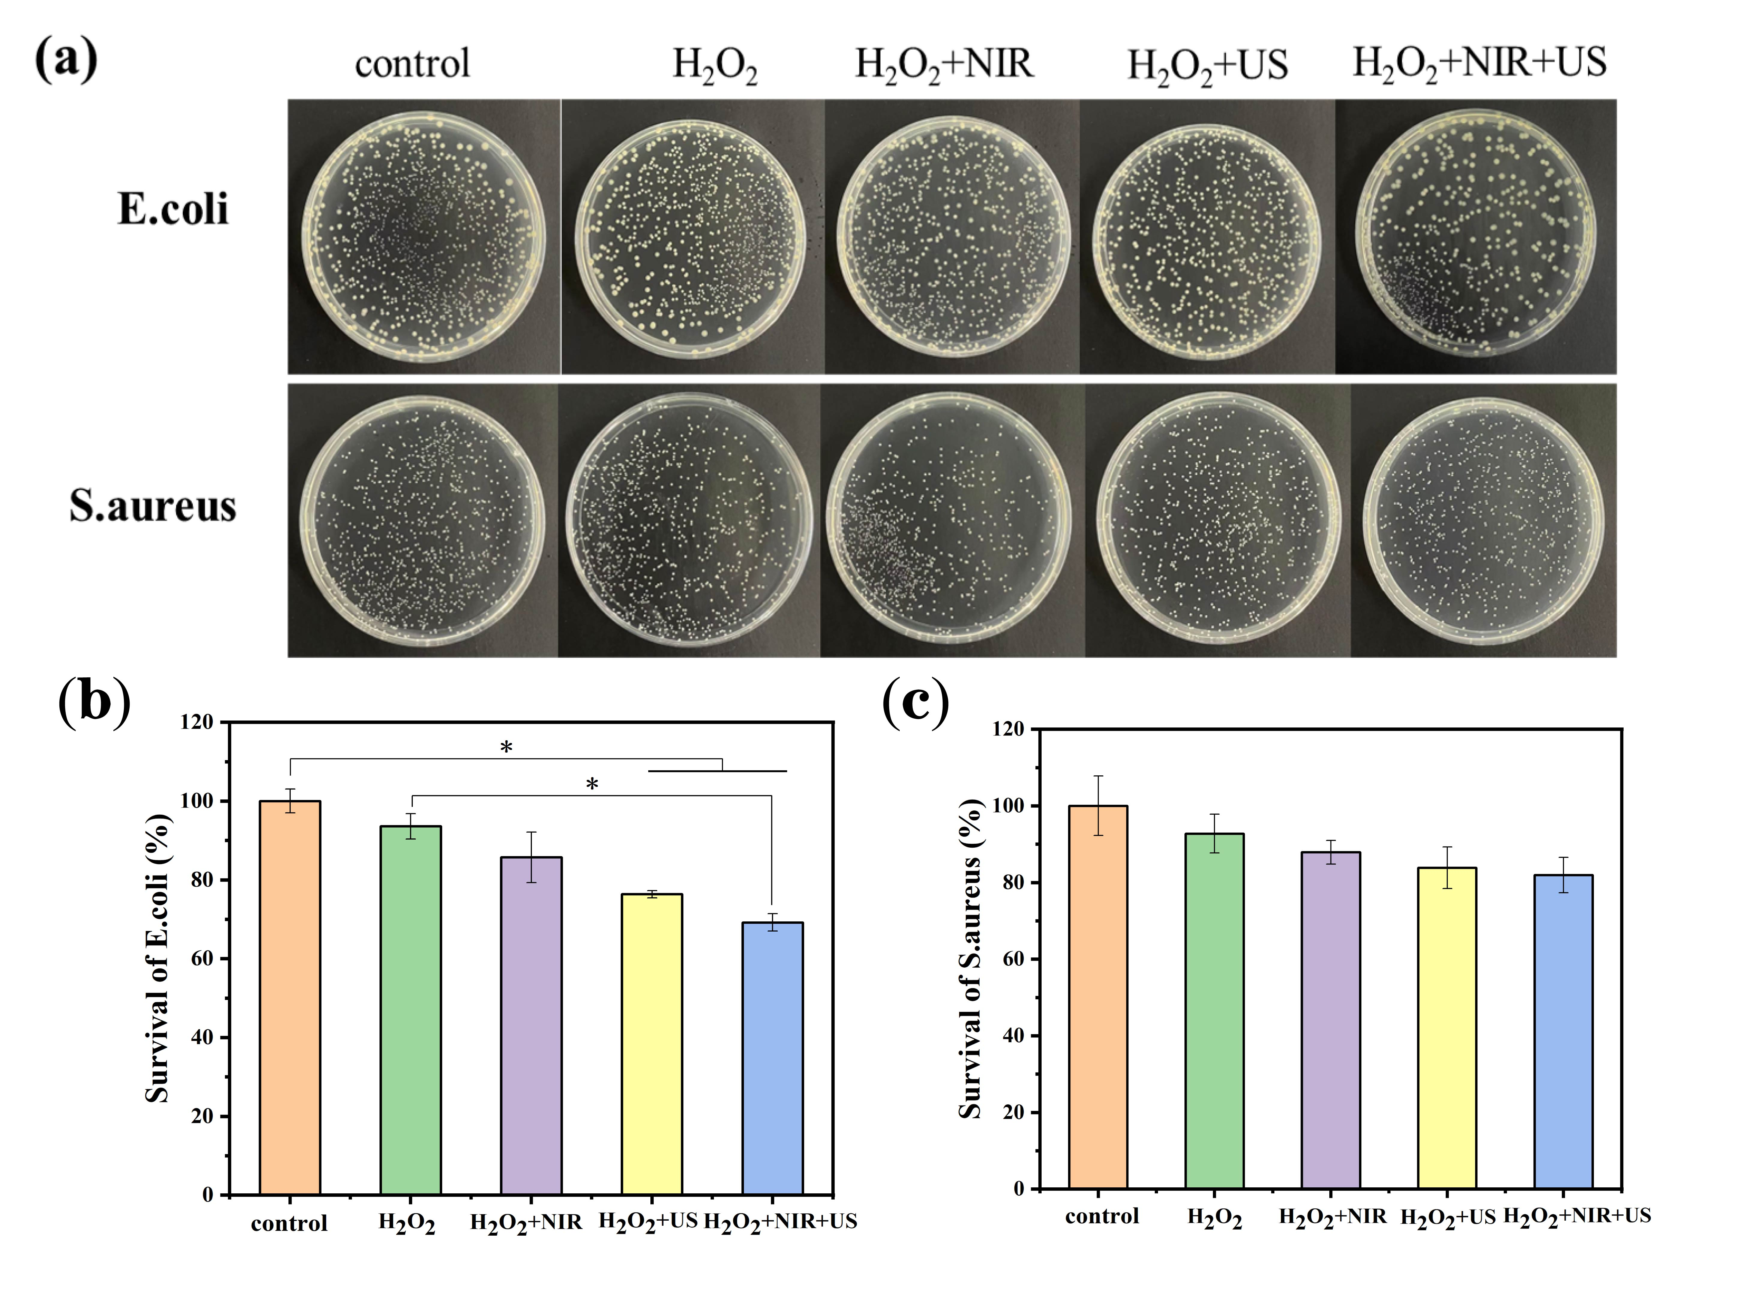
Fig S10. (a) The pictures of E. coli and S. aureus colonies on agar plates after different treatments. The corresponding viabilities of (b) E. coli and (c) S. aureus from the data in (a). The data are expressed as means ± SD (n = 3). *p<0.05.

