A schematic representation of the synthesis route is shown in Figure S1.
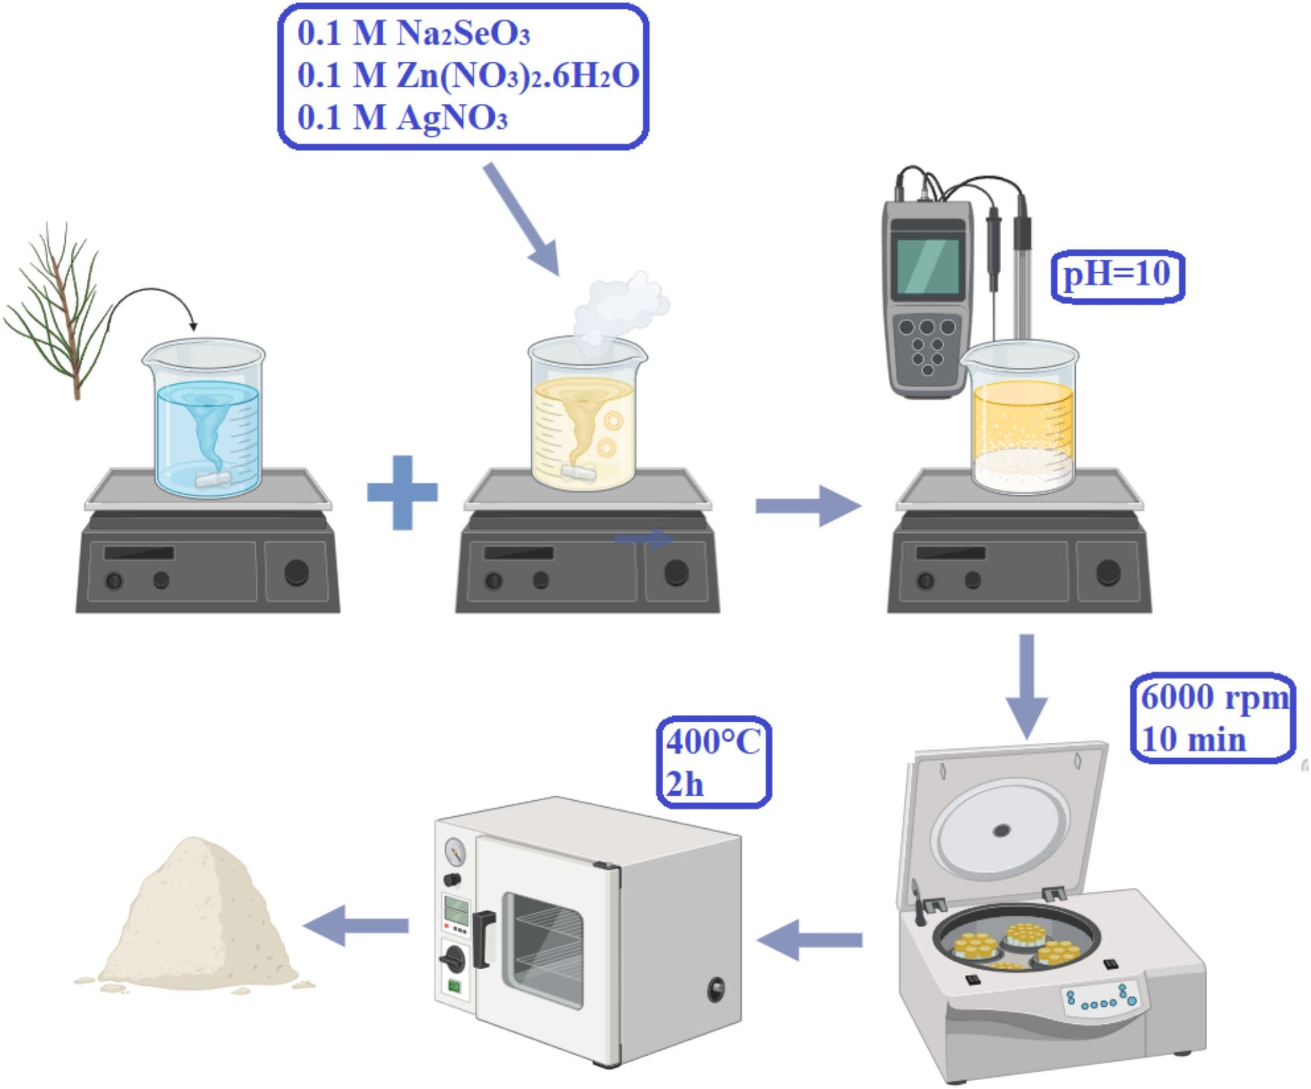
Figure S1. Schematic representation of the green co‑precipitation synthesis route for Se@Ag/AgO–ZnO nanocomposites using Pinus nigra pollen extract

