Table S1 Matrix design of experimental runs with obtained responses expressed as mean ± SD (n = 3)

Run | A:Lipid quantity (mg) | B: Total drug quantity (mg) | C: Type of lipid | D: Type of PLGA | Response Y1: PS (nm) | Response Y2: PDI | Response Y3: ZP (mV) | Response Y4: Total DL (%) | Response Y5: ROS to EZE ratio | EE of  ROS (%) | EE of  EZE (%)
1 | 5.20 | 10.00 | DSPЕ | A | 139.80 ± 2.63 | 0.266 ± 0.03 | -0.40 ± 0.31 | 6.39 ± 0.04 | 1.6 ± 0.01 | 55.07 ± 0.07 | 34.79 ± 0.17
2 | 5.20 | 10.00 | DOTAP | E | 239.10 ± 16.47 | 0.219 ± 0.02 | -0.49 ± 0.48 | 10.55 ± 0.88 | 2.4 ± 0.02 | 69.86 ± 0.15 | 28.54 ± 0.13
3 | 9.20 | 10.00 | DSPЕ | E | 496.60 ± 25.91 | 0.478 ± 0.08 | -0.27 ± 0.19 | 7.66 ± 0.79 | 2.1 ± 0.01 | 58.41 ± 0.09 | 27.44 ± 0.13
4 | 0.80 | 10.00 | DOTAP | A | 296.10 ± 25.77 | 0.166 ±0.07 | -0.39 ± 0.32 | 10.64 ± 3.55 | 2.2 ± 0.01 | 51.60 ± 0.04 | 23.11 ± 0.09
5 | 0.80 | 10.00 | DOTAP | E | 187.40 ± 2.52 | 0.195 ± 0.03 | -0.02 ± 0.33 | 5.36 ± 0.96 | 2.4 ± 0.01 | 57.44 ± 0.10 | 24.06 ± 0.09
6 | 9.20 | 10.00 | DSPЕ | A | 139.60 ± 0.62 | 0.250 ± 0.02 | -0.13 ± 0.33 | 5.02 ± 0.35 | 2.6 ± 0.03 | 59.97 ± 0.62 | 22.56 ± 0.09
7 | 5.20 | 10.00 | DSPЕ | A | 201.86 ± 39.54 | 0.352 ± 0.04 | -0.34 ± 0.28 | 7.75 ± 0.55 | 1.4 ± 0.07 | 43.55 ± 2.71 | 29.71 ± 0.87
8 | 5.20 | 10.00 | DOTAP | E | 227.20 ± 8.35 | 0.153 ± 0.12 | 0.34 ± 0.41 | 9.27 ± 1.24 | 3.0 ± 0.18 | 67.53 ± 2.74 | 22.97 ± 1.50
9 | 0.80 | 10.00 | DSPЕ | A | 168.90 ± 3.36 | 0.385 ± 0.02 | -0.09 ± 0.29 | 4.43 ± 0.09 | 2.2 ± 0.02 | 51.49 ± 1.32 | 23.74 ± 0.72
10 | 5.20 | 18.48 | DSPЕ | E | 213.00 ± 9.97 | 0.248 ± 0.04 | -0.04 ± 0.15 | 6.97 ± 0.13 | 3.4 ± 0.56 | 62.63 ± 5.42 | 15.79 ± 1.16
11 | 8.00 | 4.00 | DOTAP | A | 180.93 ± 2.80 | 0.080 ± 0.02 | -0.15 ± 0.14 | 3.90 ± 0.45 | 1.1 ± 0.00 | 80.10 ± 0.01 | 71.41 ± 0.08
12 | 2.00 | 16.00 | DSPЕ | A | 418.93 ± 64.59 | 0.471 ± 0.06 | 0.12 ± 0.21 | 3.24 ± 0.17 | 0.3 ± 0.02 | 8.18 ± 0.51 | 22.87 ± 0.02
13 | 2.00 | 4.00 | DSPЕ | E | 161.73 ± 0.96 | 0.210 ± 0.03 | -0.16 ± 0.18 | 4.13 ± 0.83 | 0.7 ± 0.00 | 51.91 ± 0.03 | 70.09 ± 0.04
14 | 5.20 | 1.52 | DOTAP | A | 225.30 ± 8.26 | 0.200 ± 0.07 | -0.04 ± 0.18 | 1.62 ± 0.16 | 0.7 ± 0.01 | 66.21 ± 0.87 | 95.40 ± 0.12
15 | 2.00 | 16.00 | DOTAP | A | 193.40 ± 5.40 | 0.183 ± 0.06 | 11.61 ± 2.74 | 2.14 ± 1.33 | 1.5 ± 0.00 | 28.96 ± 0.09 | 19.38 ± 0.02
16 | 5.20 | 10.00 | DSPЕ | E | 210.06 ± 13.40 | 0.384 ± 0.08 | -13.43 ± 0.42 | 9.26 ± 1.85 | 1.7 ± 0.01 | 44.43 ± 0.23 | 25.74 ± 0.02
17 | 5.20 | 18.48 | DOTAP | A | 190.73 ± 5.46 | 0.143 ± 0.10 | -0.01 ± 0.25 | 6.38 ± 0.82 | 2.2 ± 0.01 | 32.46 ± 0.15 | 14.62 ± 0.01
18 | 2.00 | 16.00 | DOTAP | E | 215.20 ± 11.22 | 0.254 ± 0.03 | -0.30 ± 0.26 | 13.53 ± 0.80 | 2.0 ± 0.02 | 35.11 ± 0.12 | 18.09 ± 0.12
19 | 5.20 | 10.00 | DOTAP | A | 349.87 ± 31.51 | 0.262 ± 0.08 | -0.87 ± 0.64 | 10.68 ± 4.48 | 2.1 ± 0.60 | 57.73 ± 0.09 | 42.06 ± 0.03
20 | 8.00 | 16.00 | DSPЕ | A | 581.33 ± 65.91 | 0.522 ± 0.06 | -12.70 ± 0.46 | 7.54 ± 0.54 | 1.9 ± 0.00 | 33.69 ± 0.02 | 17.73 ± 0.02
21 | 8.00 | 4.00 | DSPЕ | E | 224.53 ± 66.04 | 0.433 ± 0.06 | -18.76 ± 1.25 | 7.09 ± 1.77 | 0.8 ± 0.00 | 50.09 ± 0.07 | 61.38 ± 0.09
22 | 2.00 | 4.00 | DOTAP | A | 266.26 ± 3.78 | 0.326 ± 0.15 | -5.55 ± 0.32 | 5.59 ± 0.96 | 0.7 ± 0.05 | 71.15 ± 4.35 | 93.50 ± 0.13
23 | 5.20 | 1.52 | DSPЕ | E | 155.20 ± 5.22 | 0.389 ± 0.06 | 0.01 ± 0.32 | 1.89 ± 0.24 | 0.7 ± 0.01 | 53.75 ± 0.51 | 76.28 ± 0.10
24 | 8.00 | 16.00 | DOTAP | E | 341.40 ± 7.59 | 0.310 ± 0.05 | 29.83 ± 0.98 | 7.72 ± 0.29 | 1.3 ± 0.00 | 71.24 ± 0.06 | 22.41 ± 0.04
25 | 5.20 | 1.52 | DSPЕ | A | 207.46 ± 4.30 | 0.361 ± 0.06 | 0.02 ± 0.41 | 1.47 ± 0.20 | 0.6 ± 0.00 | 43.45 ± 0.03 | 73.59 ± 0.06
26 | 8.00 | 4.00 | DSPЕ | A | 323.30 ± 34.01 | 0.349 ± 0.03 | -0.15 ± 0.07 | 3.80 ± 0.59 | 0.6 ± 0.00 | 35.19 ± 0.23 | 54.99 ± 0.31
27 | 5.20 | 1.52 | DOTAP | E | 230.80 ± 10.52 | 0.221 ± 0.03 | -0.07 ± 0.55 | 2.78 ± 0.43 | 0.7 ± 0.00 | 66.00 ± 0.02 | 90.93 ± 0.06
28 | 9.20 | 10.00 | DOTAP | A | 200.23 ± 3.21 | 0.250 ± 0.01 | 21.83 ± 0.83 | 3.96 ± 1.06 | 2.4 ± 0.09 | 85.05 ± 3.15 | 34.21 ± 0.04
29 | 2.00 | 16.00 | DSPЕ | E | 350.16 ± 30.79 | 0.470 ± 0.06 | -9.43 ± 0.58 | 4.95 ±0.22 | 1.9 ± 0.00 | 31.59 ± 0.64 | 16.29 ± 0.31
30 | 8.00 | 16.00 | DOTAP | A | 169.83 ± 3.65 | 0.221 ± 0.01 | 28.96 ± 0.49 | 11.92 ± 1.99 | 3.5 ± 0.00 | 73.97 ± 1.50 | 20.99 ± 0.41
31 | 5.20 | 10.00 | DSPЕ | E | 171.83 ± 3.61 | 0.218 ± 0.02 | -20.23 ± 3.39 | 6.13 ± 1.38 | 1.4 ± 0.01 | 41.71 ± 0.25 | 29.04 ± 0.03
32 | 9.20 | 10.00 | DOTAP | E | 253.30 ± 5.59 | 0.281 ± 0.01 | 22.53 ± 11.45 | 11.09 ± 0.62 | 2.2 ± 0.01 | 85.68 ± 0.01 | 38.77 ± 0.08
33 | 0.80 | 10.00 | DSPЕ | E | 194.06 ± 7.16 | 0.258 ± 0.05 | -0.32 ± 0.43 | 7.13 ± 0.96 | 1.6 ± 0.16 | 67.26 ± 6.93 | 36.75 ± 0.57
34 | 2.00 | 4.00 | DOTAP | E | 373.93 ± 7.84 | 0.328 ± 0.11 | -0.05 ± 0.29 | 5.39 ± 0.67 | 0.6 ± 0.00 | 56.85 ± 0.05 | 87.65 ± 0.05
35 | 2.00 | 4.00 | DSPЕ | A | 136.06 ± 3.59 | 0.193 ± 0.02 | -16.60 ± 0.71 | 3.35 ± 0.60 | 0.4 ± 0.00 | 35.35 ± 0.05 | 80.65 ± 0.05
36 | 8.00 | 4.00 | DOTAP | E | 265.13 ± 3.27 | 0.281 ± 0.04 | 24.96 ± 0.25 | 5.23 ± 0.28 | 0.8 ± 0.00 | 76.00 ± 0.05 | 95.05 ± 0.05
37 | 5.20 | 18.48 | DOTAP | E | 243.96 ± 7.35 | 0.260 ± 0.03 | 0.34 ± 0.19 | 10.17 ± 1.37 | 2.9 ± 0.26 | 52.64 ± 4.52 | 17.20 ± 0.02
38 | 8.00 | 16.00 | DSPЕ | E | 538.03 ± 24.35 | 0.523 ± 0.04 | -0.33 ± 0.33 | 4.29 ± 0.45 | 1.3 ± 0.00 | 22.41 ± 0.34 | 16.74 ± 0.23
39 | 5.20 | 18.48 | DSPЕ | A | 204.50 ± 8.01 | 0.511 ± 0.01 | -13.60 ± 1.04 | 7.09 ± 1.50 | 1.8 ± 0.00 | 28.84 ± 0.20 | 15.73 ± 0.12
40 | 5.20 | 10.00 | DOTAP | A | 161.26 ± 4.68 | 0.161 ±0.03 | -0.46 ± 0.27 | 4.41 ± 0.40 | 1.2 ± 0.12 | 31.08 ± 0.29 | 23.88 ± 2.01

Table S2 ANOVA-based model diagnostics for each response
Parameter | Y1: PS  (nm) | Y2: PDI | Y3: ZP  (mV) | Y4: Total DL  (%) | Y5: ROS to EZE ratio
Model type | 2FI | Linear | Quadratic | Quadratic | Linear
Model F-value | 3.330 | 7.072 | 13.275 | 7.615 | 5.632
p-value (Model) | 0.015 | <0.001 | <0.001 | <0.001 | 0.001
R² | 0.329 | 0.447 | 0.603 | 0.465 | 0.392
Adjusted R² | 0.230 | 0.384 | 0.557 | 0.404 | 0.322
Predicted R² (Q²) | 0.052 | 0.272 | 0.505 | 0.322 | 0.196
PRESS | 4.252×10⁵ | 0.372 | 2546.009 | 242.701 | 23.350
Adequate precision | 7.229 | 7.826 | 12.265 | 9.907 | 8.206
Lack of fit p-value | 0.298 (ns) | 0.431 (ns) | 0.015 (s) | 0.683 (ns) | 0.113 (ns)
Residual Std. Dev. | 94.107 | 0.090 | 7.638 | 2.338 | 0.711
C.V. (%) | 37.462 | 30.543 | 1212.497 | 37.129 | 45.391
*”ns” refers to not significant and “s” refers to significant.

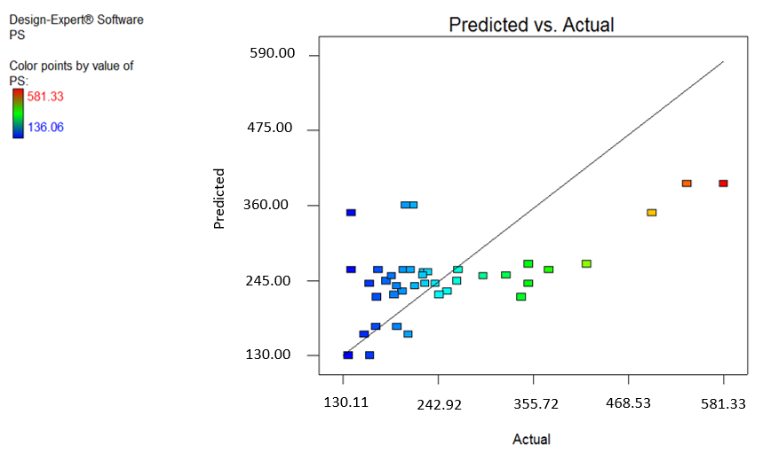
Fig. S1 Parity plot (observed vs. predicted values) for PS
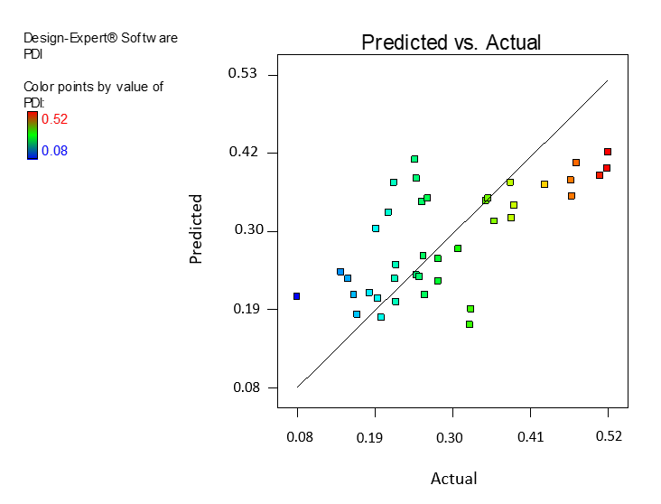
Fig. S2 Parity plot (observed vs. predicted values) for PDI
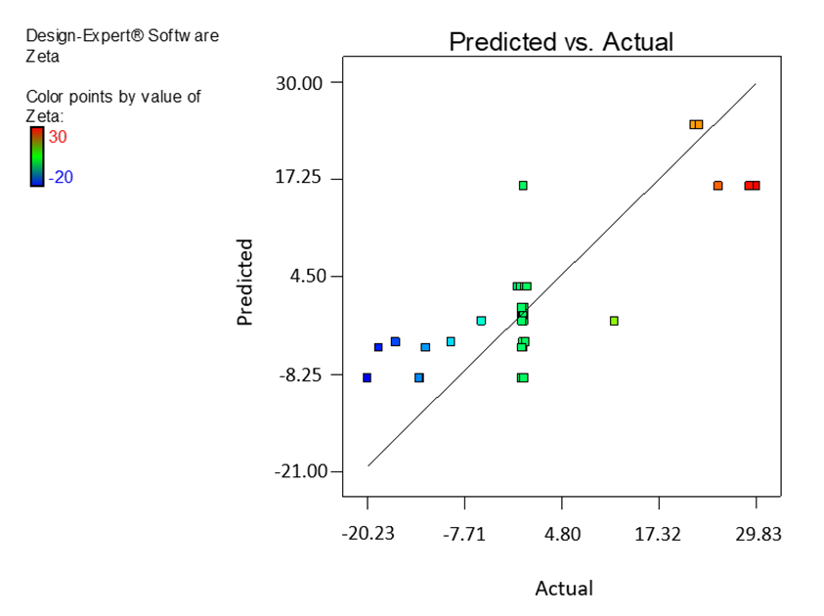
Fig. S3 Parity plot (observed vs. predicted values) for ZP
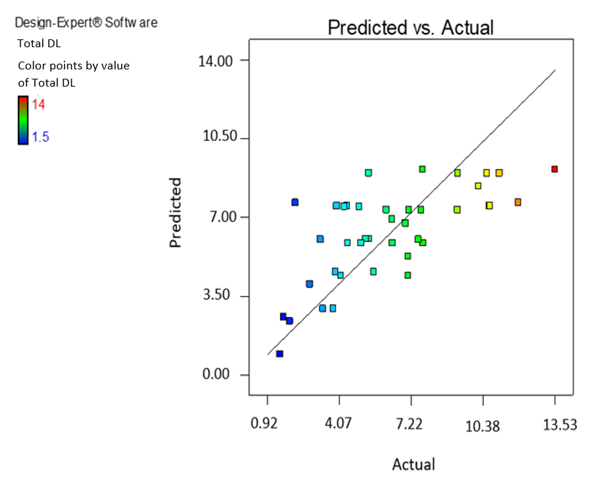
Fig. S4 Parity plot (observed vs. predicted values) for total DL
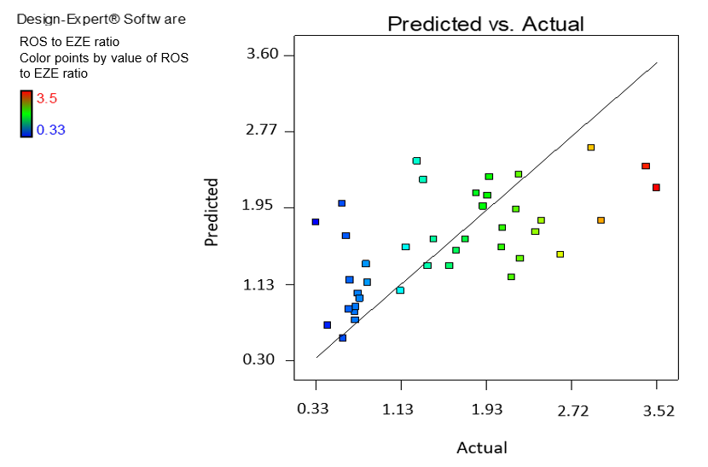
Fig. S5 Parity plot (observed vs. predicted values) for ROS to EZE ratio
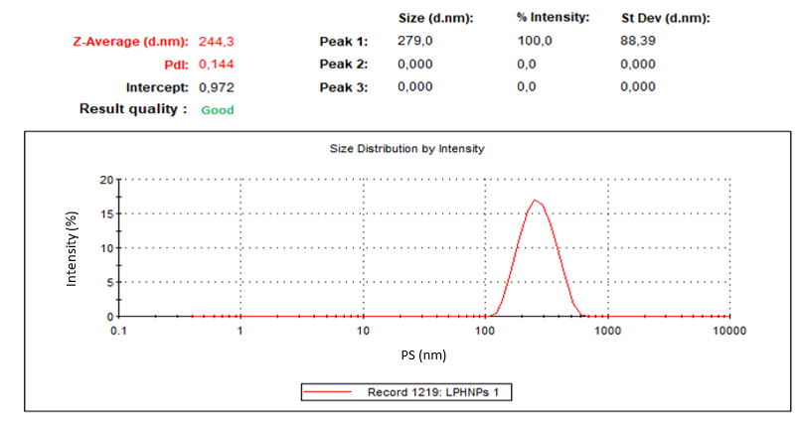
Fig. S6 ROS and EZE-loaded LPHNPs optimal formulation 1 (ratio 1), DLS size measurement 1 composed of multiple automatically optimized runs
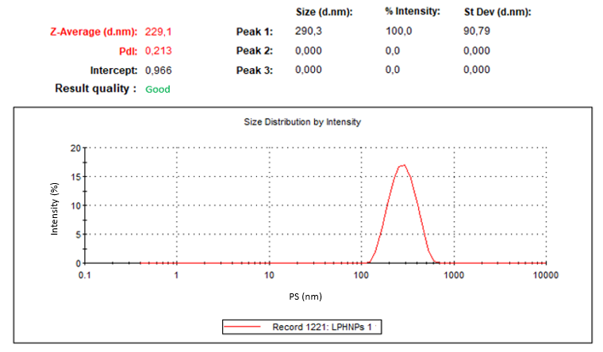
Fig. S7 ROS and EZE-loaded LPHNPs optimal formulation 1 (ratio 1), DLS size measurement 2 composed of multiple automatically optimized runs

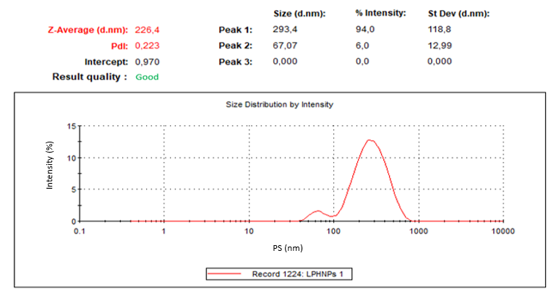
Fig. S8 ROS and EZE-loaded LPHNPs optimal formulation 1 (ratio 1), DLS size measurement 3 composed of multiple automatically optimized runs
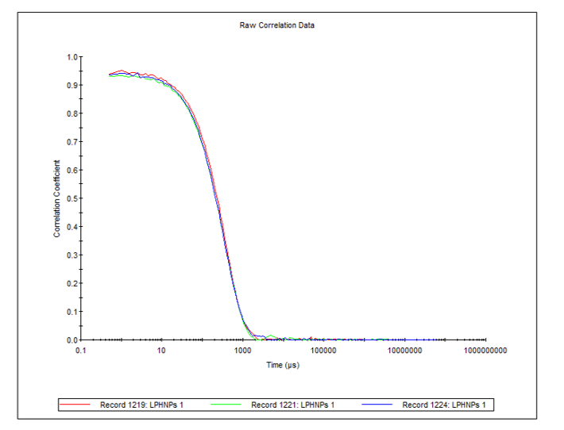
Fig. S9 ROS and EZE-loaded LPHNPs formulation 1 (ratio 1), DLS size correlogram of three replicate measurements each composed of multiple automatically optimized runs
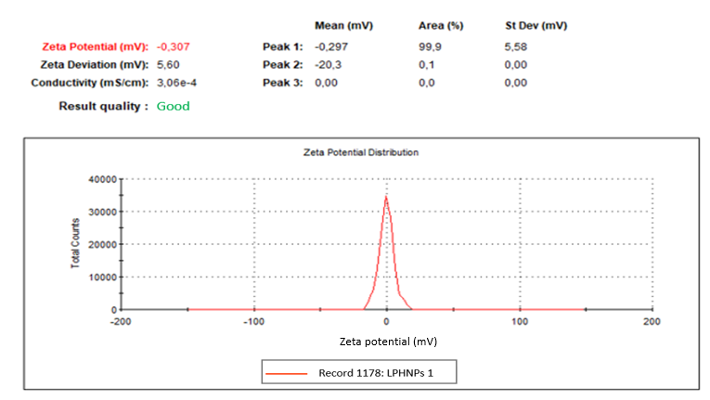
Fig. S10 ROS and EZE-loaded LPHNPs formulation 1 (ratio 1), ZP measurement 1 composed of multiple automatically optimized runs
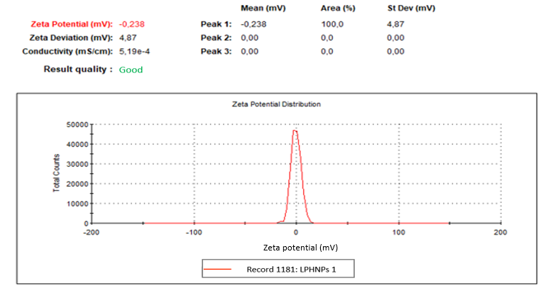
Fig. S11 ROS and EZE-loaded LPHNPs formulation 1 (ratio 1), ZP measurement 2 composed of multiple automatically optimized runs
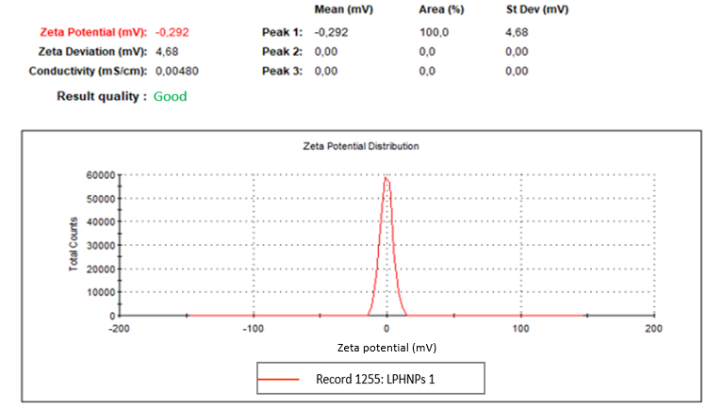
Fig. S12 ROS and EZE-loaded LPHNPs formulation 1 (ratio 1), ZP measurement 3 composed of multiple automatically optimized runs
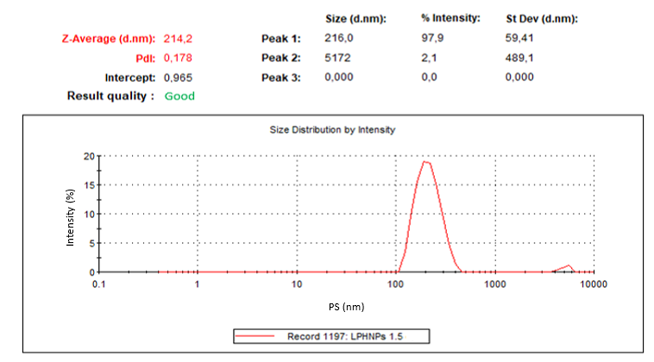
Fig. S13 ROS and EZE-loaded LPHNPs formulation 2 (ratio 1.5), DLS size measurement 1 composed of multiple automatically optimized runs
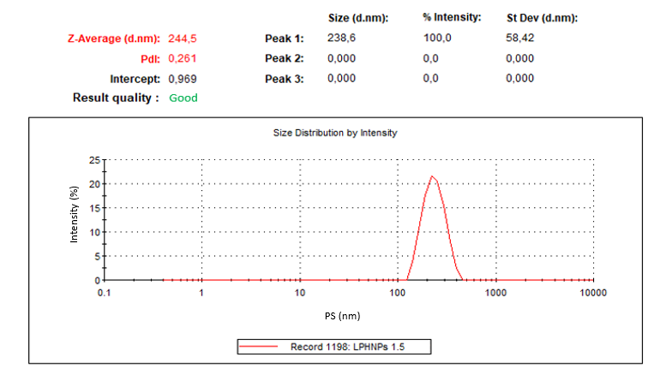
Fig. S14 ROS and EZE-loaded LPHNPs formulation 2 (ratio 1.5), DLS size measurement 2 composed of multiple automatically optimized runs
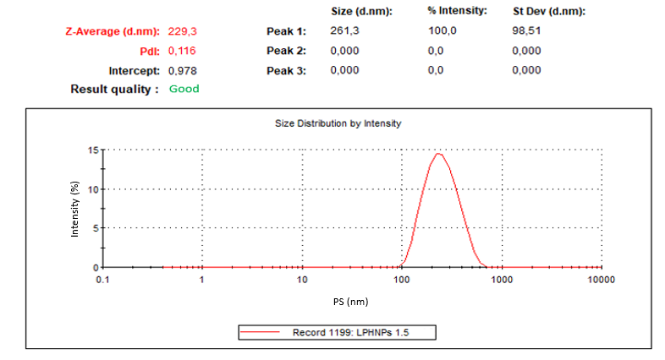
Fig. S15 ROS and EZE-loaded LPHNPs formulation 2 (ratio 1.5), DLS size measurement 3 composed of multiple automatically optimized runs
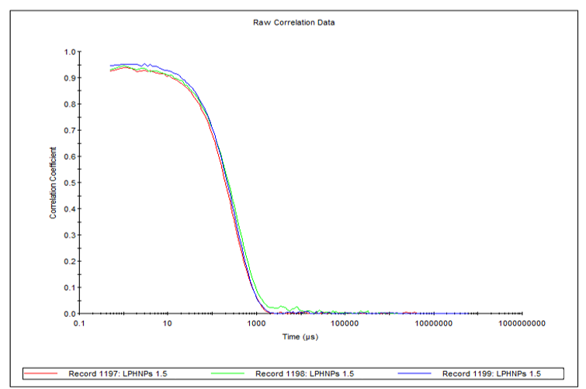
Fig. S16 ROS and EZE-loaded LPHNPs formulation 2 (ratio 1.5), DLS size correlogram of three replicate measurements each composed of multiple automatically optimized runs
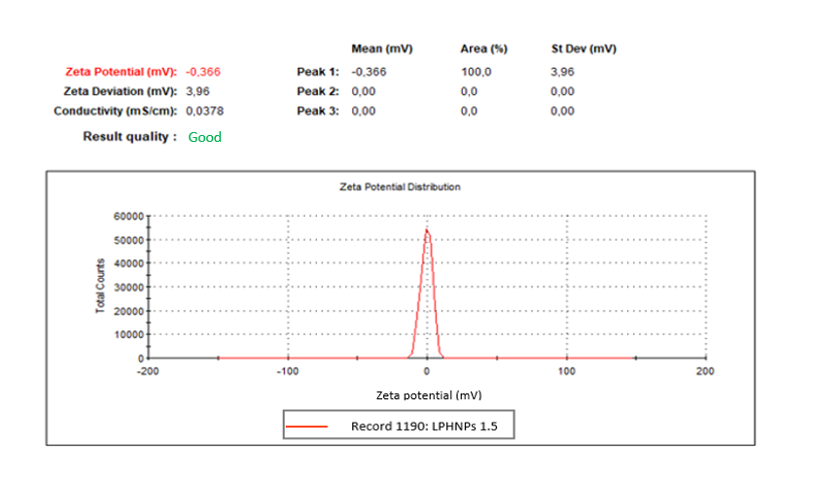
Fig. S17 ROS and EZE-loaded LPHNPs formulation 2 (ratio 1.5), ZP measurement 1 composed of multiple automatically optimized runs
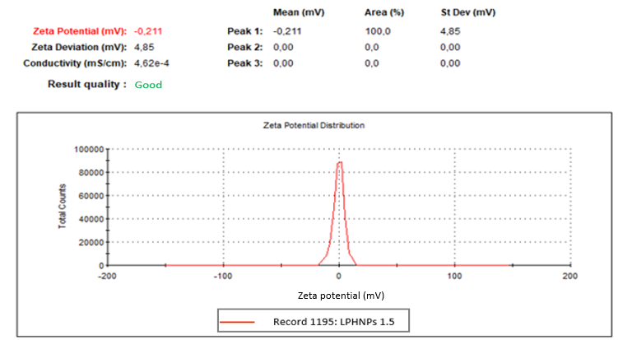
Fig. S18 ROS and EZE-loaded LPHNPs formulation 2 (ratio 1.5), ZP measurement 2 composed of multiple automatically optimized runs
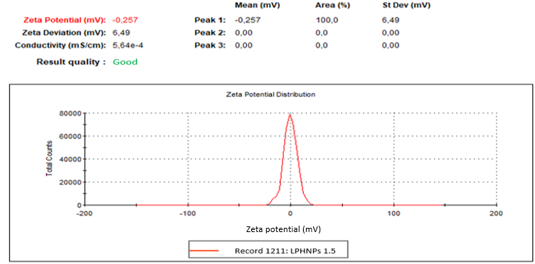
Fig. S19 ROS and EZE-loaded LPHNPs formulation 2 (ratio 1.5), ZP measurement 3 composed of multiple automatically optimized runs
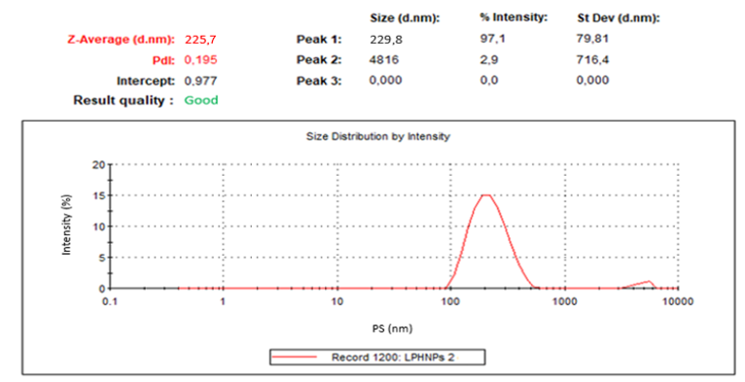
Fig. S20 ROS and EZE-loaded LPHNPs formulation 3 (ratio 2), DLS size measurement 1 composed of multiple automatically optimized runs
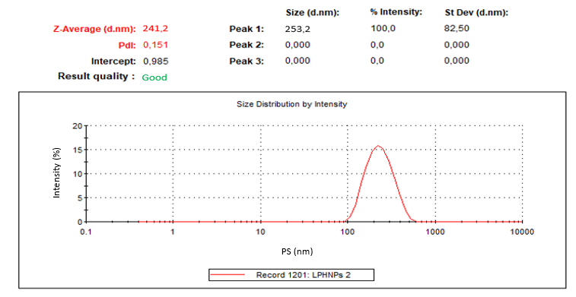
Fig. S21 ROS and EZE-loaded LPHNPs formulation 3 (ratio 2), DLS size measurement 2 composed of multiple automatically optimized runs
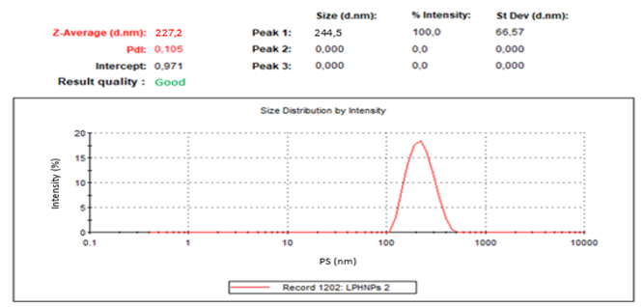
Fig. S22 ROS and EZE-loaded LPHNPs formulation 3 (ratio 2), DLS size measurement 3 composed of multiple automatically optimized runs
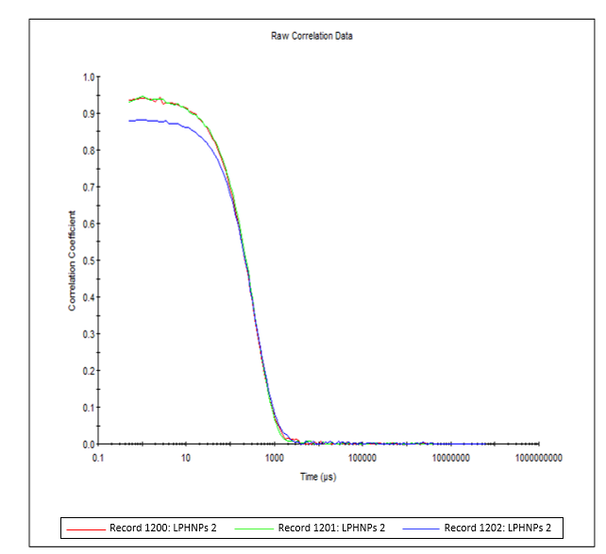
Fig. S23 ROS and EZE-loaded LPHNPs formulation 3 (ratio 2), DLS size correlogram of three replicate measurements each composed of multiple automatically optimized runs
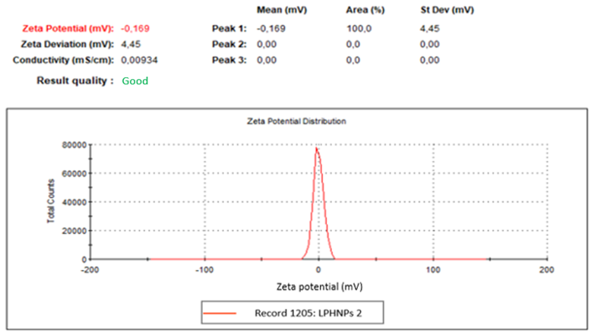
Fig. S24 ROS and EZE-loaded LPHNPs formulation 3 (ratio 2), ZP measurement 1 composed of multiple automatically optimized runs
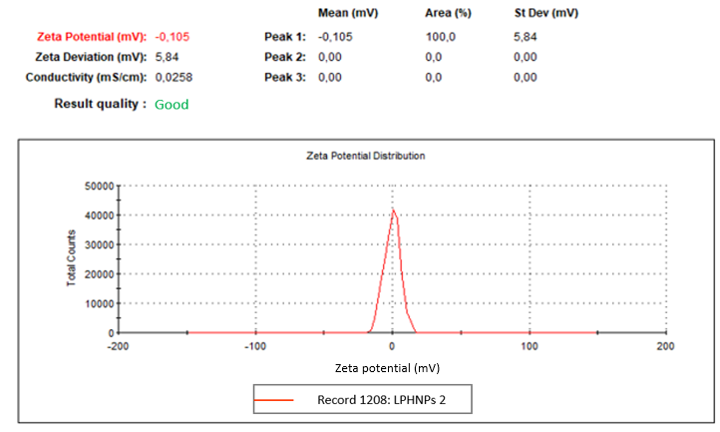
Fig. S25 ROS and EZE-loaded LPHNPs formulation 3 (ratio 2), ZP measurement 2 composed of multiple automatically optimized runs
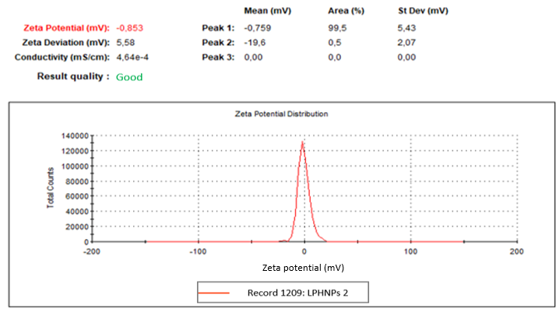
Fig. S26 ROS and EZE-loaded LPHNPs formulation 3 (ratio 2), ZP measurement 3 composed of multiple automatically optimized runs
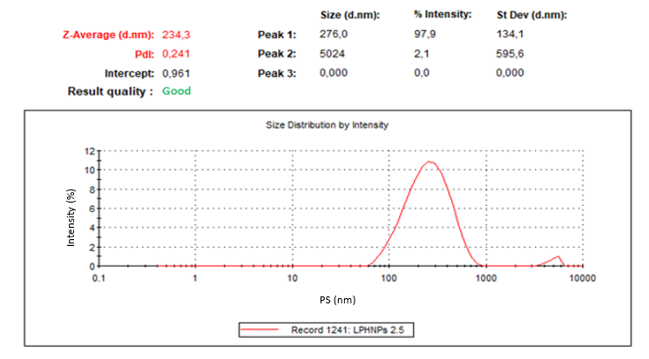
Fig. S27 ROS and EZE-loaded LPHNPs formulation 4 (ratio 2.5), DLS size measurement 1 composed of multiple automatically optimized runs
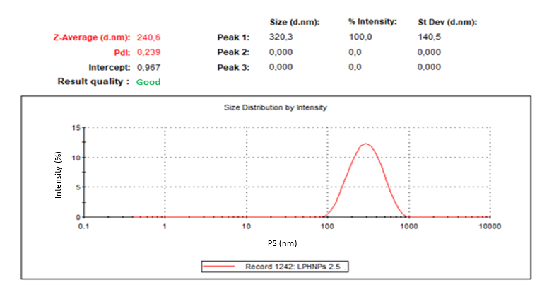
Fig. S28 ROS and EZE-loaded LPHNPs formulation 4 (ratio 2.5), DLS size measurement 2 composed of multiple automatically optimized runs
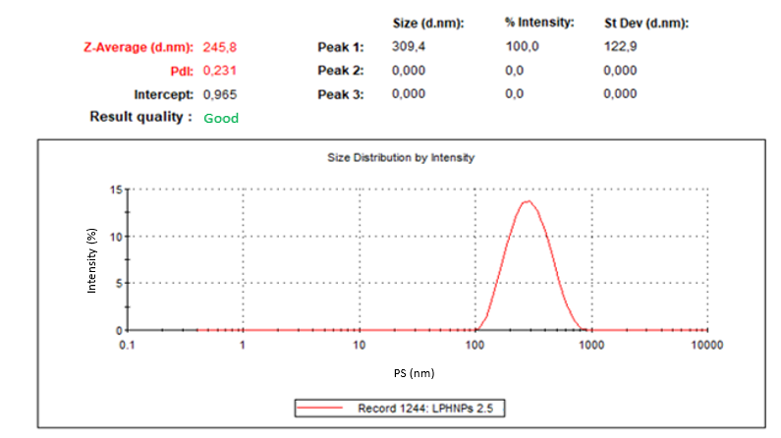
Fig. S29 ROS and EZE-loaded LPHNPs formulation 4 (ratio 2.5), DLS size measurement 3 composed of multiple automatically optimized runs
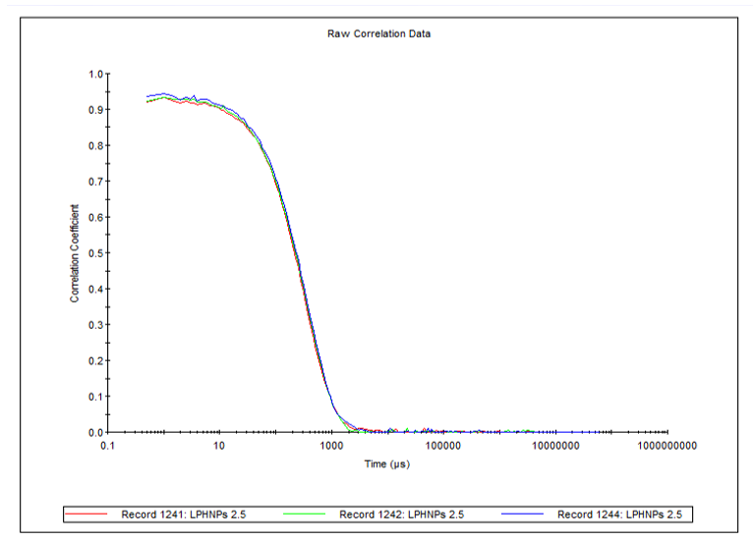
Fig. S30 ROS and EZE-loaded LPHNPs formulation 4 (ratio 2.5), DLS size correlogram of three replicate measurements each composed of multiple automatically optimized runs
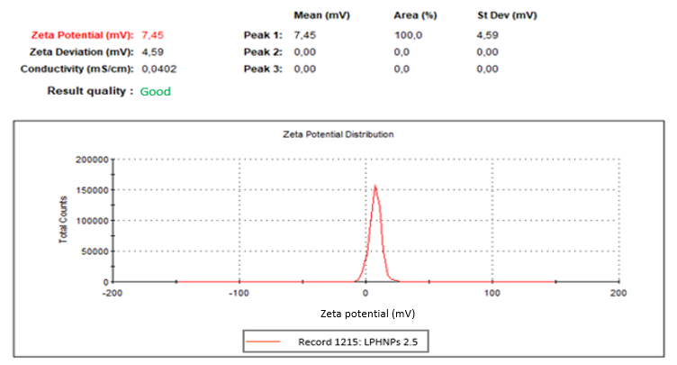
Fig. S31 ROS and EZE-loaded LPHNPs formulation 4 (ratio 2.5), ZP measurement 1 composed of multiple automatically optimized runs
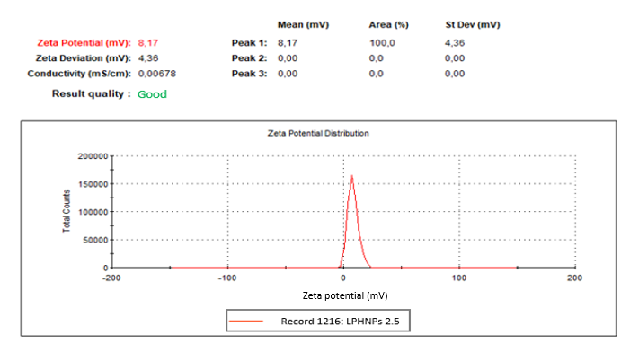
Fig. S32 ROS and EZE-loaded LPHNPs formulation 4 (ratio 2.5), ZP measurement 2 composed of multiple automatically optimized runs
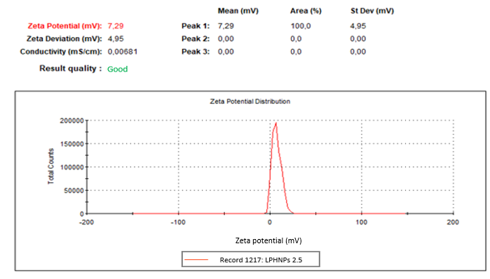
Fig. S33 ROS and EZE-loaded LPHNPs formulation 4 (ratio 2.5), ZP measurement 3 composed of multiple automatically optimized runs
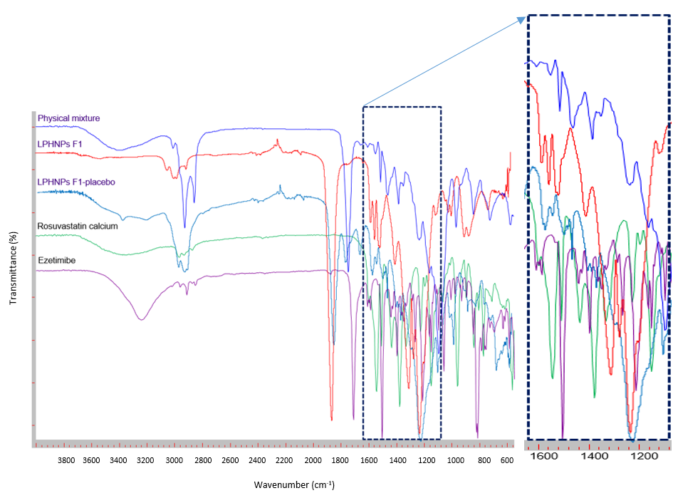
Fig. S34 FTIR spectra of ROS, EZE, physical mixture, optimal drugs loaded and placebo LPHNPs (formulation 1)

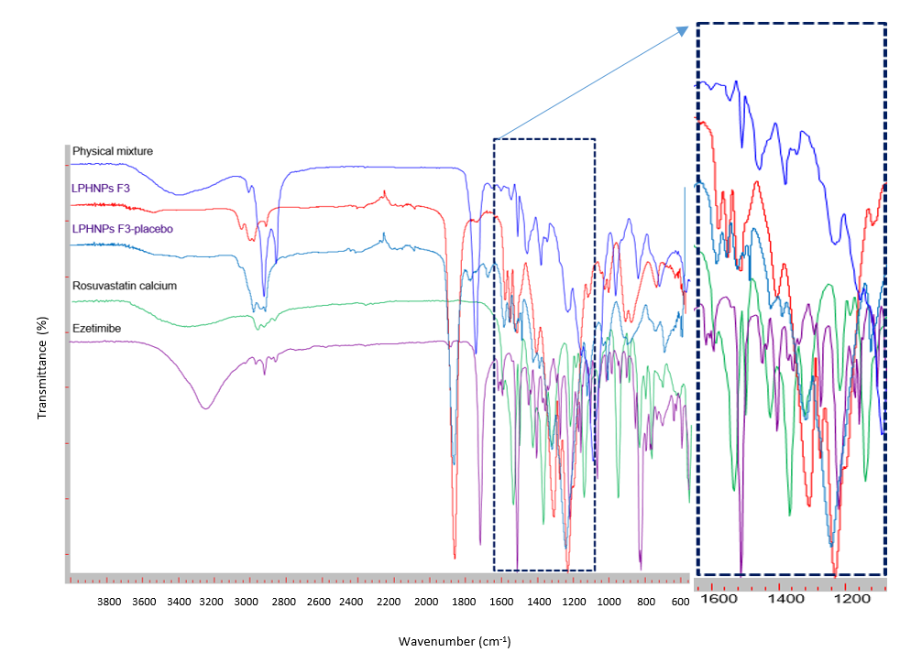
Fig. S35 FTIR spectra of ROS, EZE, physical mixture, optimal drugs loaded and placebo LPHNPs (formulation 3)

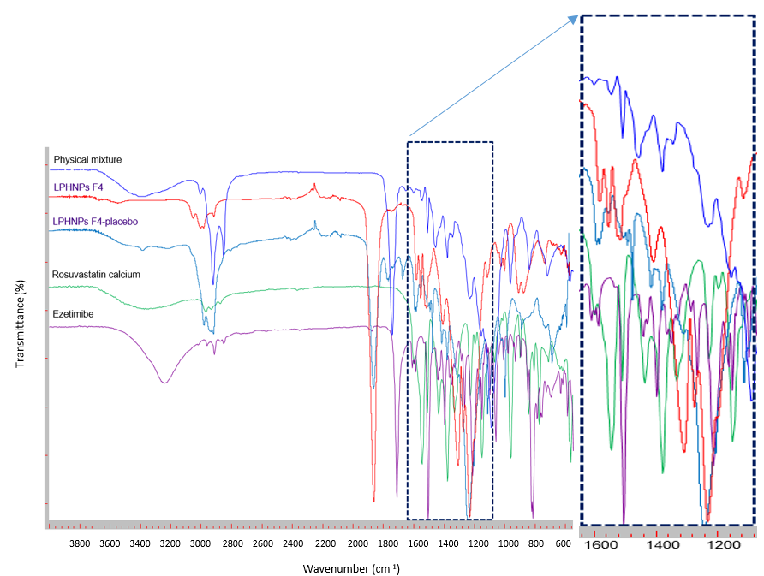
Fig. S36 FTIR spectra of ROS, EZE, physical mixture, optimal drugs loaded and placebo LPHNPs (formulation 4)
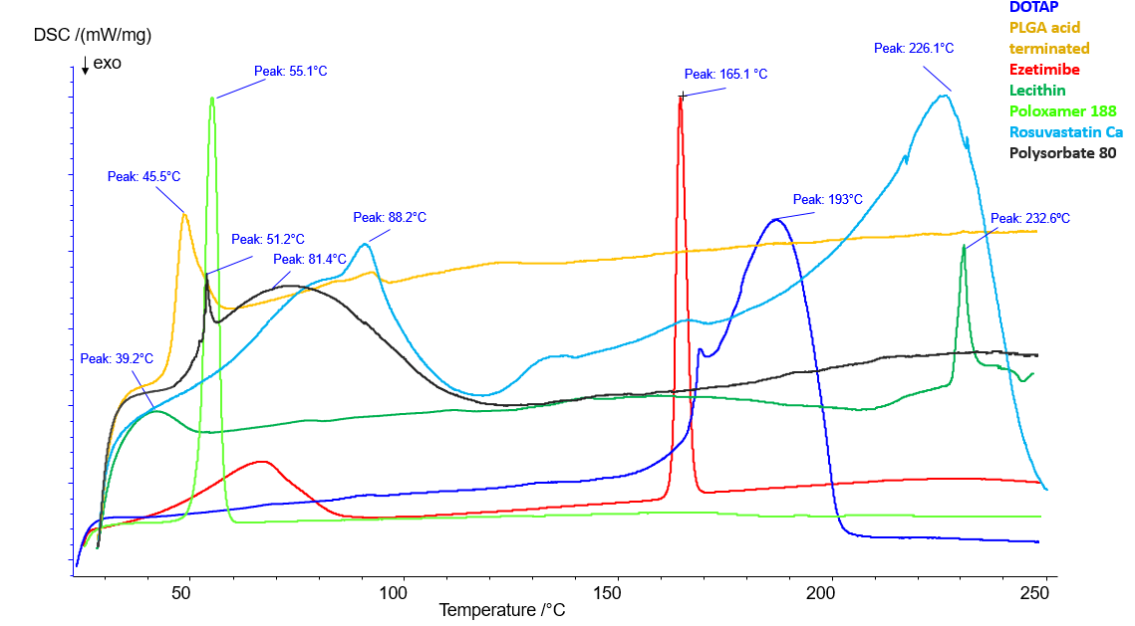
Fig. S37 DSC thermograms of individual ingredients included in optimal LPHNPs formulations
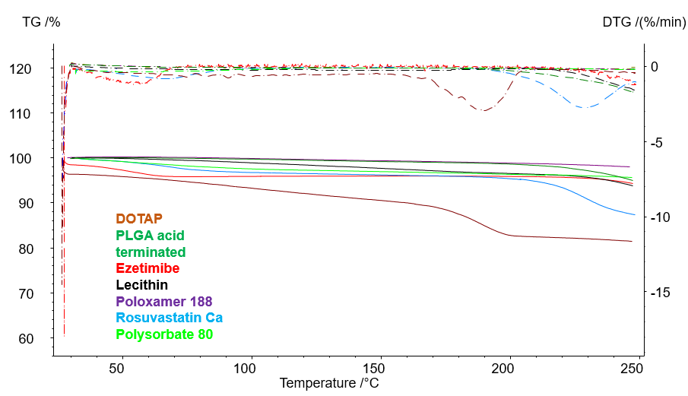
Fig. S38 TGA and DTG thermograms of individual ingredients included in optimal LPHNPs formulations
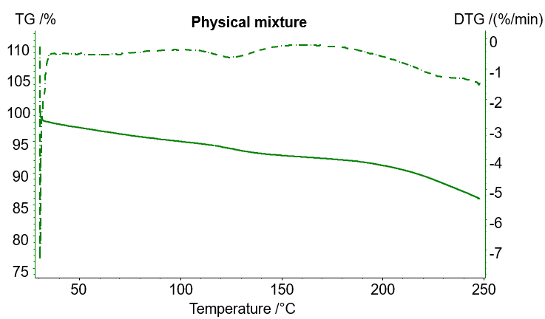
Fig. S39 TGA and DTG thermograms of physical mixture

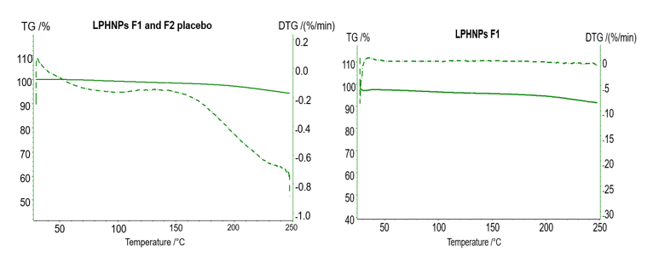
Fig. S40 TGA and DTG thermograms of ROS and EZE-loaded LPHNPs F1 and placebo
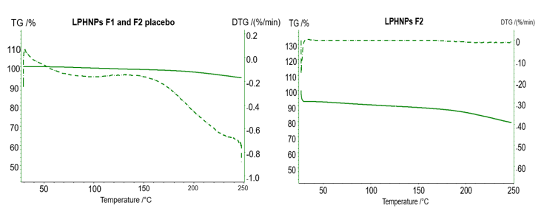
Fig. S41 TGA and DTG thermograms of ROS and EZE-loaded LPHNPs F2 and placebo

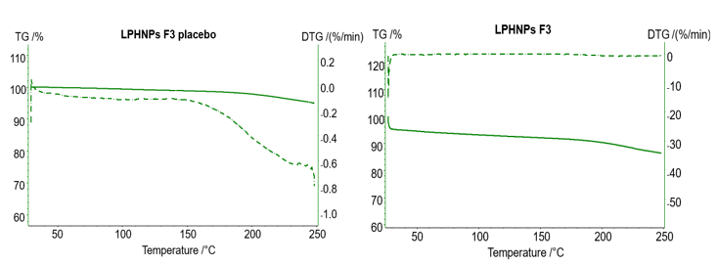
Fig. S42 TGA and DTG thermograms of ROS and EZE-loaded LPHNPs F3 and placebo
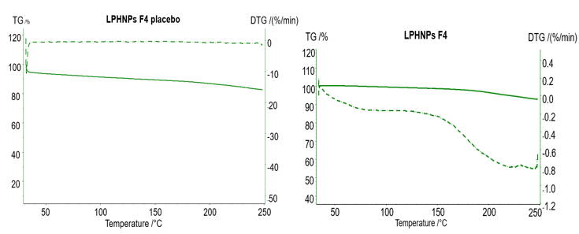
Fig. S43 TGA and DTG thermograms of ROS and EZE-loaded LPHNPs F4 and placebo

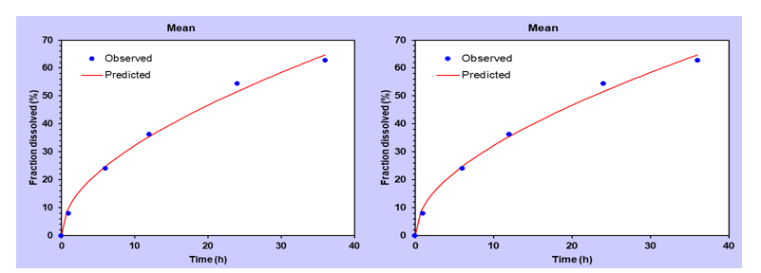
Fig. S44 Dissolution data modeling of ROS from LPHNPs formulation 1 in pH 6.8 (left) and in 7.4 (right) to Peppas-Sahlin model, each fraction is expressed as mean (n = 3)

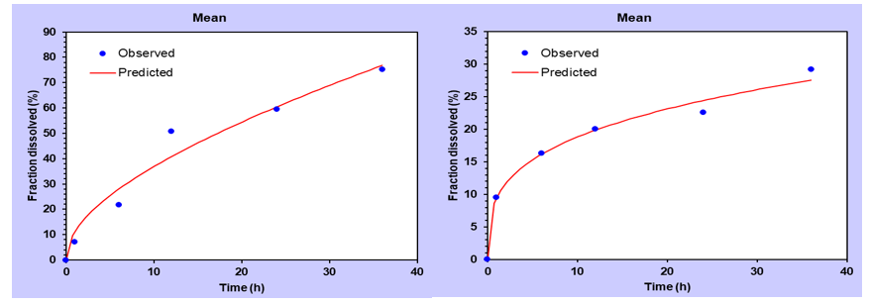
Fig. S45 Dissolution data modeling of ROS from LPHNPs formulation 2 in pH 6.8 (left) to Peppas-Sahlin model and in 7.4 (right) to Korsemeyer-Peppas, model each fraction is expressed as mean (n = 3)

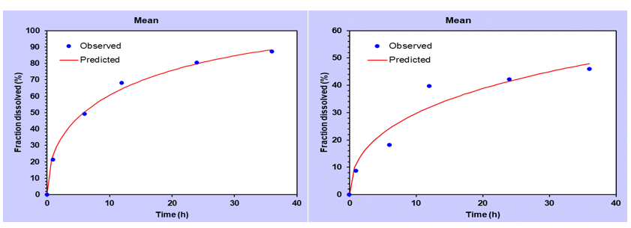
Fig. S46 Dissolution data modeling of ROS from LPHNPs formulation 3 in pH 6.8 (left) and in 7.4 (right) to Peppas-Sahlin model, each fraction is expressed as mean (n = 3)

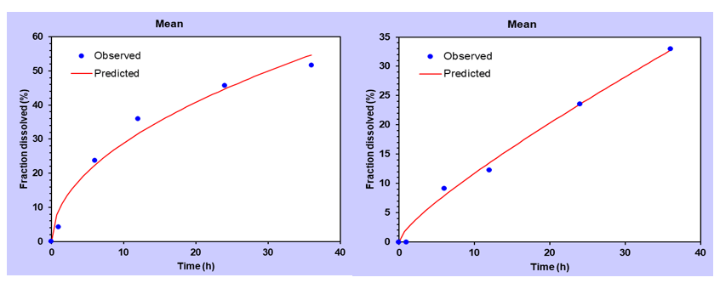
Fig. S47 Dissolution data modeling of ROS from LPHNPs formulation 4 in pH 6.8 (left) to Higuchi and in 7.4 (right) to Peppas-Sahlin model, each fraction is expressed as mean (n = 3)

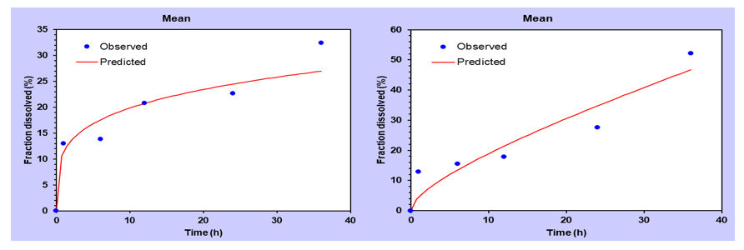
Fig. S48 Dissolution data modeling of EZE from LPHNPs formulation 1 in pH 6.8 (left) to Korsemeyer-Peppas model and in 7.4 (right) to Peppas-Sahlin model, each fraction is expressed as mean (n = 3)
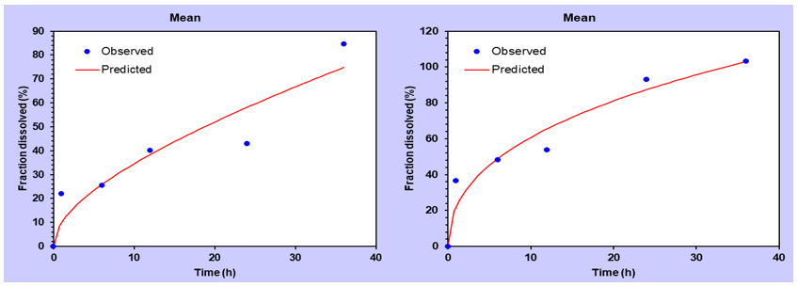Fig. S49 Dissolution data modeling of EZE from LPHNPs formulation 2 in pH 6.8 (left) and in 7.4 (right) to Peppas-Sahlin model, each fraction is expressed as mean (n = 3)

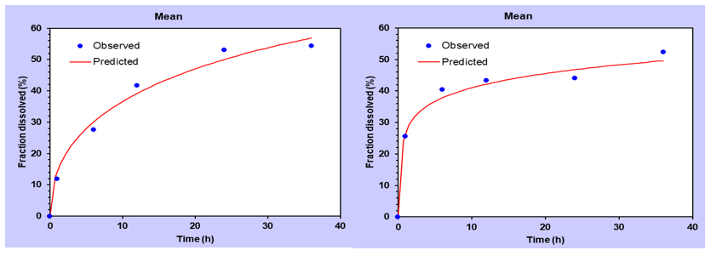Fig. S50 Dissolution data modeling of EZE from LPHNPs formulation 3 in pH 6.8 (left) and in 7.4 (right) to Peppas-Sahlin model, each fraction is expressed as mean (n = 3)

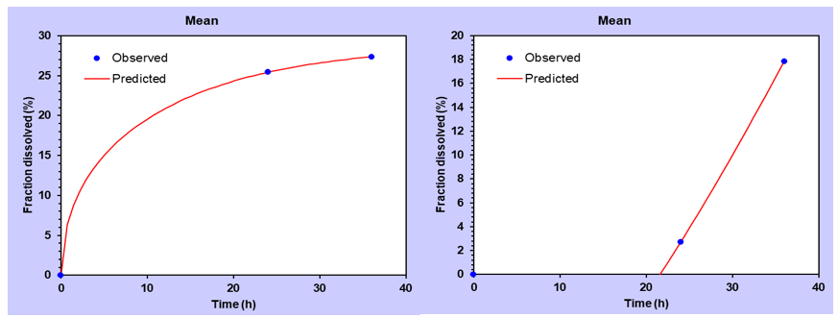
Fig. S51 Dissolution data modeling of EZE from LPHNPs formulation 4 in pH 6.8 (left) and in 7.4 (right) to Peppas-Sahlin model, each fraction is expressed as mean (n = 3)
Table S3 Kinetic models and regression coefficients (full-fitted models)
Formulation/pH | Drug | Zero-order |  | First-order |  | Higuchi |  | Hixon- Crowell |  | Korsmeyer-Peppas |  | Peppas-Sahlin
Formulation/pH | Drug | k₀ | R² | k ₁ | R² | K_{H} | R² | k _{HC} | R² | n | R² | k₁ | k₂ | R²
F1  pH 6.8 | ROS | 2.021 | 0.855 | 0.030 | 0.956 | 10.569 | 0.994 | 0.009 | 0.931 | 0.589 | 0.993 | 9.566 | 0.665 | 0.994
F1  pH 6.8 | EZE | 1.002 | 0.501 | 0.012 | 0.571 | 5.376 | 0.871 | 0.004 | 0.549 | 0.239 | 0.918 | 7.879 | -0.382 | 0.912
F1  pH 7.4 | ROS | 1.436 | 0.947 | 0.019 | 0.969 | 7.339 | 0.960 | 0.007 | 0.964 | 0.547 | 0.968 | 3.561 | 1.201 | 0.991
F1  pH 7.4 | EZE | 1.394 | 0.858 | 0.018 | 0.852 | 7.103 | 0.855 | 0.006 | 0.856 | 0.336 | 0.766 | 3.359 | 1.185 | 0.893
F2  pH 6.8 | ROS | 2.377 | 0.852 | 0.040 | 0.962 | 12.384 | 0.964 | 0.011 | 0.937 | 0.674 | 0.958 | 10.255 | 1.007 | 0.965
F2  pH 6.8 | EZE | 2.300 | 0.794 | 0.043 | 0.796 | 11.887 | 0.869 | 0.011 | 0.807 | 0.328 | 0.807 | 8.864 | 1.206 | 0.883
F2  pH 7.4 | ROS | 0.945 | 0.461 | 0.011 | 0.544 | 5.124 | 0.910 | 0.003 | 0.518 | 0.297 | 0.988 | 8.377 | -0.573 | 0.978
F2  pH 7.4 | EZE | 3.366 | 0.647 | 0.102 | 0.854 | 17.897 | 0.933 | 0.024 | 0.846 | 0.357 | 0.921 | 22.877 | -0.471 | 0.948
F3  pH 6.8 | ROS | 3.018 | 0.525 | 0.095 | 0.939 | 16.368 | 0.940 | 0.024 | 0.889 | 0.404 | 0.979 | 26.493 | -1.770 | 0.995
F3  pH 6.8 | EZE | 1.903 | 0.611 | 0.027 | 0.784 | 10.250 | 0.958 | 0.008 | 0.737 | 0.446 | 0.973 | 15.101 | -0.751 | 0.986
F3  pH 7.4 | ROS | 1.587 | 0.633 | 0.021 | 0.761 | 8.512 | 0.927 | 0.006 | 0.724 | 0.494 | 0.928 | 11.816 | -0.451 | 0.943
F3  pH 7.4 | EZE | 0.594 | 0.383 | 0.025 | 0.106 | 10.178 | 0.635 | 0.007 | 0.028 | 0.185 | 0.983 | 31.622 | -2.635 | 0.986
F4  pH 6.8 | ROS | 1.720 | 0.762 | 0.023 | 0.875 | 9.115 | 0.976 | 0.007 | 0.844 | 0.618 | 0.909 | 10.496 | 0.033 | 0.975
F4  pH 6.8 | EZE | 0.851 | 0.923 | 0.010 | 0.946 | 4.809 | 0.988 | 0.003 | 0.939 | 0.179 | 1.000 | 8.002 | -0.574 | 1.000
F4  pH 7.4 | ROS | 0.952 | 0.982 | 0.011 | 0.990 | 4.843 | 0.923 | 0.003 | 0.988 | 0.736 | 0.987 | 1.118 | 1.078 | 0.991
F4  pH 7.4 | EZE | 0.378 | 0.684 | 0.004 | 0.668 | 2.007 | 0.544 | 0.001 | 0.674 | 4.640 | 1.000 | -10.211 | 2.198 | 1.000

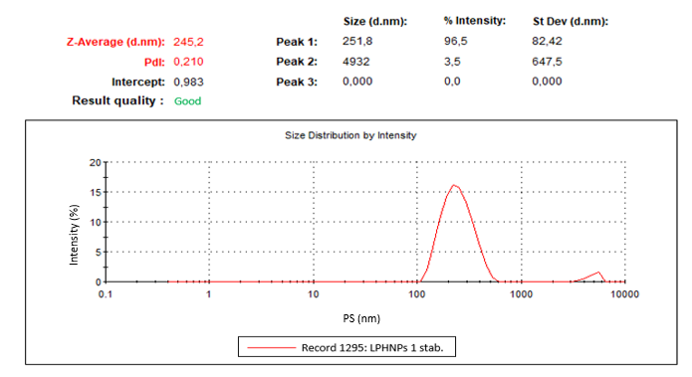
Fig. S52 ROS and EZE-loaded LPHNPs formulation 1 (ratio 1), DLS size measurement 1 after three months composed of multiple automatically optimized runs

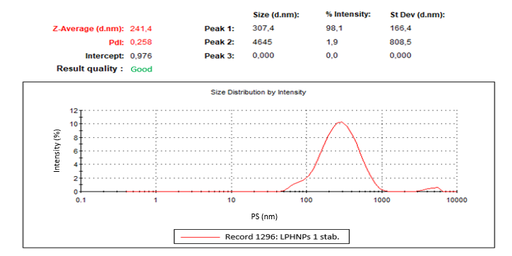
Fig. S53 ROS and EZE-loaded LPHNPs formulation 1 (ratio 1), DLS size measurement 2 after three months composed of multiple automatically optimized runs
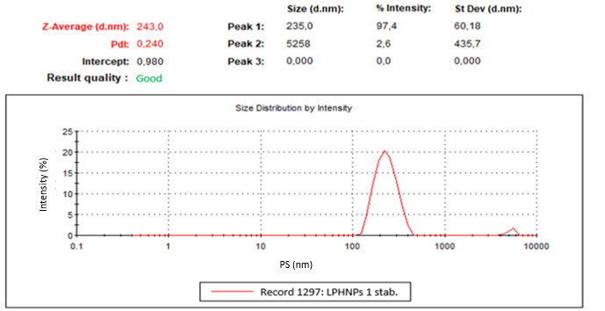
Fig. S54 ROS and EZE-loaded LPHNPs formulation 1 (ratio 1), DLS size measurement 3 after three months composed of multiple automatically optimized runs
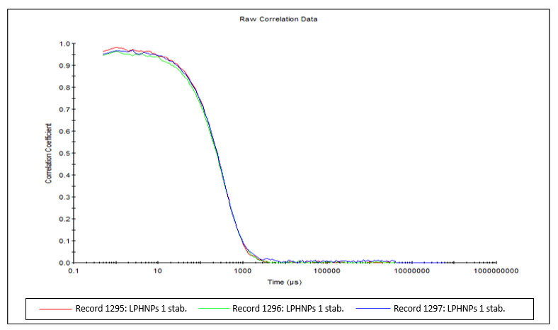
Fig. S55 ROS and EZE-loaded LPHNPs formulation 1 (ratio 1), DLS size correlogram composed of three replicate measurements after three months each composed of multiple automatically optimized runs
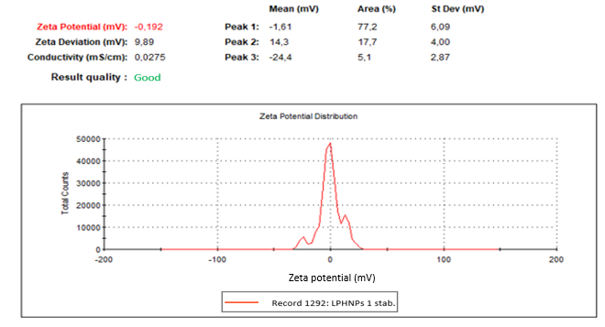
Fig. S56 ROS and EZE-loaded LPHNPs formulation 1 (ratio 1), ZP measurement 1 after three months composed of multiple automatically optimized runs
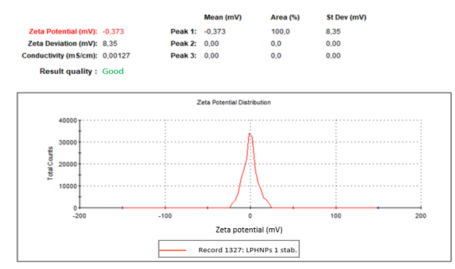
Fig. S57 ROS and EZE-loaded LPHNPs formulation 1 (ratio 1), ZP measurement 2 after three months composed of multiple automatically optimized runs
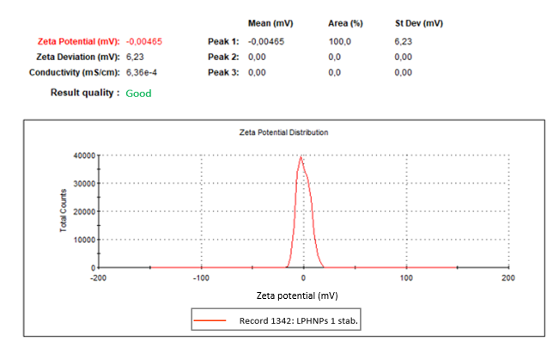
Fig. S58 ROS and EZE-loaded LPHNPs formulation 1 (ratio 1), ZP measurement 3 after three months composed of multiple automatically optimized runs
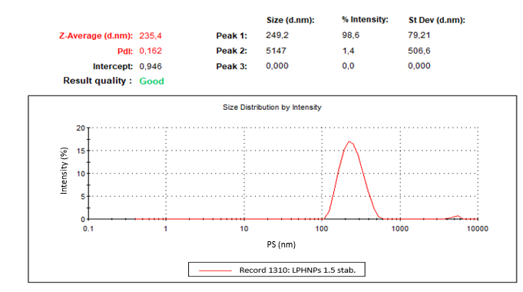
Fig. S59 ROS and EZE-loaded LPHNPs formulation 2 (ratio 1.5), DLS size measurement 1 after three months composed of multiple automatically optimized runs
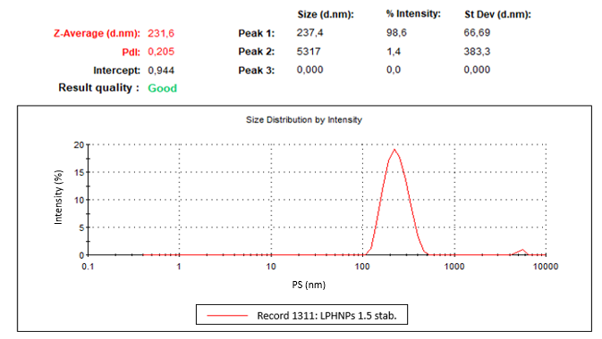
Fig. S60 ROS and EZE-loaded LPHNPs formulation 2 (ratio 1.5), DLS size measurement 2 after three months composed of multiple automatically optimized runs
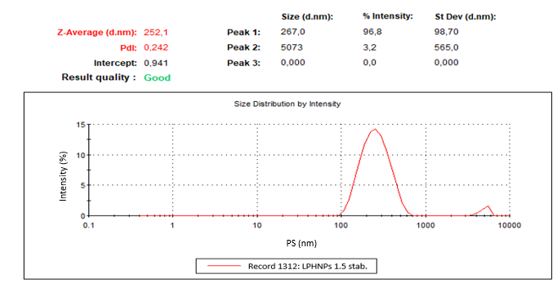
Fig. S61 ROS and EZE-loaded LPHNPs formulation 2 (ratio 1.5), DLS size measurement 3 after three months composed of multiple automatically optimized runs
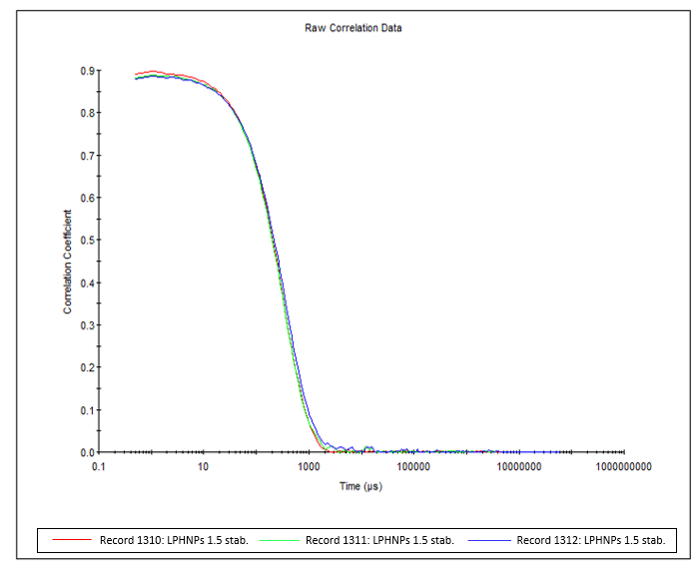
Fig. S62 ROS and EZE-loaded LPHNPs formulation 2 (ratio 1.5), DLS size correlogram composed of three replicate measurements after three months each composed of multiple automatically optimized runs
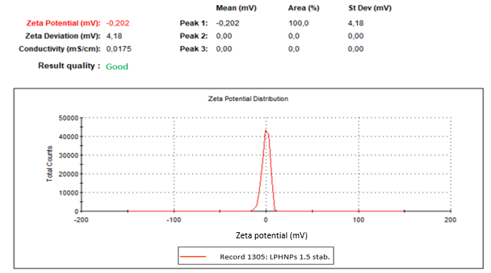
Fig. S63 ROS and EZE-loaded LPHNPs formulation 2 (ratio 1.5), ZP measurement 1 after three months composed of multiple automatically optimized runs
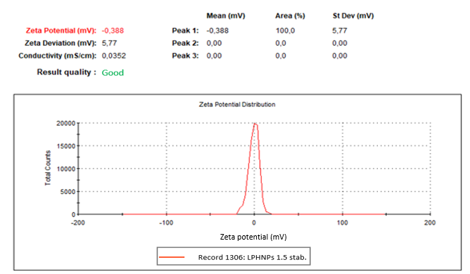
Fig. S64 ROS and EZE-loaded LPHNPs formulation 2 (ratio 1.5), ZP measurement 2 after three months composed of multiple automatically optimized runs
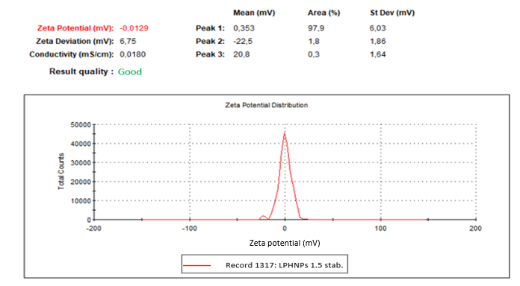
Fig. S65 ROS and EZE-loaded LPHNPs formulation 2 (ratio 1.5), ZP measurement 3 after three months composed of multiple automatically optimized runs
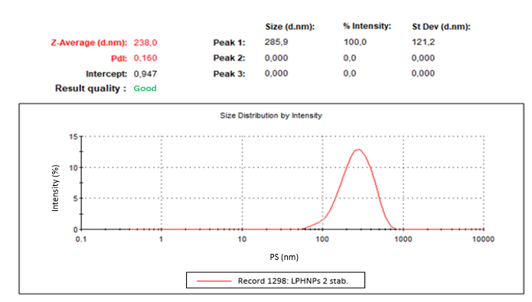
Fig. S66 ROS and EZE-loaded LPHNPs formulation 3 (ratio 2), DLS size measurement 1 after three months composed of multiple automatically optimized runs
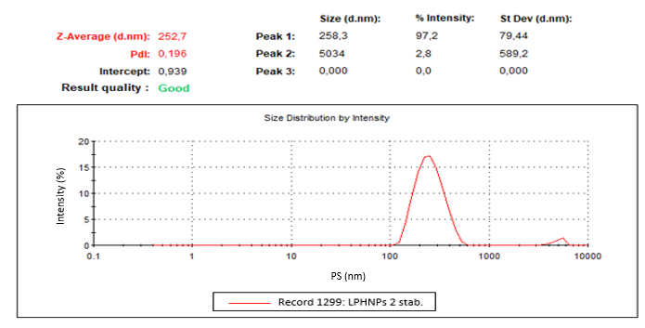
Fig. S67 ROS and EZE-loaded LPHNPs formulation 3 (ratio 2), DLS size measurement 2 after three months composed of multiple automatically optimized runs
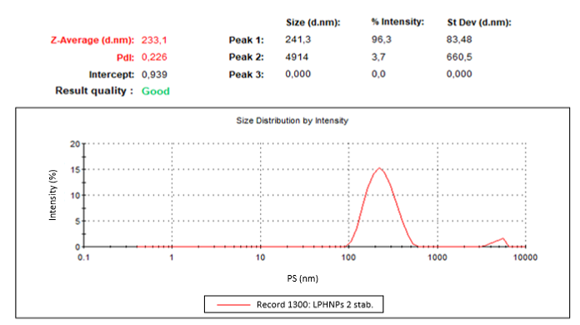
Fig. S68 ROS and EZE-loaded LPHNPs formulation 3 (ratio 2), DLS size measurement 3 after three months composed of multiple automatically optimized runs
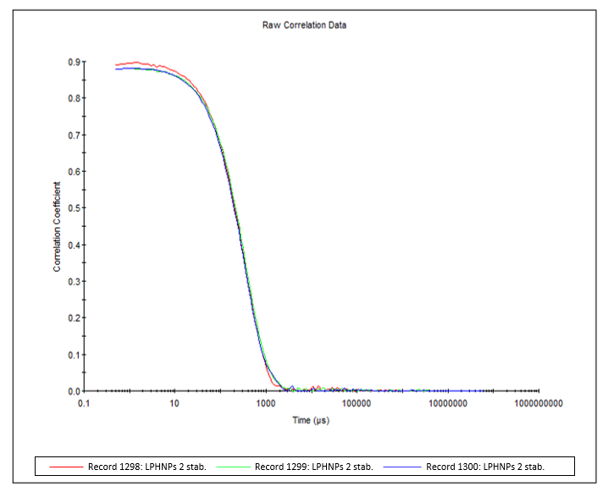
Fig. S69 ROS and EZE-loaded LPHNPs formulation 3 (ratio 2), DLS size measurement correlogram composed of three replicate measurements after three months each composed of multiple automatically optimized runs
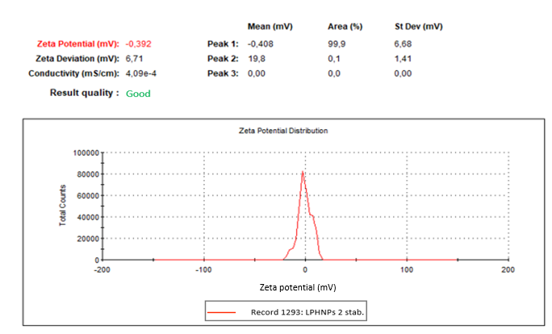
Fig. S70 ROS and EZE-loaded LPHNPs formulation 3 (ratio 2), ZP measurement 1 after three months composed of multiple automatically optimized runs
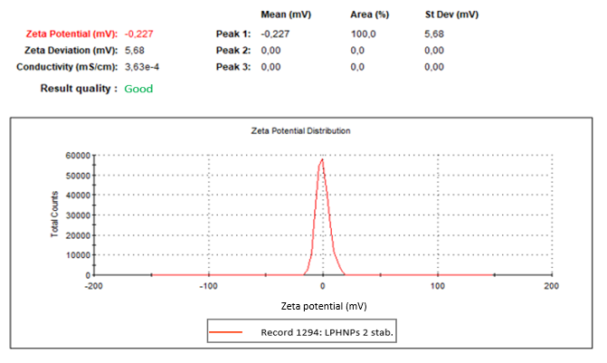
Fig. S71 ROS and EZE-loaded LPHNPs formulation 3 (ratio 2), ZP measurement 2 after three months composed of multiple automatically optimized runs
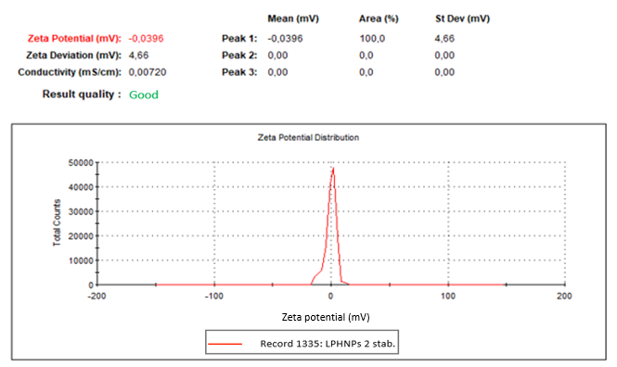
Fig. S72 ROS and EZE-loaded LPHNPs formulation 3 (ratio 2), ZP measurement 3 after three months composed of multiple automatically optimized runs
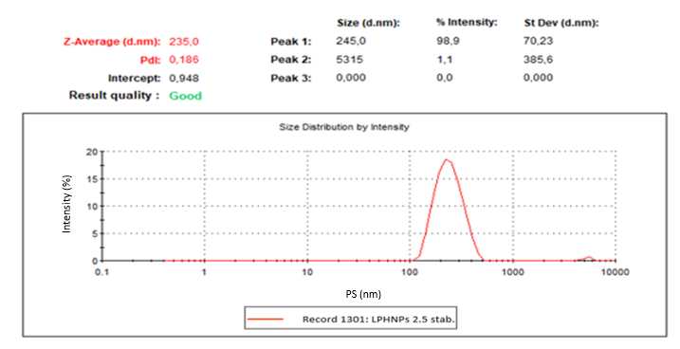
Fig. S73 ROS and EZE-loaded LPHNPs formulation 4 (ratio 2.5), DLS size measurement 1 after three months composed of multiple automatically optimized runs
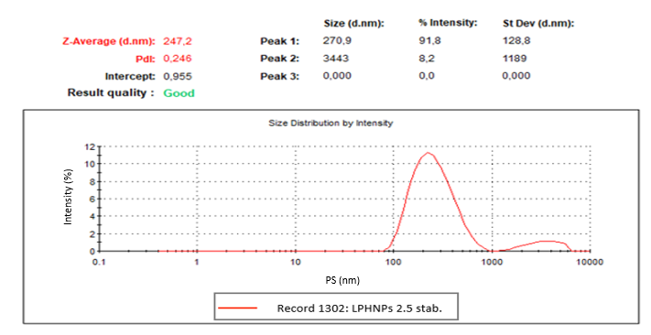
Fig. S74 ROS and EZE-loaded LPHNPs formulation 4 (ratio 2.5), DLS size measurement 2 after three months composed of multiple automatically optimized runs
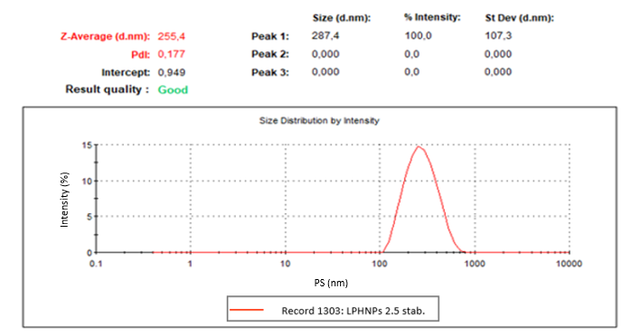
Fig. S75 ROS and EZE-loaded LPHNPs formulation 4 (ratio 2.5), DLS size measurement 3 after three months composed of multiple automatically optimized runs
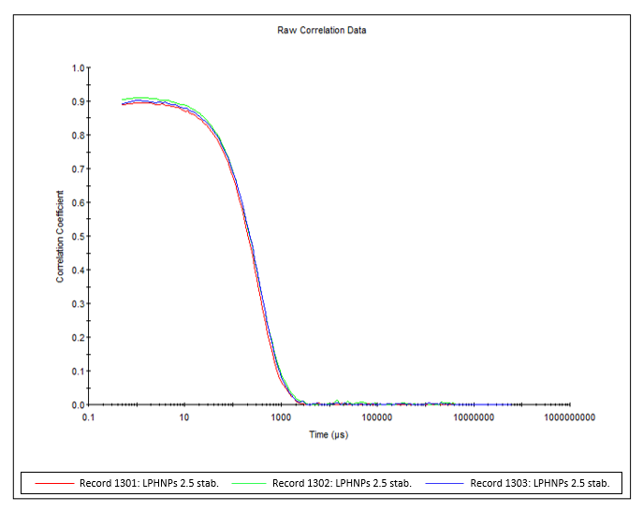
Fig. S76 ROS and EZE-loaded LPHNPs formulation 4 (ratio 2.5), DLS size measurement correlogram composed of three replicate measurements after three months each composed of multiple automatically optimized runs
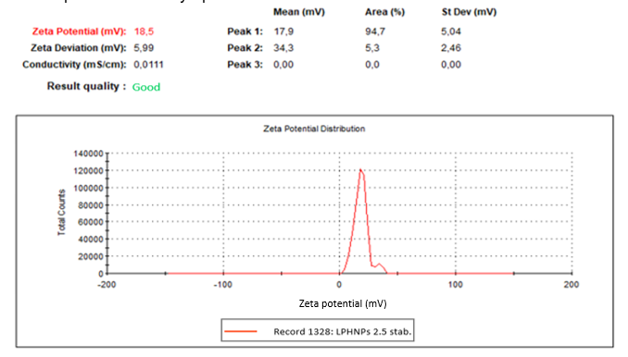
Fig. S77 ROS and EZE-loaded LPHNPs formulation 4 (ratio 2.5), ZP measurement 1 after three months composed of multiple automatically optimized runs
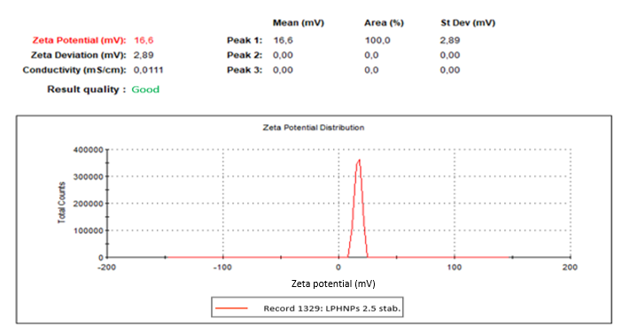
Fig. S78 ROS and EZE-loaded LPHNPs formulation 4 (ratio 2.5), ZP measurement 2 after three months composed of multiple automatically optimized runs
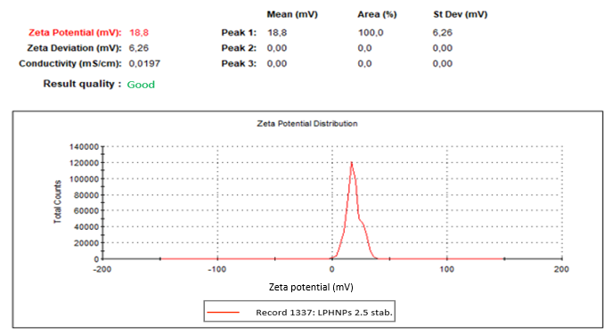
Fig. S79 ROS and EZE-loaded LPHNPs formulation 4 (ratio 2.5), ZP measurement 3 after three months composed of multiple automatically optimized runs
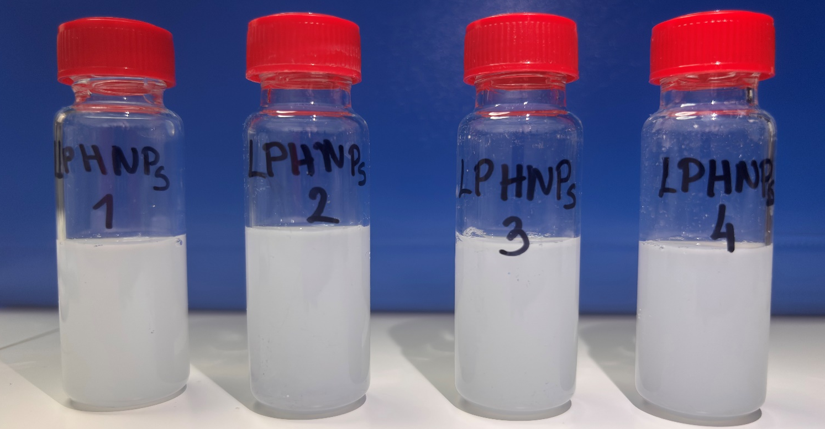
Fig. S80 Dispersions of optimal ROS and EZE-loaded LPHNPs after 3 months hold-time storage

