Fig S 1: Uncropped Western blot images in section (1), (2) and (3) A: The first original blot PVDF membrane showed the target protein BCL2 which is normalized versus housekeeping protein beta actin. B: The first original blot PVDF membrane showed the target protein Cyclin D1 which is normalized versus housekeeping protein beta actin. C: The first original blot PVDF membrane showed the house keeping protein beta actin.

Fig S 2: Caspase-3 dot plot for Lenvatinib, ZnO-NPs and cotherapy of ZnO-NPs + Lenvatinib and unstained cell.
Fig S 3: Dot plot of cell cycle analysis Lenvatinib, ZnO-NPs and cotherapy of ZnO-NPs + Lenvatinib

Fig S 4: Normal mice showed preserved liver architecture. SEC mice showed portal vessel dilation, edema, marked extramedullary hematopoiesis, and fatty changes. ZnO-NPs- and Lenvatinib-treated mice showed variable portal dilation, reduced extramedullary hematopoiesis, and mild to diffuse steatosis. The ZnO-NPs + Lenvatinib group showed nearly normal liver architecture with minimal histopathological changes. Dilation: red arrows; edema: blue arrow; extramedullary hematopoiesis: thick black arrows; vesicular steatosis: thin black arrows. H&E Low magnification: 100x, bar 100; high magnification: 400x, bar:50.
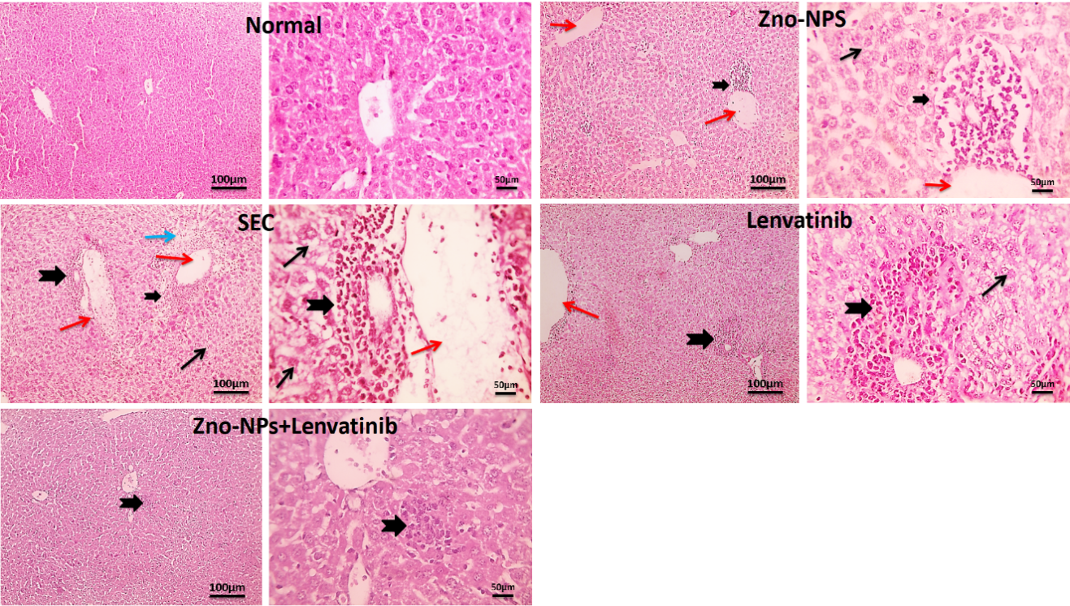

Fig S 5: Normal mice showed normal glomeruli, tubules, and interstitial tissue. SEC mice showed tubular dilation and atrophy, interstitial edema and inflammation, and glomerular distortion. ZnO-NPs-treated mice showed similar but milder renal changes. Lenvatinib-treated mice showed mostly normal tubules and glomeruli with mild vascular congestion, edema, and inflammation. The ZnO-NPs + Lenvatinib group showed nearly normal renal architecture with minimal interstitial edema and inflammation. Tubular dilation and atrophy: thin black arrows; interstitial edema: blue arrow; inflammation: thick black arrows; distorted glomeruli: arrowheads; vascular congestion: red arrow. H&E Low magnification: 100x, bar 100; high magnification: 400x, bar 50
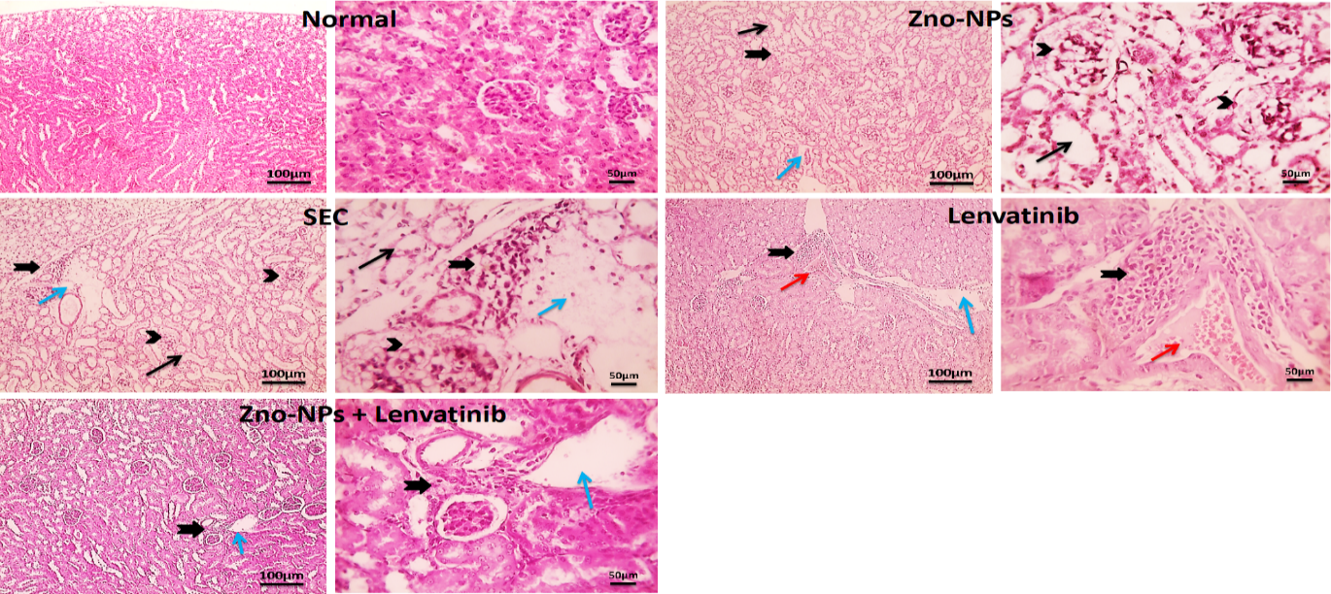

Fig S 6: Normal mice showed normal cardiac muscle fibers with minimal interstitial space. SEC mice showed marked muscle fiber shrinkage, increased interstitial space, and leukocytic infiltration. ZnO-NPs-treated mice showed similar but milder changes, while Lenvatinib-treated mice showed nearly normal muscle fibers with reduced interstitial space. The ZnO-NPs + Lenvatinib group showed normal cardiac architecture. Muscle fiber shrinkage and atrophy: thin black arrows; interstitial space: blue arrow; leukocytic infiltration: arrowheads. H&E, Low magnification: 100x, bar 100; high magnification: 400x, bar 50.
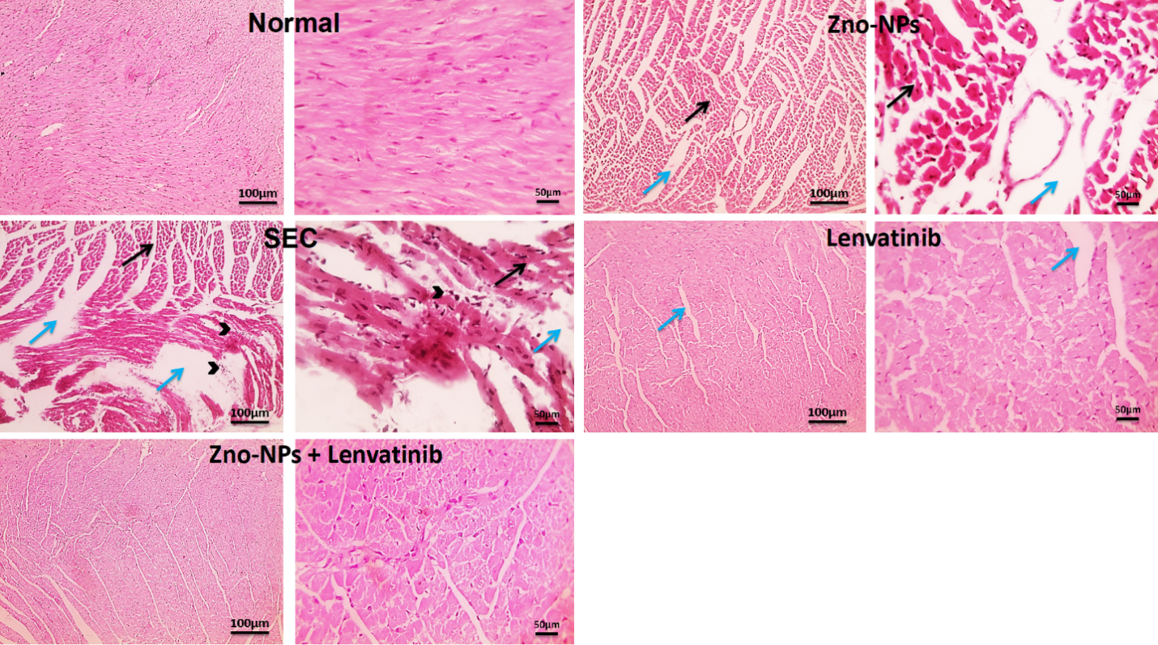
Fig S 7: Normal mice showed preserved splenic architecture with clear lymphoid follicles and normal red pulp. SEC mice showed disrupted splenic architecture with marked lymphocyte depletion. ZnO-NPs-treated mice showed similar but milder changes. Lenvatinib and ZnO-NPs + Lenvatinib groups showed restored splenic architecture with increased lymphocyte population. Lymphocyte depletion: thin black arrows. Low magnification: 100x, bar 100; high magnification: 400x, bar 50.
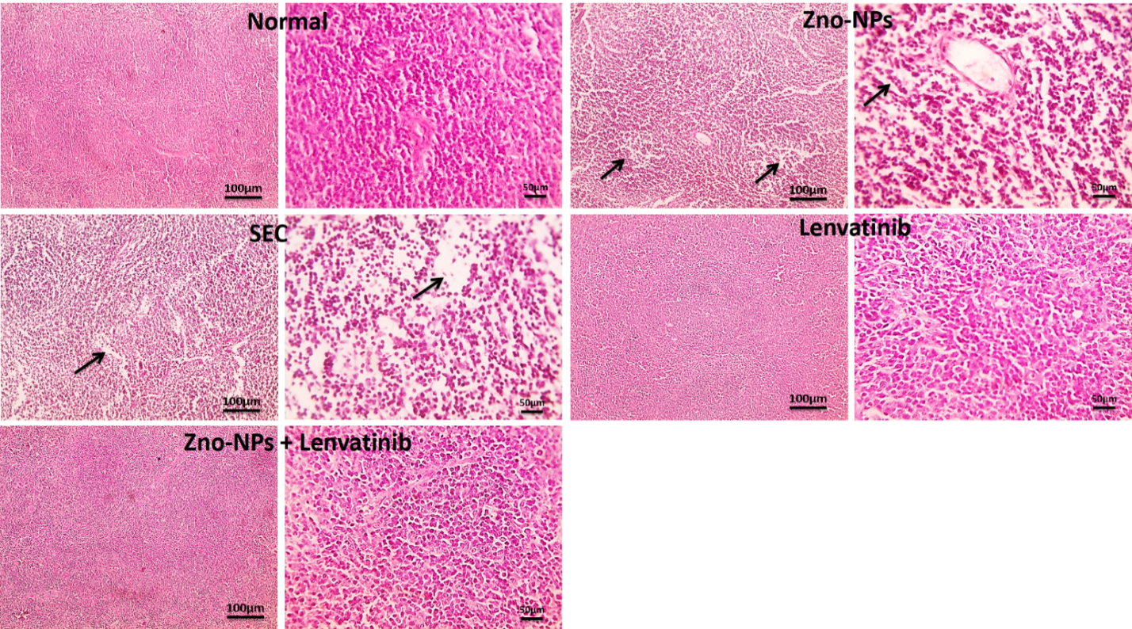

table S 1: FTIR band and their assignments to particular functional groups of the synthesized ZnO nanoparticles
Wavenumber (cm⁻¹) | Assignment | Functional Group
1639.68 | O-H bending vibration | Surface hydroxyl groups on ZnO surface because of adsorbed water molecules
1371.56 | C–O stretching | Characteristic residual carbonate (CO₃⁻²) species
823.06 | Zn-O stretching vibration | Hexagonal ZnO crystalline structure
564.20-404.51 | Zn-O stretching vibration | Metal–oxygen framework of ZnO lattice

