SUPPLEMENTAL RESULTS

Table of Contents:
Figure S1 ADI-R and SCQ score distributions.
Table S1 Proband SCQ predicting sibling diagnostic outcome at 24-months
Table S2 Distribution of recurrence and predictors across SCQ quartiles
Table S3 Behavioral and clinical measures compared across concordant pairs
Figure S2 VABS-II RL score differences for concordant pairs
Table S4 Linear Regression Analyses: VABS-II Full Model Results
Table S5 Linear Regression Analyses: MSEL Full Model Results
Table S6 ICCs: Male-Only Sibling Pairs
Table S7 Linear regression analyses: VABS-II Parent Reported Behavior: Male-Only Pairs
Table S9 Linear regression analyses: MSEL Examiner-based Assessment: Male-Only Pairs
Table S9 ICCs: Pairs where Proband ABC > 60
Table S10 Linear regression analyses: VABS-II Parent Reported Behavior: Proband ABC >60
Table S11 Linear regression analyses: MSEL Examiner-based Assessment: Proband ABC >60
Table S12 Linear regression analyses: VABS-II Parent Reported Behavior: Maternal Education
Table S13 Linear regression analyses: MSEL Examiner-based Assessment: Maternal Education
Table S14 Linear regression analyses: MSEL Age-Adjusted Scores
Figure S3. Scatterplots: MSEL Age-Adjusted Scores

Notes regarding linear models: All models report standardized beta coefficients. Covariates include chronological age and sex of the proband and sibling, sibling diagnostic outcome group, and clinical study site. Reference groups for sex, sibling diagnostic group, and clinical study site are female (vs. male), ASD (vs. no ASD), and CHOP (Children’s hospital of Philadelphia) vs. all other clinical sites (UNC Chapel Hill, Washington University (STL), University of Washington in Seattle (SEA)), respectively.

Figure S1. ADI-R and SCQ score distributions. (A) Score distributions for proband SCQ split by probands of concordant (n = 89) and discordant (n = 296) pairs. (B-D) ADI-R score distributions for probands (top panels) and siblings (bottom panels) for the social, verbal communication, and non-verbal communication scores, respectively.

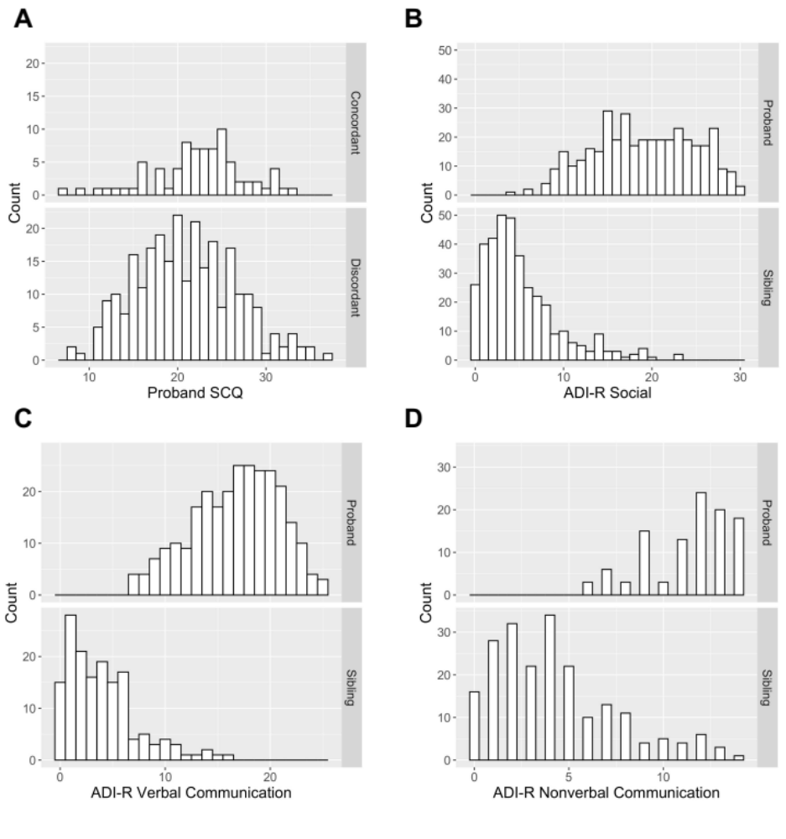
Table S1. Proband SCQ predicting sibling diagnostic outcome at 24-months
 | Beta |  | SE |  | p-value |  | Odds  Ratio |  | 95% CI  Lower |  | 95% CI  Lower
Model: SCQ Scoreª
SCQ Score | 0.06 |  | 0.03 |  | 0.014 |  | 1.06 |  | 1.01 |  | 1.12
Sibling Sex | 1.21 |  | 0.31 |  | 0.0001 |  | 3.34 |  | 1.84 |  | 6.36
Proband Sex | -0.35 |  | 0.38 |  | 0.361 |  | 0.71 |  | 0.34 |  | 1.53
Proband Age at SCQ | -0.009 |  | 0.01 |  | 0.056 |  | 0.99 |  | 0.47 |  | 2.04
Site – SEA | -0.02 |  | 0.38 |  | 0.965 |  | 0.98 |  | 0.47 |  | 2.04
Site – STL | -0.36 |  | 0.37 |  | 0.330 |  | 0.70 |  | 0.33 |  | 1.44
Site – UNC | 0.04 |  | 0.39 |  | 0.911 |  | 1.04 |  | 0.48 |  | 2.23
Model: SCQ Quartile^{b}
SCQ Q2 | 0.60 |  | 0.43 |  | 0.162 |  | 1.81 |  | 0.79 |  | 4.27
SCQ Q3 | 1.29 |  | 0.40 |  | 0.001 |  | 3.65 |  | 1.69 |  | 8.25
SCQ Q4 | 0.84 |  | 0.44 |  | 0.054 |  | 2.31 |  | 1.00 |  | 5.55
Sibling Sex | 1.18 |  | 0.32 |  | 0.0002 |  | 3.26 |  | 1.79 |  | 6.23
Proband Sex | -0.37 |  | 0.39 |  | 0.333 |  | 0.69 |  | 0.33 |  | 1.50
Proband Age at SCQ | -0.009 |  | 0.01 |  | 0.073 |  | 0.99 |  | 0.98 |  | 1.00
Site – SEA | -0.08 |  | 0.38 |  | 0.831 |  | 0.92 |  | 0.44 |  | 1.94
Site – STL | -0.44 |  | 0.38 |  | 0.239 |  | 0.64 |  | 0.30 |  | 1.34
Site – UNC | 0.03 |  | 0.39 |  | 0.934 |  | 1.03 |  | 0.47 |  | 2.23
Model: SCQ Score + Verbal^{c}
SCQ Score | 0.06 |  | 0.02 |  | 0.024 |  | 1.06 |  | 1.01 |  | 1.11
Proband verbal status | 0.56 |  | 0.30 |  | 0.066 |  | 1.75 |  | 0.96 |  | 3.16
Sibling Sex | 1.18 |  | 0.31 |  | 0.0002 |  | 3.26 |  | 1.79 |  | 6.21
Proband Sex | -0.32 |  | 0.38 |  | 0.399 |  | 0.72 |  | 0.35 |  | 1.58
Proband Age at SCQ | -0.01 |  | 0.00 |  | 0.141 |  | 0.99 |  | 0.98 |  | 1.00
Site – SEA | -0.09 |  | 0.38 |  | 0.811 |  | 0.91 |  | 0.43 |  | 1.92
Site – STL | -0.42 |  | 0.37 |  | 0.262 |  | 0.66 |  | 0.31 |  | 1.37
Site – UNC | -0.01 |  | 0.39 |  | 0.975 |  | 0.99 |  | 0.45 |  | 2.12
Model: SCQ Quartile + Verbal^{d}
SCQ Q2 | 0.53 |  | 0.43 |  | 0.221 |  | 1.69 |  | 0.73 |  | 4.01
SCQ Q3 | 1.19 |  | 0.43 |  | 0.004 |  | 3.28 |  | 1.51 |  | 7.53
SCQ Q4 | 0.80 |  | 0.41 |  | 0.068 |  | 2.22 |  | 0.95 |  | 5.35
Proband verbal status | 0.46 |  | 0.31 |  | 0.138 |  | 1.59 |  | 0.85 |  | 2.90
Sibling Sex | 1.16 |  | 0.32 |  | 0.0002 |  | 3.20 |  | 1.75 |  | 6.11
Proband Sex | -0.34 |  | 0.39 |  | 0.377 |  | 0.71 |  | 0.34 |  | 1.56
Proband Age at SCQ | -0.01 |  | 0.00 |  | 0.147 |  | 0.99 |  | 0.98 |  | 1.00
Site – SEA | -0.13 |  | 0.38 |  | 0.726 |  | 0.87 |  | 0.41 |  | 1.85
Site – STL | -0.48 |  | 0.38 |  | 0.202 |  | 0.62 |  | 0.29 |  | 1.29
Site – UNC | -0.01 |  | 0.40 |  | 0.973 |  | 0.99 |  | 0.45 |  | 2.14
ªModel includes SCQ as a continuous variable
^{b}Model includes proband SCQ quartile as a categorical predictor (Q1-Q4); Q1 is coded as the reference group.
^{c}Model includes SCQ score and verbal status of the proband; verbal is coded as the reference group.
^{d}Model includes SCQ quartile and verbal status of the proband; verbal is coded as the reference group.

Table S2. Distribution of recurrence and predictors across SCQ quartiles

 | Q1 (n = 90)  SCQ [7,17] |  |  | Q2 (n = 85)  SCQ [18,21] |  |  | Q3 (n = 92)  SCQ [22,25] |  |  | Q4 (n = 79)  SCQ [26,37] |  |  | ChiSq |  | p-val
 | N | % |  | N | % |  | N | % |  | N | %
Sib ASD | 12 | 13% |  | 17 | 20% |  | 31 | 34% |  | 18 | 23% |  | 11.24 |  | 0.01
Sib No-ASD | 78 | 87% |  | 68 | 80% |  | 61 | 66% |  | 61 | 77% |  | 11.24 |  | 0.01
Sib Male | 51 | 57% |  | 46 | 54% |  | 64 | 70% |  | 47 | 59% |  | 5.16 |  | 0.16
Sib Female | 39 | 43% |  | 39 | 46% |  | 28 | 30% |  | 32 | 41% |  | 5.16 |  | 0.16
Pro Verbal | 77 | 86% |  | 62 | 73% |  | 60 | 65% |  | 65 | 82% |  | 12.64 |  | 0.006
Pro NonVerbal | 13 | 14% |  | 23 | 27% |  | 32 | 35% |  | 14 | 18% |  | 12.64 |  | 0.006
The pattern of recurrence risk across quartiles may be reflective of the significant difference in distribution of non-verbal probands, where the third quartile is comprised of nearly twice as many non-verbal probands as the fourth quartile, reflective of differences in the SCQ scoring algorithm for verbal and non-verbal children.

Table S3. Behavioral and clinical measures compared across concordant siblings

 | Probands |  |  | Siblings |  |  | Group Comparison
 | Mean | SD |  | Mean | SD |  | t | df | p | Cohen’s d
ADI-R
Social | 19.02 | 5.69 |  | 8.98 | 5.36 |  | 12.35 | 166.1 | <0.001 | 1.90
NV Communication | 11.35 | 2.22 |  | 6.47 | 3.63 |  | 8.90 | 91.67 | <0.001 | 1.62
V Communication | 16.73 | 4.11 |  | 7.55 | 4.56 |  | 8.47 | 31.39 | <0.001 | 2.34
VABS-II
ABC | 76.43 | 12.76 |  | 89.78 | 9.29 |  | -8.54 | 133.72 | <0.001 | -1.40
Socialization | 71.31 | 12.57 |  | 89.59 | 9.30 |  | -10.28 | 139.98 | <0.001 | -1.66
Communication | 80.39 | 16.79 |  | 89.05 | 11.44 |  | -4.95 | 134.94 | <0.001 | -0.80
Expressive | 10.51 | 3.14 |  | 13.57 | 2.42 |  | -7.79 | 140.82 | <0.001 | -1.25
Receptive | 11.19 | 3.16 |  | 12.77 | 2.59 |  | -4.75 | 142.53 | <0.001 | -0.76
Motor | 83.07 | 13.35 |  | 95.09 | 8.51 |  | -8.23 | 129.95 | <0.001 | -1.37
Fine | 12.13 | 2.88 |  | 14.51 | 1.51 |  | -8.14 | 110.43 | <0.001 | -1.38
Gross | 12.37 | 2.18 |  | 14.33 | 1.78 |  | -6.08 | 137.67 | <0.001 | -1.01

Figure S1. VABS-II RL score differences for concordant pairs
Absolute differences in RL scores were calculated between probands and siblings concordant for ASD (n = 71). The majority of siblings scored very similarly to their proband, with 66% scoring within 1 SD (3 points).
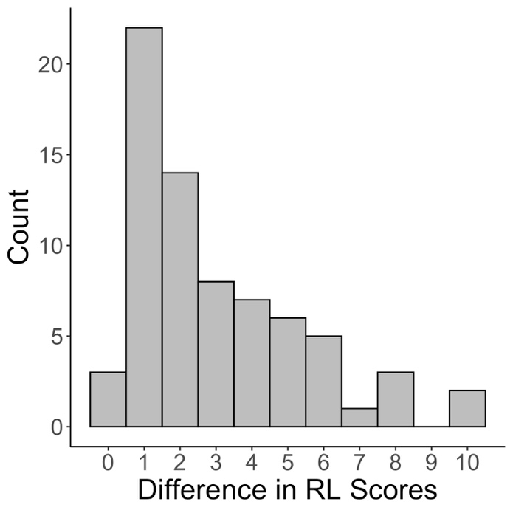

Table S4. Linear Regression Analyses: VABS-II Full Model Results

 | Standardized Beta |  | 95% CI Lower |  | 95% CI Upper |  | p-value
ABC Model
Proband ABC | 0.33 |  | 0.11 |  | 0.55 |  | 0.004
Sibling Sex | -0.27 |  | -0.48 |  | -0.07 |  | 0.009
Proband Sex | -0.08 |  | -0.36 |  | 0.21 |  | 0.591
Group | 0.99 |  | 0.75 |  | 1.23 |  | 0.000
Proband Score x Group | -0.18 |  | -0.43 |  | 0.07 |  | 0.149
Sibling Age | -0.09 |  | -0.19 |  | 0.02 |  | 0.110
Proband Age | -0.02 |  | -0.12 |  | 0.08 |  | 0.666
Site – SEA | -0.02 |  | -0.30 |  | 0.27 |  | 0.914
Site – STL | -0.12 |  | -0.37 |  | 0.14 |  | 0.366
Site – UNC | -0.16 |  | -0.44 |  | 0.13 |  | 0.282
SOC Model
Proband SOC | 0.25 |  | 0.04 |  | 0.46 |  | 0.022
Sibling Sex | -0.33 |  | -0.53 |  | -0.14 |  | 0.001
Proband Sex | -0.19 |  | -0.47 |  | 0.10 |  | 0.194
Group | 0.88 |  | 0.64 |  | 1.12 |  | 0.000
Proband Score x Group | -0.21 |  | -0.45 |  | 0.03 |  | 0.089
Sibling Age | -0.05 |  | -0.15 |  | 0.05 |  | 0.325
Proband Age | -0.07 |  | -0.17 |  | 0.03 |  | 0.148
Site – SEA | -0.10 |  | -0.38 |  | 0.18 |  | 0.487
Site – STL | 0.19 |  | -0.06 |  | 0.44 |  | 0.133
Site – UNC | -0.48 |  | -0.77 |  | -0.20 |  | 0.000
COM Model
Proband COM | 0.40 |  | 0.20 |  | 0.61 |  | 0.000
Sibling Sex | -0.16 |  | -0.35 |  | 0.04 |  | 0.113
Proband Sex | -0.02 |  | -0.29 |  | 0.26 |  | 0.899
Group | 1.07 |  | 0.83 |  | 1.30 |  | 0.000
Proband Score x Group | -0.28 |  | -0.51 |  | -0.04 |  | 0.021
Sibling Age | -0.04 |  | -0.14 |  | 0.06 |  | 0.459
Proband Age | -0.06 |  | -0.15 |  | 0.04 |  | 0.219
Site – SEA | -0.02 |  | -0.29 |  | 0.26 |  | 0.913
Site – STL | -0.17 |  | -0.42 |  | 0.08 |  | 0.173
Site – UNC | -0.24 |  | -0.52 |  | 0.03 |  | 0.085
EL Model
Proband EL | 0.44 |  | 0.23 |  | 0.65 |  | 0.000
Sibling Sex | -0.23 |  | -0.44 |  | -0.03 |  | 0.028
Proband Sex | -0.05 |  | -0.34 |  | 0.24 |  | 0.716
Group | 0.80 |  | 0.55 |  | 1.04 |  | 0.000
Proband Score x Group | -0.36 |  | -0.60 |  | -0.12 |  | 0.003
Sibling Age | -0.06 |  | -0.17 |  | 0.04 |  | 0.229
Proband Age | -0.04 |  | -0.14 |  | 0.06 |  | 0.483
Site – SEA | -0.17 |  | -0.46 |  | 0.11 |  | 0.238
Site – STL | -0.24 |  | -0.51 |  | 0.02 |  | 0.073
Site – UNC | -0.30 |  | -0.60 |  | 0.00 |  | 0.049
RL Model
Proband RL | 0.53 |  | 0.32 |  | 0.73 |  | 0.000
Sibling Sex | -0.08 |  | -0.27 |  | 0.12 |  | 0.429
Proband Sex | 0.08 |  | -0.19 |  | 0.36 |  | 0.557
Group | 1.05 |  | 0.82 |  | 1.28 |  | 0.000
Proband Score x Group | -0.42 |  | -0.65 |  | -0.19 |  | 0.000
Sibling Age | -0.05 |  | -0.14 |  | 0.05 |  | 0.342
Proband Age | -0.05 |  | -0.14 |  | 0.04 |  | 0.302
Site – SEA | 0.07 |  | -0.19 |  | 0.34 |  | 0.588
Site – STL | -0.08 |  | -0.32 |  | 0.17 |  | 0.541
Site – UNC | -0.26 |  | -0.54 |  | 0.02 |  | 0.065
GM Model
Proband GM | 0.22 |  | -0.05 |  | 0.50 |  | 0.113
Sibling Sex | 0.03 |  | -0.22 |  | 0.27 |  | 0.832
Proband Sex | 0.05 |  | -0.29 |  | 0.38 |  | 0.792
Group | 0.55 |  | 0.27 |  | 0.84 |  | 0.000
Proband Score x Group | -0.01 |  | -0.32 |  | 0.29 |  | 0.933
Sibling Age | -0.13 |  | -0.25 |  | -0.02 |  | 0.024
Proband Age | 0.11 |  | -0.03 |  | 0.24 |  | 0.124
Site – SEA | -0.15 |  | -0.50 |  | 0.20 |  | 0.413
Site – STL | -0.24 |  | -0.55 |  | 0.07 |  | 0.133
Site – UNC | 0.02 |  | -0.32 |  | 0.36 |  | 0.917

Table S5. Linear Regression Analyses: MSEL Full Model Results

 | Standardized  Beta |  | 95% CI  Lower |  | 95% CI  Upper |  | p-value
ELC Model | 0.30 |  | 0.09 |  | 0.50 |  | 0.004
Proband ELC | -0.29 |  | -0.49 |  | -0.10 |  | 0.003
Sibling Sex | 0.06 |  | -0.22 |  | 0.33 |  | 0.689
Proband Sex | 1.13 |  | 0.90 |  | 1.36 |  | 0.000
Group | -0.22 |  | -0.44 |  | 0.01 |  | 0.066
Proband Score x Group | -0.03 |  | -0.13 |  | 0.06 |  | 0.472
Sibling Age | -0.04 |  | -0.13 |  | 0.05 |  | 0.389
Proband Age | 0.08 |  | -0.19 |  | 0.35 |  | 0.566
Site – SEA | -0.12 |  | -0.36 |  | 0.13 |  | 0.347
Site – STL | 0.24 |  | -0.04 |  | 0.52 |  | 0.091
Site – UNC | 0.30 |  | 0.09 |  | 0.50 |  | 0.004
EL Model
Proband EL | 0.34 |  | 0.14 |  | 0.55 |  | 0.001
Sibling Sex | -0.18 |  | -0.38 |  | 0.03 |  | 0.089
Proband Sex | -0.07 |  | -0.36 |  | 0.21 |  | 0.625
Group | 0.80 |  | 0.57 |  | 1.04 |  | 0.000
Proband Score x Group | -0.18 |  | -0.42 |  | 0.05 |  | 0.122
Sibling Age | -0.01 |  | -0.11 |  | 0.09 |  | 0.839
Proband Age | -0.05 |  | -0.15 |  | 0.05 |  | 0.317
Site – SEA | -0.30 |  | -0.58 |  | -0.02 |  | 0.034
Site – STL | -0.22 |  | -0.47 |  | 0.04 |  | 0.099
Site – UNC | 0.21 |  | -0.08 |  | 0.50 |  | 0.148
RL Model
Proband RL | 0.47 |  | 0.28 |  | 0.66 |  | 0.000
Sibling Sex | -0.14 |  | -0.33 |  | 0.05 |  | 0.140
Proband Sex | 0.00 |  | -0.27 |  | 0.27 |  | 0.990
Group | 1.14 |  | 0.91 |  | 1.36 |  | 0.000
Proband Score x Group | -0.39 |  | -0.61 |  | -0.17 |  | 0.000
Sibling Age | -0.06 |  | -0.16 |  | 0.03 |  | 0.179
Proband Age | -0.09 |  | -0.18 |  | 0.00 |  | 0.061
Site – SEA | 0.09 |  | -0.17 |  | 0.36 |  | 0.500
Site – STL | 0.02 |  | -0.22 |  | 0.26 |  | 0.859
Site – UNC | -0.01 |  | -0.28 |  | 0.26 |  | 0.934

Table S6. ICCs: Male-Only Sibling Pairs

 |  | Concordant  Pairs |  |  |  | Discordant  Pairs
 |  | n | ICC | p |  | n | ICC | p
ADI-R
Social |  | 58 | 0.01 | 0.441 |  | 134 | -0.01 | 0.631
RRB |  | 58 | 0.02 | 0.402 |  | 134 | 0.02 | 0.284
NV Communication |  | 21 | 0.12 | 0.262 |  | 16 | 0.09 | 0.097
V Communication |  | 10 | 0.10 | 0.172 |  | 41 | -0.03 | 0.776
VABS-II
ABC |  | 47 | 0.26 | 0.016 |  | 117 | 0.10 | 0.028
Socialization |  | 55 | 0.25 | 0.007 |  | 118 | 0.01 | 0.463
Communication |  | 49 | 0.35 | 0.018 |  | 118 | 0.11 | 0.087
Expressive |  | 51 | 0.30 | 0.011 |  | 119 | 0.01 | 0.405
Receptive |  | 51 | 0.50 | 0.001⁺ |  | 120 | 0.16 | 0.017
Motor |  | 44 | -0.16 | 0.834 |  | 105 | 0.18 | 0.032
Fine |  | 43 | -0.16 | 0.851 |  | 106 | 0.10 | 0.202
Gross |  | 43 | 0.32 | 0.040 |  | 105 | 0.28 | <0.001⁺
⁺significant at p ≤ 0.004 after Bonferroni correction (12 comparisons).

Table S7. Linear regression analyses: VABS-II Parent Reported Behavior: Male-Only Pairs

 | Betaª |  | 95% CI  Lower |  | 95% CI  Upper |  | p-value
ABC Model
Proband ABC | 0.37 |  | 0.12 |  | 0.63 |  | 0.005⁺
Group | 0.94 |  | 0.64 |  | 1.24 |  | <0.0001
Proband Score x Group | -0.22 |  | -0.52 |  | 0.09 |  | 0.161
SOC Model
Proband SOC | 0.41 |  | 0.16 |  | 0.67 |  | 0.002⁺
Group | 0.78 |  | 0.46 |  | 1.06 |  | <0.0001
Proband Score x Group | -0.43 |  | -0.73 |  | -0.12 |  | 0.006
COM Model
Proband COM | 0.37 |  | 0.12 |  | 0.63 |  | 0.004⁺
Group | 1.02 |  | 0.72 |  | 1.32 |  | <0.0001
Proband Score x Group | -0.28 |  | -0.58 |  | 0.02 |  | 0.069
EL Model
Proband EL | 0.36 |  | 0.12 |  | 0.60 |  | 0.003⁺
Group | 0.86 |  | 0.56 |  | 1.16 |  | <0.0001
Proband Score x Group | -0.38 |  | -0.68 |  | -0.08 |  | 0.014
RL Model
Proband RL | 0.57 |  | 0.33 |  | 0.82 |  | <0.0001⁺
Group | 0.91 |  | 0.63 |  | 1.20 |  | <0.0001
Proband Score x Group | -0.47 |  | -0.76 |  | -0.18 |  | 0.002⁺
GM Model
Proband GM | 0.28 |  | -0.04 |  | 0.60 |  | 0.087
Group | 0.63 |  | 0.30 |  | 0.96 |  | <0.0001
Proband Score x Group | -0.02 |  | -0.38 |  | 0.34 |  | 0.899
ABC Adaptive Behavior Composite, SOC Socialization composite, COM Communication composite,
EL Expressive Language, RL Receptive Language, GM Gross Motor
ªStandardized beta coefficients from linear regression models. Reference groups for Sibling sex and Group
are female (vs. male) and ASD (vs. no ASD), respectively.
⁺significant at p ≤ 0.004 after Bonferroni correction for main and interacting
effects of proband score (12 comparisons).

Table S8. Linear regression analyses: MSEL Examiner-based Assessment: Male-Only Pairs

 | Betaª |  | 95% CI  Lower |  | 95% CI  Upper |  | p-value
ELC Model
Proband VABS-II ABC | 0.27 |  | 0.04 |  | 0.51 |  | 0.025
Group | 1.10 |  | 0.81 |  | 1.39 |  | <0.0001
Proband Score x Group | -0.25 |  | -0.54 |  | 0.04 |  | 0.086
EL Model
Proband VABS-II EL | 0.32 |  | 0.08 |  | 0.56 |  | 0.010
Group | 0.72 |  | 0.41 |  | 1.02 |  | <0.0001
Proband Score x Group | -0.23 |  | -0.53 |  | 0.07 |  | 0.132
RL Model
Proband VABS-II RL | 0.42 |  | 0.19 |  | 0.66 |  | <0.0001⁺
Group | 1.08 |  | 0.80 |  | 1.37 |  | <0.0001
Proband Score x Group | -0.41 |  | -0.69 |  | -0.13 |  | 0.005⁺
ELC Early Learning Composite, EL Expressive Language, RL Receptive Language
ªStandardized beta coefficients from linear regression models. Reference groups for Sibling sex and Group
are female (vs. male) and HR-ASD (vs. HR-NoASD), respectively.
⁺significant at p ≤ 0.008 after Bonferroni correction for main and interacting
effects of proband score (6 comparisons).

Table S9. ICCs: Pairs where Proband ABC > 60

 |  | Concordant  Pairs |  |  |  | Discordant  Pairs
 |  | n | ICC | p |  | n | ICC | p
ADI-R
Social |  | 58 | -0.10 | 0.787 |  | 211 | 0.04 | 0.042
RRB |  | 58 | 0.00 | 0.483 |  | 211 | 0.04 | 0.074
NV Communication |  | 16 | 0.40 | 0.030 |  | 21 | 0.05 | 0.209
V Communication |  | 18 | 0.08 | 0.209 |  | 83 | 0.01 | 0.369
VABS-II
ABC |  | 56 | 0.24 | 0.022 |  | 215 | 0.11 | 0.002⁺
Socialization |  | 56 | 0.26 | 0.007 |  | 216 | 0.05 | 0.092
Communication |  | 56 | 0.42 | 0.008 |  | 223 | 0.20 | <0.001⁺
Expressive |  | 58 | 0.41 | 0.001⁺ |  | 219 | 0.09 | 0.026
Receptive |  | 59 | 0.51 | 0.001⁺ |  | 220 | 0.18 | 0.001⁺
Motor |  | 51 | 0.10 | 0.258 |  | 197 | 0.12 | 0.058
Fine |  | 51 | -0.04 | 0.587 |  | 197 | 0.07 | 0.228
Gross |  | 51 | 0.31 | 0.029 |  | 196 | 0.22 | <0.001⁺
⁺significant at p ≤ 0.004 after Bonferroni correction (12 comparisons).

Table S10. Linear regression analyses: VABS-II Parent Reported Behavior: Proband ABC >60

 | Betaª |  | 95% CI  Lower |  | 95% CI  Upper |  | p-value
ABC Model
Proband ABC | 0.30 |  | 0.05 |  | 0.54 |  | 0.017
Group | 0.92 |  | 0.65 |  | 1.19 |  | <0.0001
Proband Score x Group | -0.11 |  | -0.38 |  | 0.16 |  | 0.412
SOC Model
Proband SOC | 0.27 |  | 0.02 |  | 0.51 |  | 0.032
Group | 0.82 |  | 0.56 |  | 1.09 |  | <0.0001
Proband Score x Group | -0.21 |  | -0.48 |  | 0.06 |  | 0.132
COM Model
Proband COM | 0.40 |  | 0.15 |  | 0.64 |  | 0.002⁺
Group | 1.01 |  | 0.75 |  | 1.27 |  | <0.0001
Proband Score x Group | -0.23 |  | -0.50 |  | 0.04 |  | 0.097
EL Model
Proband EL | 0.53 |  | 0.27 |  | 0.78 |  | <0.0001⁺
Group | 0.74 |  | 0.47 |  | 1.01 |  | <0.0001
Proband Score x Group | -0.44 |  | -0.72 |  | -0.16 |  | 0.002⁺
RL Model
Proband RL | 0.50 |  | 0.27 |  | 0.73 |  | <0.0001⁺
Group | 0.99 |  | 0.73 |  | 1.24 |  | <0.0001
Proband Score x Group | -0.35 |  | -0.60 |  | -0.09 |  | 0.008
GM Model
Proband GM | 0.25 |  | -0.02 |  | 0.52 |  | 0.073
Group | 0.46 |  | 0.17 |  | 0.76 |  | 0.002
Proband Score x Group | -0.03 |  | -0.33 |  | 0.27 |  | 0.858
ABC Adaptive Behavior Composite, SOC Socialization composite, COM Communication composite,
EL Expressive Language, RL Receptive Language, GM Gross Motor
ªStandardized beta coefficients from linear regression models. Reference groups for Sibling sex and Group
are female (vs. male) and ASD (vs. no ASD), respectively.
⁺significant at p ≤ 0.004 after Bonferroni correction for main and interacting
effects of proband score (12 comparisons).

Table S11. Linear regression analyses: MSEL Examiner-based Assessment: Proband ABC >60

 | Betaª |  | 95% CI  Lower |  | 95% CI  Upper |  | p-value
ELC Model
Proband VABS-II ABC | 0.25 |  | 0.04 |  | 0.47 |  | 0.023
Group | 1.07 |  | 0.82 |  | 1.32 |  | <0.0001
Proband Score x Group | -0.13 |  | -0.37 |  | 0.12 |  | 0.315
EL Model
Proband VABS-II EL | 0.51 |  | 0.27 |  | 0.75 |  | <0.0001⁺
Group | 0.81 |  | 0.55 |  | 1.06 |  | <0.0001
Proband Score x Group | -0.35 |  | -0.61 |  | -0.08 |  | 0.011
RL Model
Proband VABS-II RL | 0.47 |  | 0.26 |  | 0.68 |  | <0.0001⁺
Group | 1.06 |  | 0.80 |  | 1.31 |  | <0.0001
Proband Score x Group | -0.35 |  | -0.59 |  | -0.11 |  | 0.004⁺
ELC Early Learning Composite, EL Expressive Language, RL Receptive Language
ªStandardized beta coefficients from linear regression models. Reference groups for Sibling sex and Group
are female (vs. male) and HR-ASD (vs. HR-NoASD), respectively.
⁺significant at p ≤ 0.008 after Bonferroni correction for main and interacting
effects of proband score (6 comparisons).

Table S12. Linear regression analyses: VABS-II Parent Reported Behavior: Maternal Education

 | Standardized  Beta |  | 95% CI  Lower |  | 95% CI  Upper |  | p-value
ABC Model
Proband ABC | 0.31 |  | 0.09 |  | 0.54 |  | 0.006
Group | 1.00 |  | 0.76 |  | 1.25 |  | <0.0001
Proband Score x Group | -0.18 |  | -0.43 |  | 0.07 |  | 0.156
MEDU – College^{b} | 0.17 |  | -0.06 |  | 0.40 |  | 0.153
MEDU – Grad Degree | 0.22 |  | -0.05 |  | 0.49 |  | 0.113
SOC Model
Proband SOC | 0.25 |  | 0.03 |  | 0.46 |  | 0.023
Group | 0.88 |  | 0.64 |  | 1.12 |  | <0.0001
Proband Score x Group | -0.22 |  | -0.46 |  | 0.03 |  | 0.079
MEDU – College | 0.16 |  | -0.07 |  | 0.39 |  | 0.164
MEDU – Grad Degree | 0.15 |  | -0.12 |  | 0.42 |  | 0.270
COM Model
Proband COM | 0.37 |  | 0.16 |  | 0.57 |  | 0.001⁺
Group | 0.08 |  | -0.20 |  | 0.36 |  | 0.565
Proband Score x Group | -0.13 |  | -0.38 |  | 0.12 |  | 0.312
MEDU – College | 0.25 |  | 0.03 |  | 0.47 |  | 0.026
MEDU – Grad Degree | 0.32 |  | 0.06 |  | 0.58 |  | 0.017
EL Model
Proband EL | 0.43 |  | 0.21 |  | 0.64 |  | <0.0001⁺
Group | 0.84 |  | 0.59 |  | 1.08 |  | <0.0001
Proband Score x Group | -0.33 |  | -0.57 |  | -0.09 |  | 0.007
MEDU – College | 0.28 |  | 0.05 |  | 0.51 |  | 0.018
MEDU – Grad Degree | 0.33 |  | 0.06 |  | 0.60 |  | 0.017
RL Model
Proband RL | 0.48 |  | 0.28 |  | 0.69 |  | <0.0001⁺
Group | 1.05 |  | 0.82 |  | 1.29 |  | <0.0001
Proband Score x Group | -0.40 |  | -0.63 |  | -0.16 |  | 0.001⁺
MEDU – College | 0.19 |  | -0.03 |  | 0.41 |  | 0.091
MEDU – Grad Degree | 0.27 |  | 0.01 |  | 0.53 |  | 0.042
GM Model
Proband GM | 0.24 |  | -0.03 |  | 0.51 |  | 0.085
Group | 0.60 |  | 0.32 |  | 0.89 |  | <0.0001
Proband Score x Group | -0.06 |  | -0.36 |  | 0.24 |  | 0.689
MEDU – College | 0.03 |  | -0.25 |  | 0.30 |  | 0.846
MEDU – Grad Degree | 0.06 |  | -0.26 |  | 0.38 |  | 0.718
ABC Adaptive Behavior Composite, COM Communication composite, SOC Socialization composite
EL Expressive Language, RL Receptive Language, GM Gross Motor
ªStandardized beta coefficients from linear regression models. Reference groups for Sibling sex and Group
are female (vs. male) and HR-ASD (vs. HR-NoASD), respectively.
^{b}Maternal education coded as a 3-level variable: high school (reference group), college degree (College), graduate degree (Grad Degree).
⁺significant at p ≤ 0.004 after Bonferroni correction for main and interacting effects of proband score (12 comparisons).

Table S13. Linear regression analyses: MSEL Assessment: Maternal Education

 | Standardized  Beta |  | 95% CI  Lower |  | 95% CI  Upper |  | p-value
ELC Model
Proband ABC | 0.27 |  | 0.06 |  | 0.47 |  | 0.011
Group | 1.13 |  | 0.90 |  | 1.36 |  | <0.0001
Proband Score x Group | -0.20 |  | -0.43 |  | 0.03 |  | 0.095
MEDU – College^{b} | 0.29 |  | 0.07 |  | 0.50 |  | 0.010
MEDU – Grad Degree | 0.35 |  | 0.09 |  | 0.60 |  | 0.008
EL Model
Proband EL | 0.32 |  | 0.11 |  | 0.53 |  | 0.002⁺
Group | 0.81 |  | 0.58 |  | 1.04 |  | <0.0001
Proband Score x Group | -0.16 |  | -0.39 |  | 0.08 |  | 0.187
MEDU – College | 0.31 |  | 0.08 |  | 0.53 |  | 0.007
MEDU – Grad Degree | 0.30 |  | 0.04 |  | 0.56 |  | 0.026
RL Model
Proband RL | 0.45 |  | 0.26 |  | 0.65 |  | <0.0001⁺
Group | 1.14 |  | 0.92 |  | 1.37 |  | <0.0001
Proband Score x Group | -0.40 |  | -0.62 |  | -0.18 |  | <0.0001⁺
MEDU – College | 0.26 |  | 0.04 |  | 0.47 |  | 0.018
MEDU – Grad Degree | 0.30 |  | 0.05 |  | 0.55 |  | 0.021
ELC Early Learning Composite, EL Expressive Language, RL Receptive Language
ªStandardized beta coefficients from linear regression models. Reference groups for Sibling sex and Group
are female (vs. male) and HR-ASD (vs. HR-NoASD), respectively.
^{b}Maternal education coded as a 3-level variable: high school (reference group), college degree (College), graduate degree (Grad Degree).
⁺significant at p ≤ 0.008 after Bonferroni correction for main and interacting effects of proband score (6 comparisons).

Table S14. Linear regression analyses: MSEL Age-Adjusted Scores

 | Betaª |  | 95% CI  Lower |  | 95% CI  Upper |  | p-value
EL Model
Proband VABS-II EL | 0.36 |  | 0.15 |  | 0.56 |  | <0.0001⁺
Group | 0.79 |  | 0.55 |  | 1.02 |  | <0.0001
Proband Score x Group | -0.21 |  | -0.44 |  | 0.03 |  | 0.081
RL Model
Proband VABS-II RL | 0.50 |  | 0.31 |  | 0.68 |  | <0.0001⁺
Group | 1.16 |  | 0.94 |  | 1.38 |  | <0.0001
Proband Score x Group | -0.43 |  | -0.65 |  | -0.22 |  | <0.0001⁺
ELC Early Learning Composite, EL Expressive Language, RL Receptive Language
ªStandardized beta coefficients from linear regression models. Reference groups for Sibling sex and Group
are female (vs. male) and HR-ASD (vs. HR-NoASD), respectively.
⁺significant at p ≤ 0.008 after Bonferroni correction for main and interacting
effects of proband score (6 comparisons).

Figure S2. Scatterplots: MSEL Age-Adjusted Scores
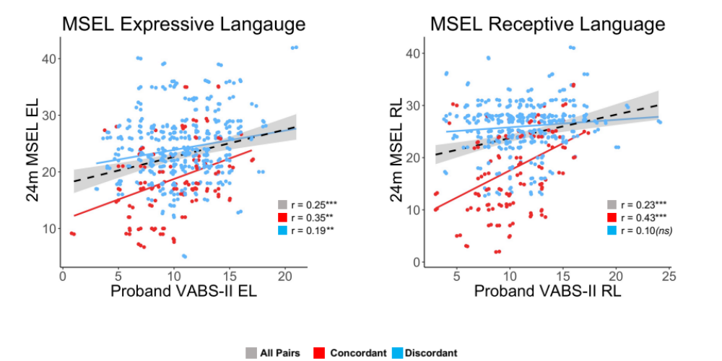

Raw scatterplots between proband VABS-II EL, RL and Sibling MSEL EL, RL age-adjusted scores. Pearson’s correlations are shown for the full group (gray), concordant pairs (red), and discordant pairs (blue). Significance is indicated as follows: * ≤0.05, ** ≤0.01, ***≤0.001

