Figure S1 MS/MS identification of peak 1521.93 Da

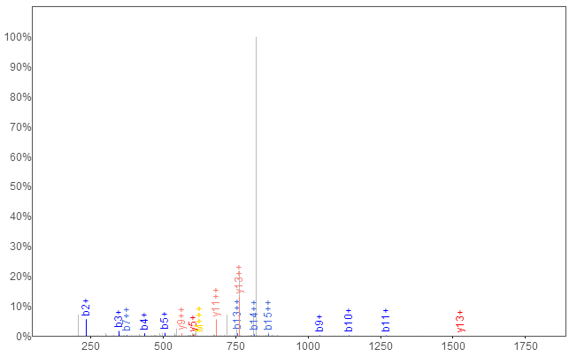

 | b+ | b2+ | # | Seq | # | y+ | y2+
 | 88.0393 | 44.5233 | 1 | S | 16
 | 235.1077 | 118.0575 | 2 | F | 15 | 1784.9429 | 892.9751
 | 348.1918 | 174.5995 | 3 | L | 14 | 1637.8745 | 819.4409
 | 435.2238 | 218.1155 | 4 | S | 13 | 1524.7904 | 762.8988
 | 506.2609 | 253.6341 | 5 | A | 12 | 1437.7584 | 719.3828
 | 619.3450 | 310.1761 | 6 | L | 11 | 1366.7213 | 683.8643
 | 748.3876 | 374.6974 | 7 | E | 10 | 1253.6372 | 627.3222
 | 877.4302 | 439.2187 | 8 | E | 9 | 1124.5946 | 562.8009
 | 1040.4935 | 520.7504 | 9 | Y | 8 | 995.5520 | 498.2796
 | 1141.5412 | 571.2742 | 10 | T | 7 | 832.4887 | 416.7480
 | 1269.6361 | 635.3217 | 11 | K | 6 | 731.4410 | 366.2241
 | 1397.7311 | 699.3692 | 12 | K | 5 | 603.3461 | 302.1767

 | 1510.8152 | 755.9112 | 13 | L | 4 | 475.2511 | 238.1292
 | 1624.8581 | 812.9327 | 14 | N | 3 | 362.1670 | 181.5872
 | 1725.9058 | 863.4565 | 15 | T | 2 | 248.1241 | 124.5657
 |  |  | 16 | Q | 1 | 147.0764 | 74.0418

Figure S2 MS/MS identification of peak 1265.49 Da

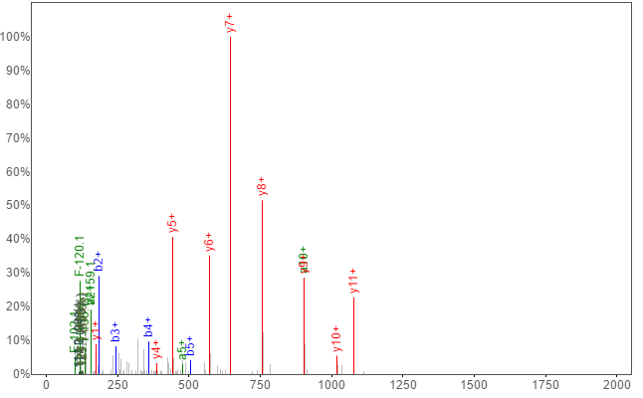

a+ | b+ | b2+ | # | Seq | # | y+ | y2+
30.0338 | 58.0287 | 29.5180 | 1 | G | 13
159.0764 | 187.0713 | 94.0393 | 2 | E | 12 | 1206.5749 | 603.7911
216.0979 | 244.0928 | 122.5500 | 3 | G | 11 | 1077.5323 | 539.2698
331.1248 | 359.1197 | 180.0635 | 4 | D | 10 | 1020.5109 | 510.7591
478.1932 | 506.1882 | 253.5977 | 5 | F | 9 | 905.4839 | 453.2456
591.2773 | 619.2722 | 310.1397 | 6 | L | 8 | 758.4155 | 379.7114
662.3144 | 690.3093 | 345.6583 | 7 | A | 7 | 645.3315 | 323.1694
791.3570 | 819.3519 | 410.1796 | 8 | E | 6 | 574.2944 | 287.6508
848.3785 | 876.3734 | 438.6903 | 9 | G | 5 | 445.2518 | 223.1295
905.3999 | 933.3949 | 467.2011 | 10 | G | 4 | 388.2303 | 194.6188
962.4214 | 990.4163 | 495.7118 | 11 | G | 3 | 331.2088 | 166.1081
1061.4898 | 1089.4847 | 545.2460 | 12 | V | 2 | 274.1874 | 137.5973
 |  |  | 13 | R | 1 | 175.1190 | 88.0631

Figure S3 MS/MS identification of peak 1352.84 Da
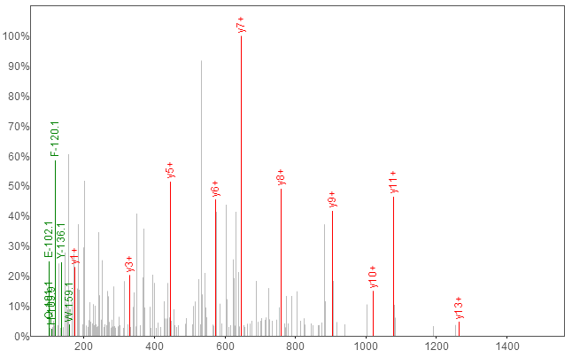

 | b+ | # | Seq | # | y+
 | 116.0342 | 1 | D | 15
 | 283.0326 | 2 | S | 14 | 1430.5948
 | 340.0540 | 3 | G | 13 | 1263.5964
 | 469.0966 | 4 | E | 12 | 1206.5749
 | 526.1181 | 5 | G | 11 | 1077.5323
 | 641.1450 | 6 | D | 10 | 1020.5109
 | 788.2135 | 7 | F | 9 | 905.4839
 | 901.2975 | 8 | L | 8 | 758.4155
 | 972.3346 | 9 | A | 7 | 645.3315
 | 1101.3772 | 10 | E | 6 | 574.2944
 | 1158.3987 | 11 | G | 5 | 445.2518
 | 1215.4202 | 12 | G | 4 | 388.2303
 | 1272.4416 | 13 | G | 3 | 331.2088
 | 1371.5100 | 14 | V | 2 | 274.1874

 |  | 15 | R | 1 | 175.1190

Figure S4 MS/MS identification of peak 1575.90 Da
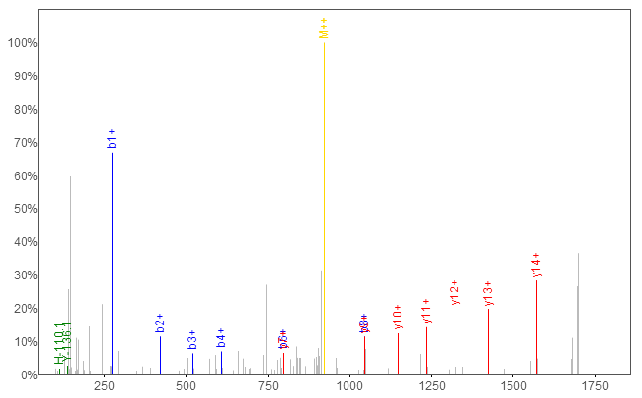

 | b+ | # | Seq | # | y+
 | 273.1679 | 1 | Q | 15
 | 420.2363 | 2 | F | 14 | 1569.6816
 | 521.2840 | 3 | T | 13 | 1422.6132
 | 608.3160 | 4 | S | 12 | 1321.5655
 | 695.3481 | 5 | S | 11 | 1234.5335
 | 796.3957 | 6 | T | 10 | 1147.5014
 | 883.4278 | 7 | S | 9 | 1046.4538
 | 1046.4911 | 8 | Y | 8 | 959.4217
 | 1160.5340 | 9 | N | 7 | 796.3584

 | 1316.6351 | 10 | R | 6 | 682.3155
 | 1373.6566 | 11 | G | 5 | 526.2144
 | 1488.6835 | 12 | D | 4 | 469.1929
 | 1575.7156 | 13 | S | 3 | 354.1660
 | 1676.7633 | 14 | T | 2 | 267.1339
 |  | 15 | F | 1 | 166.0863

Figure S5 MS/MS identification of peak 2663.12 Da

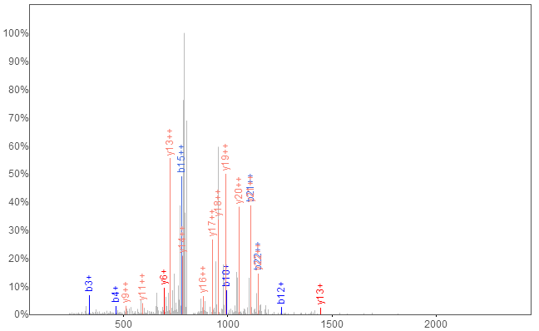

 | b+ | b2+ | # | Seq | # | y+ | y2+
 | 148.0427 | 74.5250 | 1 | M | 23
 | 219.0798 | 110.0435 | 2 | A | 22 | 2291.0395 | 1146.0234
 | 334.1067 | 167.5570 | 3 | D | 21 | 2220.0024 | 1110.5049
 | 463.1493 | 232.0783 | 4 | E | 20 | 2104.9755 | 1052.9914
 | 534.1864 | 267.5969 | 5 | A | 19 | 1975.9329 | 988.4701
 | 591.2079 | 296.1076 | 6 | G | 18 | 1904.8958 | 952.9515
 | 678.2399 | 339.6236 | 7 | S | 17 | 1847.8743 | 924.4408

 | 807.2825 | 404.1449 | 8 | E | 16 | 1760.8423 | 880.9248
 | 878.3196 | 439.6635 | 9 | A | 15 | 1631.7997 | 816.4035
 | 993.3466 | 497.1769 | 10 | D | 14 | 1560.7626 | 780.8849
 | 1130.4055 | 565.7064 | 11 | H | 13 | 1445.7356 | 723.3715
 | 1259.4481 | 630.2277 | 12 | E | 12 | 1308.6767 | 654.8420
 | 1316.4696 | 658.7384 | 13 | G | 11 | 1179.6341 | 590.3207
 | 1417.5172 | 709.2623 | 14 | T | 10 | 1122.6127 | 561.8100
 | 1554.5761 | 777.7917 | 15 | H | 9 | 1021.5650 | 511.2861
 | 1641.6082 | 821.3077 | 16 | S | 8 | 884.5061 | 442.7567
 | 1742.6558 | 871.8316 | 17 | T | 7 | 797.4740 | 399.2407
 | 1870.7508 | 935.8790 | 18 | K | 6 | 696.4264 | 348.7168
 | 2026.8519 | 1013.9296 | 19 | R | 5 | 568.3314 | 284.6693
 | 2083.8734 | 1042.4403 | 20 | G | 4 | 412.2303 | 206.6188
 | 2220.9323 | 1110.9698 | 21 | H | 3 | 355.2088 | 178.1081
 | 2291.9694 | 1146.4883 | 22 | A | 2 | 218.1499 | 109.5786
 |  |  | 23 | K | 1 | 147.1128 | 74.0600

Figure S6 MS/MS identification of peak 2716.91 Da
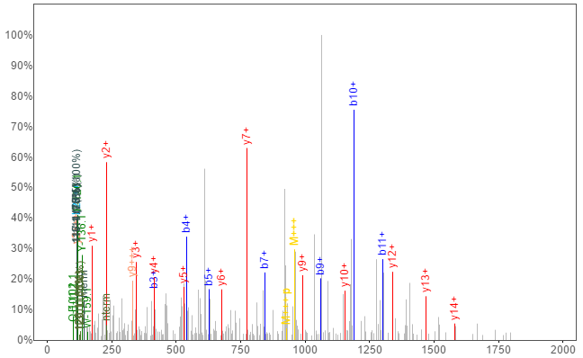
a+ | b+ | b2+ | b3+ | # | Seq | # | y+ | y2+ | y3+
216.1828 | 244.1778 | 122.5925 | 82.0641 | 1 | V | 25
315.2513 | 343.2462 | 172.1267 | 115.0869 | 2 | V | 24 | 2640.2821 | 1320.6447 | 880.7656
386.2884 | 414.2833 | 207.6453 | 138.7659 | 3 | A | 23 | 2541.2137 | 1271.1105 | 847.7428
514.3469 | 542.3419 | 271.6746 | 181.4521 | 4 | Q | 22 | 2470.1766 | 1235.5919 | 824.0637
601.3790 | 629.3739 | 315.1906 | 210.4628 | 5 | S | 21 | 2342.1180 | 1171.5627 | 781.3775
702.4267 | 730.4216 | 365.7144 | 244.1454 | 6 | T | 20 | 2255.0860 | 1128.0466 | 752.3669
816.4696 | 844.4645 | 422.7359 | 282.1597 | 7 | N | 19 | 2154.0383 | 1077.5228 | 718.6843
903.5016 | 931.4965 | 466.2519 | 311.1704 | 8 | S | 18 | 2039.9954 | 1020.5013 | 680.6700
1032.5442 | 1060.5391 | 530.7732 | 354.1846 | 9 | E | 17 | 1952.9634 | 976.9853 | 651.6593
1161.5868 | 1189.5817 | 595.2945 | 397.1988 | 10 | E | 16 | 1823.9208 | 912.4640 | 608.6451
1274.6709 | 1302.6658 | 651.8365 | 434.8934 | 11 | I | 15 | 1694.8782 | 847.9427 | 565.6309
1387.7549 | 1415.7498 | 708.3786 | 472.5881 | 12 | I | 14 | 1581.7941 | 791.4007 | 527.9362
1516.7975 | 1544.7924 | 772.8999 | 515.6023 | 13 | E | 13 | 1468.7101 | 734.8587 | 490.2415
1573.8190 | 1601.8139 | 801.4106 | 534.6095 | 14 | G | 12 | 1339.6675 | 670.3374 | 447.2273
1702.8616 | 1730.8565 | 865.9319 | 577.6237 | 15 | E | 11 | 1282.6460 | 641.8266 | 428.2202
1865.9249 | 1893.9198 | 947.4635 | 631.9781 | 16 | Y | 10 | 1153.6034 | 577.3053 | 385.2060
1979.9678 | 2007.9627 | 1004.4850 | 669.9924 | 17 | N | 9 | 990.5401 | 495.7737 | 330.8515
2081.0155 | 2109.0104 | 1055.0088 | 703.6750 | 18 | T | 8 | 876.4971 | 438.7522 | 292.8372
2180.0839 | 2208.0788 | 1104.5431 | 736.6978 | 19 | V | 7 | 775.4495 | 388.2284 | 259.1547
2327.1193 | 2355.1142 | 1178.0608 | 785.7096 | 20 | M | 6 | 676.3811 | 338.6942 | 226.1319
2440.2034 | 2468.1983 | 1234.6028 | 823.4043 | 21 | L | 5 | 529.3457 | 265.1765 | 177.1201
2511.2405 | 2539.2354 | 1270.1213 | 847.0833 | 22 | A | 4 | 416.2616 | 208.6344 | 139.4254
2624.3246 | 2652.3195 | 1326.6634 | 884.7780 | 23 | I | 3 | 345.2245 | 173.1159 | 115.7463
2681.3460 | 2709.3409 | 1355.1741 | 903.7852 | 24 | G | 2 | 232.1404 | 116.5738 | 78.0517
 |  |  |  | 25 | R | 1 | 175.1190 | 88.0631 | 59.0445

Figure S7 MS/MS identification of peak 4213.82Da
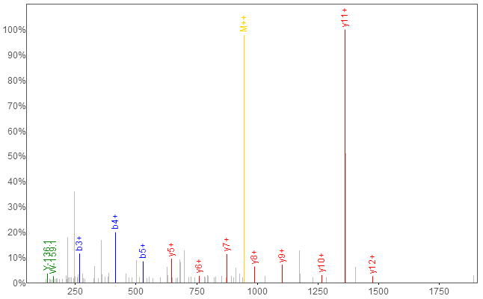

b+ | # | Seq | # | y+
58.0287 | 1 | G | 16
171.1128 | 2 | L | 15 | 1832.9694
268.1656 | 3 | P | 14 | 1719.8853
415.2340 | 4 | F | 13 | 1622.8326
528.3180 | 5 | I | 12 | 1475.7641
625.3708 | 6 | P | 11 | 1362.6801
788.4341 | 7 | Y | 10 | 1265.6273
901.5182 | 8 | L | 9 | 1102.5640
1016.5451 | 9 | D | 8 | 989.4799
1130.5881 | 10 | N | 7 | 874.4530
1243.6721 | 11 | L | 6 | 760.4100
1340.7249 | 12 | P | 5 | 647.3260
1454.7678 | 13 | N | 4 | 550.2732
1601.8362 | 14 | F | 3 | 436.2303
1715.8792 | 15 | N | 2 | 289.1619
 | 16 | R | 1 | 175.1190
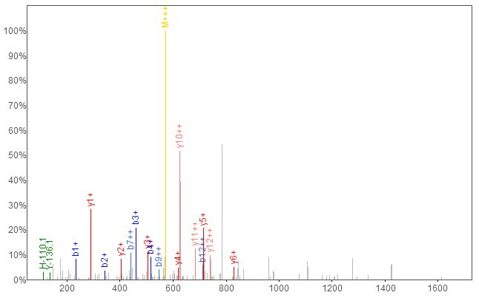

b+ | b2+ | # | Seq | # | y+ | y2+
232.1414 | 116.5743 | 1 | S | 13
345.2254 | 173.1164 | 2 | I | 12 | 1479.9015 | 740.4544
460.2524 | 230.6298 | 3 | D | 11 | 1366.8175 | 683.9124
517.2738 | 259.1406 | 4 | G | 10 | 1251.7905 | 626.3989
614.3266 | 307.6669 | 5 | P | 9 | 1194.7691 | 597.8882
727.4107 | 364.2090 | 6 | I | 8 | 1097.7163 | 549.3618
883.5118 | 442.2595 | 7 | R | 7 | 984.6322 | 492.8198
996.5958 | 498.8016 | 8 | L | 6 | 828.5311 | 414.7692
1093.6486 | 547.3279 | 9 | P | 5 | 715.4471 | 358.2272
1206.7327 | 603.8700 | 10 | I | 4 | 618.3943 | 309.7008
1305.8011 | 653.4042 | 11 | V | 3 | 505.3102 | 253.1587
1420.8280 | 710.9177 | 12 | D | 2 | 406.2418 | 203.6245
 |  | 13 | K | 1 | 291.2149 | 146.1111

Figure S8 MS/MS identification of peak 1506.07Da

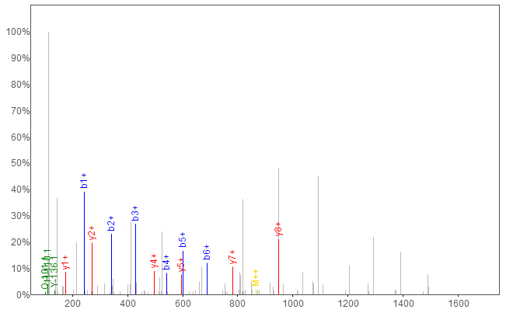

b+ | # | Seq | # | y+
244.1778 | 1 | V | 15
343.2462 | 2 | V | 14 | 1488.6842
430.2782 | 3 | S | 13 | 1389.6158
543.3623 | 4 | L | 12 | 1302.5838
600.3837 | 5 | G | 11 | 1189.4997
687.4158 | 6 | S | 10 | 1132.4783
784.4685 | 7 | P | 9 | 1045.4463
951.4669 | 8 | S | 8 | 948.3935
1008.4883 | 9 | G | 7 | 781.3951
1137.5309 | 10 | E | 6 | 724.3737
1236.5993 | 11 | V | 5 | 595.3311
1323.6314 | 12 | S | 4 | 496.2627
1460.6903 | 13 | H | 3 | 409.2306
1557.7430 | 14 | P | 2 | 272.1717
 | 15 | R | 1 | 175.1190

Figure S9 MS/MS identification of peak 1629.81 Da
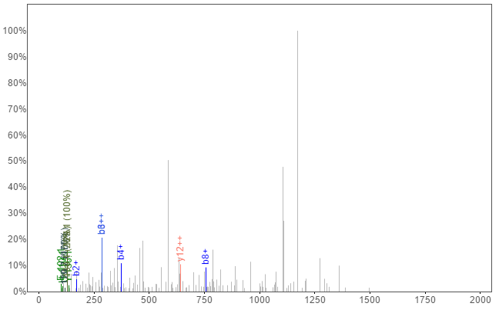
a+ | b+ | b2+ | # | Seq | # | y+ | y2+
30.0338 | 58.0287 | 29.5180 | 1 | G | 16
145.0608 | 173.0557 | 87.0315 | 2 | D | 15 | 1599.8449 | 800.4261
258.1448 | 286.1397 | 143.5735 | 3 | L | 14 | 1484.8180 | 742.9126
345.1769 | 373.1718 | 187.0895 | 4 | S | 13 | 1371.7339 | 686.3706
446.2245 | 474.2195 | 237.6134 | 5 | T | 12 | 1284.7019 | 642.8546
543.2773 | 571.2722 | 286.1397 | 6 | P | 11 | 1183.6542 | 592.3308
658.3042 | 686.2992 | 343.6532 | 7 | D | 10 | 1086.6015 | 543.8044
729.3414 | 757.3363 | 379.1718 | 8 | A | 9 | 971.5745 | 486.2909
828.4098 | 856.4047 | 428.7060 | 9 | V | 8 | 900.5374 | 450.7723
975.4452 | 1003.4401 | 502.2237 | 10 | M | 7 | 801.4690 | 401.2381
1032.4666 | 1060.4616 | 530.7344 | 11 | G | 6 | 654.4336 | 327.7204
1146.5096 | 1174.5045 | 587.7559 | 12 | N | 5 | 597.4121 | 299.2097
1243.5623 | 1271.5572 | 636.2823 | 13 | P | 4 | 483.3692 | 242.1882
1377.6774 | 1405.6723 | 703.3398 | 14 | K | 3 | 386.3164 | 193.6619
1476.7458 | 1504.7407 | 752.8740 | 15 | V | 2 | 252.2013 | 126.6043
 |  |  | 16 | K | 1 | 153.1329 | 77.0701

Figure S10 MS/MS identification of peak 2865.39 Da
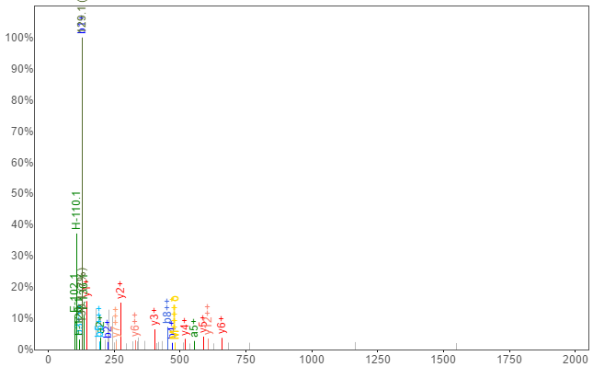
a+ | b+ | b2+ | b3+ | # | Seq | # | y+ | y2+ | y3+
101.1073 | 129.1022 | 65.0548 | 43.7056 | 1 | K | 18
200.1757 | 228.1707 | 114.5890 | 76.7284 | 2 | V | 17 | 1807.0436 | 904.0254 | 603.0194
329.2183 | 357.2132 | 179.1103 | 119.7426 | 3 | E | 16 | 1707.9752 | 854.4912 | 569.9966
442.3024 | 470.2973 | 235.6523 | 157.4373 | 4 | L | 15 | 1578.9326 | 789.9699 | 526.9824
555.3865 | 583.3814 | 292.1943 | 195.1320 | 5 | I | 14 | 1465.8485 | 733.4279 | 489.2877
692.4454 | 720.4403 | 360.7238 | 240.8183 | 6 | H | 13 | 1352.7645 | 676.8859 | 451.5930
749.4668 | 777.4617 | 389.2345 | 259.8254 | 7 | G | 12 | 1215.7056 | 608.3564 | 405.9067
877.5618 | 905.5567 | 453.2820 | 302.5238 | 8 | K | 11 | 1158.6841 | 579.8457 | 386.8996
1005.6568 | 1033.6517 | 517.3295 | 345.2221 | 9 | K | 10 | 1030.5891 | 515.7982 | 344.2012
1076.6939 | 1104.6888 | 552.8480 | 368.9011 | 10 | A | 9 | 902.4942 | 451.7507 | 301.5029
1133.7153 | 1161.7103 | 581.3588 | 387.9083 | 11 | G | 8 | 831.4571 | 416.2322 | 277.8239
1246.7994 | 1274.7943 | 637.9008 | 425.6030 | 12 | L | 7 | 774.4356 | 387.7214 | 258.8167
1317.8365 | 1345.8314 | 673.4194 | 449.2820 | 13 | A | 6 | 661.3515 | 331.1794 | 221.1220
1388.8736 | 1416.8685 | 708.9379 | 472.9610 | 14 | A | 5 | 590.3144 | 295.6608 | 197.4430
1503.9006 | 1531.8955 | 766.4514 | 511.3033 | 15 | D | 4 | 519.2773 | 260.1423 | 173.7640
1631.9955 | 1659.9905 | 830.4989 | 554.0017 | 16 | K | 3 | 404.2504 | 202.6288 | 135.4216
1760.0905 | 1788.0854 | 894.5463 | 596.7000 | 17 | K | 2 | 276.1554 | 138.5813 | 92.7233
 |  |  |  | 18 | E | 1 | 148.0604 | 74.5339 | 50.0250

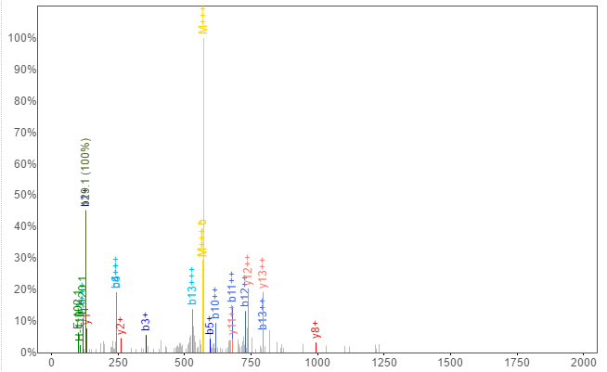

a+ | b+ | b2+ | b3+ | # | Seq | # | y+ | y2+ | y3+
101.1073 | 129.1022 | 65.0548 | 43.7056 | 1 | K | 14
214.1914 | 242.1863 | 121.5968 | 81.4003 | 2 | L | 13 | 1590.8407 | 795.9240 | 530.9518
329.2183 | 357.2132 | 179.1103 | 119.7426 | 3 | D | 12 | 1477.7567 | 739.3820 | 493.2571
457.3133 | 485.3082 | 243.1577 | 162.4409 | 4 | K | 11 | 1362.7297 | 681.8685 | 454.9148
570.3974 | 598.3923 | 299.6998 | 200.1356 | 5 | I | 10 | 1234.6348 | 617.8210 | 412.2164
698.4923 | 726.4872 | 363.7473 | 242.8339 | 6 | K | 9 | 1121.5507 | 561.2790 | 374.5218
827.5349 | 855.5298 | 428.2686 | 285.8481 | 7 | E | 8 | 993.4557 | 497.2315 | 331.8234
987.5656 | 1015.5605 | 508.2839 | 339.1917 | 8 | C | 7 | 864.4131 | 432.7102 | 288.8092
1074.5976 | 1102.5925 | 551.7999 | 368.2024 | 9 | S | 6 | 704.3825 | 352.6949 | 235.4657
1203.6402 | 1231.6351 | 616.3212 | 411.2166 | 10 | E | 5 | 617.3505 | 309.1789 | 206.4550
1331.7351 | 1359.7301 | 680.3687 | 453.9149 | 11 | K | 4 | 488.3079 | 244.6576 | 163.4408
1430.8036 | 1458.7985 | 729.9029 | 486.9377 | 12 | V | 3 | 360.2129 | 180.6101 | 120.7425
1559.8462 | 1587.8411 | 794.4242 | 529.9519 | 13 | E | 2 | 261.1445 | 131.0759 | 87.7197
 |  |  |  | 14 | L | 1 | 132.1019 | 66.5546 | 44.7055

