Supplementary Materials:

Figure S1. Ceruloplasmin and S100 A9 levels in EBOV- and Bp infected NHP
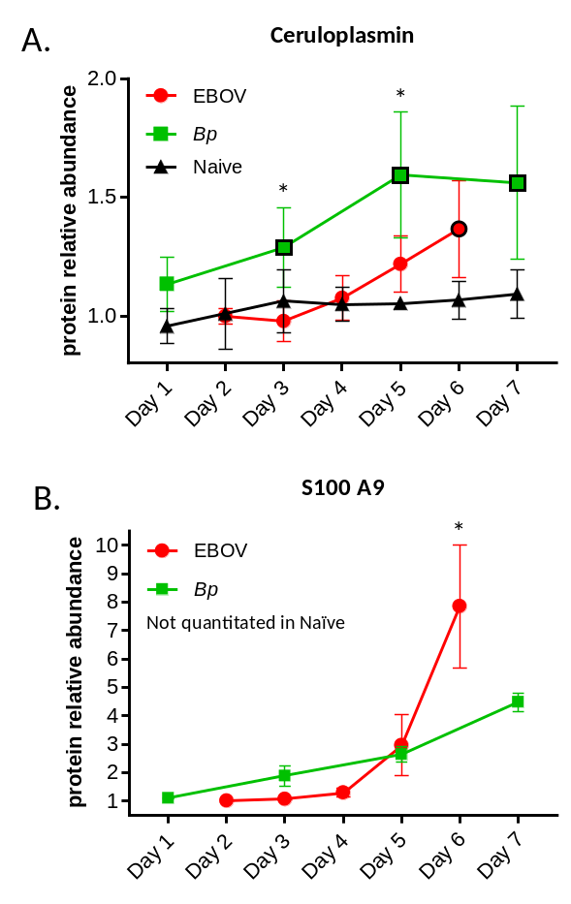
Fig. S1. Ceruloplasmin and S100A9 levels during infection with EBOV or Bp. A) Ceruloplasmin levels were higher in Bp infected NHP when compared to EBOV infected animals on Days 5 and 6 PI. B) S100 A9 levels in EBOV infected NHP were significantly higher than level in Bp-infected animals. Abundance levels that were significantly different from levels found in naïve NHPs are designated with a black border around the symbol and levels that were significantly different between EBOV- and Bp-infected NHPs are designated with an asterisk (*). Statistical significance was based on 2-way ANOVA analysis

Figure S2. Apo A1, Complement C1s, C2 and C4 levels.
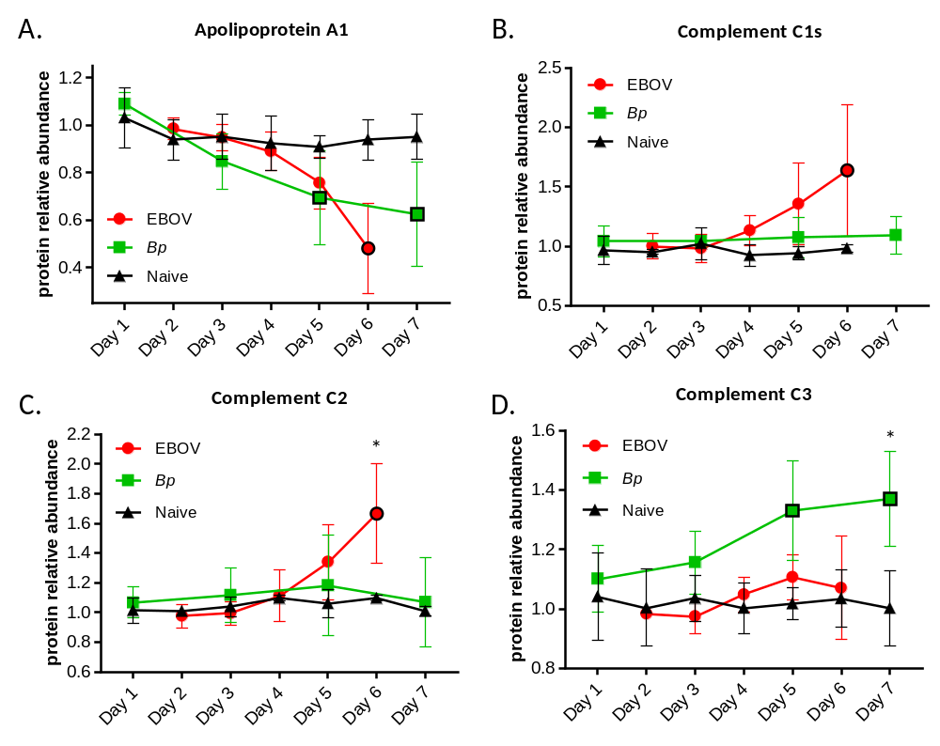
Figure S2. Apo A1, Complement C1s, C2 and C4 levels during infection with EBOV or BP in rhesus macaques.
A) Apo A1 levels decreased to comparable levels in EBOV- and Bp- infected NHP. B) Complement C1s levels were higher in EBOV infected NHP, but the difference was not significant. C) Complement C2 levels were significantly higher in EBOV-infected NHP on Day 6 PI. D). Complement C3 levels were significantly higher in Bp infected NHP on Day 6/7 PI. Abundance levels that were significantly different from levels found in naïve NHPs are designated with a black border around the symbol and levels that were significantly different between EBOV- and Bp-infected NHPs are designated with an asterisk (*).Statistical significance was based on 2-way ANOVA analysis.

Figure S3. Complement Factor B, C9 and Fibronectin-1 levels
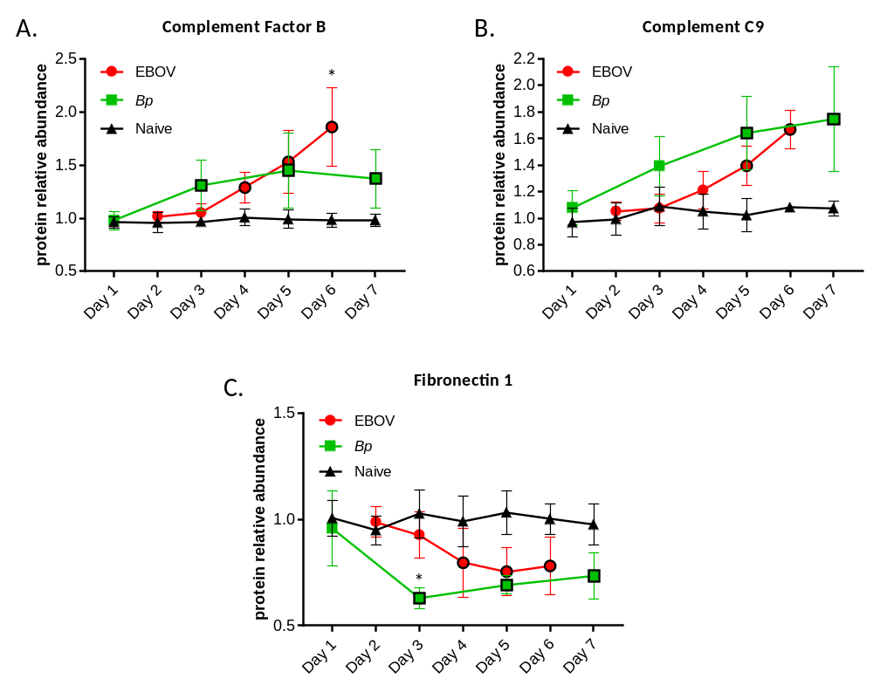
Figure S3. Complement factor B, C9 and Fibronectin-1 levels during infection with EBOV or BP in rhesus macaques
A) Complement Factor B is significantly higher in EBOV infected NHP on Day 6/7 PI. B) Levels of C9 were comparable in both infection types. C) Fibronectin levels are reduced in both EBOV- and Bp-infected NHP, and the reduction is significantly different between the two infection types on Day 3 PI. Abundance levels that were significantly different from levels found in naïve NHPs are designated with a black border around the symbol and levels that were significantly different between EBOV- and Bp-infected NHPs are designated with an asterisk (*).Statistical significance was based on 2-way ANOVA analysis.

Table S1. EBOV viral RNA levels in EBOV infected NHP.
Pathogen/exp.route | NHP# | Copies of serum EBOV RNA ge/ml
Pathogen/exp.route | NHP# | Day 2 | Day 3 | Day 4 | Day5 | Day 6 | Day 7 | Day 9
Ebola Zaire (1000 pfu:IM) | 1509 | <LLOD | 3.44E+06 | 1.45E+08 | 3.22E+08 | ND | 3.76E+08 | ND
Ebola Zaire (1000 pfu:IM) | 1500 | <LLOD | 2.47E+05 | 2.42E+07 | 2.44E+09 | ND | 1.54E+09 | ND
Ebola Zaire (1000 pfu:IM) | 1285 | <LLOD | <LLOD | 4.13E+06 | 2.63E+08 | ND | 2.45E+08 | 1.18E+08
Ebola Zaire (1000 pfu:IM) | 1315 | <LLOD | 6.41E+05 | 6.41E+08 | 9.29E+09 | ND | 2.06E+10 | ND
Ebola Zaire (1000 pfu:IM) | 1305 | <LLOD | <LLOD | 4.30E+06 | 1.12E+09 | ND | 9.94E+09 | 2.83E+09
Ebola Zaire (1000 pfu:IM) | 1129 | <LLOD | <LLOD | 3.51E+05 | 7.79E+08 | ND | 6.70E+09 | 4.16E+09
Ebola Zaire (1000 pfu:IM) | 1120 | <LLOD | 2.10E+05 | 3.24E+08 | 2.78E+10 | 1.60E+11 | ND | ND
Ebola Zaire (1000 pfu:IM) | 1456 | <LLOD | 1.87E+06 | 2.19E+09 | 1.58E+10 | 2.28E+10 | ND | ND
Ebola Zaire (1000 pfu:IM) | 469 | <LLOD | <LLOD | 2.35E+07 | 4.61E+09 | 6.39E+09 | ND | ND
Ebola Zaire (1000 pfu:IM) | 1000 | <LLOD | <LLOD | 1.44E+06 | 2.38E+08 | ND | 5.68E+09 | 2.25E+09

ND = No Data (sample not collected)

Table S2. Blood culture results for Bp infected NHP.
Pathogen/exp.route | NHP# | Blood culture results (CFU/ml)
Pathogen/exp.route | NHP# | Day 0 | Day 2 | Day 3 | Day 4 | Day5 | Day 6 | Day 7 | Day 8 | Day9
Burkholderia (300-500 cfu: Aerosol) | JD 27 | 0.0 | 0.0 | 0.0 | 0.0 | 0.0 | 2.5 | 0.0 | 0.0 | 0.0
Burkholderia (300-500 cfu: Aerosol) | JF18 | 0.0 | 0.0 | 0.0 | 0.0 | 0.0 | 0.0 | 0.0 | 0.0 | 0.0
Burkholderia (300-500 cfu: Aerosol) | JH28 | 0.0 | 0.0 | 3.3 | 0.0 | 0.0 | 0.0 | 0.0 | 0.0 | 0.0
Burkholderia (300-500 cfu: Aerosol) | JM 26 | 0.0 | 0.0 | 0.0 | 0.0 | 0.0 | 0.0 | 0.0 | 0.0 | 0.0
Burkholderia (300-500 cfu: Aerosol) | JP28 | 0.0 | 0.0 | 0.0 | 0.0 | 0.0 | 0.0 | 0.0 | 0.0 | 0.0

Table S3. Bacterial burden in terminal tissues and urine from Bp infected NHP.
Pathogen/exp. Route | NHP # | Day | Terminal Tissue (CFU/g) and urine (CFU/ml) burden
Pathogen/exp. Route | NHP # | Day | Lung | Bronch LN | Spleen | Liver | Mes LN | Kidney | Urine*
Burkholderia (300-500 cfu: Aerosol) | JD 27 | 13 | 1.60E+07 | 2.90E+04 | 3.70E+04 | 1.40E+04 | 5.60E+01 | 2.90E+02 | 0
Burkholderia (300-500 cfu: Aerosol) | JF18 | 46 | 0 | 8.20E+04 | 0 | 0 | 0 | 0 | 0
Burkholderia (300-500 cfu: Aerosol) | JH28 | 46 | 0 | 5.10E+04 | 2.60E+03 | 0 | 0 | 0 | 0
Burkholderia (300-500 cfu: Aerosol) | JM 26 | 46 | 0 | 1.50E+02 | 5.80E+03 | 0 | 5.60E+01 | 0 | ND
Burkholderia (300-500 cfu: Aerosol) | JP28 | 46 | 4.00E+02 | 2.60E+04 | 4.30E+05 | 2.00E+05 | 8.00E+02 | 4.70E+03 | 4.00E+01

