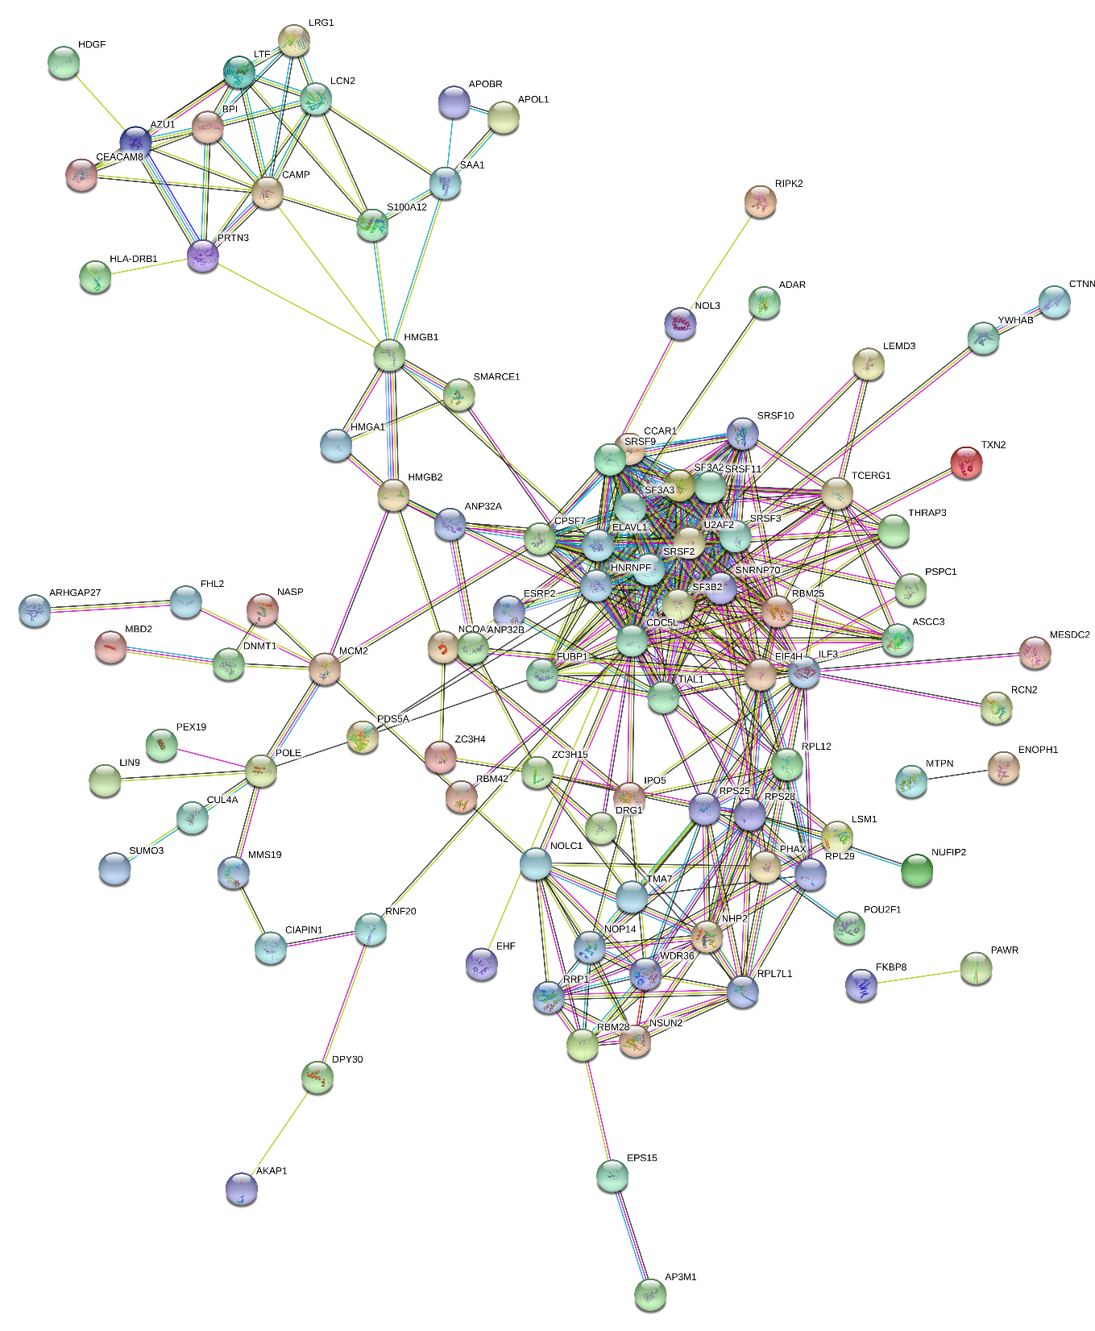
cell division cycle/
RNA processing
(i)
Increased in all (III)
Metabolism of RNA
FDR = 6.12E-15
chromatin remodelling
epigenetic modifications
Immune response

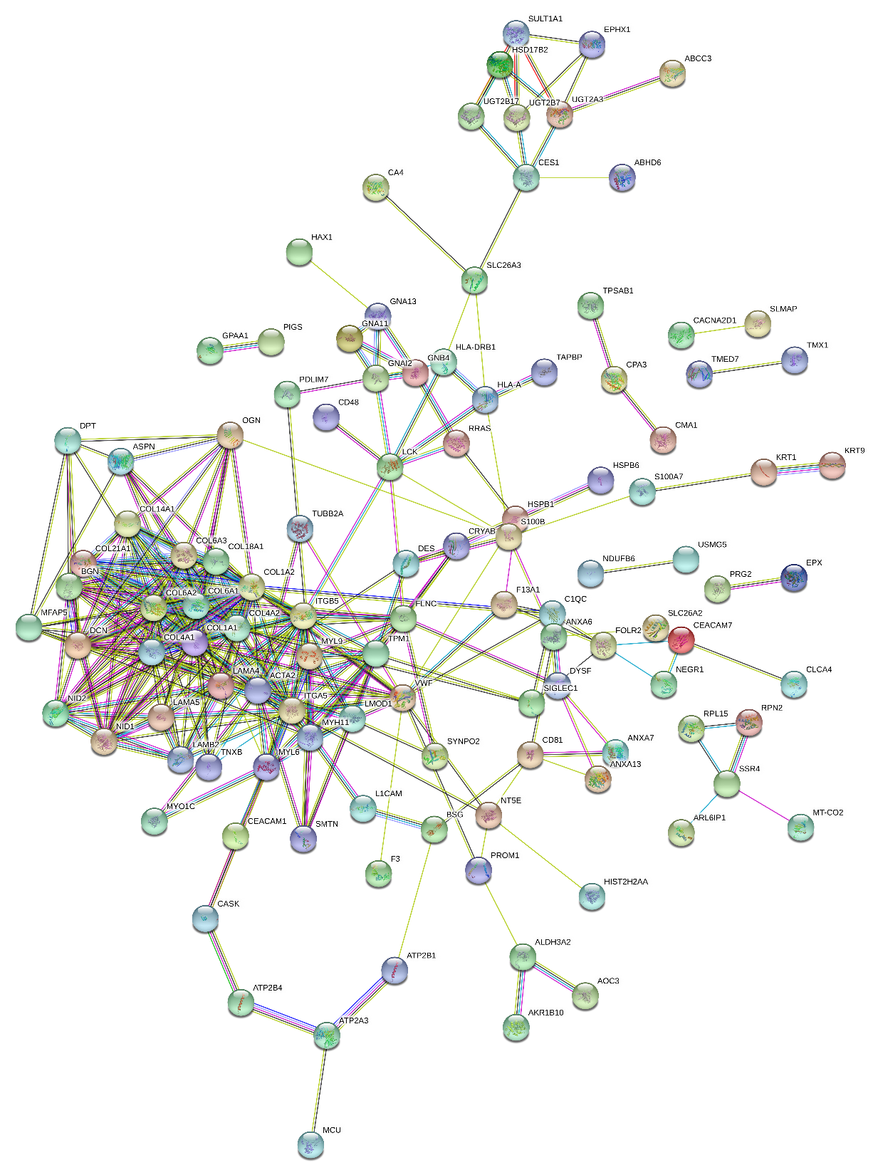
extracellular matrix
xenobiotic metabolism and transport
G-protein linked transmembrane signalling
(ii)
Decreased in all (DDD)
Extracellular matrix organisation
FDR = 8.86E-20

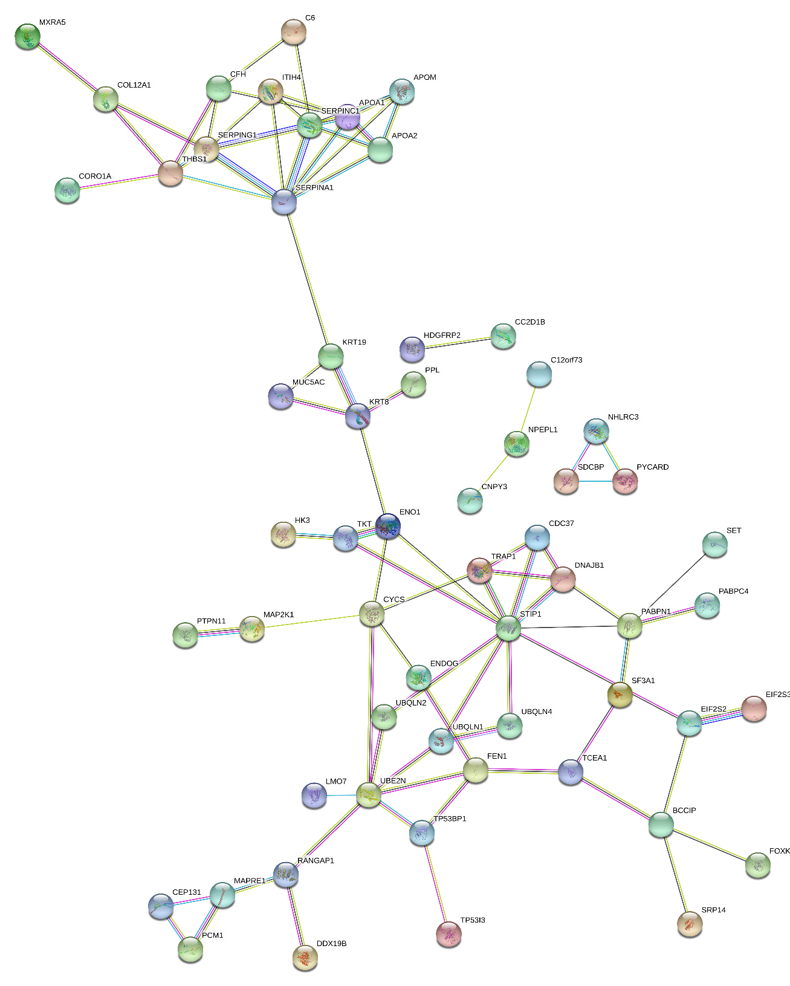
ubiquitin-associated protein turnover/ LC3-associated autophagy
immune response/ cell motility
HSP90/HSC70 associated complexes
(iii)
UUI
Innate Immune System
FDR = 3.47 E-05

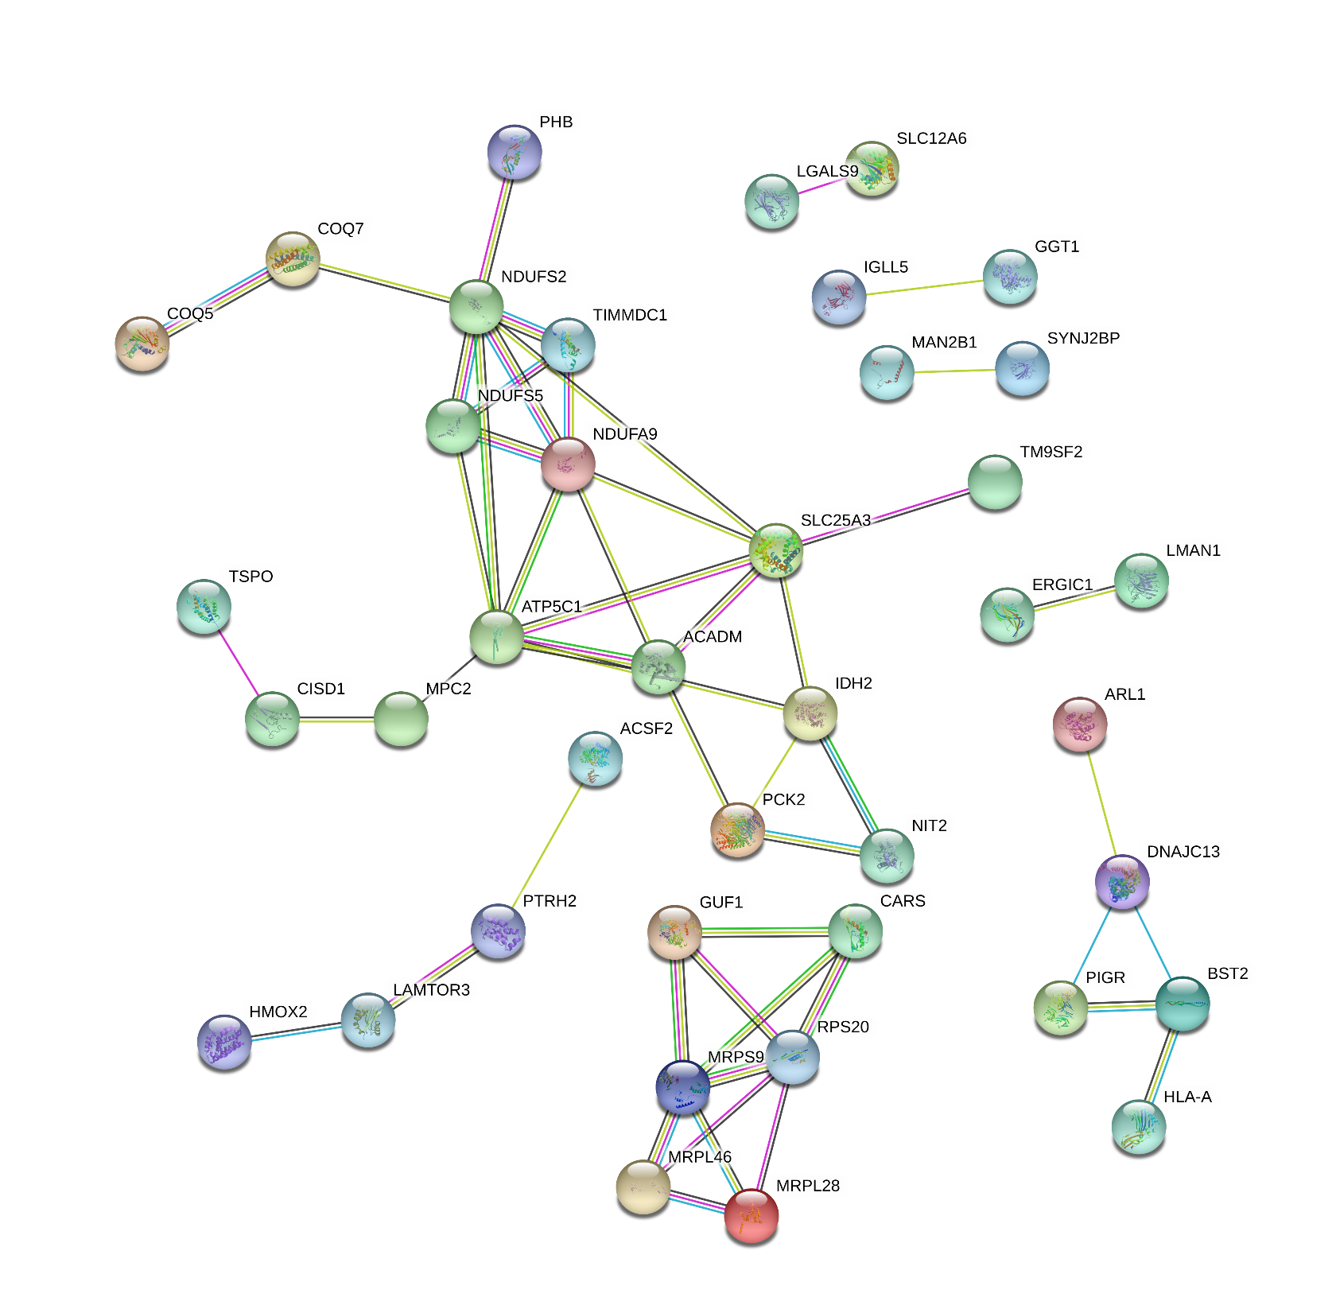
(iv)
UUD
The citric acid (TCA) cycle and respiratory electron transport
FDR = 3.1 E-04
mitochondrial function

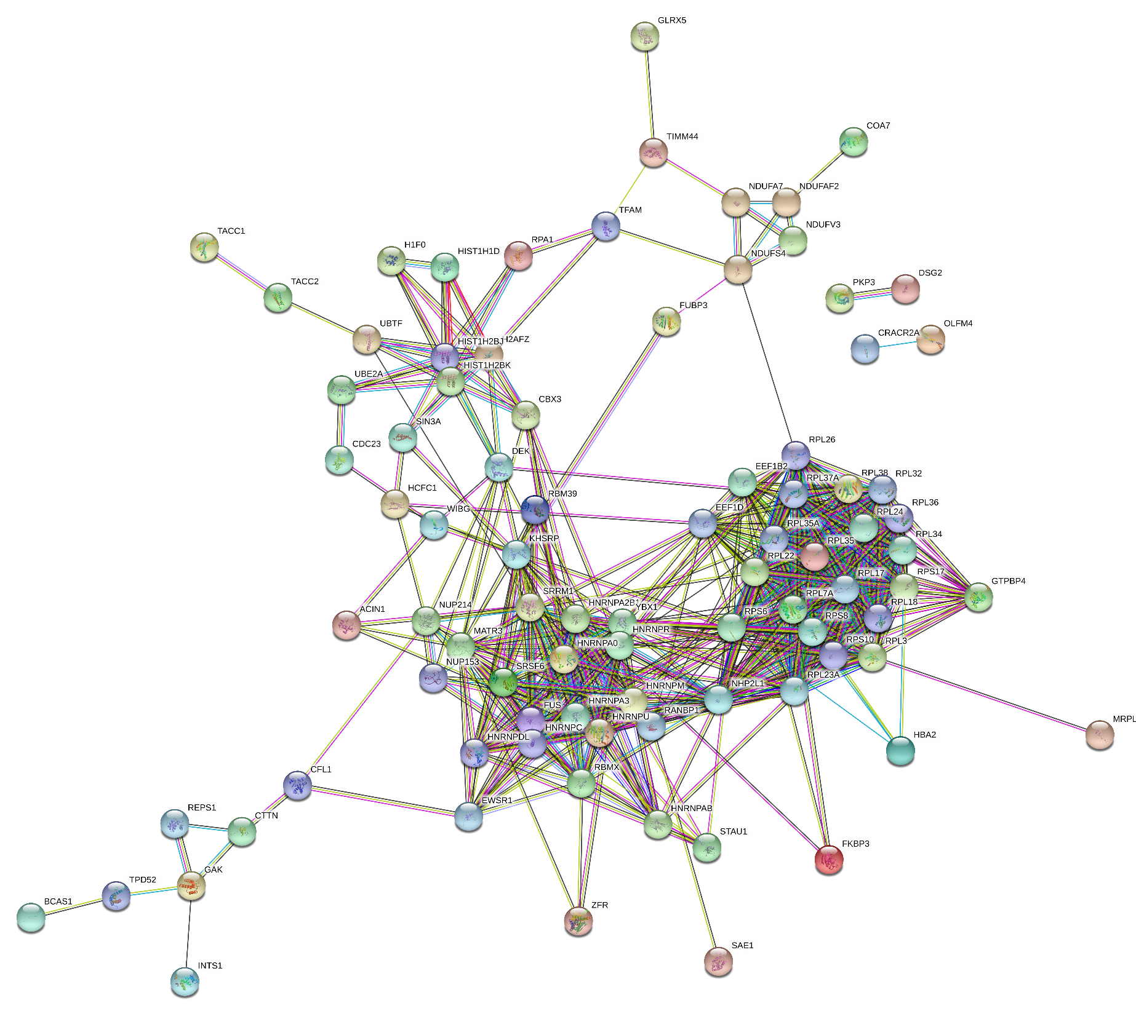
(v)
IUU
Eukaryotic Translation Elongation
FDR = 8.13E-25
Transcriptional processing
Translational processing

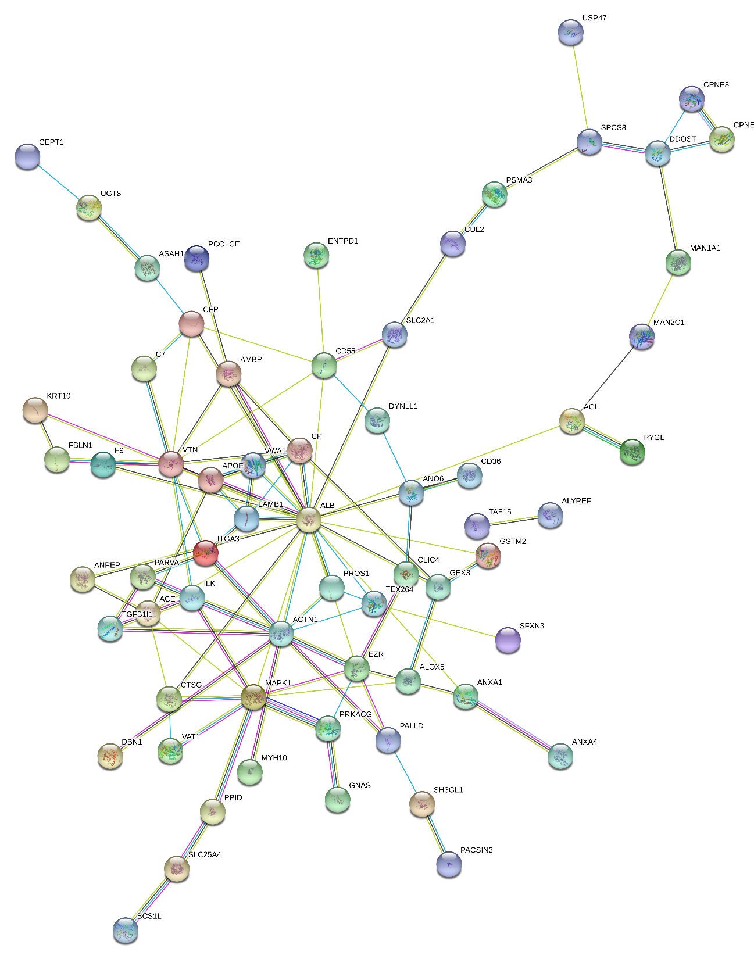
(vi)
DUU
Neutrophil degranulation
FDR = 4.01E-07

Additional Figure S1

