Serum proteomics unveil characteristic protein diagnostic biomarkers and signaling pathways in patients with esophageal squamous cell carcinoma
Wenhu Liu^{#1}, Qiang Wang^{#2}, Jinxia Chang¹, Anup Bhetuwal³, Nisha Bhattarai⁴, Fan Zhang^{*1}, Jiancai Tang^{*1}
¹ School of Pharmacy, School of Basic Medical Sciences & Forensic Medical, North Sichuan Medical College, Nanchong, China
² Department of Clinical Laboratory, Translational Medicine Research Center, Affiliated Hospital of North Sichuan Medical College, Nanchong, China
³ Sichuan Key Laboratory of Medical Imaging, North Sichuan Medical College, Nanchong, China
⁴ Department of Neurology, North Sichuan Medical College, Nanchong, China
*Corresponding author: F. Zhang, zhangfan596@163.com; J. Tang, tangjiancai@nsmc.edu.cn
# These authors contributed equally.

Additional figure
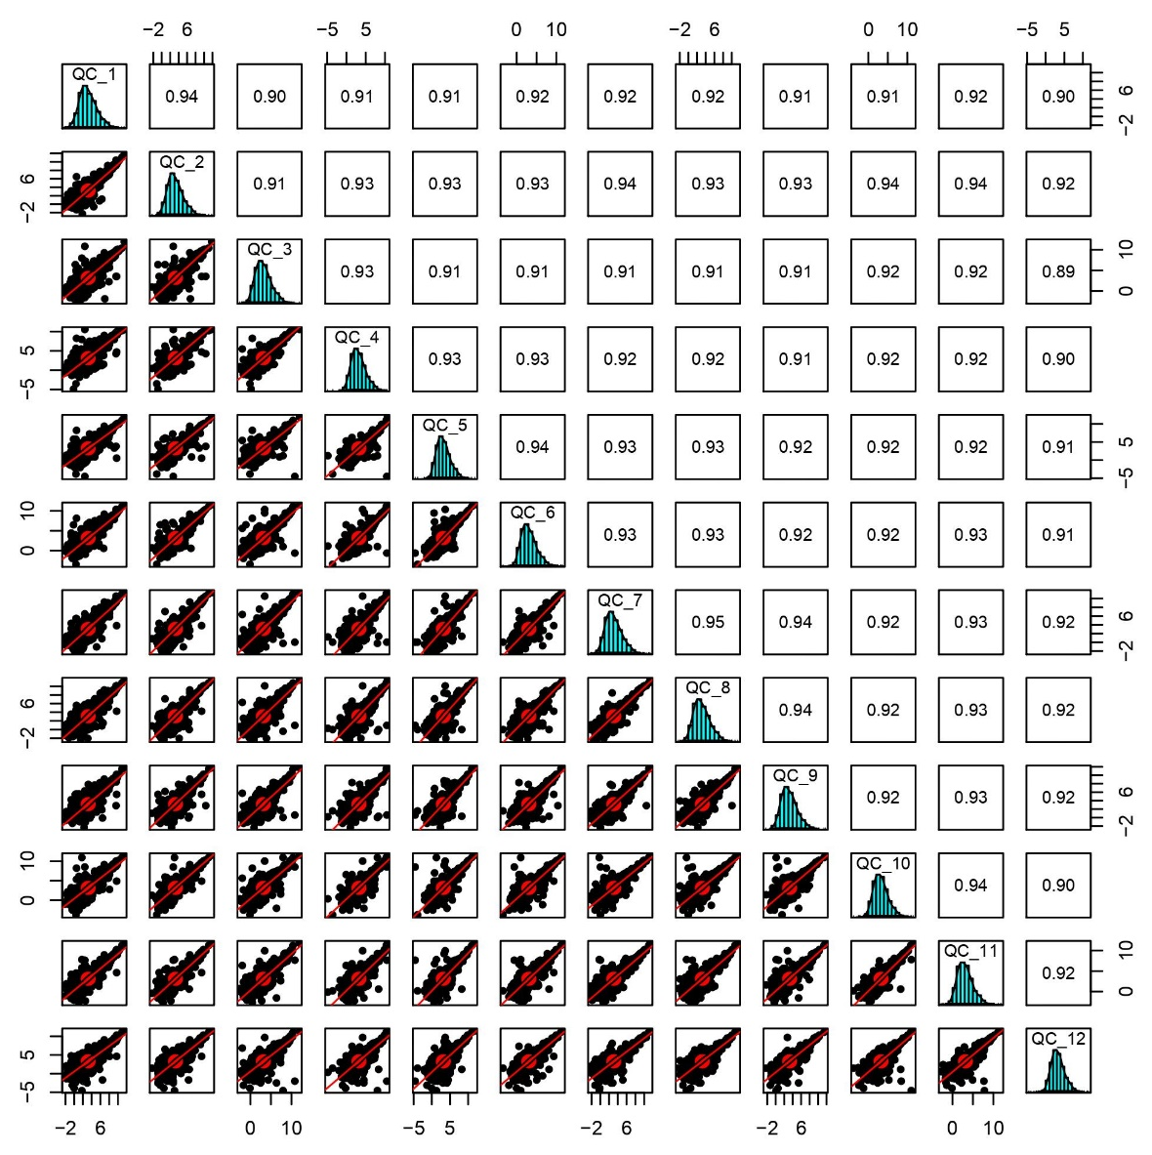
Figure S1: Spearman’s correlation coefficients from QCs samples to assess the experiment reproducibility of control and ESCC groups. The lower-left half shows pairwise scatter plots of biological repeats. The upper-right half shows pairwise Spearman’s correlation coefficients for the same comparison.

