Supplemental Material

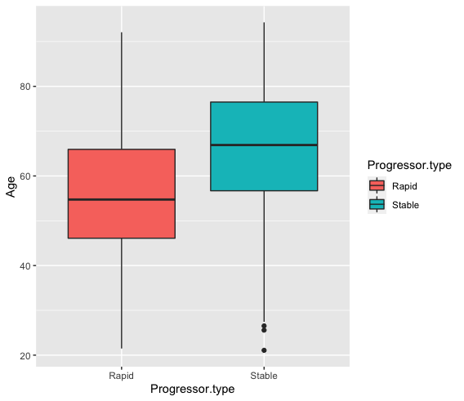
Supplementary Figure 1. Box plot comparison between rapid and stable patients and their mean age.
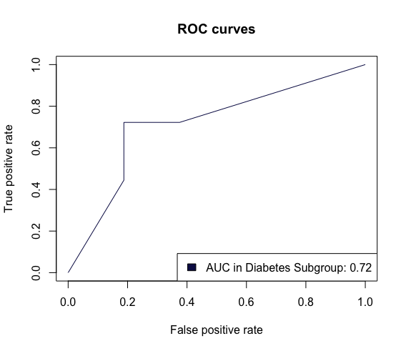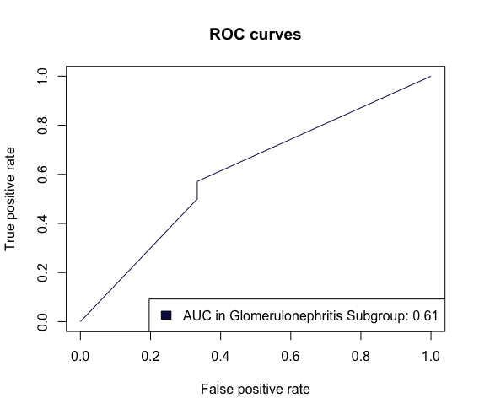
Supplementary Figure 2. ROC Curves for the model built to test performance of our potential biomarkers in patient primary disease cause subgroups (Diabetes and Glomerulonephritis).

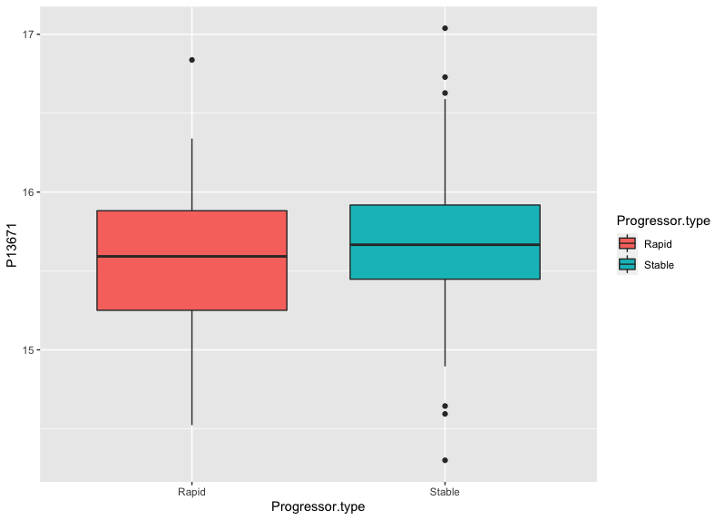
Supplementary Figure 3. Box plot comparison between rapid and stable patients and the levels of Complement 6 protein.
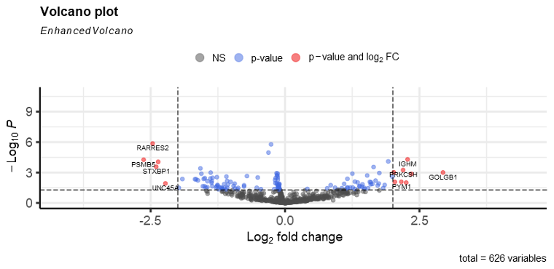
Supplementary Figure 4. Volcano Plot showing differentially expressed proteins.

Supplementary Table 1. Differential Expression Analysis Results
Uniprot ID | Name | Protein Name | logFC | AveExpr | P.Value | adj.P.Val
P00746 | CFD | Complement factor D (EC 3.4.21.46) (Adipsin) (C3 convertase activator) (Properdin factor D) | 1.25 | 13.76 | 0 | 0.04
P02766 | TTR | Transthyretin (ATTR) (Prealbumin) (TBPA) | -0.31 | 18.37 | 0 | 0
P13671 | C6 | Complement component C6 | -0.14 | 15.64 | 0 | 0.04
P14314 | PRKCSH | Glucosidase 2 subunit beta (80K-H protein) (Glucosidase II subunit beta) (Protein kinase C substrate 60.1 kDa protein heavy chain) (PKCSH) | 2.2 | 8.22 | 0 | 0.03
P29622 | SERPINA4 | Kallistatin (Kallikrein inhibitor) (Peptidase inhibitor 4) (PI-4) (Serpin A4) | -0.16 | 15.94 | 0 | 0.04
P31327 | CPS1 | Carbamoyl-phosphate synthase [ammonia], mitochondrial (EC 6.3.4.16) (Carbamoyl-phosphate synthetase I) (CPSase I) | 1.75 | 12.19 | 0 | 0.04
P32119 | PRDX2 | Peroxiredoxin-2 (EC 1.11.1.24) (Natural killer cell-enhancing factor B) (NKEF-B) (PRP) (Thiol-specific antioxidant protein) (TSA) (Thioredoxin peroxidase 1) (Thioredoxin-dependent peroxide reductase 1) (Thioredoxin-dependent peroxiredoxin 2) | -1.56 | 7.61 | 0 | 0.04
P43121 | MCAM | Cell surface glycoprotein MUC18 (Cell surface glycoprotein P1H12) (Melanoma cell adhesion molecule) (Melanoma-associated antigen A32) (Melanoma-associated antigen MUC18) (S-endo 1 endothelial-associated antigen) (CD antigen CD146) | -1.38 | 6.95 | 0 | 0.04
P43652 | AFM | Afamin (Alpha-albumin) (Alpha-Alb) | -0.26 | 18.25 | 0 | 0
P04220 | IGHM | Immunoglobulin mu heavy chain | 2.28 | 6.29 | 0 | 0.01
P21810 | BGN | Biglycan (Bone/cartilage proteoglycan I) (PG-S1) | 1.65 | 3.04 | 0 | 0.02
P50991 | CCT4 | T-complex protein 1 subunit delta (TCP-1-delta) (CCT-delta) (Stimulator of TAR RNA-binding) | 1.92 | 14.66 | 0 | 0.01
P61764 | STXBP1 | Syntaxin-binding protein 1 (MUNC18-1) (N-Sec1) (Protein unc-18 homolog 1) (Unc18-1) (Protein unc-18 homolog A) (Unc-18A) (p67) | -2.4 | 8.25 | 0 | 0.02
Q86WR0 | CCDC25 | Coiled-coil domain-containing protein 25 | 2.35 | 12.07 | 0 | 0.04
P28074 | PSMB5 | Proteasome subunit beta type-5 (EC 3.4.25.1) (Macropain epsilon chain) (Multicatalytic endopeptidase complex epsilon chain) (Proteasome chain 6) (Proteasome epsilon chain) (Proteasome subunit MB1) (Proteasome subunit X) | -2.63 | 6.62 | 0 | 0.01
Q99969 | RARRES2 | Retinoic acid receptor responder protein 2 (Chemerin) (RAR-responsive protein TIG2) (Tazarotene-induced gene 2 protein) | -2.46 | 3.98 | 0 | 0
Q9H0W9 | C11orf54 | Ester hydrolase C11orf54 (EC 3.1) | -2.36 | 11.34 | 0 | 0.01
O00203 | AP3B1 | AP-3 complex subunit beta-1 (Adaptor protein complex AP-3 subunit beta-1) (Adaptor-related protein complex 3 subunit beta-1) (Beta-3A-adaptin) (Clathrin assembly protein complex 3 beta-1 large chain) | 2.02 | 4.68 | 0 | 0.04
Q14789 | GOLGB1 | Golgin subfamily B member 1 (372 kDa Golgi complex-associated protein) (GCP372) (Giantin) (Macrogolgin) | 2.94 | 5.69 | 0 | 0.04
Q14515 | SPARCL1 | SPARC-like protein 1 (High endothelial venule protein) (Hevin) (MAST 9) | -1.57 | 2.76 | 0 | 0.02

Supplementary Table 2. Primary Disease Causes Code and Number of patients.
Code | Occurrences | Disease | Rapid | Stable
80 | 83 | Diabetes Type 1 and 2 | 37 | 46
1 | 52 | Aetiology Uncertain | 13 | 39
41 | 47 | Polycystic Kidneys - Adult Type (Dominant) | 43 | 4
72 | 39 | Renal Vascular Disease due to Hypertension | 15 | 24
12* | 30 (12+ 18) | IgA Nephropathy (Proven by Immunofluorescence) | 20 | 29
14* | 10 ( 5 + 5) | Membranous nephropathy | 20 | 29
17* | 9 ( 3 + 6 ) | Focal segmental glomerulosclerosis with nephrotic syndrome in adults | 20 | 29

Supplementary Table 3. P-values of T-test to determine if there is a significant difference between the means of our two progression type groups.
Protein | Name | All Data | Diabetes Subgroup | Glomerulonephritis Subgroup
P43652 | AFM | 1.17E-06 | 0.002137 | 0.1222
P50991 | CCT4 | 2.02E-06 | 0.01577 | 0.02467
P02766 | TTR | 4.34E-06 | 0.001264 | 0.8743
Q01581 | HMGCS1 | 3.41E-05 | 0.161 | 0.01355
Q86WR0 | CCDC25 | 0.000359 | 0.1188 | 0.3269
P30041 | PRDX6 | 0.000767 | 0.0003521 | 0.5016
P13671 | C6 | 0.000874 | 0.001816 | 0.1061
P02745 | C1QA | 0.002353 | 0.04061 | 0.01075
P01031 | C5 | 0.002964 | 0.03112 | 0.6577
P20851 | C4BPB | 0.003314 | 0.4325 | 0.0608
P61106 | RAB14 | 0.006154 | 0.099 | 0.2636
P02747 | C1QC | 0.007985 | 0.1605 | 0.01463
P09871 | C1S | 0.008341 | 0.209 | 0.254
Q9Y3I0 | RTCB | 0.01516 | 0.4865 | 0.2226
O00299 | CLIC1 | 0.02676 | 0.01966 | 0.4435
P40925 | MDH1 | 0.03221 | 0.03796 | 0.6193
P20618 | PSMB1 | 0.08305 | 0.3994 | 0.4333
P31943 | HNRNPH1 | 0.09314 | 0.8142 | 0.09947
P13667 | PDIA4 | 0.09562 | 0.499 | 0.2845
P08670 | VIM | 0.1001 | 0.313 | 0.6069
P28074 | PSMB5 | 0.1079 | 0.3993 | 0.5525
P19320 | VCAM1 | 0.2409 | 0.7077 | 0.188
Q99969 | RARRES2 | 0.2459 | 0.2912 | 0.9375
Q8NC51 | SERBP1 | 0.3168 | 0.7461 | 0.426
P07942 | LAMB1 | 0.4828 | 0.007224 | 0.3581
P21810 | BGN | 0.5134 | 0.7713 | 0.5041
P04220 | IGHM | 0.8837 | 0.9102 | 0.3836
P52566 | ARHGDIB | 0.9325 | 0.08171 | 0.3978

Supplementary Table 4. Functional Annotation Chart for enrichment analysis with the Database for Annotation, Visualisation and Integrated Discovery (DAVID)

Category | Term | Count | % | P-Value
KEGG_PATHWAY | Complement and coagulation cascades | 3 | 12.5 | 0.0091
KEGG_PATHWAY | Prion disease | 4 | 16.7 | 0.01
KEGG_PATHWAY | Proteasome | 2 | 8.3 | 0.077

