Supporting Information
Development of a Rapid and Specific MALDI-TOF Mass Spectrometric Assay for SARS-CoV-2 Detection
Lydia Kollhoff^{1,2}, Marc Kipping^{1,2}, Manfred Rauh³, Uta Ceglarek⁴, Günes Barka⁵, Frederik Barka⁵, Andrea Sinz^{1,2*}
¹Department of Pharmaceutical Chemistry and Bioanalytics, Martin Luther University Halle-Wittenberg, Halle (Saale), Germany; ²Center for Structural Mass Spectrometry, Martin Luther University Halle-Wittenberg, Halle (Saale), Germany; ³Department of Pediatrics and Adolescent Medicine, Friedrich Alexander University Erlangen-Nürnberg, Germany; ⁴Institute for Laboratory Medicine, Clinical Chemistry and Molecular Diagnostics, University of Leipzig, Leipzig, Germany; ⁵SunChrom Wissenschaftliche Geräte GmbH, 61381 Friedrichsdorf, Germany

*Address correspondence to: andrea.sinz@pharmazie.uni-halle.de
Department of Pharmaceutical Chemistry and Bioanalytics, Center for Structural Mass Spectrometry, Martin Luther University Halle-Wittenberg, Kurt-Mothes-Str. 3, D-06120 Halle (Saale), Germany

Table of Contents
Table S1. LC-MS/MS MRM (multiple reaction monitoring) method settings using the SARS-CoV-2 LC-MS Kit (RUO, Waters Corp).
Figure S1. MALDI-TOF mass spectrum of tryptic peptides from SARS-CoV-2 nucleoprotein.
Figure S2. MALDI-TOF mass spectrum of peptides C and D (antibody-enriched) from SARS-CoV-2 nucleoprotein.
Figure S3. MALDI-TOF mass spectrum of peptides A and C (antibody-enriched) from SARS-CoV-2 nucleoprotein, spiked into Cobas PCR Medium.
Figure S4. Comparison of SARS-CoV-2 quantification with peptides SIL-A and SIL-C.

Table S1. LC-MS/MS MRM (multiple reaction monitoring) method settings.

Peptide | MRM |  | Cone (V) | Collison (V) | Retention Time (min) | Scan Window (min)
D | 564.8>400.2 | Quantifier | 35 | 19 | 1.24 | 0-5.0
 | 564.8>584.4 | Qualifier | 35 | 20 | 1.24 | 0-5.0
 | 564.8>712.4 | Qualifier | 35 | 24 | 1.24 | 0-5.0
C | 563.8>679.4 | Quantifier | 35 | 19 | 1.93 | 0-5.0
 | 563.8>578.3 | Qualifier | 35 | 18 | 1.93 | 0-5.0
 | 563.8>892.5 | Qualifier | 35 | 19 | 1.93 | 0-5.0
B | 687.4>841.5 | Quantifier | 35 | 18 | 2.63 | 0-5.0
 | 687.4>766.4 | Qualifier | 35 | 23 | 2.63 | 0-5.0
 | 687.4>865.5 | Qualifier | 35 | 23 | 2.63 | 0-5.0
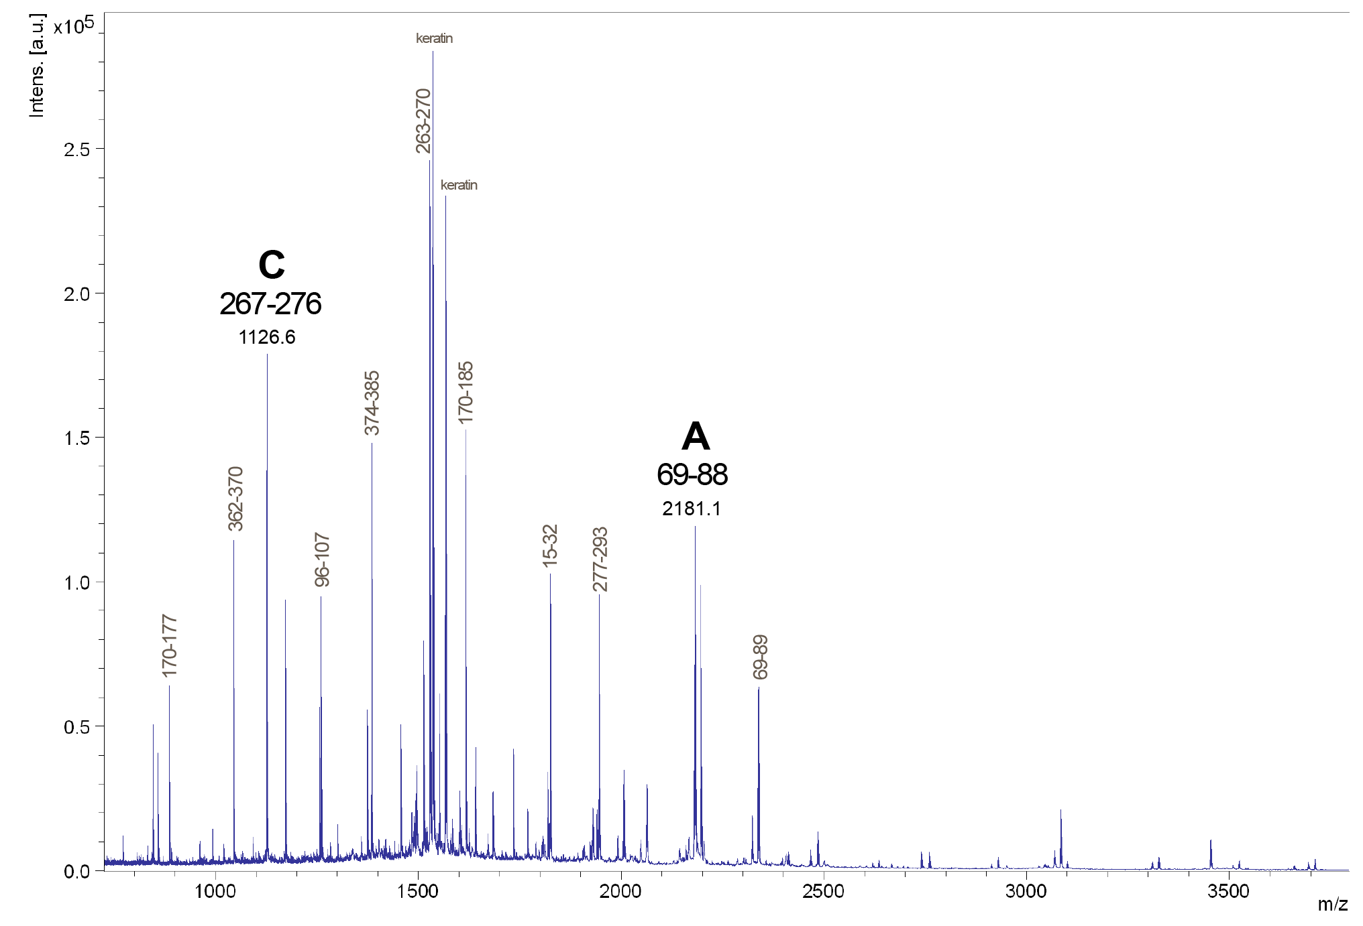
Figure S1. MALDI-TOF mass spectrum of tryptic peptides from SARS-CoV-nucleoprotein. Peptides from SARS-CoV-2 nucleoprotein are marked with their numbers in the amino acid sequence (see Figure 1). Peptides A and C are labeled.

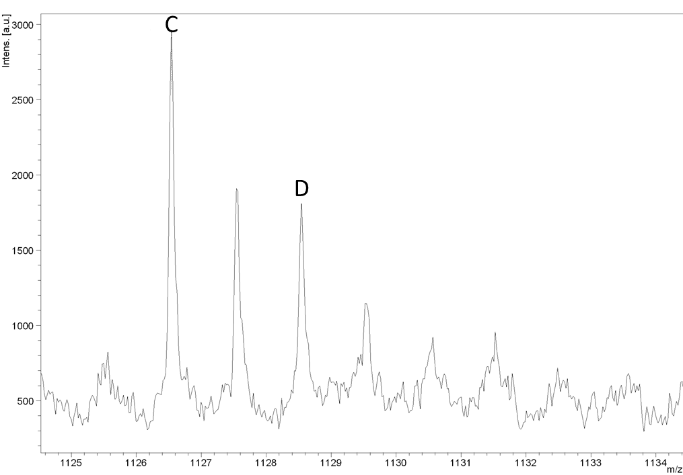
Figure S2. MALDI-TOF mass spectrum of peptides C and D (antibody-enriched) from SARS-CoV-2 nucleoprotein. Signals of peptide D (ADETQALPQR), [M+H]⁺ at m/z 1128.6 and peptide C (AYNVTQAFGR), [M+H]⁺ at m/z 1126.6 are shown enlarged.

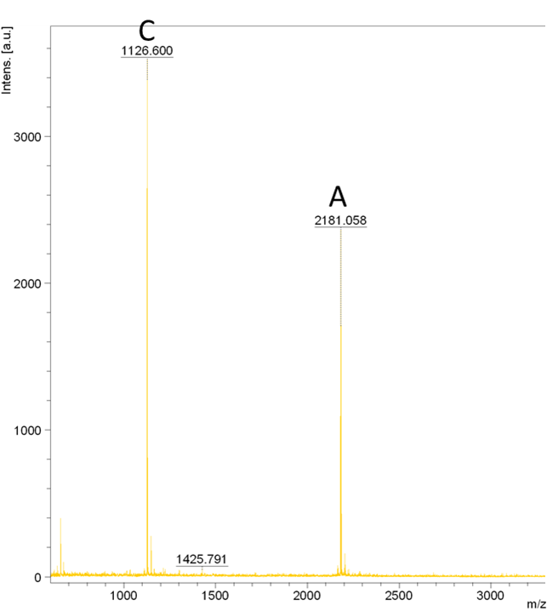
Figure S3. MALDI-TOF mass spectrum of peptides A and C (antibody-enriched) from SARS-CoV-2 nucleoprotein, spiked into Cobas PCR Medium. Peptides A and C are labeled.

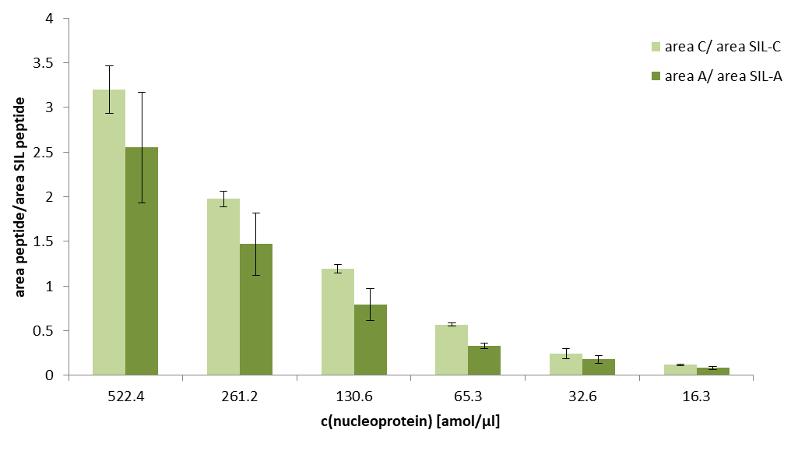
Figure S4. Comparison of SARS-CoV-2 quantification with peptides SIL-A and SIL-C. SARS-CoV-2 nucleoprotein was spiked at different concentrations (x-axis) into nasopharyngeal samples of healthy individuals (n=3). Samples were processed according to the workflow described in Figure 2 using MALDI-TOF-MS detection of peptides.

