Supplementary Figure 1
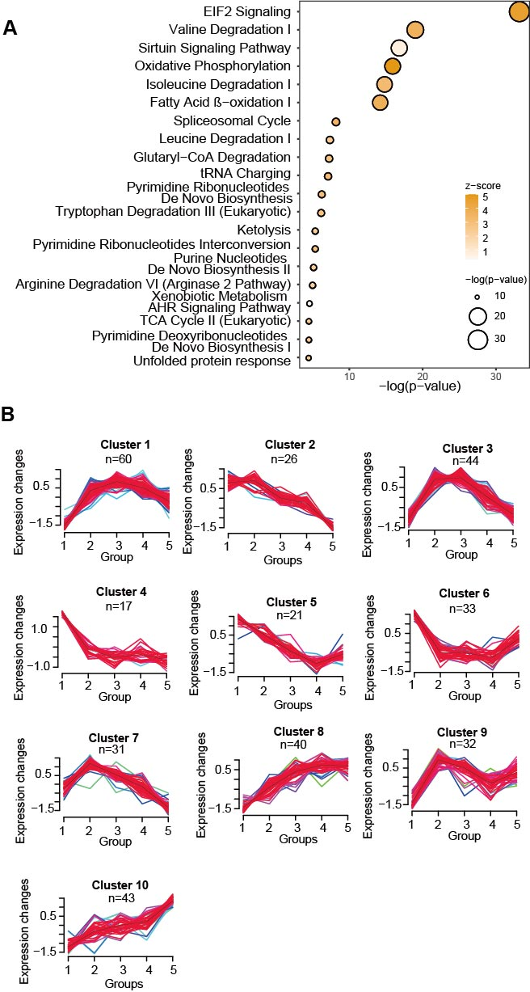
Figure S1. Differentially expressed proteins. (A) Pathway enrichment of the dysregulated proteins from comparing tumor and adjacent benign samples (B-H adjusted P-value < 0.05) from STRING(43) (P-value < 0.05). (B) Mfuzz clustering analysis of protein expression across the different groups (One-way ANOVA, B-H adjusted P-value < 0.05).

Supplementary Figure 2
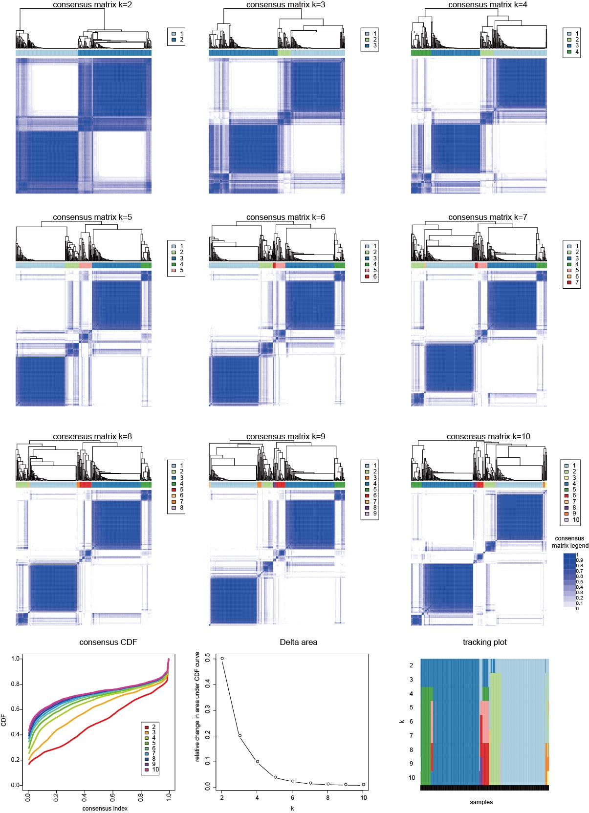
Figure S2. Consensus clustering of the proteomic data. The subgroups are identified based on proteomic data by K-means consensus clustering upon their abundance.

Supplementary Figure 3
Figure S3. Genomic analysis for the proteomic pathway-based subtypes. (A) The genomic alterations in the seven pathways were compared among the three clusters of proteomic-pathway-based subtypes, including gene mutation frequency (green), amplification frequency (red), and deletion frequency (blue). (B) Sankey diagrams for the mutation frequencies of the genes showing significant P-value (P<0.05) in the comparison between all possible pairs between the two subtypes. The color of the gene name represents the subtype where each gene shows the highest mutation frequency. ANOVA P-value: * <0.05; ** <0.01; *** <0.001.

