Additional file 1: Figure S1. Survival rate between immune subtypes in the total cohort and TNBC cohort. (a) OS in three immune subtypes (p=.666) in the total cohort. (b) OS in two immune groups in the total cohort (p=.440). (c) RFS in three immune subtypes in the total cohort (p=.795). (d) RFS in two immune groups in the total cohort (p=.776). (e) OS in three immune subtypes (p=.777) in the TNBC cohort. (f) OS in two immune groups in the TNBC cohort (p=.930). (g) RFS in three immune subtypes in the TNBC cohort (p=.630). (h) RFS in two immune groups in the TNBC cohort (p=.820).
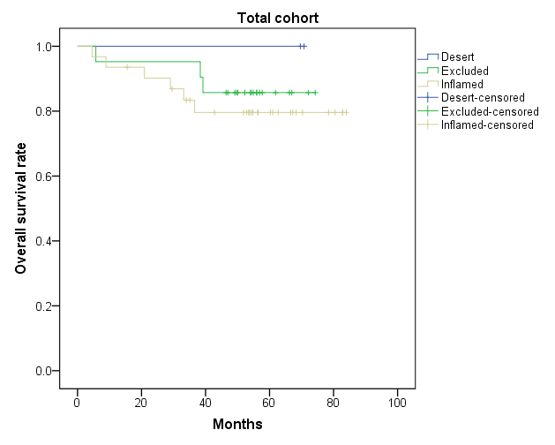
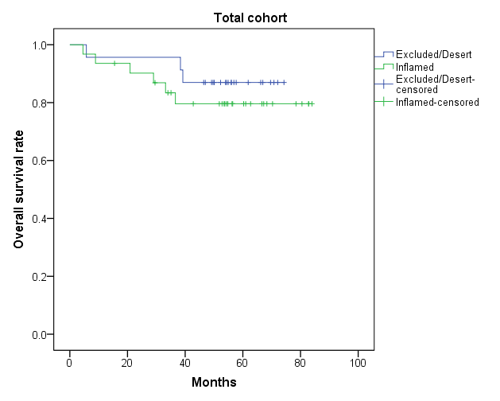
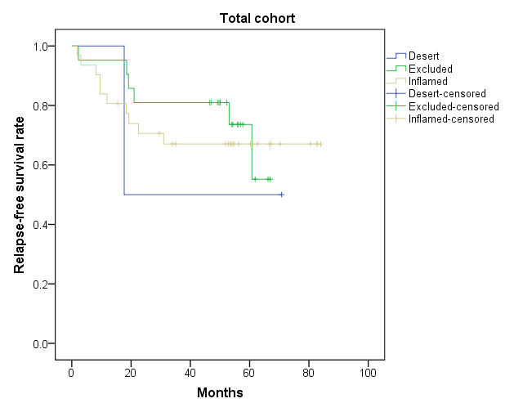
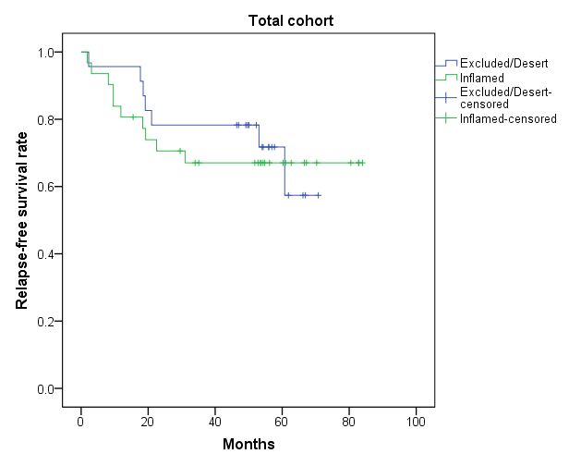
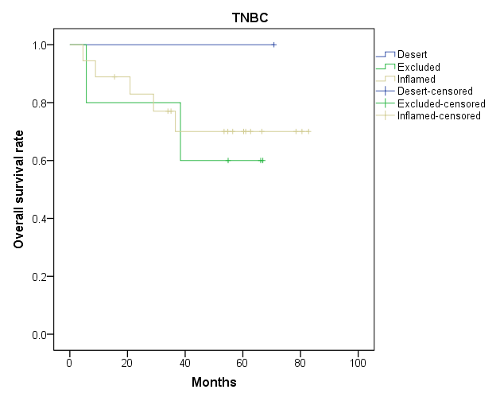
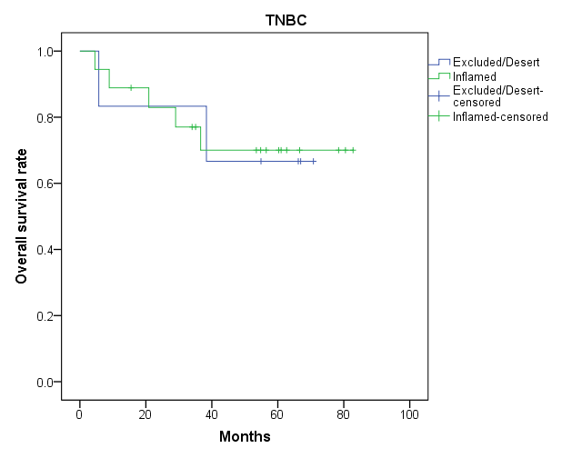
A
B
C
D
E
F
p=.666
p=.440
p=.795
p=.776
p=.777
p=.930
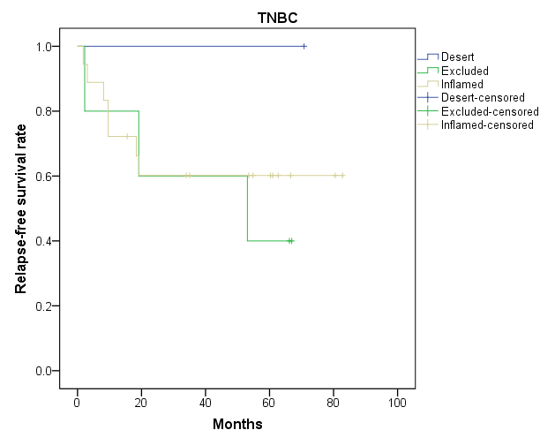
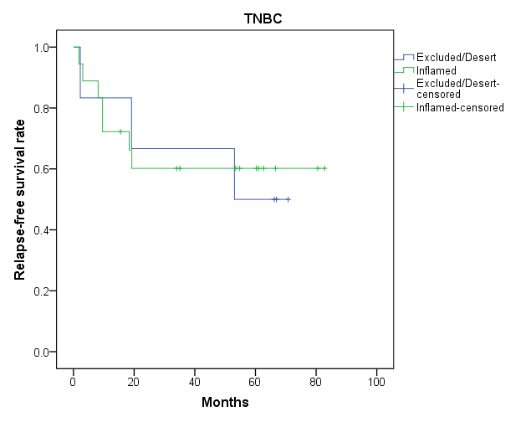
G
H
p=.630
p=.820

