Supplementary materials

Supplementary methods
1. Untargeted metabolomics assay of urine specimens
1.1 Urine sample preparation
All urine samples were used for metabolomics analysis. Quality control (QC) samples were applied by mixing equal amounts of all samples to ensure data quality for metabolic profiling. Samples (100 µL) were thoroughly mixed with 400 µL of cold methanol acetonitrile (v/v, 1:1) via vortexing. After sonication for 1 h in ice baths, the mixture was then incubated at -20°C for 1 h and centrifuged at 14, 000 g for 20 min at 4 °C. The supernatants were then harvested and dried under vacuum LC-MS analysis.
1.2 UHPLC-MS/MS analysis
Metabolomics profiling was analyzed using a UPLC-ESI-Q-Orbitrap-MS system (UHPLC, Shimadzu Nexera X2 LC-30AD， Shimadzu，Japan) coupled with Q-Exactive Plus (Thermo Scientific, San Jose, USA). For liquid chromatography (LC) separation, samples were analyzed using a ACQUITY UPLC® HSS T3 column （2.1×100 mm, 1.8μm）(Waters, Milford, MA, USA). The flow rate was 0.3 mL/min and the mobile phase contained: A: 0.1% FA in water and B: 100% acetonitrile (ACN). The gradient was 0% buffer B for 2 min and was linearly increase to 48% in 4 min, and then up to 100% in4 min and maintained for 2 min, and then decreased to 0% buffer B in 0.1 min, with 3 min re-equilibration period employed. The electrospray ionization (ESI) with positive-mode and negative mode were applied for MS data acquisition separately. The HESI source conditions were set as follows: Spray Voltage：3.8kv (positive) and 3.2kv (negative)；Capillary Temperature：320 ℃; Sheath Gas (nitrogen) flow: 30 arb (arbitrary units); Aux Gas flow: 5 arb; Probe Heater Temp: 350 ℃; S-Lens RF Level：50. The instrument was set to acquire over the m/z range 70-1050 Da for full MS. The full MS scans were acquired at a resolution of 70,000 at m/z 200, and 17,500 at m/z 200 for MS/MS scan. The maximum injection time was set to for 100 ms for MS and 50 ms for MS/MS. The isolation window for MS2 was set to 2 m/z and the normalized collision energy (stepped) was set as 20, 30 and 40 for fragmentation.
1.3 Data preprocessing and filtering
Quality control (QC) samples were prepared by pooling aliquots of all samples that were representative of the samples under analysis, and used for data normalization, Blank samples (75%ACN in water) and QC samples were injected every six samples during acquisition. The raw MS data were processed using MS-DIAL for peak alignment, retention time correction and peak area extraction. The metabolites were identified by accuracy mass (mass tolerance < 10 ppm) and MS/MS data (mass tolerance < 0.02Da) which were matched with HMDB, MassBank and other public databases and our self-built metabolite standard library. In the extracted-ion features, only the variables having more than 50% of the nonzero measurement values in at least one group were kept.
1.4 Multivariate statistical analysis
R(version:4.0.3) and R packages were used for all multivariate data analyses and modeling. Data were mean-centered using Pareto scaling. Models were built on principal component analysis (PCA), orthogonal partial least-square discriminant analysis (PLS-DA) and partial least-square discriminant analysis (OPLS-DA). All the models evaluated were tested for over fitting with methods of permutation tests. The discriminating metabolites were obtained using a statistically significant threshold of variable influence on projection (VIP) values obtained from the OPLS-DA model and two-tailed Student’s t test (p value) on the normalized raw data at univariate analysis level. The p value was calculated by one-way analysis of variance (ANOVA) for multiple groups analysis. Statistically significant differentially abundant metabolites (DAMs) were identified using the following criteria: VIP>1, and p < 0.05. Fold change was calculated as the logarithm of the average mass response (area) ratio between two arbitrary classes. On the other side, the identified differential metabolites were used to perform cluster analyses with R package.
2. Proteomic analysis of urine specimens
2.1 Protein Digestion and High-pH Reverse-phase Fractionation
Protein was extracted from urine samples using SDT lysis buffer (4% SDS, 100 mM DTT, 100 mM Tris-HCl pH 8.0). The supernatant was collected and quantified with a BCA Protein Assay Kit (BeyoTime, China). Protein digestion was performed using FASP methods, and detergent, DTT and IAA in UA buffer was added to block reduced cysteine. The protein suspension was digested with trypsin (Promega) at ratio 50:1 overnight at 37℃. The peptide mixtures were collected by centrifugation at 16 000g for 15 min and desalted with C18 StageTip for further LC-MS analysis. The concentrations of re-dissolved peptides were determined with OD280 by Nanodrop One device (Thermo, USA). Pooled peptide mixture form each sample were fractionated using a Waters XBridge BEH130 column (C18, 3.5μm, 2.1×150 mm) on an Agilent 1260 high-performance liquid chromatographer (HPLC) operating at 0.3 mL/min. A total of 60 fractions were collected for each peptide mixture and then pooled to 20. Each fraction was dried for nano LC-MS/MS analysis.
2.2 LC-MS/MS Analysis for DDA (Data-dependent Acquisition)
Peptide from HPRP fraction was first spiked with iRT standard peptides (Biognosys AG, Switzerland) and separated using reverse-phase high-performance liquid chromatography (RP-HPLC) on EASY- nLC system (Thermo Fisher Scientific, Bremen, Germany). The RP−HPLC mobile phase A was 0.1% formic acid in water, and B was 0.1% formic acid in 95% acetonitrile. Peptide were eluted over 120 min with a linear gradient of buffer B. The eluted peptides were analyzed on a Q Exactive HF-X mass spectrometer. MS data was acquired using a data-dependent top20 method dynamically choosing the most abundant precursor ions from the survey scan (350–1500 m/z) for HCD fragmentation. The instrument was run with peptide recognition mode enabled.
2.3 LC-MS/MS Analysis for DIA (Data-independent Acquisition)
Peptides from each sample were spiked with iRT equally and separately. LC-MS/MS were also performed on a Q Exactive HF-X mass spectrometer coupled with Easy 1200 nLC (Thermo Fisher Scientific). The LC condition was set as the same as DDA method above. The spectra of full MS scan and DIA scan were recorded in profile and centroid type respectively.
2.4 Sequence Database Searching
The DDA MS data were analyzed using MaxQuant software version 1.6.0.16. MS data were searched against the Uniprot-Homo sapiens (Human) [9606]-207393-20221227.fast(207393 total entries, downloaded 12/2022) spiked in protein consisted with 11 iRT peptide sequences. The trypsin was selected as digestion enzyme. The maximal two missed cleavage sites and the mass tolerance of 4.5 ppm for precursor ions and 20 ppm for fragment ions were defined for database search. Carbamidomethylation of cysteines was defined as fixed modification, while acetylation of protein N-terminal, oxidation of Methionine was set as variable modifications for database searching. The database search results were filtered and exported with <1% false discovery rate (FDR) at peptide-spectrum-matched level, and protein level, respectively.
2.5 DIA Raw Data analysis
The DIA MS data were analyzed with Spectronaut pulsar X (Biognosys AG, Switzerland). The Spectronaut was used for a spectral library generation from Maxquant search results. The Spectronaut search were set as the default settings and the dynamic iRT was used for retention time prediction. The interference correction for MS/MS scan was enabled. The results were exported with <1% FDR at peptide level. Differentially abundance proteins (DAPs) were analyzed by MS stats with linear mixed-effects models, and significant DAPs were considered with the conditions of |fold change| >1.5 and p value < 0.05.

Supplementary figures
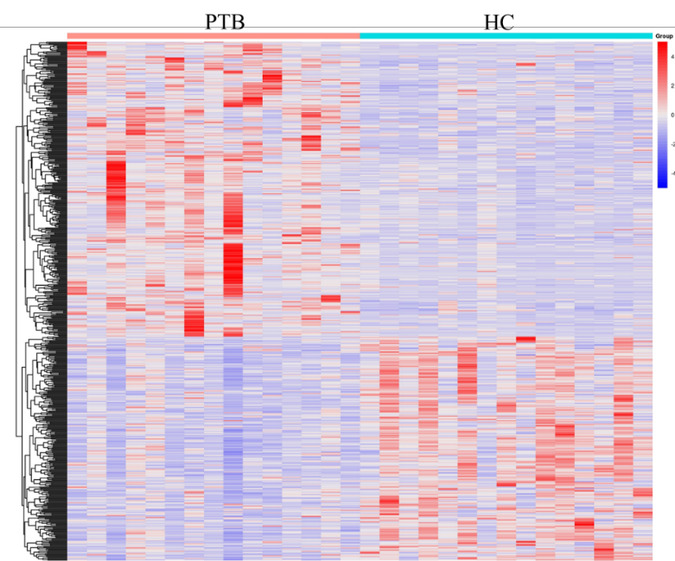
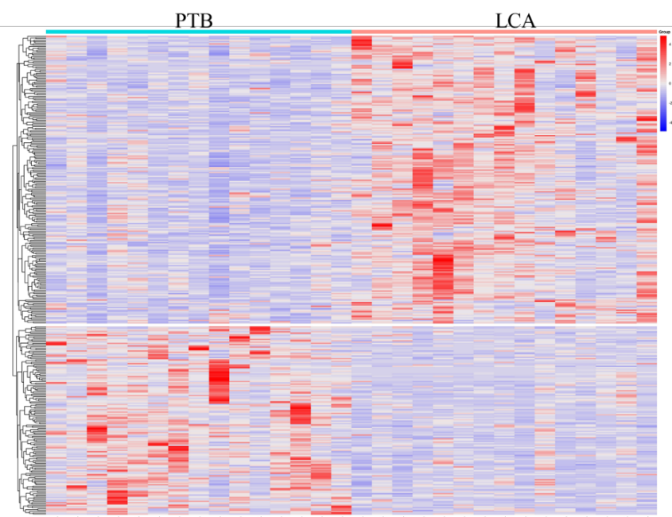
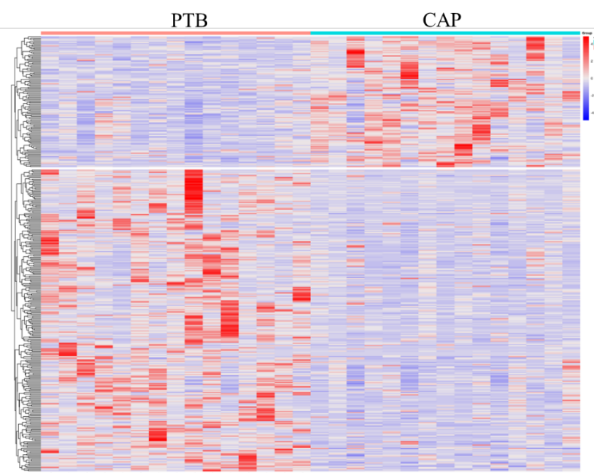
Supplementary Figure S1: Heatmap of the proteomics data for each pairwise comparison.
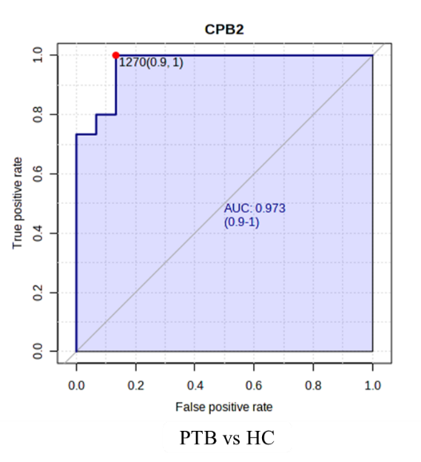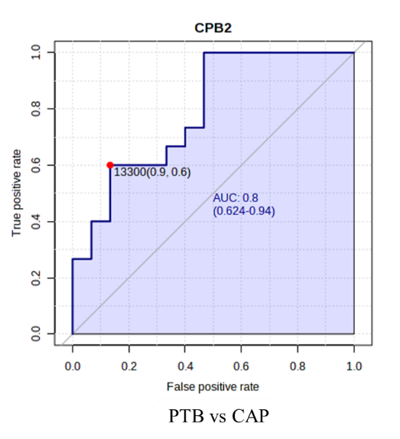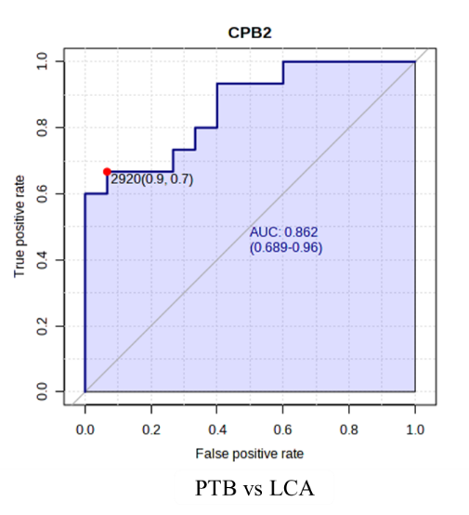
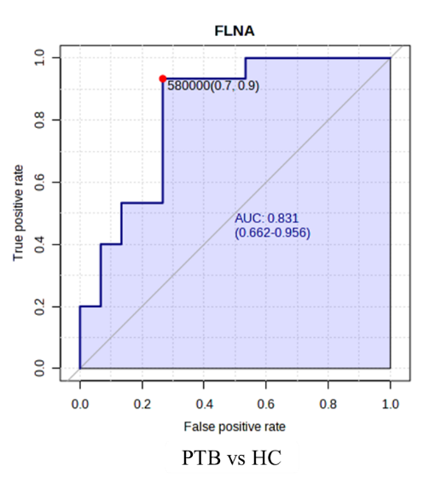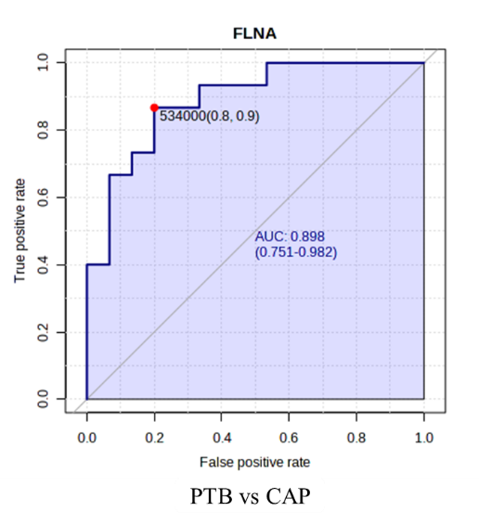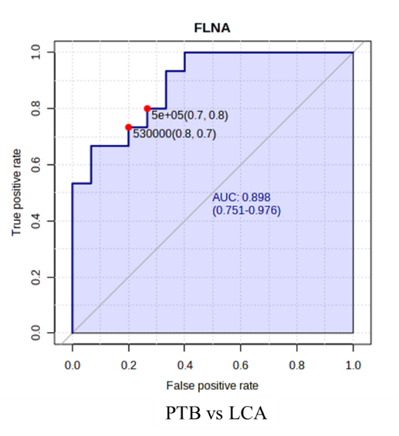
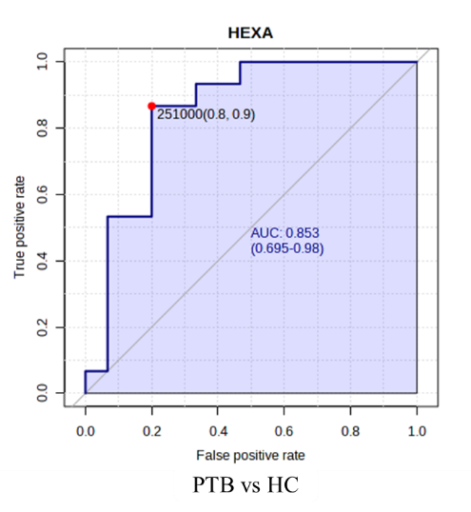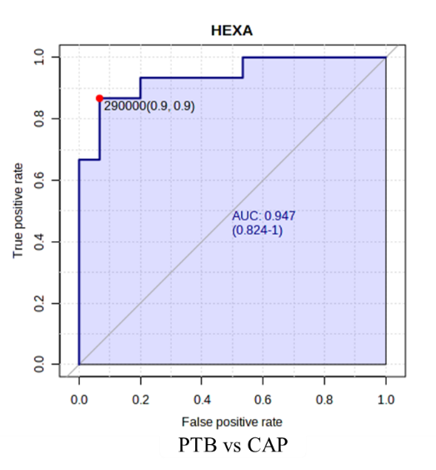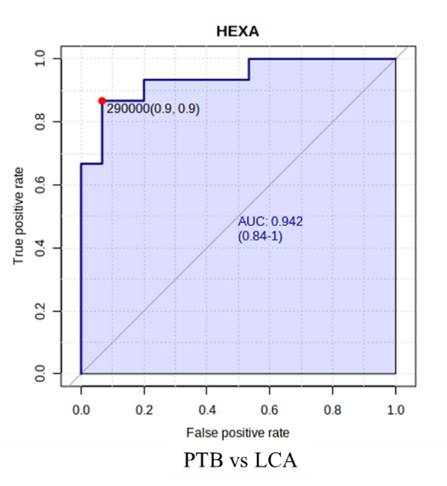
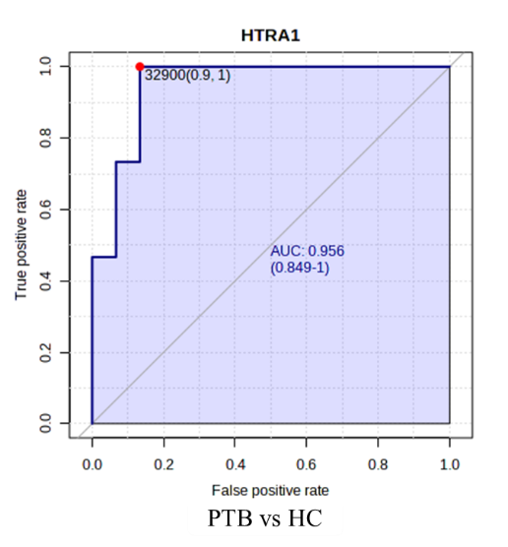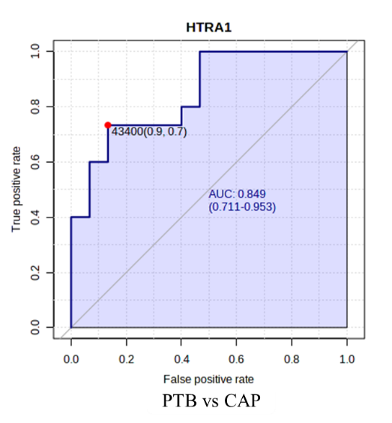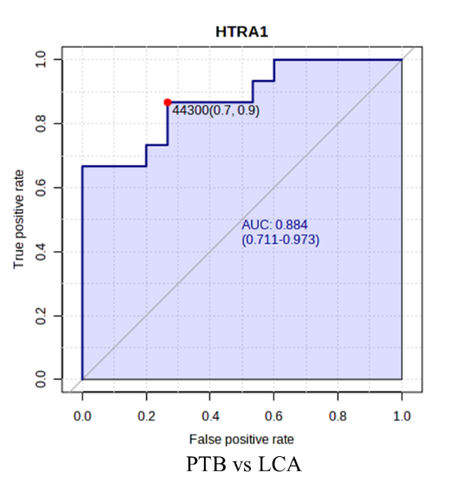
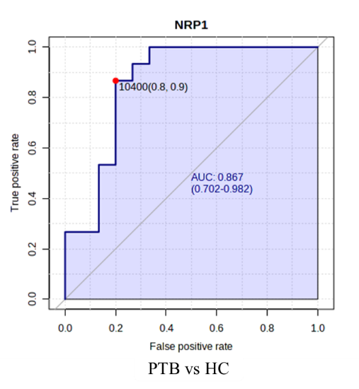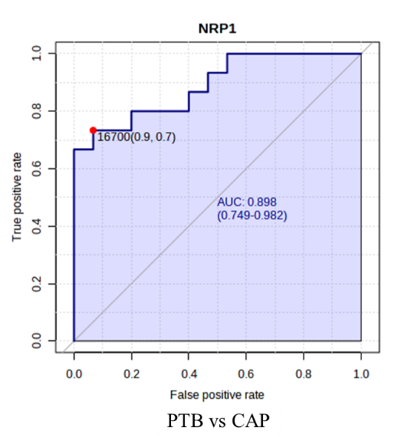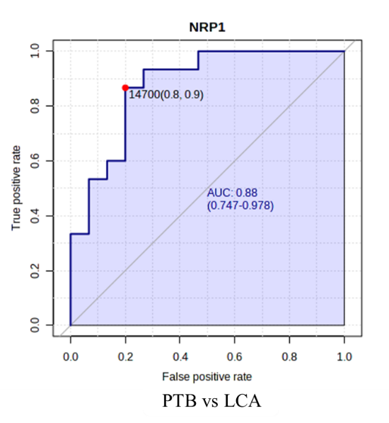
Supplementary Figure S2: The area under curve (AUC) value of five DAPs based on the ROC analysis.

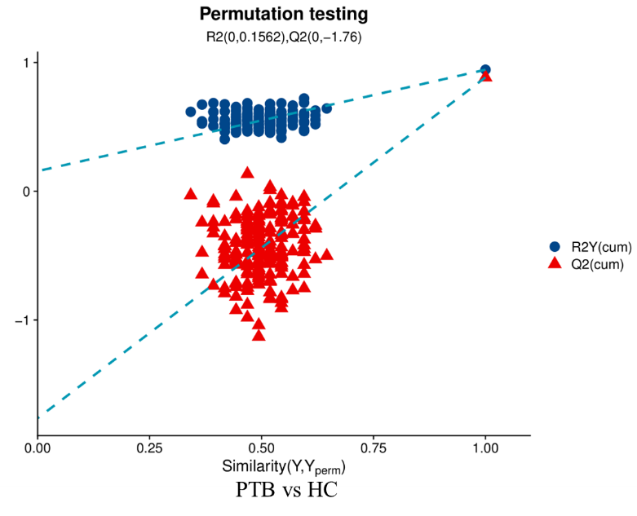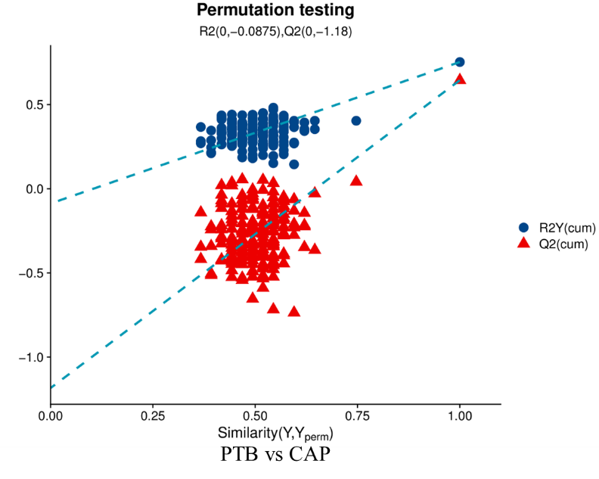
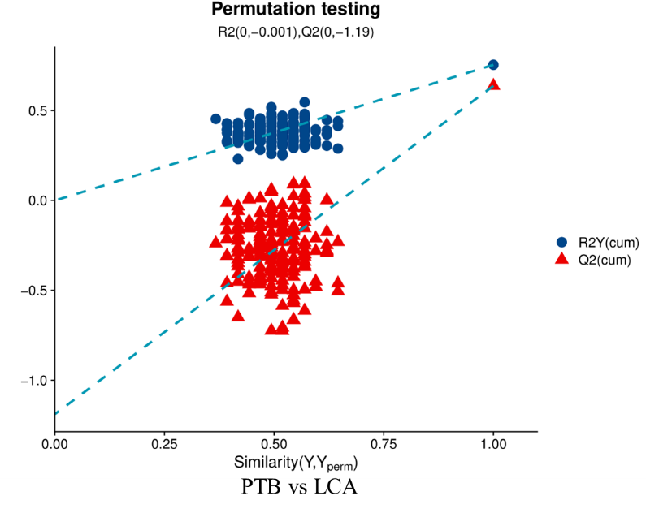
Supplementary Figure S3: Validation model of permutation test for group PTB/HC, PTB/CAP and PTB/LCA

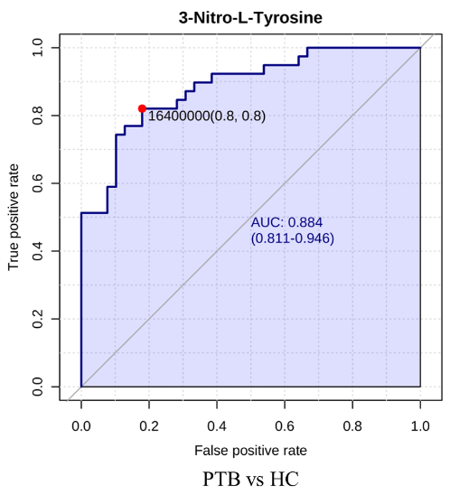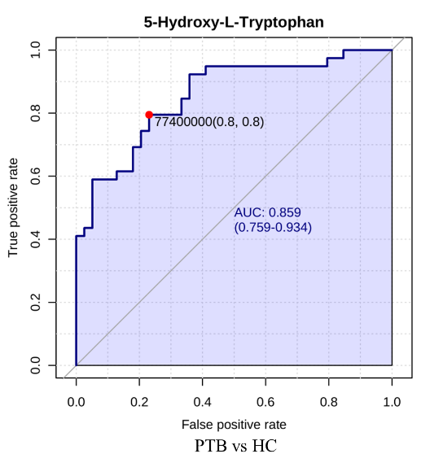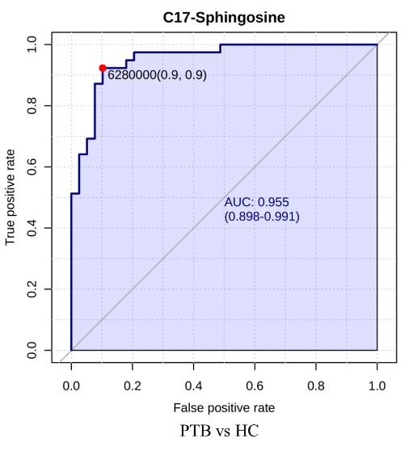
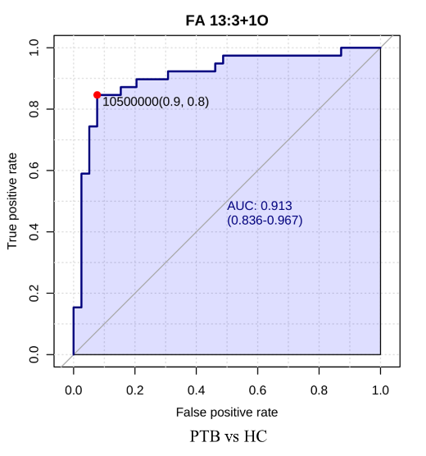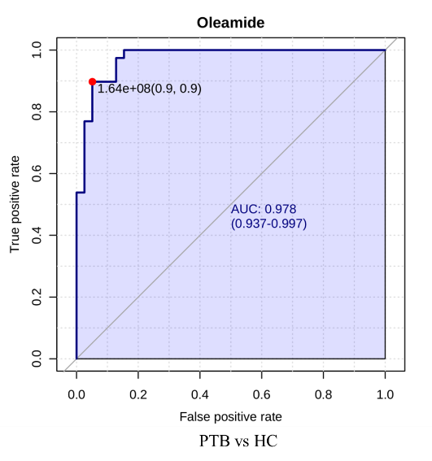
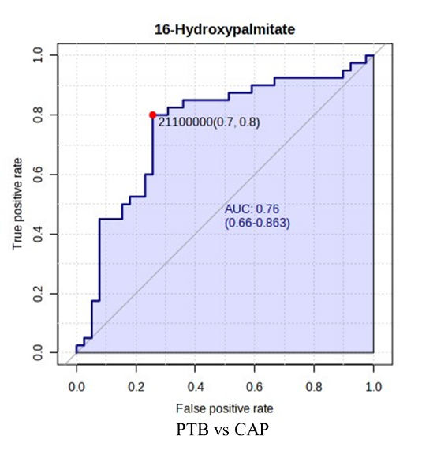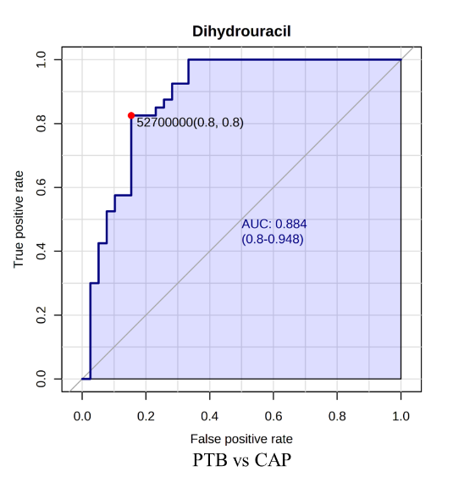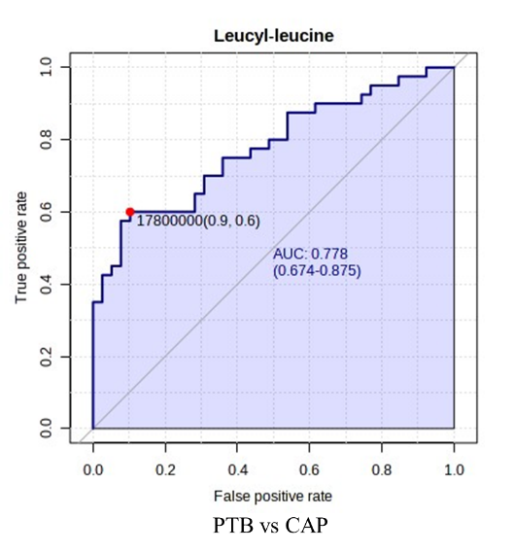
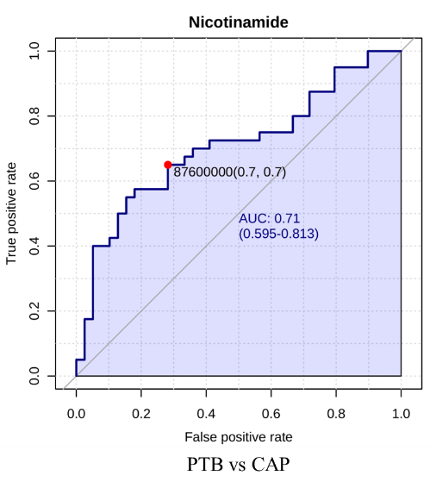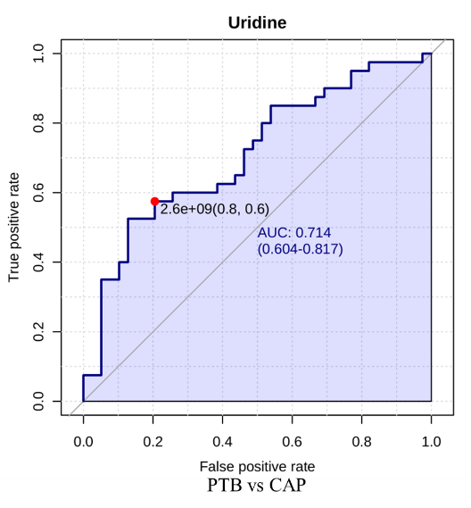
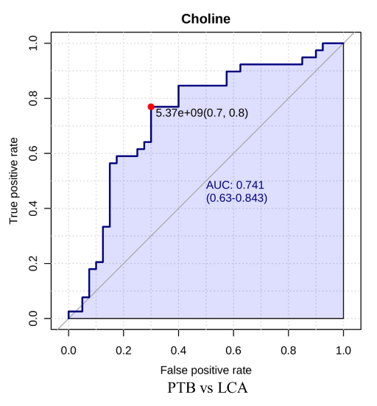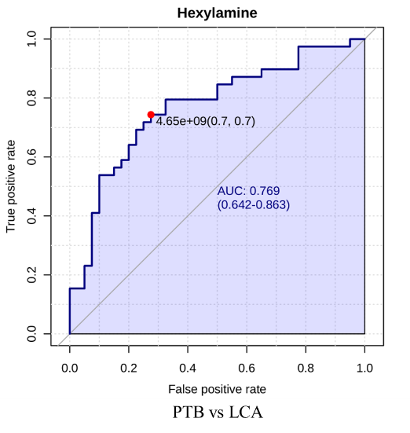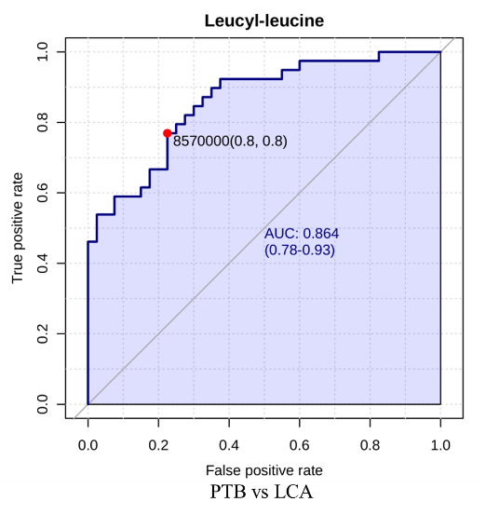
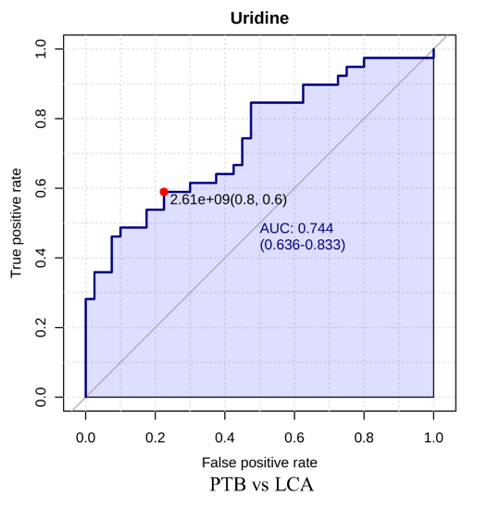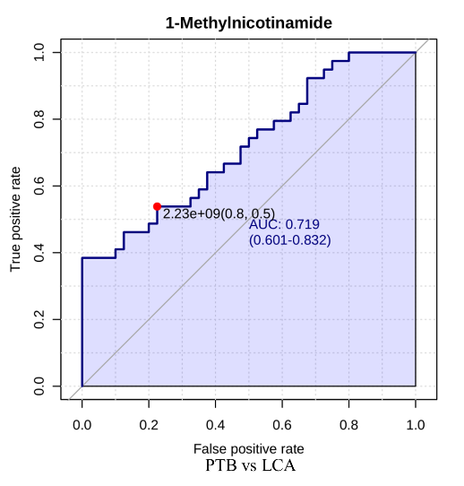
Supplementary Figure S4. ROC curves of selected five endogenous DAMs for group PTB/HC, PTB/CAP and PTB/LCA

Supplementary tables
Supplementary Table S1. 88 DAPs
NO. | Accession | Gene Symbol | Protein name
1 | A0A024QZZ9 | hCG_1979341 | HCG1979341, isoform CRA_a
2 | Q16620 | NTRK2 | BDNF/NT-3 growth factors receptor
3 | P61313 | RPL15 | 60S ribosomal protein L15
4 | Q8N114 | SHISA5 | Protein shisa-5
5 | P49789 | FHIT | Bis(5'-adenosyl)-triphosphatase
6 | O43813 | LANCL1 | Glutathione S-transferase LANCL1
7 | P36957 | DLST | Dihydrolipoyllysine-residue succinyltransferase component of 2-oxoglutarate dehydrogenase complex, mitochondrial
8 | P05154 | SERPINA5 | Plasma serine protease inhibitor
9 | P13284 | IFI30 | Gamma-interferon-inducible lysosomal thiol reductase
10 | O75348 | ATP6V1G1 | V-type proton ATPase subunit G 1
11 | A0A024R884 | TNC | Tenascin C (Hexabrachion), isoform CRA_a
12 | Q86TH1 | ADAMTSL2 | ADAMTS-like protein 2
13 | P10253 | GAA | Lysosomal alpha-glucosidase
14 | Q92954 | PRG4 | Proteoglycan 4
15 | Q9Y646 | CPQ | Carboxypeptidase Q
16 | P10451 | SPP1 | Osteopontin
17 | Q96IY4 | CPB2 | Carboxypeptidase B2
18 | Q16363 | LAMA4 | Laminin subunit alpha-4
19 | P02649 | APOE | Apolipoprotein E
20 | P11597 | CETP | Cholesteryl ester transfer protein
21 | SLC25A4 | SLC25A4 | ADP/ATP translocase 1
22 | P49908 | SELENOP | Selenoprotein P
23 | O75787 | ATP6AP2 | Renin receptor
24 | P06858 | LPL | Lipoprotein lipase
25 | P21796 | VDAC1 | Voltage-dependent anion-selective channel protein 1
26 | Q9UKM7 | MAN1B1 | Endoplasmic reticulum mannosyl-oligosaccharide 1,2-alpha-mannosidase
27 | P14138 | EDN3 | Endothelin-3
28 | O43405 | COCH | Cochlin
29 | P35555 | FBN1 | Fibrillin-1
30 | Q9Y287 | ITM2B | Integral membrane protein 2B
31 | P06280 | GLA | Alpha-galactosidase A
32 | O43493 | TGOLN2 | Trans-Golgi network integral membrane protein 2
33 | P18850 | ATF6 | Cyclic AMP-dependent transcription factor ATF-6 alpha
34 | B4DVA7 | HEXA | Beta-hexosaminidase
35 | Q9UJF2 | RASAL2 | Ras GTPase-activating protein nGAP
36 | P00450 | CP | Ceruloplasmin
37 | O95274 | LYPD3 | Ly6/PLAUR domain-containing protein 3
38 | Q8N474 | SFRP1 | Secreted frizzled-related protein 1
39 | P35858 | IGFALS | Insulin-like growth factor-binding protein complex acid labile subunit
40 | O43155 | FLRT2 | Leucine-rich repeat transmembrane protein FLRT2
41 | P48960 | ADGRE5 | Adhesion G protein-coupled receptor E5
42 | Q6UX71 | PLXDC2 | Plexin domain-containing protein 2
43 | P23327 | HRC | Sarcoplasmic reticulum histidine-rich calcium-binding protein
44 | Q96MM7 | HS6ST2 | Heparan-sulfate 6-O-sulfotransferase 2
45 | Q9UHG3 | PCYOX1 | Prenylcysteine oxidase 1
46 | Q9UMS6 | SYNPO2 | Synaptopodin-2
47 | C9JVW0 | INAFM1 | Putative transmembrane protein INAFM1
48 | P05496 | ATP5MC1 | ATP synthase F(0) complex subunit C1, mitochondrial
49 | Q99715 | COL12A1 | Collagen alpha-1(XII) chain
50 | Q02978 | SLC25A1 | Mitochondrial 2-oxoglutarate/malate carrier protein
51 | P04004 | VTN | Vitronectin
52 | Q9GZM5 | YIPF3 | Protein YIPF3
53 | O14786 | NRP1 | Neuropilin-1
54 | Q9Y2E5 | MAN2B2 | Epididymis-specific alpha-mannosidase
55 | Q6UXB3 | LYPD2 | Ly6/PLAUR domain-containing protein 2
56 | P36941 | LTBR | Tumor necrosis factor receptor superfamily member 3
57 | H3BNI4 | ATP6V0C | V-type proton ATPase proteolipid subunit
58 | Q8N2U0 | TMEM256 | Transmembrane protein 256
59 | O00602 | FCN1 | Ficolin-1
60 | O60701 | UGDH | UDP-glucose 6-dehydrogenase
61 | P01040 | CSTA | Cystatin-A
62 | P10153 | RNASE2 | Non-secretory ribonuclease
63 | P15907 | ST6GAL1 | Beta-galactoside alpha-2,6-sialyltransferase 1
64 | P17050 | AGA | Alpha-N-acetylgalactosaminidase
65 | P21333 | FLNA | Filamin-A
66 | P23468 | PTPRD | Receptor-type tyrosine-protein phosphatase delta
67 | P25940 | COL5A3 | Collagen alpha-3(V) chain
68 | P28799 | GRN | Progranulin
69 | P54826 | GAS1 | Growth arrest-specific protein 1
70 | P98164 | LRP2 | Low-density lipoprotein receptor-related protein 2
71 | Q01151 | CD83 | CD83 antigen
72 | Q07507 | DPT | Dermatopontin
73 | Q14432 | PDE3A | cGMP-inhibited 3',5'-cyclic phosphodiesterase 3A
74 | Q16777 | H2AC20 | Histone H2A type 2-C
75 | Q1L6U9 | MSMP | Prostate-associated microseminoprotein
76 | Q9H756 | LRRC19 | Leucine-rich repeat-containing protein 19
77 | Q8IWU5 | SULF2 | Extracellular sulfatase Sulf-2
78 | Q92743 | HTRA1 | Serine protease HTRA1
79 | Q969P0 | IGSF8 | Immunoglobulin superfamily member 8
80 | Q96RW7 | HMCN1 | Hemicentin-1
81 | Q99623 | PHB2 | Prohibitin-2
82 | Q9BRT3 | MIEN1 | Migration and invasion enhancer 1
83 | Q9H6B4 | CLMP | CXADR-like membrane protein
84 | Q9HB40 | SCPEP1 | Retinoid-inducible serine carboxypeptidase
85 | Q9UHL4 | DPP7 | Dipeptidyl peptidase 2
86 | Q9UI40 | SLC24A2 | Sodium/potassium/calcium exchanger 2
87 | Q9UMX5 | NENF | Neudesin
88 | Q9Y512 | SAMM50 | Sorting and assembly machinery component 50 homolog

Supplementary Table S2. List of the 88 DAPs detailed information in PTB/HC
NO. | Accession | FC | Log₂FC | FDR | Threshold
1 | Q9UI40 | 0.352213091 | -1.50548 | 0.001294 | Down
2 | Q86TH1 | 2.352267048 | 1.234052 | 0.124096 | Up
3 | P48960 | 0.573893163 | -0.80115 | 0.107289 | Down
4 | P20933 | 0.572696776 | -0.80416 | 0.113125 | Down
5 | P02649 | 1.802229032 | 0.849782 | 0.08692 | Up
6 | P18850 | 11.16950198 | 3.481493 | 0.157822 | Up
7 | P05496 | 3.268831034 | 1.708775 | 0.045499 | Up
8 | O75787 | 2.164288479 | 1.113893 | 0.051292 | Up
9 | H3BNI4 | 4.75981162 | 2.250904 | 0.016061 | Up
10 | O75348 | 4.278729668 | 2.097183 | 0.014706 | Up
11 | Q01151 | 0.410500204 | -1.28455 | 0.044662 | Down
12 | P11597 | 2.112621419 | 1.079034 | 0.072363 | Up
13 | Q9H6B4 | 3.291035146 | 1.718541 | 0.0316 | Up
14 | O43405 | 0.635521506 | -0.65399 | 0.070206 | Down
15 | Q99715 | 0.534946973 | -0.90253 | 0.0316 | Down
16 | P25940 | 0.391586444 | -1.3526 | 0.018707 | Down
17 | P00450 | 3.087985988 | 1.626666 | 0.051292 | Up
18 | Q96IY4 | 19.31046518 | 4.271311 | 0.010791 | Up
19 | Q9Y646 | 0.45340984 | -1.14111 | 0.167818 | Down
20 | P01040 | 0.33598539 | -1.57353 | 0.02335 | Down
21 | P36957 | 0.657319606 | -0.60533 | 0.064555 | Down
22 | Q9UHL4 | 0.548279548 | -0.86702 | 0.148358 | Down
23 | Q07507 | 0.620860099 | -0.68766 | 0.132514 | Down
24 | P14138 | 0.608565405 | -0.71652 | 0.139515 | Down
25 | P35555 | 0.620880182 | -0.68761 | 0.02443 | Down
26 | O00602 | 3.078791366 | 1.622364 | 0.027943 | Up
27 | P49789 | 13.63932349 | 3.7697 | 0.052443 | Up
28 | P21333 | 0.609387679 | -0.71457 | 0.02335 | Down
29 | O43155 | 2.533787718 | 1.341296 | 0.029507 | Up
30 | P10253 | 0.540545888 | -0.88751 | 0.055659 | Down
31 | P54826 | 0.494494328 | -1.01597 | 0.016864 | Down
32 | P06280 | 0.563166137 | -0.82837 | 0.086408 | Down
33 | P28799 | 0.589606023 | -0.76218 | 0.04183 | Down
34 | Q16777 | 21.78771732 | 4.445443 | 0.114415 | Up
35 | A0A024QZZ9 | 3.415460322 | 1.77208 | 0.12973 | Up
36 | B4DVA7 | 0.546730757 | -0.8711 | 0.018707 | Down
37 | Q96RW7 | 0.644791032 | -0.6331 | 0.071601 | Down
38 | P23327 | 0.36936002 | -1.4369 | 0.006949 | Down
39 | Q96MM7 | 3.008732225 | 1.589156 | 0.02039 | Up
40 | Q92743 | 3.76699742 | 1.913415 | 0.012751 | Up
41 | P13284 | 0.500470558 | -0.99864 | 0.116831 | Down
42 | P35858 | 2.067527324 | 1.047906 | 0.049544 | Up
43 | Q969P0 | 0.544980381 | -0.87572 | 0.032344 | Down
44 | C9JVW0 | 0.614634787 | -0.7022 | 0.060424 | Down
45 | Q9Y287 | 1.857672883 | 0.893496 | 0.100698 | Up
46 | Q16363 | 0.548153367 | -0.86735 | 0.155958 | Down
47 | O43813 | 17.60133996 | 4.137613 | 0.049544 | Up
48 | P06858 | 3.015189245 | 1.592249 | 0.014706 | Up
49 | P98164 | 0.66473633 | -0.58915 | 0.130316 | Down
50 | Q9H756 | 0.481244253 | -1.05516 | 0.048007 | Down
51 | P36941 | 0.312715309 | -1.67708 | 0.076625 | Down
52 | Q6UXB3 | 0.324999106 | -1.62149 | 0.067963 | Down
53 | O95274 | 0.494783949 | -1.01513 | 0.014706 | Down
54 | Q9UKM7 | 4.876926108 | 2.285972 | 0.067483 | Up
55 | Q9Y2E5 | 0.490582754 | -1.02743 | 0.15944 | Down
56 | Q9BRT3 | 0.40409866 | -1.30722 | 0.006949 | Down
57 | Q1L6U9 | 3.38068822 | 1.757317 | 0.123158 | Up
58 | Q9UMX5 | 0.382436993 | -1.38671 | 0.014706 | Down
59 | O14786 | 3.743310308 | 1.904315 | 0.024435 | Up
60 | Q16620 | 0.220493035 | -2.1812 | 0.02335 | Down
61 | Q9UHG3 | 2.6734903 | 1.418724 | 0.125613 | Up
62 | Q14432 | 0.233598575 | -2.0979 | 0.123158 | Down
63 | Q99623 | 3.146731314 | 1.653854 | 0.181003 | Up
64 | Q6UX71 | 0.529369273 | -0.91765 | 0.014706 | Down
65 | Q92954 | 0.661579773 | -0.59601 | 0.120469 | Down
66 | P23468 | 0.517374877 | -0.95072 | 0.018545 | Down
67 | Q9UJF2 | 29.78146519 | 4.896343 | 0.016864 | Up
68 | P10153 | 0.423194138 | -1.24061 | 0.014706 | Down
69 | P61313 | 21.31926264 | 4.414086 | 0.157822 | Up
70 | Q9Y512 | 3.908033627 | 1.966443 | 0.007747 | Up
71 | Q9HB40 | 0.653410477 | -0.61394 | 0.105692 | Down
72 | P49908 | 1.924657756 | 0.944602 | 0.006949 | Up
73 | P05154 | 1.772576335 | 0.825848 | 0.061832 | Up
74 | Q8N474 | 14.35662381 | 3.843645 | 0.027681 | Up
75 | Q8N114 | 0.534251758 | -0.90441 | 0.029145 | Down
76 | P53007 | 9.386317057 | 3.230559 | 0.035724 | Up
77 | P12235 | 27.3372518 | 4.772796 | 0.051781 | Up
78 | P10451 | 0.419199516 | -1.25429 | 0.012372 | Down
79 | P15907 | 2.16051434 | 1.111375 | 0.119818 | Up
80 | Q8IWU5 | 0.605759229 | -0.72318 | 0.086408 | Down
81 | Q9UMS6 | 2.20030476 | 1.137703 | 0.104963 | Up
82 | O43493 | 0.40209031 | -1.31441 | 0.005173 | Down
83 | Q8N2U0 | 3.534798938 | 1.821628 | 0.08692 | Up
84 | A0A024R884 | 0.581798065 | -0.78141 | 0.051706 | Down
85 | O60701 | 3.817722308 | 1.932712 | 0.086677 | Up
86 | P21796 | 2.70269473 | 1.434399 | 0.018707 | Up
87 | P04004 | 1.836115801 | 0.876657 | 0.055674 | Up
88 | Q9GZM5 | 0.420856612 | -1.2486 | 0.02335 | Down

Supplementary Table S3. List of the 88 DAPs detailed information in PTB/CAP
NO. | Accession | FC | Log₂FC | FDR | Threshold
1 | Q9Y646 | 0.449892 | -1.15235 | 0.025209 | Down
2 | Q86TH1 | 2.731484 | 1.449685 | 0.315934 | Up
3 | P48960 | 0.569423 | -0.81243 | 0.334022 | Down
4 | P20933 | 0.526385 | -0.92581 | 0.160447 | Down
5 | P02649 | 1.693955 | 0.760395 | 0.367063 | Up
6 | P18850 | 32.36245 | 5.016249 | 0.380976 | Up
7 | P05496 | 3.657632 | 1.87091 | 0.166329 | Up
8 | O75787 | 1.776916 | 0.829376 | 0.367559 | Up
9 | H3BNI4 | 4.052724 | 2.018892 | 0.082068 | Up
10 | O75348 | 2.334693 | 1.223233 | 0.180657 | Up
11 | Q01151 | 0.560506 | -0.8352 | 0.459817 | Down
12 | P11597 | 2.307675 | 1.20644 | 0.197568 | Up
13 | Q9H6B4 | 1.810897 | 0.856705 | 0.420056 | Up
14 | O43405 | 0.486896 | -1.03831 | 0.402893 | Down
15 | Q99715 | 0.463805 | -1.10841 | 0.262027 | Down
16 | P25940 | 0.552737 | -0.85533 | 0.166329 | Down
17 | P00450 | 2.494354 | 1.318666 | 0.238428 | Up
18 | Q96IY4 | 2.672264 | 1.418063 | 0.273282 | Up
19 | P01040 | 0.38044 | -1.39426 | 0.209969 | Down
20 | P36957 | 0.562913 | -0.82902 | 0.114086 | Down
21 | Q9UHL4 | 0.46027 | -1.11945 | 0.077554 | Down
22 | Q07507 | 0.556032 | -0.84676 | 0.209969 | Down
23 | P14138 | 0.528858 | -0.91905 | 0.402893 | Down
24 | P35555 | 0.561049 | -0.8338 | 0.077998 | Down
25 | O00602 | 1.708387 | 0.772635 | 0.387194 | Up
26 | P49789 | 3.249314 | 1.700135 | 0.443377 | Up
27 | P21333 | 0.557649 | -0.84257 | 0.082068 | Down
28 | O43155 | 2.834929 | 1.503313 | 0.083138 | Up
29 | P10253 | 0.622843 | -0.68306 | 0.283978 | Down
30 | P54826 | 0.624854 | -0.67841 | 0.380976 | Down
31 | P06280 | 0.542971 | -0.88105 | 0.154885 | Down
32 | P28799 | 0.548373 | -0.86677 | 0.114713 | Down
33 | Q16777 | 8.035629 | 3.006411 | 0.400434 | Up
34 | A0A024QZZ9 | 6.45391 | 2.690173 | 0.179843 | Up
35 | B4DVA7 | 0.456453 | -1.13146 | 0.059459 | Down
36 | Q96RW7 | 0.654826 | -0.61082 | 0.402893 | Down
37 | P23327 | 0.495852 | -1.01202 | 0.090159 | Down
38 | Q96MM7 | 2.938159 | 1.554913 | 0.082068 | Up
39 | Q92743 | 2.148444 | 1.103292 | 0.158974 | Up
40 | P13284 | 0.443974 | -1.17145 | 0.326198 | Down
41 | P35858 | 2.492906 | 1.317828 | 0.114086 | Up
42 | Q969P0 | 0.560622 | -0.8349 | 0.082068 | Down
43 | C9JVW0 | 0.611588 | -0.70937 | 0.238428 | Down
44 | Q9Y287 | 2.661022 | 1.41198 | 0.083571 | Up
45 | Q16363 | 1.522738 | 0.606668 | 0.457269 | Up
46 | O43813 | 3.756548 | 1.909407 | 0.380976 | Up
47 | P06858 | 1.780622 | 0.832381 | 0.468624 | Up
48 | P98164 | 0.638648 | -0.64691 | 0.430334 | Down
49 | Q9H756 | 0.624936 | -0.67822 | 0.402269 | Down
50 | P36941 | 0.352338 | -1.50497 | 0.288117 | Down
51 | Q6UXB3 | 0.30553 | -1.71061 | 0.373742 | Down
52 | O95274 | 0.544826 | -0.87613 | 0.082068 | Down
53 | Q9UKM7 | 3.278309 | 1.712952 | 0.341212 | Up
54 | Q9Y2E5 | 0.43244 | -1.20943 | 0.059459 | Down
55 | Q9BRT3 | 0.414785 | -1.26956 | 0.053827 | Down
56 | Q1L6U9 | 6.473133 | 2.694464 | 0.180657 | Up
57 | Q9UMX5 | 0.527875 | -0.92173 | 0.15358 | Down
58 | O14786 | 2.65744 | 1.410037 | 0.1247 | Up
59 | Q16620 | 0.426899 | -1.22803 | 0.429309 | Down
60 | Q9UHG3 | 2.67104 | 1.417402 | 0.391678 | Up
61 | Q14432 | 0.297062 | -1.75116 | 0.402893 | Down
62 | Q99623 | 3.756523 | 1.909398 | 0.380976 | Up
63 | Q6UX71 | 0.663582 | -0.59165 | 0.349289 | Down
64 | Q92954 | 0.544833 | -0.87611 | 0.083571 | Down
65 | P23468 | 0.627611 | -0.67206 | 0.318933 | Down
66 | Q9UJF2 | 4.587199 | 2.197614 | 0.22521 | Up
67 | P10153 | 0.419505 | -1.25324 | 0.179843 | Down
68 | P61313 | 46.43057 | 5.537003 | 0.402893 | Up
69 | Q9Y512 | 2.971855 | 1.571364 | 0.100129 | Up
70 | Q9HB40 | 0.511071 | -0.96841 | 0.061458 | Down
71 | P49908 | 1.54765 | 0.630079 | 0.378652 | Up
72 | P05154 | 1.691845 | 0.758597 | 0.260292 | Up
73 | Q8N474 | 3.606414 | 1.850565 | 0.311159 | Up
74 | Q8N114 | 0.566592 | -0.81962 | 0.082068 | Down
75 | Q9UI40 | 0.515553 | -0.95581 | 0.228303 | Down
76 | P53007 | 21.97343 | 4.457688 | 0.083138 | Up
77 | P12235 | 5.067914 | 2.341392 | 0.332659 | Up
78 | P10451 | 0.54602 | -0.87298 | 0.082068 | Down
79 | P15907 | 2.18121 | 1.125128 | 0.380976 | Up
80 | Q8IWU5 | 0.572677 | -0.80421 | 0.219972 | Down
81 | Q9UMS6 | 1.995043 | 0.99642 | 0.449085 | Up
82 | O43493 | 0.65887 | -0.60194 | 0.238428 | Down
83 | Q8N2U0 | 2.93183 | 1.551802 | 0.373742 | Up
84 | A0A024R884 | 0.45143 | -1.14743 | 0.260292 | Down
85 | O60701 | 2.467536 | 1.303071 | 0.402893 | Up
86 | P21796 | 2.667277 | 1.415368 | 0.082068 | Up
87 | P04004 | 1.517285 | 0.601492 | 0.402893 | Up
88 | Q9GZM5 | 0.564089 | -0.82601 | 0.234137 | Down

Supplementary Table S4. List of the 88 DAPs detailed information in PTB/LCA
NO. | Accession | FC | Log₂FC | FDR | Threshold
1 | P06280 | 0.442474 | -1.17634 | 0.011664 | Down
2 | Q86TH1 | 1.952067 | 0.965003 | 0.364494 | Up
3 | P48960 | 0.387145 | -1.36905 | 0.271759 | Down
4 | P20933 | 0.485397 | -1.04276 | 0.053649 | Down
5 | P02649 | 2.53461 | 1.341764 | 0.069469 | Up
6 | P18850 | 9.95325 | 3.315168 | 0.364488 | Up
7 | P05496 | 2.706038 | 1.436182 | 0.202785 | Up
8 | O75787 | 2.066585 | 1.047248 | 0.158481 | Up
9 | H3BNI4 | 3.567014 | 1.834717 | 0.071956 | Up
10 | O75348 | 1.870466 | 0.903397 | 0.224528 | Up
11 | Q01151 | 0.465537 | -1.10303 | 0.112618 | Down
12 | P11597 | 1.712169 | 0.775825 | 0.331219 | Up
13 | Q9H6B4 | 2.0611 | 1.043414 | 0.211425 | Up
14 | O43405 | 0.598241 | -0.7412 | 0.117451 | Down
15 | Q99715 | 0.473332 | -1.07908 | 0.117502 | Down
16 | P25940 | 0.315836 | -1.66275 | 0.022587 | Down
17 | P00450 | 2.053528 | 1.038105 | 0.300335 | Up
18 | Q96IY4 | 3.968948 | 1.988757 | 0.096681 | Up
19 | Q9Y646 | 0.458094 | -1.12628 | 0.112542 | Down
20 | P01040 | 0.635951 | -0.65301 | 0.299286 | Down
21 | P36957 | 0.608191 | -0.7174 | 0.112618 | Down
22 | Q9UHL4 | 0.367711 | -1.44335 | 0.117451 | Down
23 | Q07507 | 0.466757 | -1.09926 | 0.069469 | Down
24 | P14138 | 0.483585 | -1.04816 | 0.117451 | Down
25 | P35555 | 0.633733 | -0.65805 | 0.076746 | Down
26 | O00602 | 1.897144 | 0.923829 | 0.23146 | Up
27 | P49789 | 7.154242 | 2.838799 | 0.176935 | Up
28 | P21333 | 0.571468 | -0.80726 | 0.032195 | Down
29 | O43155 | 2.349651 | 1.232446 | 0.161467 | Up
30 | P10253 | 0.603263 | -0.72914 | 0.161467 | Down
31 | P54826 | 0.469027 | -1.09226 | 0.037025 | Down
32 | P28799 | 0.525986 | -0.9269 | 0.085892 | Down
33 | Q16777 | 78.06877 | 6.286674 | 0.224528 | Up
34 | A0A024QZZ9 | 3.211599 | 1.683292 | 0.271115 | Up
35 | B4DVA7 | 0.45836 | -1.12545 | 0.050769 | Down
36 | Q96RW7 | 0.666479 | -0.58537 | 0.321277 | Down
37 | P23327 | 0.58484 | -0.77389 | 0.210306 | Down
38 | Q96MM7 | 2.157537 | 1.109386 | 0.192868 | Up
39 | Q92743 | 2.584461 | 1.369864 | 0.085892 | Up
40 | P13284 | 0.507866 | -0.97748 | 0.296798 | Down
41 | P35858 | 1.981702 | 0.98674 | 0.164261 | Up
42 | Q969P0 | 0.492679 | -1.02128 | 0.050769 | Down
43 | C9JVW0 | 0.563164 | -0.82837 | 0.071875 | Down
44 | Q9Y287 | 1.711397 | 0.775174 | 0.322163 | Up
45 | Q16363 | 0.381599 | -1.38987 | 0.050769 | Down
46 | O43813 | 4.910427 | 2.295848 | 0.232188 | Up
47 | P06858 | 2.179607 | 1.124068 | 0.182212 | Up
48 | P98164 | 0.605492 | -0.72382 | 0.182212 | Down
49 | Q9H756 | 0.483768 | -1.04761 | 0.198416 | Down
50 | P36941 | 0.454857 | -1.13652 | 0.173947 | Down
51 | Q6UXB3 | 0.357799 | -1.48278 | 0.357639 | Down
52 | O95274 | 0.622614 | -0.68359 | 0.232188 | Down
53 | Q9UKM7 | 3.144528 | 1.652843 | 0.271115 | Up
54 | Q9Y2E5 | 0.335472 | -1.57574 | 0.032195 | Down
55 | Q9BRT3 | 0.480112 | -1.05856 | 0.150265 | Down
56 | Q1L6U9 | 3.094964 | 1.629923 | 0.359025 | Up
57 | Q9UMX5 | 0.533107 | -0.9075 | 0.124883 | Down
58 | O14786 | 2.514633 | 1.330348 | 0.100057 | Up
59 | Q16620 | 0.26269 | -1.92857 | 0.092448 | Down
60 | Q9UHG3 | 2.308416 | 1.206903 | 0.364488 | Up
61 | Q14432 | 0.13033 | -2.93976 | 0.117451 | Down
62 | Q99623 | 3.30331 | 1.723912 | 0.362407 | Up
63 | Q6UX71 | 0.627103 | -0.67323 | 0.125238 | Down
64 | Q92954 | 0.563265 | -0.82811 | 0.124442 | Down
65 | P23468 | 0.463099 | -1.11061 | 0.052943 | Down
66 | Q9UJF2 | 3.798793 | 1.925541 | 0.198416 | Up
67 | P10153 | 0.635094 | -0.65496 | 0.112618 | Down
68 | P61313 | 15.35479 | 3.940617 | 0.370073 | Up
69 | Q9Y512 | 2.268445 | 1.181704 | 0.117451 | Up
70 | Q9HB40 | 0.52761 | -0.92246 | 0.113289 | Down
71 | P49908 | 1.972653 | 0.980138 | 0.022587 | Up
72 | P05154 | 1.92198 | 0.942594 | 0.112618 | Up
73 | Q8N474 | 2.577313 | 1.365867 | 0.338454 | Up
74 | Q8N114 | 0.491204 | -1.0256 | 0.052943 | Down
75 | Q9UI40 | 0.543565 | -0.87948 | 0.142229 | Down
76 | P53007 | 5.341139 | 2.417147 | 0.185515 | Up
77 | P12235 | 7.182329 | 2.844452 | 0.189034 | Up
78 | P10451 | 0.602504 | -0.73096 | 0.23146 | Down
79 | P15907 | 2.16851 | 1.116704 | 0.234577 | Up
80 | Q8IWU5 | 0.611386 | -0.70984 | 0.182212 | Down
81 | Q9UMS6 | 2.436507 | 1.284815 | 0.198416 | Up
82 | O43493 | 0.488743 | -1.03285 | 0.015368 | Down
83 | Q8N2U0 | 3.506766 | 1.810141 | 0.188255 | Up
84 | A0A024R884 | 0.493986 | -1.01746 | 0.176935 | Down
85 | O60701 | 3.030266 | 1.599444 | 0.206427 | Up
86 | P21796 | 1.808298 | 0.854632 | 0.26017 | Up
87 | P04004 | 2.115246 | 1.080826 | 0.050769 | Up
88 | Q9GZM5 | 0.587924 | -0.7663 | 0.343663 | Down

Supplementary Table S5. Aggregate and rank by EFS approach and student’s t test
PTB vs CAP |  |  | PTB vs LCA |  |  | PTB vs HC
Name | Score | P value | Name | Score | P value | Name | Score | P value
GLA | 0.7964 | 0.002322476 | MIEN1 | 0.885372625 | 0.004817193 | CPB2 | 0.861552 | 5.58244E-05
MAN2B2 | 0.742192 | 0.000107604 | CPQ | 0.762097966 | 0.002356756 | HTRA1 | 0.814263 | 7.91583E-05
HEXA | 0.588698 | 9.36998E-05 | MAN2B2 | 0.724870395 | 8.03096E-05 | RASAL2 | 0.639173 | 0.00025415
APOE | 0.587334 | 0.020704369 | SPP1 | 0.616264985 | 0.011804981 | SLC24A2 | 0.597808 | 2.00762E-06
VTN | 0.568851 | 0.032622593 | ITM2B | 0.591282966 | 0.030483839 | SELENOP | 0.595878 | 2.69971E-05
COL5A3 | 0.552293 | 0.003103248 | HS6ST2 | 0.588315183 | 0.009523713 | HRC | 0.582953 | 2.87587E-05
FLNA | 0.506211 | 0.000328683 | NRP1 | 0.513980197 | 0.001914217 | SAMM50 | 0.580842 | 3.40659E-05
LAMA4 | 0.506011 | 0.046578081 | HRC | 0.497107109 | 0.012287773 | ATP6V1G1 | 0.534174 | 0.000109526
DPT | 0.499929 | 0.005536935 | ATF6 | 0.496958624 | 0.03937391 | MIEN1 | 0.482391 | 2.57962E-05
IGSF8 | 0.488471 | 0.000544385 | DPP7 | 0.487893062 | 0.002867381 | LPL | 0.48004 | 0.000131469
TGOLN2 | 0.483976 | 0.006914198 | SLC24A2 | 0.466797476 | 0.004375721 | NRP1 | 0.448268 | 0.000726856
HTRA1 | 0.47947 | 0.002424895 | SLC25A1 | 0.462158927 | 0.008249368 | SPP1 | 0.438715 | 7.04041E-05
NRP1 | 0.467794 | 0.00157971 | HEXA | 0.461991407 | 0.000272469 | CP | 0.438154 | 0.002971905
SELENOP | 0.439182 | 0.024669172 | DLST | 0.439456577 | 0.002649484 | CSTA | 0.433687 | 0.000629825
SHISA5 | 0.438777 | 0.000500337 | VDAC1 | 0.428473413 | 0.019201022 | HEXA | 0.419965 | 0.000387101
NTRK2 | 0.428308 | 0.039179478 | IGFALS | 0.425333469 | 0.006025803 | LANCL1 | 0.41473 | 0.002730402
SULF2 | 0.376864 | 0.005971328 | CETP | 0.421829246 | 0.032225679 | UGDH | 0.413981 | 0.009326837
LPL | 0.369954 | 0.049915473 | SAMM50 | 0.415435663 | 0.003045364 | LRRC19 | 0.400082 | 0.002545619
GAS1 | 0.366151 | 0.028131091 | FLRT2 | 0.413420142 | 0.00557434 | HS6ST2 | 0.398236 | 0.000464126
GRN | 0.363171 | 0.001423532 | RASAL2 | 0.41217669 | 0.010557848 | CLMP | 0.380593 | 0.00121213
LANCL1 | 0.3539 | 0.026890968 | HTRA1 | 0.410910677 | 0.001130043 | FCN1 | 0.379814 | 0.000895367
PDE3A | 0.348038 | 0.034282461 | SELENOP | 0.408099374 | 4.67154E-05 | IGSF8 | 0.363568 | 0.001346968
LTBR | 0.345636 | 0.011917988 | hCG_1979341 | 0.400750783 | 0.020803903 | FLRT2 | 0.357849 | 0.001065037
HS6ST2 | 0.344168 | 0.000459293 | FLNA | 0.393486661 | 9.09816E-05 | COL12A1 | 0.357521 | 0.00123503
IGFALS | 0.342228 | 0.001303998 | SCPEP1 | 0.390007503 | 0.002694571 | SFRP1 | 0.357362 | 0.000865001
CD83 | 0.340212 | 0.047808235 | FBN1 | 0.371433863 | 0.000792291 | RNASE2 | 0.356581 | 0.000182041
RASAL2 | 0.338378 | 0.006288187 | LYPD3 | 0.365459818 | 0.015667303 | SLC25A1 | 0.355468 | 0.001598596
ATP5MC1 | 0.334302 | 0.003268108 | IGSF8 | 0.35988946 | 0.000233998 | TGOLN2 | 0.340898 | 1.60557E-05
SLC25A4 | 0.33148 | 0.016512528 | GAA | 0.359088584 | 0.005604182 | ATP6V0C | 0.336912 | 0.000224343
CPB2 | 0.330733 | 0.01080974 | RPL15 | 0.358548972 | 0.041618859 | ATF6 | 0.33598 | 0.03779742
SLC25A1 | 0.330601 | 0.000636624 | AGA | 0.358074335 | 0.000388359 | YIPF3 | 0.333617 | 0.000617518
ATF6 | 0.326658 | 0.026138859 | PRG4 | 0.357411728 | 0.003493834 | IGFALS | 0.332508 | 0.002793735
SERPINA5 | 0.326194 | 0.008430875 | CP | 0.354064531 | 0.026710275 | CETP | 0.328958 | 0.007034523
COCH | 0.324089 | 0.034408323 | CSTA | 0.338884942 | 0.026075332 | FLNA | 0.316889 | 0.000581013
FBN1 | 0.324051 | 0.000205546 | ATP6V1G1 | 0.333897326 | 0.014519292 | SULF2 | 0.312521 | 0.009250491
FHIT | 0.323593 | 0.041945508 | DPT | 0.333277875 | 0.000581989 | COL5A3 | 0.309221 | 0.00037907
PTPRD | 0.321106 | 0.015418945 | CPB2 | 0.329793881 | 0.001785225 | VTN | 0.308793 | 0.003954739
 |  |  | MSMP | 0.32701027 | 0.037963066 | NENF | 0.307518 | 0.000173333
 |  |  |  |  |  | VDAC1 | 0.307464 | 0.000372436

Supplementary Table S6. Comparative quantitative analysis of five protein biomarkers in corresponding groups
 |  |  | PTB vs HC |  | PTB vs CAP |  | PTB vs LCA
Uniprot ID | Gene symbol | Protein name | FC | AUC (95% CI) | FC | AUC (95% CI) | FC | AUC (95% CI)
Q96IY4 | CPB2 | Carboxypeptidase B2 | 19.3105 | 0.9730(0.9000-1.0000) | 2.6723 | 0.8000(0.6240-0.9400) | 3.9689 | 0.8620(0.6890-0.9600)
P21333 | FLNA | Filamin-A | 0.6094 | 0.8310(0.6620-0.9560) | 0.5576 | 0.8980(0.7510-0.9820) | 0.5715 | 0.8980(0.7510-0.9760)
Q92743 | HTRA1 | Serine protease HTRA1 | 3.7669 | 0.9560(0.8490-1.0000) | 2.1484 | 0.8490(0.7110-0.9530) | 2.5845 | 0.8840(0.7110-0.9730)
O14786 | NRP1 | Neuropilin-1 | 3.7433 | 0.8680(0.7020-0.9820) | 2.6574 | 0.8980(0.7490-0.9820) | 2.5146 | 0.8800(0.7470-0.9780)
B4DVA7 | HEXA | Beta-hexosaminidase | 0.5467 | 0.8530(0.6950-0.9800) | 0.4565 | 0.9470(0.8240-1.0000) | 0.4584 | 0.9420(0.8400-1.0000)

Supplementary Table S7. Endogenous DAMs for group PTB/HC
NO | RT (min) | Adduct type | MetaboName | m/z | Formula | Fold Change | P value | FDR | VIP
1 | 5.241 | [M-H]- | Uridine-5-Monophosphate | 323.0249 | C9H13N2O9P | 32.94520658 | 0.018949925 | 0.072193 | 1.017852
2 | 5.49 | [M+Hac-H]- | Indole-3-Acetyl-L-Tryptophan | 406.1407 | C21H19N3O3 | 15.9626689 | 0.036744829 | 0.115396 | 1.012447
3 | 6.931 | [M-H]- | Taurocholic Acid | 514.2815 | C26H45NO7S | 9.512866016 | 0.002356673 | 0.015551 | 1.416141
4 | 5.145 | [M+H-H2O]+ | Isoleucylvaline | 231.1698 | C11H22N2O3 | 7.688846144 | 0.000113568 | 0.00087 | 1.504175
5 | 5.649 | [M-H]- | 3-Nitro-L-Tyrosine | 225.0502 | C9H10N2O5 | 6.845044413 | 0.000413917 | 0.003989 | 1.647483
6 | 5.028 | [M+NH4]+ | Leucyl-leucine | 245.1853 | C12H24N2O3 | 3.519014163 | 0.001260986 | 0.005952 | 1.273626
7 | 1.254 | [M+H]+ | Glycine | 76.03978 | C2H5NO2 | 3.233008328 | 0.002619428 | 0.010744 | 1.225391
8 | 5.561 | [M-H]- | 2-Isopropylmalic Acid | 175.0595 | C7H12O5 | 3.191588848 | 0.017997594 | 0.069627 | 1.055748
9 | 5.048 | [M-H]- | 4-Pyridoxic Acid | 182.0443 | C8H9NO4 | 3.14454027 | 0.03725529 | 0.116371 | 1.007329
10 | 6.4 | [M-H]- | Indolelactate | 204.065 | C11H11NO3 | 2.393300988 | 0.003052054 | 0.018849 | 1.34419
11 | 5.211 | [M-H]- | UDP-beta-L-rhamnose | 549.0576 | C15H24N2O16P2 | 2.33543753 | 0.008565145 | 0.040655 | 1.151531
12 | 1.253 | [M+H]+ | Serine | 106.0503 | C3H7NO3 | 2.134274564 | 0.001033974 | 0.005091 | 1.310299
13 | 1.263 | [M+H]+ | Beta-Alanine | 90.05522 | C3H7NO2 | 2.1229169 | 0.009660209 | 0.030221 | 1.060325
14 | 5.161 | [M-H]- | Hydroxymethylglutaric Acid | 161.044 | C6H10O5 | 2.104705376 | 0.005196092 | 0.028118 | 1.311319
15 | 1.301 | [M-H]- | D-Saccharic Acid | 209.0288 | C6H10O8 | 2.079184224 | 0.008853372 | 0.041657 | 1.151034
16 | 5.029 | [M-H]- | 5-Hydroxy-L-Tryptophan | 219.0766 | C11H12N2O3 | 1.951131718 | 7.29E-07 | 2.03E-05 | 2.1025
17 | 5.064 | [M+H]+ | N-Acetyl-D-Glucosamine | 222.0983 | C8H15NO6 | 1.747374456 | 0.004292088 | 0.015938 | 1.067221
18 | 4.738 | [M-H]- | 3-Hydroxy-3-methylglutarate | 161.044 | C6H10O5 | 1.706729877 | 2.85E-05 | 0.000448 | 1.869562
19 | 1.336 | [M]+ | 1-Methylnicotinamide | 137.0705 | C7H9N2O | 1.649755625 | 0.007215738 | 0.024001 | 1.096699
20 | 5.216 | [M+H]+ | 5'-Methylthioadenosine | 298.096 | C11H15N5O3S | 1.587506519 | 0.001945542 | 0.008408 | 1.182822
21 | 1.362 | [M-H]- | N-Acetylneuraminate | 308.0975 | C11H19NO9 | 1.526644144 | 0.000112495 | 0.001402 | 1.693501
22 | 13.282 | [M-H]- | Palmitic Acid | 255.232 | C16H32O2 | 1.362968278 | 0.007862857 | 0.038226 | 1.215445
23 | 1.3 | [M-H]- | Gluconate | 195.0496 | C6H12O7 | 1.35561667 | 0.003755537 | 0.022159 | 1.293267
24 | 13.318 | [M+H]+ | Pyrimidine | 81.04529 | C4H4N2 | 1.316745553 | 0.009700364 | 0.03032 | 1.086263
25 | 5.012 | [M+H]+ | Adenosine | 268.1035 | C10H13N5O4 | 1.307873775 | 0.007743088 | 0.025329 | 1.047836
26 | 5.952 | [M+H]+ | N-Acetylleucine | 174.1122 | C8H15NO3 | 0.77435278 | 0.012436267 | 0.036898 | 1.024711
27 | 2.056 | [M-H]- | Cis-Aconitate | 173.0077 | C6H6O6 | 0.75174647 | 0.027742054 | 0.094776 | 1.075127
28 | 6.806 | [M+H]+ | 4-Methylpyrimidine | 95.06066 | C5H6N2 | 0.746722416 | 0.011478827 | 0.034642 | 1.008983
29 | 5.145 | [M-H]- | Porphobilinogen | 225.0874 | C10H14N2O4 | 0.744167904 | 0.024528217 | 0.087019 | 1.183474
30 | 6.301 | [M-H]- | Deoxyloganic Acid | 359.1335 | C16H24O9 | 0.742423987 | 0.012590056 | 0.053928 | 1.180127
31 | 5.063 | [M+ACN+H]+ | D-Xylulose | 151.0611 | C5H10O5 | 0.741221971 | 4.41E-06 | 6.16E-05 | 1.777028
32 | 9.649 | [M-H]- | 16-Hydroxypalmitate | 271.2276 | C16H32O3 | 0.737766739 | 0.017234219 | 0.0676 | 1.124772
33 | 13.415 | [M+H]+ | Hexylamine | 102.1282 | C6H15N | 0.734631915 | 0.003076303 | 0.012218 | 1.16772
34 | 6.959 | [M-H]- | 5Alpha-Cholestanol | 387.2378 | C27H48O | 0.73156794 | 0.002201074 | 0.014795 | 1.352325
35 | 5.125 | [M+H]+ | Indoline | 120.0808 | C8H9N | 0.726787552 | 0.000264785 | 0.001716 | 1.402982
36 | 4.099 | [M+H]+ | 2-Phenylacetamide | 136.0752 | C8H9NO | 0.709366494 | 0.001131677 | 0.005462 | 1.292418
37 | 5.717 | [M+H]+ | Phenylacetylglutamine | 265.1173 | C13H16N2O4 | 0.7022346 | 0.000944736 | 0.004727 | 1.330078
38 | 5.719 | [M+H]+ | L-5-Oxoproline | 130.0493 | C5H7NO3 | 0.681223156 | 6.44E-06 | 8.28E-05 | 1.756022
39 | 5.199 | [M+H]+ | Butyryl Carnitine | 232.1536 | C11H21NO4 | 0.678049543 | 0.000952921 | 0.004762 | 1.361504
40 | 2.408 | [M+H]+ | N-Acetylarginine | 217.1293 | C8H16N4O3 | 0.674039247 | 0.00019425 | 0.001338 | 1.470566
41 | 2.142 | [M-H]- | Isocitric Acid | 191.0181 | C6H8O7 | 0.668087447 | 0.002506329 | 0.01626 | 1.364987
42 | 8.587 | [M+H]+ | Dihydrosphingosine | 302.3048 | C18H39NO2 | 0.665881083 | 0.001694694 | 0.007541 | 1.274192
43 | 5.394 | [M+H]+ | Indole-3-Carboxylic Acid | 162.0546 | C9H7NO2 | 0.657319265 | 4.55E-05 | 0.000418 | 1.615674
44 | 6.817 | [M-H]- | 12:4+3O Fatty Acyl Hexoside | 387.1652 | C18H28O9 | 0.646915536 | 0.001756368 | 0.01236 | 1.432998
45 | 5.143 | [M+H]+ | Phenylethyl 2-Glucoside | 302.1584 | C14H20O6 | 0.635858332 | 0.000140212 | 0.001029 | 1.489212
46 | 1.925 | [M+H]+ | Citrulline | 176.1026 | C6H13N3O3 | 0.622788398 | 0.000604269 | 0.003321 | 1.342296
47 | 6.923 | [M+Hac-H]- | Adenosine Monophosphate | 346.1321 | C10H14N5O7P | 0.608143237 | 0.003285535 | 0.019971 | 1.347348
48 | 5.299 | [M+H]+ | Indole-3-carbaldehyde | 146.0597 | C9H7NO | 0.58722531 | 2.75E-08 | 8.60E-07 | 2.032923
49 | 7.425 | [M+H]+ | Guanosine | 283.2414 | C10H13N5O5 | 0.552847045 | 0.00052866 | 0.002979 | 1.342388
50 | 8.422 | [M+H]+ | Derysphingosine | 300.2883 | C18H37NO2 | 0.520770326 | 0.000502843 | 0.002859 | 1.386657
51 | 5.6 | [M+H]+ | Dihydrouracil | 115.0504 | C4H6N2O2 | 0.481681067 | 6.43E-09 | 2.58E-07 | 2.157847
52 | 1.35 | [M+H]+ | Homoarginine | 189.1339 | C7H16N4O2 | 0.4803842 | 0.000514662 | 0.002915 | 1.409182
53 | 7.906 | [M+H]+ | C17-Sphinganine | 288.2889 | C17H37NO2 | 0.480315231 | 5.25E-09 | 2.16E-07 | 2.125403
54 | 6.26 | [M+ACN+H]+ | 2-Methylindole | 132.0806 | C9H9N | 0.455749884 | 0.008236098 | 0.026566 | 1.024429
55 | 7.332 | [M+H]+ | Hexadecanedioate | 287.2208 | C16H30O4 | 0.451473686 | 0.001036606 | 0.005103 | 1.238604
56 | 2.036 | [M+H]+ | 5-Methyluridine | 259.0925 | C10H14N2O6 | 0.448303287 | 2.29E-05 | 0.000238 | 1.615753
57 | 5.441 | [M-H]- | 2'-Deoxyguanosine 5'-Monophosphate | 346.0591 | C10H14N5O7P | 0.447163701 | 0.023977671 | 0.085736 | 1.110953
58 | 9.137 | [M-H]- | Phosphatidylethanolamine Lyso 20 | 500.277 | C25H44NO7P | 0.440096131 | 0.002436551 | 0.015929 | 1.405631
59 | 10.651 | [M+H]+ | Butylamine | 74.09696 | C4H11N | 0.421843529 | 3.35E-07 | 7.31E-06 | 1.932931
60 | 10.588 | [M+H]+ | Isobutylamine | 74.09693 | C4H11N | 0.404276807 | 1.02E-08 | 3.81E-07 | 2.142937
61 | 7.226 | [M-H]2- | FA 13:3+1O | 223.1324 | C13H20O3 | 0.365427046 | 2.24E-10 | 1.94E-08 | 2.669529
62 | 7.302 | [M-H]- | Decanoic Acid | 171.1377 | C10H20O2 | 0.364867087 | 0.002494358 | 0.016207 | 1.380074
63 | 6.298 | [M+H]+ | Cysteine | 122.0268 | C3H7NO2S | 0.35767239 | 0.00398686 | 0.015028 | 1.157654
64 | 7.837 | [M-H]- | Glycoursodeoxycholic Acid | 448.3057 | C26H43NO5 | 0.318556984 | 0.002374323 | 0.015615 | 1.390184
65 | 7.31 | [M+H]+ | Pregnenolone | 317.2511 | C21H32O2 | 0.30318649 | 6.70E-05 | 0.000573 | 1.60518
66 | 5.591 | [M]+ | Caffeoylcholine | 266.1382 | C14H20NO4 | 0.296784486 | 2.35E-07 | 5.34E-06 | 1.918246
67 | 8.134 | [M+H]+ | C17-Sphingosine | 286.273 | C17H35NO2 | 0.253308369 | 9.78E-08 | 2.55E-06 | 2.003398
68 | 6.499 | [M+H]+ | Indole-3-Acetyl-L-Alanine | 247.1072 | C13H14N2O3 | 0.230766766 | 2.57E-05 | 0.00026 | 1.611431
69 | 6.494 | [M-H]- | N-Acetyltryptophan | 245.0928 | C13H14N2O3 | 0.212190182 | 2.70E-05 | 0.000427 | 1.87125
70 | 7.222 | [M+H]+ | Decanoyl-L-Carnitine | 316.2474 | C17H33NO4 | 0.189050594 | 9.26E-05 | 0.000744 | 1.5506
71 | 7.506 | [M-H]- | Taurohyodeoxycholic Acid | 498.2882 | C26H45NO6S | 0.187498193 | 0.004503684 | 0.025303 | 1.332589
72 | 5.435 | [M+H]+ | Levodopa | 220.0594 | C9H11NO4 | 0.180483001 | 0.002758469 | 0.011209 | 1.230338
73 | 6.961 | [M+H]+ | All-Trans-Retinoic Acid | 301.2146 | C20H28O2 | 0.17843483 | 0.001523799 | 0.006914 | 1.26213
74 | 9.301 | [M-H]- | Deoxycholic Acid | 391.2838 | C24H40O4 | 0.160517029 | 0.000797373 | 0.006702 | 1.517413
75 | 7.4 | [M+H]+ | Methyltestosterone | 303.2301 | C20H30O2 | 0.155813935 | 2.13E-06 | 3.44E-05 | 1.827608
76 | 11.574 | [M+H]+ | Oleamide | 282.2776 | C18H35NO | 0.102054516 | 4.53E-10 | 2.56E-08 | 2.259239

Supplementary Table S8. Endogenous DAMs for group PTB/CAP
NO | RT (min) | Adduct type | MetaboName | m/z | Formula | FC | P value | FDR | VIP
1 | 5.4 | [M+H]2+ | Glycyl-L-leucine | 189.123 | C8H16N2O3 | 33.73158 | 0.033278 | 0.142624 | 1.364616
2 | 5.028 | [M+NH4]+ | Leucyl-leucine | 245.1853 | C12H24N2O3 | 6.591775 | 0.000141 | 0.004287 | 2.075226
3 | 5.145 | [M+H-H2O]+ | Isoleucylvaline | 231.1698 | C11H22N2O3 | 4.998058 | 0.000371 | 0.00792 | 1.999552
4 | 5.22 | [M+H]+ | Phenylalanine Betaine | 208.1333 | C12H17NO2 | 4.279719 | 0.02525 | 0.12064 | 1.246369
5 | 8.972 | [M-H]- | FA 18:2+2O | 311.2216 | C18H32O4 | 2.775615 | 0.027202 | 0.172612 | 1.621166
6 | 1.254 | [M+H]+ | Glycine | 76.03978 | C2H5NO2 | 2.596252 | 0.007089 | 0.055042 | 1.606409
7 | 5.094 | [M+H]+ | 1-Methylxanthine | 167.056 | C6H6N4O2 | 2.2738 | 0.048206 | 0.178481 | 1.203985
8 | 5.45 | [M-H2O-H]- | 12:4+4O Fatty Acyl Hexoside | 403.1603 | C18H28O10 | 1.967911 | 0.037086 | 0.201765 | 1.479873
9 | 5.168 | [M+H]+ | 2-Piperidone | 100.0758 | C5H9NO | 1.946698 | 0.030039 | 0.134097 | 1.096444
10 | 5.186 | [M]+ | Nicotinoylcholine | 209.1284 | C11H17N2O2 | 1.87579 | 0.003118 | 0.03224 | 1.581428
11 | 5.161 | [M-H]- | Hydroxymethylglutaric Acid | 161.044 | C6H10O5 | 1.86939 | 0.015276 | 0.125306 | 1.697884
12 | 1.336 | [M]+ | 1-Methylnicotinamide | 137.0705 | C7H9N2O | 1.857318 | 0.002593 | 0.028226 | 1.79425
13 | 9.76 | [M-H]- | FA 18:2+1O | 295.227 | C18H32O3 | 1.78574 | 0.00282 | 0.04541 | 1.758917
14 | 5.162 | [M+H]+ | Dopamine | 154.0861 | C8H11NO2 | 1.593612 | 0.038151 | 0.155766 | 1.192898
15 | 1.253 | [M+H]+ | Serine | 106.0503 | C3H7NO3 | 1.510553 | 0.037897 | 0.154985 | 1.389509
16 | 5.174 | [M-H]- | N-Isovaleroylglycine | 158.0808 | C7H13NO3 | 1.506056 | 0.011421 | 0.106812 | 1.819362
17 | 5.182 | [M+H]+ | Nicotinamide | 123.055 | C6H6N2O | 1.464548 | 0.000478 | 0.009279 | 1.948198
18 | 4.217 | [M+H]+ | 1-Methyladenosine | 282.1191 | C11H15N5O4 | 1.371695 | 0.044336 | 0.17028 | 1.175212
19 | 1.286 | [M]+ | Choline | 104.1074 | C5H14NO | 0.832128 | 0.043977 | 0.169593 | 1.011338
20 | 5.063 | [M+ACN+H]+ | D-Xylulose | 151.0611 | C5H10O5 | 0.828619 | 0.010977 | 0.072543 | 1.316003
21 | 2.371 | [M+H]+ | Uridine | 245.0757 | C9H12N2O6 | 0.77502 | 0.000565 | 0.010374 | 1.786984
22 | 5.394 | [M+H]+ | Kynurenic Acid | 190.0496 | C10H7NO3 | 0.773878 | 0.030746 | 0.135893 | 1.097721
23 | 5.299 | [M+H]+ | Indole-3-carbaldehyde | 146.0597 | C9H7NO | 0.761878 | 0.022282 | 0.112068 | 1.222353
24 | 5.394 | [M+H]+ | Indole-3-Carboxylic Acid | 162.0546 | C9H7NO2 | 0.732502 | 0.004471 | 0.041029 | 1.457298
25 | 8.587 | [M+H]+ | Dihydrosphingosine | 302.3048 | C18H39NO2 | 0.70293 | 0.008271 | 0.060725 | 1.471244
26 | 9.649 | [M-H]- | 16-Hydroxypalmitate | 271.2276 | C16H32O3 | 0.698668 | 0.000597 | 0.017102 | 2.449827
27 | 8.422 | [M+H]+ | Derysphingosine | 300.2883 | C18H37NO2 | 0.666315 | 0.001681 | 0.021206 | 1.695476
28 | 2.37 | [M-H]- | Pseudouridine | 243.0613 | C9H12N2O6 | 0.661652 | 0.002587 | 0.043087 | 1.481993
29 | 2.036 | [M+H]+ | 5-Methyluridine | 259.0925 | C10H14N2O6 | 0.651687 | 0.002957 | 0.031041 | 1.689775
30 | 2.318 | [M+H]+ | Acetylcholine | 146.1171 | C7H16NO2 | 0.637257 | 0.049356 | 0.181159 | 1.125238
31 | 8.134 | [M+H]+ | C17-Sphingosine | 286.273 | C17H35NO2 | 0.563643 | 0.003612 | 0.035599 | 1.663089
32 | 9.137 | [M-H]- | Phosphatidylethanolamine Lyso 20 | 500.277 | C25H44NO7P | 0.476958 | 0.002619 | 0.043426 | 1.522093
33 | 7.222 | [M+H]+ | Decanoyl-L-Carnitine | 316.2474 | C17H33NO4 | 0.400227 | 0.020342 | 0.105776 | 1.360902
34 | 5.268 | [M-H]- | 4-Hydroxyhippuric Acid | 194.0445 | C9H9NO4 | 0.398125 | 0.034588 | 0.194914 | 1.318541
35 | 5.6 | [M+H]+ | Dihydrouracil | 115.0504 | C4H6N2O2 | 0.296003 | 0.001761 | 0.021917 | 1.781265
36 | 9.301 | [M-H]- | Deoxycholic Acid | 391.2838 | C24H40O4 | 0.217565 | 0.011352 | 0.106603 | 1.316880
37 | 11.574 | [M+H]+ | Oleamide | 282.2776 | C18H35NO | 0.209242 | 0.001261 | 0.017565 | 1.779934
38 | 1.769 | [M+H]+ | Isoleucine | 132.1035 | C6H13NO2 | 0.089469 | 0.035597 | 0.149513 | 1.174998

Supplementary Table S9. Endogenous DAMs for group PTB/LCA
NO | RT (min) | Adduct type | MetaboName | m/z | Formula | FC | P value | FDR | VIP
1 | 2.371 | [M+H]+ | Uridine | 245.07574 | C9H12N2O6 | 0.766605 | 0.000106 | 0.001463 | 1.678827
2 | 4.074 | [M+H]+ | Tyrosine | 182.08109 | C9H11NO3 | 0.638978 | 0.002438 | 0.016215 | 1.392761
3 | 5.482 | [M+H]+ | Tryptophan Betaine | 247.1433 | C14H18N2O2 | 0.625693 | 0.04094 | 0.123012 | 1.025357
4 | 5.666 | [M+H]+ | Tryptophan | 205.09695 | C11H12N2O2 | 0.295595 | 0.021463 | 0.078124 | 1.105742
5 | 6.931 | [M-H]- | Taurocholic Acid | 514.28149 | C26H45NO7S | 6.098446 | 0.005175 | 0.047563 | 1.609964
6 | 1.288 | [M+Na]+ | Sorbitol | 205.06783 | C6H14O6 | 0.418151 | 0.028794 | 0.096248 | 1.068431
7 | 10.326 | [M+H]+ | Phthalic Anhydride | 149.02338 | C8H4O3 | 0.164838 | 0.000746 | 0.006542 | 1.585045
8 | 5.125 | [M+H]+ | Phenylalanine | 166.08638 | C9H11NO2 | 0.713933 | 0.002117 | 0.01456 | 1.388848
9 | 5.16 | [M+H]+ | Pantothenic Acid | 220.11771 | C9H17NO5 | 0.707762 | 0.010118 | 0.045498 | 1.22475
10 | 5.057 | [M+H]+ | O-Propanoylcarnitine | 218.13795 | C10H19NO4 | 0.404496 | 0.01241 | 0.052799 | 1.112947
11 | 12.138 | [M-H]- | Oleic Acid | 281.24802 | C18H34O2 | 0.703331 | 0.044529 | 0.177862 | 1.208695
12 | 5.182 | [M+H]+ | Nicotinamide | 123.05502 | C6H6N2O | 1.459101 | 0.000309 | 0.003333 | 1.699682
13 | 5.252 | [M-H]- | Nicotianamine | 302.13519 | C12H21N3O6 | 1.532265 | 0.024806 | 0.12533 | 1.343052
14 | 1.362 | [M-H]- | N-Acetylneuraminate | 308.0975 | C11H19NO9 | 1.245816 | 0.02755 | 0.133569 | 1.316669
15 | 13.288 | [M-H]- | Methylsuccinic Acid | 131.03452 | C5H8O4 | 1.294879 | 0.029495 | 0.139541 | 1.22238
16 | 1.112 | [M+H]+ | Lysine | 147.11224 | C6H14N2O2 | 0.458146 | 0.006356 | 0.032769 | 1.257516
17 | 4.353 | [M+H]+ | L-Tyrosine | 182.08107 | C9H11NO3 | 0.657028 | 0.028017 | 0.09432 | 1.063874
18 | 5.299 | [M+H]+ | L-Tryptophan | 205.09698 | C11H12N2O2 | 0.582344 | 0.000486 | 0.004708 | 1.60195
19 | 5.028 | [M+NH4]+ | Leucyl-leucine | 245.18527 | C12H24N2O3 | 9.864736 | 5.57E-05 | 0.000873 | 1.751322
20 | 5.145 | [M+H-H2O]+ | Isoleucylvaline | 231.16977 | C11H22N2O3 | 3.711653 | 0.00204 | 0.014193 | 1.350245
21 | 5.125 | [M+H]+ | Indoline | 120.08084 | C8H9N | 0.679089 | 0.000468 | 0.00457 | 1.56894
22 | 5.299 | [M+H]+ | Indole-3-carbaldehyde | 146.05972 | C9H7NO | 0.610027 | 0.001285 | 0.01001 | 1.435639
23 | 5.653 | [M+Na]+ | Indole-3-Acetyl-L-Valine | 275.13779 | C15H18N2O3 | 3.56709 | 0.034115 | 0.108451 | 1.014714
24 | 5.49 | [M+Hac-H]- | Indole-3-Acetyl-L-Tryptophan | 406.14066 | C21H19N3O3 | 25.1568 | 0.032084 | 0.146306 | 1.303178
25 | 5.161 | [M-H]- | Hydroxymethylglutaric Acid | 161.04402 | C6H10O5 | 1.900643 | 0.013812 | 0.088522 | 1.379149
26 | 13.415 | [M+H]+ | Hexylamine | 102.1282 | C6H15N | 0.638752 | 8.46E-05 | 0.001242 | 1.706294
27 | 5.4 | [M+H]2+ | Glycyl-L-leucine | 189.12297 | C8H16N2O3 | 33.20686 | 0.033346 | 0.106805 | 1.136676
28 | 7.105 | [M-H]- | Glycocholic Acid | 464.30051 | C26H43NO6 | 3.101513 | 0.006163 | 0.052853 | 1.510774
29 | 6.12 | [M+Hac-H]- | Glu-Val-Phe | 392.18146 | C19H27N3O6 | 1.687449 | 0.021974 | 0.116679 | 1.349234
30 | 1.265 | [M+Na]+ | Glutamine (L) | 169.05832 | C5H10N2O3 | 0.715241 | 0.008974 | 0.041827 | 1.221786
31 | 7.037 | [M+H-H2O]+ | FA 18:3+1O | 277.2157 | C18H30O3 | 2.083943 | 0.021601 | 0.078365 | 1.035654
32 | 10.042 | [M-H]- | FA 18:1+1O | 297.24222 | C18H34O3 | 0.689688 | 0.00171 | 0.023803 | 1.772648
33 | 8.587 | [M+H]+ | Dihydrosphingosine | 302.30475 | C18H39NO2 | 0.759508 | 0.016241 | 0.063922 | 1.10847
34 | 7.735 | [M-H]- | D-Glucuronic Acid | 193.03392 | C6H10O7 | 0.47567 | 0.008967 | 0.066858 | 1.514674
35 | 8.422 | [M+H]+ | Derysphingosine | 300.2883 | C18H37NO2 | 0.773623 | 0.016359 | 0.064189 | 1.161989
36 | 6.301 | [M-H]- | Deoxyloganic Acid | 359.13348 | C16H24O9 | 1.868412 | 4.82E-05 | 0.002271 | 2.243715
37 | 9.301 | [M-H]- | Deoxycholic Acid | 391.28375 | C24H40O4 | 0.111653 | 0.046671 | 0.182667 | 1.151912
38 | 1.286 | [M]+ | Choline | 104.10736 | C5H14NO | 0.684302 | 0.000793 | 0.006875 | 1.535524
39 | 7.906 | [M+H]+ | C17-Sphinganine | 288.28885 | C17H37NO2 | 1.286904 | 0.011323 | 0.049264 | 1.18833
40 | 5.359 | [M+H]+ | Asp-Phe | 281.1124 | C13H16N2O5 | 1.457937 | 0.018505 | 0.07018 | 1.090901
41 | 9.083 | [M+2H]2+ | Asenapine | 286.10101 | C21H20ClNO5 | 0.592869 | 3.44E-06 | 9.06E-05 | 2.131012
42 | 2.318 | [M+H]+ | Acetylcholine | 146.11707 | C7H16NO2 | 0.557652 | 0.017007 | 0.06596 | 1.133699
43 | 1.417 | [M]+ | Acetylcarnitine | 204.12282 | C9H18NO4 | 0.369321 | 0.022554 | 0.080958 | 1.021234
44 | 2.036 | [M+H]+ | 5-Methyluridine | 259.0925 | C10H14N2O6 | 0.548424 | 0.00434 | 0.024827 | 1.265558
45 | 5.029 | [M-H]- | 5-Hydroxy-L-Tryptophan | 219.07663 | C11H12N2O3 | 1.521771 | 0.001327 | 0.020119 | 1.909328
46 | 6.959 | [M-H]- | 5Alpha-Cholestanol | 387.23782 | C27H48O | 1.687845 | 0.000323 | 0.007945 | 2.076021
47 | 2.325 | [M+H]+ | 4-Guanidinobutyric Acid | 146.09193 | C5H11N3O2 | 1.650988 | 0.002432 | 0.01618 | 1.331559
48 | 5.652 | [M+H]+ | 3-Nitrotyrosine | 227.06625 | C9H10N2O5 | 0.064895 | 0.005397 | 0.029289 | 1.293311
49 | 5.649 | [M-H]- | 3-Nitro-L-Tyrosine | 225.05016 | C9H10N2O5 | 0.131206 | 0.018048 | 0.104066 | 1.337457
50 | 4.738 | [M-H]- | 3-Hydroxy-3-methylglutarate | 161.04404 | C6H10O5 | 1.342195 | 0.016629 | 0.0992 | 1.377402
51 | 4.099 | [M+H]+ | 2-Phenylacetamide | 136.0752 | C8H9NO | 0.695697 | 0.012669 | 0.053685 | 1.165467
52 | 5.094 | [M+H]+ | 1-Methylxanthine | 167.05595 | C6H6N4O2 | 2.552421 | 0.020847 | 0.076594 | 1.175375
53 | 1.336 | [M]+ | 1-Methylnicotinamide | 137.07053 | C7H9N2O | 2.523682 | 7.07E-05 | 0.001071 | 1.747235
54 | 5.45 | [M-H2O-H]- | 12:4+4O Fatty Acyl Hexoside | 403.16034 | C18H28O10 | 3.024530 | 0.005049 | 0.046835 | 1.594889

Supplementary Table S10. Relative abundance and ROC analysis of five metabolic biomarkers in corresponding groups
 | MetaboName | Formula | FC | P.value | VIP | FDR | EFS | AUC (95% CI)
PTB vs HC | Oleamide | C18H35NO | 0.1021 | 4.53E-10 | 2.2592 | 2.56E-08 | 0.8770 | 0.9780（0.9370-0.9970）
PTB vs HC | C17-Sphingosine | C17H35NO2 | 0.2533 | 9.78E-08 | 2.0034 | 2.55E-06 | 0.6526 | 0.9550（0.8980-0.9910）
PTB vs HC | FA 13:3+1O | C13H20O3 | 0.3654 | 2.24E-10 | 2.6695 | 1.94E-08 | 0.5860 | 0.9130（0.8360-0.9670）
PTB vs HC | 3-Nitro-L-Tyrosine | C9H10N2O5 | 6.8450 | 0.0004 | 1.6475 | 0.0040 | 0.3825 | 0.8840（0.8110-0.9460）
PTB vs HC | 5-Hydroxy-L-Tryptophan | C11H12N2O3 | 1.9511 | 7.29E-07 | 2.1025 | 2.03E-05 | 0.3719 | 0.8590（0.7590-0.9340）
PTB vs CAP | Dihydrouracil | C4H6N2O2 | 0.2960 | 0.0018 | 1.7813 | 0.0219 | 0.8734 | 0.8840（0.8000-0.9480）
PTB vs CAP | Leucyl-leucine | C12H24N2O3 | 6.5918 | 0.0001 | 2.0752 | 0.0043 | 0.5494 | 0.7780（0.6740-0.8750）
PTB vs CAP | 16-Hydroxypalmitate | C16H32O3 | 0.6987 | 0.0006 | 2.4498 | 0.0171 | 0.5171 | 0.7600（0.6600-0.8630）
PTB vs CAP | Nicotinamide | C6H6N2O | 1.4645 | 0.0005 | 1.9482 | 0.0093 | 0.4061 | 0.7100（0.5950-0.8130）
PTB vs CAP | Uridine | C9H12N2O6 | 0.7750 | 0.0006 | 1.7870 | 0.0104 | 0.3662 | 0.7140（0.6040-0.8170）
PTB vs LCA | Leucyl-leucine | C12H24N2O3 | 9.8647 | 5.57E-05 | 1.7513 | 0.0009 | 0.5319 | 0.8640（0.7800-0.9300）
PTB vs LCA | Hexylamine | C6H15N | 0.6388 | 8.46E-05 | 1.7063 | 0.0012 | 0.4497 | 0.7690（0.6420-0.8630）
PTB vs LCA | Choline | C5H14NO | 0.6843 | 0.0008 | 1.5355 | 0.0069 | 0.4330 | 0.7410（0.6300-0.8430）
PTB vs LCA | Uridine | C9H12N2O6 | 0.7666 | 0.0001 | 1.6788 | 0.0015 | 0.4244 | 0.7440（0.6360-0.8330）
PTB vs LCA | 1-Methylnicotinamide | C7H9N2O | 2.5237 | 7.07E-05 | 1.7472 | 0.0011 | 0.4168 | 0.7190（0.6010-0.8320）

Supplementary Table S11. ROC area under curve (AUC) value for each pairwise prediction by three different machine learning methods
 | five protein biomarkers |  |  | five metabolic biomarkers
 | PTB vs HC | PTB vs CAP | PTB vs LCA | PTB vs HC | PTB vs CAP | PTB vs LCA
linear SVM | 0.978 | 0.936 | 0.992 | 0.996 | 0.894 | 0.836
logistic regression | 0.931 | 0.868 | 0.974 | 0.987 | 0.903 | 0.864
Random Forest | 0.984 | 0.886 | 0.968 | 0.994 | 0.892 | 0.857

