SUPPLEMENTARY MATERIALS
for
Identification of Adrenocorticotropic Hormone–Specific Therapeutic Biomarkers in Infantile Epileptic Spasm Syndrome Using Data-Independent Acquisition Mass Spectrometry

Dongfang Zou¹*, Haohua Huang¹, Zhiqiang Luo¹, Dezhi Cao¹, Yan Hu¹, Xia Zhao¹, Li Chen¹, Xufeng Luo¹, Jianxiang Liao¹
¹Epilepsy Center and Department of Neurology, Affiliated Shenzhen Children's Hospital of Shantou University Medical College, Shenzhen, China.

*Correspondence:
Dr. Dongfang Zou
Affiliated Shenzhen Children's Hospital of Shantou University Medical College, 7019 Yitian Road, Shenzhen 518038, Guangdong, China
Tel: +8618938690738
E-mail address: fiesta_zou@163.com

TABLE OF CONTENTS

SUPPLEMENTARY FIGURES 2
FIGURE S1 2
FIGURE S2 3
SUPPLEMENTARY TABLES APPENDIX .XLSX

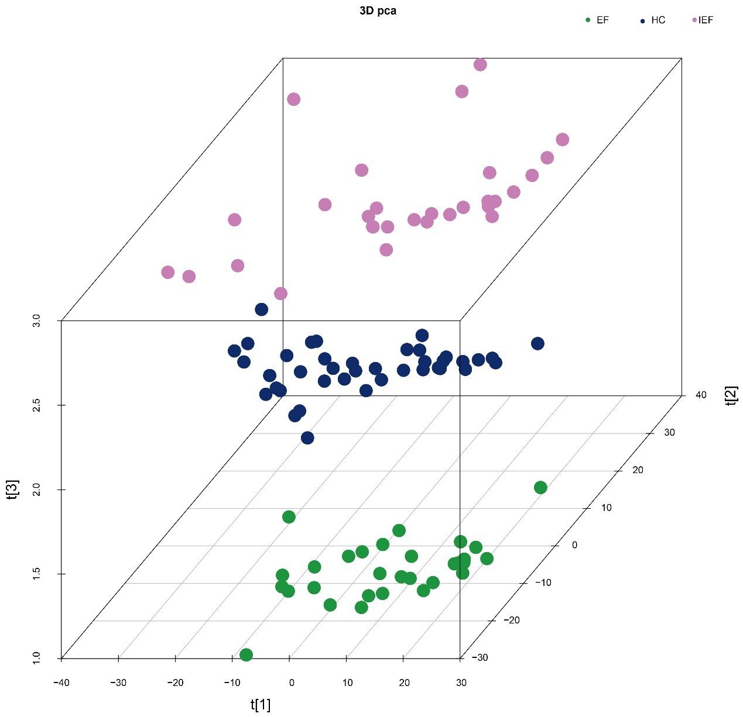
Figure S1. PCA of all samples. Each bubble represents an individual sample: green bubbles indicate IESS patients in the EF group, pink bubbles represent IESS patients in the IEF group, and blue bubbles correspond to healthy controls. The clustering of bubbles reflects the similarity in protein expression profiles among the samples.

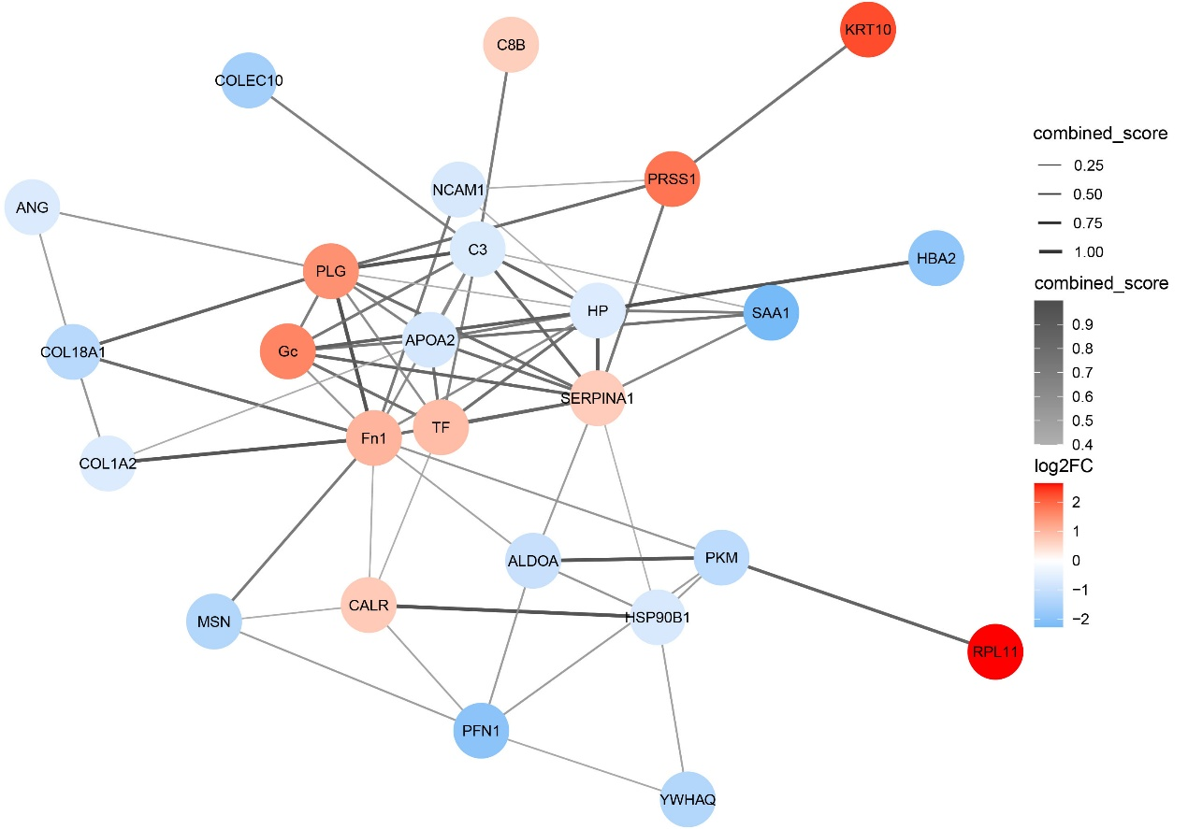
Figure S2. Schematic depiction of the PPI network for the identified DEPs in the EF vs. IEF comparison. The line width of each interaction reflects its combined interaction score, ranging from 0.4 (medium confidence) to 1 (very high confidence), with thicker lines indicating higher confidence scores. Proteins are color-coded according to their fold change (|log2FC|). In the network, PRSS1, PLG, ALDOA, Gc, HP, Fn1, SERPINA1, and COL18A1 are identified as hub proteins, playing central roles in the interaction network. ALDOA, aldolase A; COL18A1, collagen type XVIII alpha 1; DEPs, differentially expressed proteins; Fn1, fibronectin 1; Gc, group-specific component; HP, haptoglobin; PPI, protein-protein interaction; PLG, plasminogen; PRSS1, protease serine 1; SERPINA1, serpin family A member 1; EF, effective group; IEF, ineffective group.

