Additional File 1: Figure S1. ACORNS individual pre-post item scores. Figure S2. VNOS pre-post test scores. Table S1. Examples of teacher responses to the ACORNS. TABLE S2. VNOS items and teacher responses.

Figure S1. Paired t-test results comparing pre- and post-intervention test scores for ACORNS alternative conception score (Error bars represent standard errors of mean)
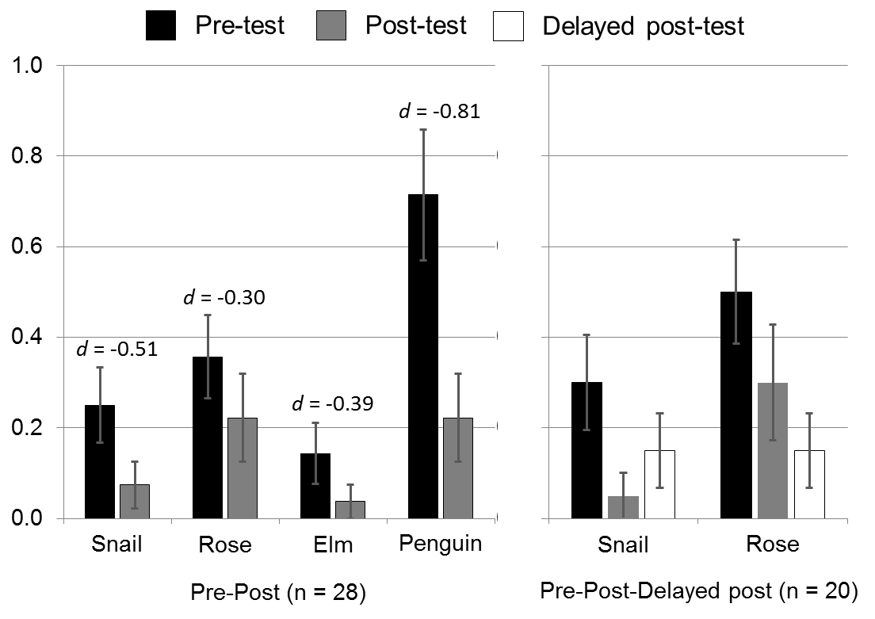

Figure S2. Paired t-test results comparing pre- and post-intervention test scores for Views of the Nature Of Science (VNOS) test (Error bars represent standard errors of mean)

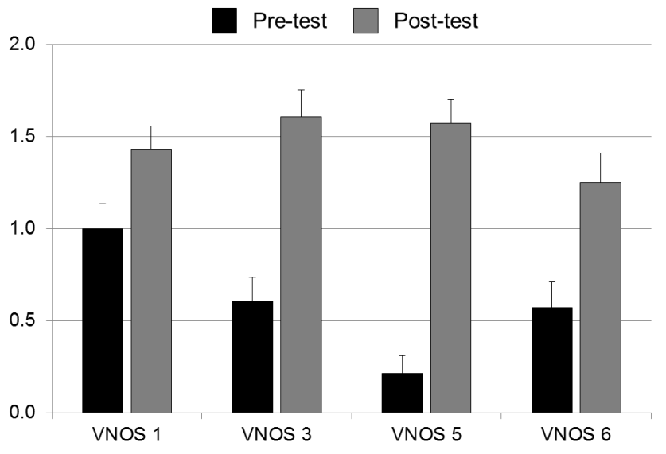

Table S1. Examples of teachers’ evolutionary explanations in response to the ACORNS instrument items. See text for full item descriptions.
Item features | Science teacher’s responses | Key concept score | alternative conception score
Elm winged seed | The seeds from an Elm without wings likely fall close to the parent tree. This would cause competition for resources [competition] decreasing the offspring chance for survival. Due to recombination, mutation, and sex a variation [variability] of Elm with more wing like seeds may have existed. The offspring of the Elm would have better chance of success [differential survival] since the seeds could be carried to a new location with less competition for resources [limited resource]. The Elm with winged seeds will pass on its genetic materials. [heritability] (ACORNS post-test) | 5 | 0
Snail poison | There is a large amount of variation within a species due to mutation, recombination and sex. [variability] The poisonous snail could have been a variation that appeared within the species. (ACORNS post-test) | 1 | 0
Penguin flightless | They would explain it as a mutation [variability] that developed as a result of the environment that the penguins were supposed to. The flightless penguins adapted to their environment and exist because flight was not necessary for survival. [need/goal] (ACORNS pre-test) | 1 | 1
Rose thorn less | The thorns were not used [use/disuse] therefore after hundreds of years they did not produce thorns. (ACORNS pre-test) | 0 | 1

Table S2. Examples of teachers’ informed and naïve Targeted Aspects of NOS responses. See text below for full items.

VNOS item 1: What, in your view, is science? What makes science (or a scientific discipline such as physics, biology, etc) different from other disciplines of inquiry (e.g. religion, philosophy)?

VNOS item 3: Does the development of scientific knowledge require experiments? If yes, explain why. Give an example to defend your position. If not, explain why. Give an example to defend your position.

VNOS item 5: Is there a difference between a scientific theory and a scientific law? Illustrate your answer with an example.

VNOS item 6: Science textbooks often represent the atom as a central nucleus composed of protons (positively charged particles) and neutrons (neutral particles) with electrons (negatively charged particles) orbiting the nucleus. How certain are scientists about the structure of the atom? What specific evidence do you think scientists used to determine what an atom looks like?

Classification | What is science? | Necessity of experiments? | Theories vs. laws | Scientific models (Atoms)
Informed responses | "In order for something to be science, the possibility must exist for it to be shown to be wrong." [concept of falsification] | "Science does not require experiments. Astronomy and earth science rely more upon inference and observation, as experimentation isn't possible in many cases." [Many ways of knowing characterize science]. | "There is a difference between a scientific theory and law. A scientific law is a generalization, a scientific theory is the explanation of a generalization (the law, or why a law happens--the mechanism)." [theory as explanation]. | "Scientists have created that model to represent the atom. It is not absolute." [models as tentative but durable representations].
Informed responses | "Science is a discipline that attempts through the use of testable question to understand the world and universe. It uses a variety of methods to answer the questions. It doesn't address untestable questions. Scientists are skeptics who try to disprove their findings. Its tentative provides the best answer for a question based on the information we have at the moment in tense." [falsification; diversity of methods; skepticism] | "Scientific knowledge does not "Require" experiments. Experiments are only one way to study the world. Keen observations, inferences, modeling are other ways to develop scientific knowledge." [Many ways of knowing characterize science]. | "Science laws are patterns that are observable and reproducible. Scientific theories are our models for how or why these patterns occur. Laws would be something like plants die without sun. Theories would be the process that the plants use light to help them live (photosynthesis)." [Theories as explanations]. | "Based on investigation, scientists are very confident about the structure of the atom. They can't be positive because science is conditional (based on information we have at the current time). At the time scientists described the modem structure of the atom, they performed tests on atoms of specific elements by hypothesizing how they should behave in certain circumstances. Based on their observations, the inferred the structure (Like our black box experiment)."
Naïve responses | "is the gathering of information of living and non-living things." | "Yes, I would think the development of scientific knowledge require experiments because it's only through experiments that you can prove that question posed is correct or incorrect." [naïve Baconian view] | "The difference between a theory and law is that the theory has not been verified/proved." [notions of "proof" and hierarchy of theories/laws]. | "Scientists are certain about atomic structure based on the development of election microscopes - allow us to "see" atoms."
Naïve responses | "Science is the study of how the world works. Unlike many other disciplines, science has a body of facts (many of which we don't really know)." | "Yes, I feel the development of scientific knowledge requires experiments to substantiate an idea or hypothesis. Experiments can lead [to] approval or disapproval depending on the outcome." [naïve Baconian view] | "I believe that in the end they are the same. Scientists' theories and laws will change as we gain deeper understanding. However, I believe we use basic assumption[s] that scientific laws are more universal and undeniable." | "Scientists are fairly certain. They used microscopic images and experiments to determining what atom is."

