APPENDICES

A. CURRICULA OUTLINES AND STUDENT ACTIVITIES............... 2-5

B. ASSESSMENT QUESTION VALIDITY ........................................... 6-7

C. CODEBOOKS A1 and A2.................................................................. 8-12

D. RUBRICS B1 and B2....................................................................... 13-15

E. ACCOUNTING FOR FAILED ASSUMPTIONS........................... 16-19

Appendix A

Table A1. Curriculum Alignment with three dimensions of learning

Evolution Big Idea | Science Process Skills | Cross-Cutting Concept | Activity Descriptions
1-Day Lesson: HOMEWORK BEFORE
Both: Adaptation by natural selection accounts for the appearance of “design” in nature and is subject to constraints due to ancestry and physical-chemical characteristics of matter. | Both: Interpret Data & Information | Both: Structure determines function | DBL: Students read ‘Biomimicry Primer’ to discover the principles of biomimicry and take 3 question quiz and online biomimicry video exploration.  Comparison: Students read ‘Structure-function – comparing species’ article to discover variation in closely related species and take 8 question quiz.
1-Day Lesson: IN CLASS
Both: Adaptation by natural selection accounts for the appearance of “design” in nature and is subject to constraints due to ancestry and physical-chemical characteristics of matter. | Both:  - Make predictions based on evidence  - Interpret data  DBL: Apply discoveries in science to society | Both: Structure determines function | Both:  - Whale Worksheet One (WhW 1) - In groups, students draw predicted graphs of lift:drag ratio versus the tilt of a whale fin in water.  - WhW 2 - Students generate multiple hypotheses on tubercle structures’ influence on function and fitness from data.  DBL: WhW 3a - Students brainstorm how tubercles could inspire redesigns of our built environment.  Comparison: WhW 3b - Students compare different whale species’ fins along the lift:drag functions and infer how this relates to their fitness.
1-Day Lesson: HOMEWORK AFTER
Both: Adaptation by natural selection accounts for the appearance of “design” in nature. | Both: Ask questions and develop testable hypotheses | Both: Structure determines function | Both: Students spend 30 minutes observing structural characteristics in nature. They describe or illustrate common structural characteristics repeated more than once in different taxa (e.g. white hairs on various plant species) and provide a hypothesis for their function(s).
Weeklong Case Study: HOMEWORK BEFORE DAY ONE
Both: Phenotypic variation is influenced by genes and environment and is necessary for evolution. | Both: Use quantitative thinking | Both: Structure determines functions | Both:  - Students assigned 1 of 4 worksheets in a jigsaw asked to estimate how optimal one specific geometric shape is with regard to efficient resource and space use for rearing offspring.  - Students also completed a pre-post week quiz to assess knowledge of different evolutionary mechanisms related to functional performance and to gauge their understanding of what ‘optimality’ is in nature.
WeeklongCase Study: DAY ONE IN CLASS
Both:  - Fitness is measured along multiple dimensions of functions relating to greatest reproductive success  - Phenotypic variation is influenced by genes and environment and is necessary for evolution. | Both:  - Use quantitative thinking.  - Use evidence to make a claim | Both: Structure determines functions | Both:  - HyW 1 - Students gather with members of the class who explored the same shape in the homework. The small group comes to consensus on an objective way to quantify resource and space use for rearing offspring for their shape.  - HyW 2 - Students in groups with members who explored one of each of the four shapes compare and contrast their shapes and objective criteria to determine the most optimal shape for resource and space use for rearing offspring.
Weeklong Case Study: HOMEWORK BEFORE DAY TWO
Both: Fitness is measured along multiple dimensions of function relating to greatest reproductive success. | Both: Generate multiple hypotheses  DBL:  - Gather evidence to make a claim.  - Apply science to society  Comparison:  Explore the primary literature | Both: Structure determines functions | Both: Students generate another dimension of fitness for honeycomb structure other than resource and space use.  DBL: In the same worksheet, students find evidence of a human created design where resource and space use are important functions, and describe the structural properties that achieve these specific functions. Once submitted, students vote on the top human design idea the class generated for a biomimicry re-design they conducted on day 3.  Comparison: In the same worksheet, students explore the literature to find another species with a structure that functions efficiently to support resource and space use. They compare and contrast the structural properties of the organism they found to the honeycomb structure.
Weeklong Case Study: DAY TWO IN CLASS
Both: Phenotypic variation is influenced by genes and environment and is necessary for evolution. | Both:  - Interpret data  - Use evidence to make a claim  - Generate predictions and hypotheses | Both: Structure determines functions | Both:  - HyW 3 - Students generate predictions on how honeycomb cell size might influence honeybee fitness  - HyW 4 - Students interpret information and generate hypotheses from a graph showing the relationship between differing amounts of honeybee genetic variation in populations and survival rates through time.
Weeklong Case Study: HOMEWORK AFTER DAY TWO
Both: Phenotypic variation is influenced by genes and environment and is necessary for evolution. | DBL:  - Explore the primary literature  - Brainstorm ideas that apply science to society  Comparison:  - Interpret graphs  - Make claims from evidence | Both: Structure determines functions | DBL: Students describe a space or resource-saving structure(s) from one organism and draw preliminary redesigns of a tiny home based on the organism’s structure(s).  Comparison: Students compare and contrast structural properties of diverse taxa of wall climbing organisms to describe the functional mechanisms. They then explore data showing the relationship between the mass of different organisms that climb walls and their climbing ability.
Weeklong Case Study: DAY THREE IN CLASS
Both: Phenotypic variation is influenced by genes and environment and is necessary for evolution. | Both: Interpret graphs and information  DBL: Apply discovers in science to society  Comparison: Make claims from evidence | Both: Structure determines functions | DBL: HyW 5 - Students discuss evidence about the individual organisms and structures used to generate their tiny-home designs. They then execute a redesign of a tiny home inspired by one student’s initial home design and organism chosen from the group.  Comparison: Students answer a series of clicker questions that ask them to identify axes labels for graphs about toe pad structures and wall climbing ability of different organisms. They then compare organisms’ toe pads along multiple dimensions to infer functional capacities.
Final Projects
Both: Chose 2 or more evolution big ideas from the semester to explain | Both: Choose 2 or more science process skills to explain | Both: Choose 2 or more cross cutting concepts to explain | DBL: Students in groups of 3-4 create a webpage that educates designers on evolutionary mechanisms that includes how it relates to the three dimensions of learning. Also, students illustrate or describe a redesign of one local design that includes aspects inspired by an organism based on design functions and constraints.  Comparison: Students in groups of 3-4 create a webpage that describes evolutionary analysis of a population or trait that includes how it relates to the three dimensions of learning (e.g. the evolution of language, the evolution of wine).

Appendix B

Accounting for Assessment Question Alignment with Knowledge Objectives

In order to validly align our two pre-post assessment questions with their targeted learning objectives and skills we emphasized during the 1-day lessons and case studies for both class conditions, we pilot tested our assessment questions before the semester started. Our team selectively distributed these two questions to 4 evolutionary biology graduate students who fell into one of the two following qualities: had participated in biology education research peripherally or had conducted research aligned with biology education in the past, and/or had previously taught science in K-12 settings. During this pilot test, our testers were asked to write how they would respond as a student to each question, ranked the question difficulty (on a 1-5 score) and then provided detailed written feedback on ways to improve or alter the question. Our curricular planning team then discussed each of these responses and identified if the targeted knowledge objectives and skills were present/absent in the graduate student responses. We did not alter either assessment question as our testers viewed they broadly captured lots of different potential responses about the processes of evolution and/or the ways in which concepts could be applied to society. We added the sentence “A biologist in this context is someone who seeks to understand living systems” to the end of Assessment Q2 to more concretely align this question with additional pre-post assessment questions the team asked beyond the scope of this research.
In addition to this pilot test, the initial construction of the structure of Assessment Q2 was designed by the primary instructor of the course and had been used in many previous semesters (both in formative and summative assessments). This assessment question was often previously restructured to include the specific organism and trait to be described by a biologist (e.g. “How would an evolutionary biologist explain the evolution of a fish that lacks eyes from an ancestor that had eyes?). The primary instructor indicated this question provided a diverse amount of ways students responded in the past, while also shifting their thinking to be like that of an expert to explain complex evolutionary concepts, especially eliciting responses that aligned with the concepts of structure-function, the appearance of “design” in nature, and phenotypic variation.

Appendix C

Table C1. Codes to Assessment Q1

Codes | Description | Example Quotes
1. Misconception Statement  1.1 Teleological Language  1.2 Anthropocentric Language  1.3 Perfect Design Language | Student uses one or more of the following misconceptions: Teleological Thinking is causal, intuitive thinking that relies on using information gathered from the outcome of the event or object to explain the goal, intended purpose or function of that event or object (Coley &Tanner, 2015; Kelemen, 1999). Anthropocentric Thinking is when students use human analogies (i.e. needs, desires) and places those qualities on organisms (Coley & Tanner, 2015). Perfect Design Thinking is when students mention that species are perfectly adapted to their environments or that evolution is a process that progresses toward perfection (Short & Hawley, 2012). | - “A biologist would describe the dependence of organismal function on it's structure by demonstrating how structure ultimately shapes it's function to ensure successful functioning.”  - “Bees make their hives in the shapes of a hexagon because it allows for the optimal usage of space.”  - “Trees have had millions of years to perfect their form and function, so understanding how they work and mimicing them can only be beneficial.”
2. Cognitive | Student makes a claim that links the benefits of knowing more about natural structure-function relationship to changes to the way we think about nature, think about our thinking, problem solve, predict the future or gain more information about nature (or the inverse where not knowing S-F will have detriments to the way we think). | “We use form and function to understand how viruses affect our cells by latching onto the outside and inserting their DNA into our own cells.”
3. Affective | Student makes a claim that links the benefits of knowing more about natural structure-function relationship to changes to the way we feel about nature (i.e. appreciation, acceptance), or how we can live in harmony with nature (or the inverse where not knowing S-F will have detriments to the way we feel). | “Society can benefit from understanding form and function in nature because it gives us…greater appreciation of the other species we inhabit our Earth with.”
4. Application/Behavior | Student makes a claim that links the benefits of knowing more about natural structure-function relationship to changes to the way we act, create or use resources in some way (the inverse where not knowing S-F will have detriments to the way we act, create or use resources). | “If designers found ways to mimic for example how efficient certain slime molds and termite colonies are at resource management and efficiency, humans could greatly reduce costs and benefit from more efficient roadways and public transit systems.”
5. Example | Student gives a concrete example of structure and/or function relationship that is linked to the benefits we gain from knowing about this structure function relationships in nature (relevant example) or is not linked to the benefit of knowing about S-F in nature (irrelevant example). This code requires a mention of a specific organism or human system in order for it to be an example (not just 'nature' or 'animals'). This can occur in instances where the concrete example is after the claim or when the concrete example is the claim. | “For example, swamps and mangroves have thick vegetation and slow or stagnant water. This form allows for the filtration of nutrients as the water flows towards the sea. Understanding this could help us in preserving this ecosystem.”
6. Incomplete or Non-coherence | Student has an incomplete thought or a sentence that is not understandable or gave a response that does not answer the question in any way. | “Apologies, but I don’t know”

Table C2. Codes to Assessment Q2

Codes | Description | Example Quotes
1. Structure-Function Claim  1.1 Structure determines function or the two are related to each other  1.2 Function determines structure (misconception) | Student makes a claim directly linking structure to function in a way that implies directionality of the relationship (one determines or causes the other) or states the relationship exists without directionality. | 1.1 “The structure directly correlates to the function of the given mechanism”  1.2 “Function defines structure.”
2. Factors Influencing S-F  2.1 Natural selection or adaptation influences  2.2 Abiotic/Biotic influences  2.3 Genetic influences (e.g. heritability, random mutation)  2.4 Scaling (i.e. going from cellular to influences on the phenotype) | Student makes a claim that links structure-function through another mechanism that is correctly explained. | 2.1 “Evolution dictates that the organisms best suited for their environment are the ones that survive and procreate.”  2.2 “Structures are shaped by environmental factors, including abiotic and biotic factors.”  2.3 “If we observe a pseudopod on some cell, we can see a structure that resulted from a random sequence of mutations.”  2.4 “The cellular structure influences phenotypic structure, which determines the function.”
3. Incomplete or Non-coherence | Student has an incomplete thought or a sentence that is not understandable or gave a response that does not answer the question in any way. | “Apologies, but I don’t know”
4. Structures or Functions influence something  4.1 S or F influence individuals, populations, communities or species  4.2 S or F influence fitness or natural selection | Student mentions that structure and/or function influences some other aspect of the organism OR evolutionary mechanism. | 4.1 “The plant is itself dependent on the structure to capture light.”  4.2 “The reproductive structures can impact the fitness of an organism if they influences the organism’s ability to breed.”
5. Constraints & Limitations | Student makes a claim about structure directly linking to function in that structures have constraints or limitations which place constraints or limitations on functions. | “...because morphological structures ultimately determine the limitations an organism has and the abilities it can do.”
6. How to Study S-F  6.1 Experiment/Test  6.2 Observe/Identify  6.3 Compare to other species | Instead of answering 'describe' relationship, the student explains how a biologist would know/gain information about the relationship. | 6.1 “A biologist may try to run experiments to figure out how changing the structure of an organism effects its function.”  6.2 “The biologist would observe how a living organism functions in it's system. Through these observation the biologist would be able to determine the dependence of that organism.  6.3 “A biologist could describe the dependence of organismal function on its structure by comparing the teeth of herbivores and carnivores.”
7. Example | Student gives a concrete example that does not provide more information but is supplemental support to the rest of their arguments. This code requires a mention of a specific organism for it to be an example (not just 'nature' or 'animals'). This can occur in instances where the concrete example is after the claim or when the concrete example is the claim. | “One example of this is animals that are able to fly, because the 'structure,' or anatomy, of their wings (such as the length, width, size, shape, feather curvature, etc) “allows” them to fly.”
8. Misconception Statement  8.1 Teleological Language  8.2 Anthropocentric Language  8.3 Perfect Design Language | Student uses one or more of the following misconceptions: Teleological Thinking is causal, intuitive thinking that relies on using information gathered from the outcome of the event or object to explain the goal, intended purpose or function of that event or object (Coley &Tanner, 2015; Kelemen, 1999). Anthropocentric Thinking is when students use human analogies (i.e. needs, desires) and places those qualities on organisms (Coley & Tanner, 2015). Perfect Design Thinking is when students mention that species are perfectly adapted to their environments or that evolution is a process that progresses toward perfection (Short & Hawley, 2012). | - “A biologist would describe the dependence of organismal function on it's structure by demonstrating how structure ultimately shapes it's function to ensure successful functioning.”  - “Bees make their hives in the shapes of a hexagon because it allows for the optimal usage of space.”  “Trees have had millions of years to perfect their form and function, so understanding how they work and mimicing them can only be beneficial.”
88.12% agreement; Kappa Coefficient = 86.8 for codes 1-7; 78% agreement; Kappa Coefficient = 49.4 for code 8.

Appendix D

Table D1. Rubric 1 to Assessment Q1 based on codebook in appendix A1

Point | Response | Required Codes
3 | Complete Response Without Misconception Language – the student mentioned at least one societal benefit gained from understanding structure-function in nature and included a relevant example. There was no misconception language used in this response. | Codes 2-4 and Code 5
2 | Partial Response – the student mentioned either one societal benefit or gave an example but did not provide both a claim and an example.  Complete & Presence of Misconception Language - the student mentioned at least one societal benefit gained from understanding structure-function in nature and included a relevant example but also used misconception language in their response. | Partial Response: Either Code 2-4 or Code 5  Complete with Misconception: Codes 2-4 & Code 5 & any Code 1
1 | Partial Response with Misconception Language - the student mentioned either one societal benefit or gave an example but did not provide both a claim and an example and used misconception language in their response. | Either Code 2-4 or Code 5 & any Code 1
0 | Non-coherent Response – the student had an incomplete thought or a sentence that is not understandable or gave a response that does not answer the question in any way. | Code 6

Table D2. Rubric 2 to Assessment Q2 based on codebook in appendix A2

Point | Response | Required Codes
5  5.1  5.2  5.3  5.4 | Quality Complete Response - the student includes a correct explanation of the S-F relationship, includes an example and ….  …a factor influencing S-F  … a description of constraints or limitations on structures or functions  … something else that is influenced by S-F  … describe two or more of these above factors | Code 1, Code 7 and…  … any Code 2  … Code 5  … any Code 4  … Code 2 and/or 5 and/or 4
4 | Complete Response - the student includes a correct explanation of the S-F relationship and an example | Code 1 and Code 7
3  3.1  3.2  3.3  3.4  3.5 | Partial Response – the student describes…  …a correct explanation of the S-F relationship only  … an example only  Complete Response with Misconception Language – the student includes a correct explanation of the S-F relationship and an example but also includes the misconception of…  … teleological language  … anthropomorphic language  … perfect design language  … two or more misconception statements | …Code 1  …Code 7  Code 1, Code 7 and …  …Code 8.1  …Code 8.2  …Code 8.3  …Code 8.1 and/or 8.2 and/or 8.3
2  2.1  2.2  2.3  2.4 | Partial Response with Misconception Language - the student includes either a correct explanation of the S-F relationship or an example but also includes the misconception of…  … teleological language  … anthropomorphic language  … perfect design langnuage  … two or more misconception statements | Code 1 OR Code 7 and …  …Code 8.1  …Code 8.2  …Code 8.3  …Code 8.1 and/or 8.2 and/or 8.3
1  1.1  1.2  1.3  1.4  1.5 | Incorrect Response – the student described the S-F relationship where function determines structure (incorrect) with…  …no other misconception language  … teleological language  … anthropomorphic language  … perfect design language  … two or more misconception statements | Code 1.2 and…  Code 1.2 only  …Code 8.1  …Code 8.2  …Code 8.3  …Code 8.1 and/or 8.2 and/or 8.3
0 | Non-coherent Response – the student had an incomplete thought or a sentence that is not understandable or gave a response that does not answer the question in any way. | Code 3
*This Rubric 2 is considered a double-digit grading rubric, which is explained in Allen & Tanner, 2006.

Appendix E

Accounting for Failed Assumptions

Student level data failed to meet the assumption of replicate independence since students were not randomly assigned to experimental conditions nor were experimental conditions assigned to multiple classes (i.e., the experimental design was quasi-experimental, Gribbons & Herman 1996). We took two main measures to account for this. First, we ran chi-square tests, t-tests or Wilcoxon rank sum tests to distinguish academic or demographic differences between the two sections in order to identify potentially confounding variables (Theobald & Freeman, 2014), and included demographic and academic variables in two full models corresponding to our main research questions as a more conservative measure. When included in the full models, all demographic and academic variables demonstrated insignificant influences (all p-values > 0.28) and small effect sizes except a student’s final course grade, which had a small influence on post structure-function model variables. In conjunction with this, statistical analysis demonstrated insignificant academic and demographic differences between the two sections for all variables (p-value > 0.25) except two. The comparison section had a significantly higher average final course grade than the DBL section (Comparison Mean = 85.30%, SE = 1.10%, DBL = 79.25%, SE= 1.29%, t(97.325) = 3.5739, p-value < 0.05) (Fig C1).

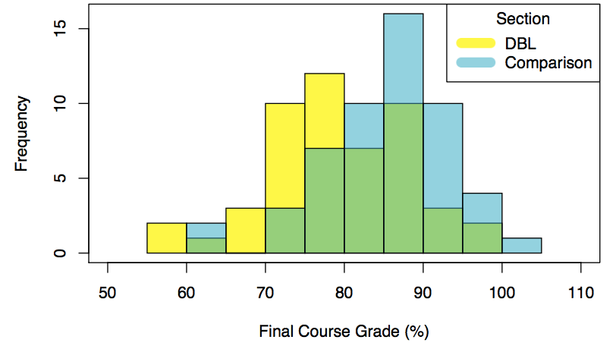

Fig E1. The distributions of final evolution course grade by section condition (t-test p-values < 0.05 between Comparison and DBL average final course grade).

The best predictor of a student’s final score was whether they turned in their assignments (R² = 0.9). Since this variable was different across class sections and had a slight influence on our post structure-function model to answer research question 2, we kept this variable in the final post structure-function model. The second characteristic difference between the two sections was the number of either Ecology and Evolutionary Biology (EBIO) or STEM courses that the students concurrently took in fall 2018 (X²(5) = 11.497, p < 0.05) (Fig C2). On average, students in the DBL condition tended to take more EBIO or STEM courses as compared to students in the comparison. This is important to consider since these classes were predicted to have a high degree of transferability to the structure-function and/or science-society learning goals tested in this study. Because differences in course-taking behavior may have influenced student thinking, we initially included this variable in regression analyses. However, there appeared to be no significant effect of this variables on the outcomes of interest; therefore, it was removed from final regression models.

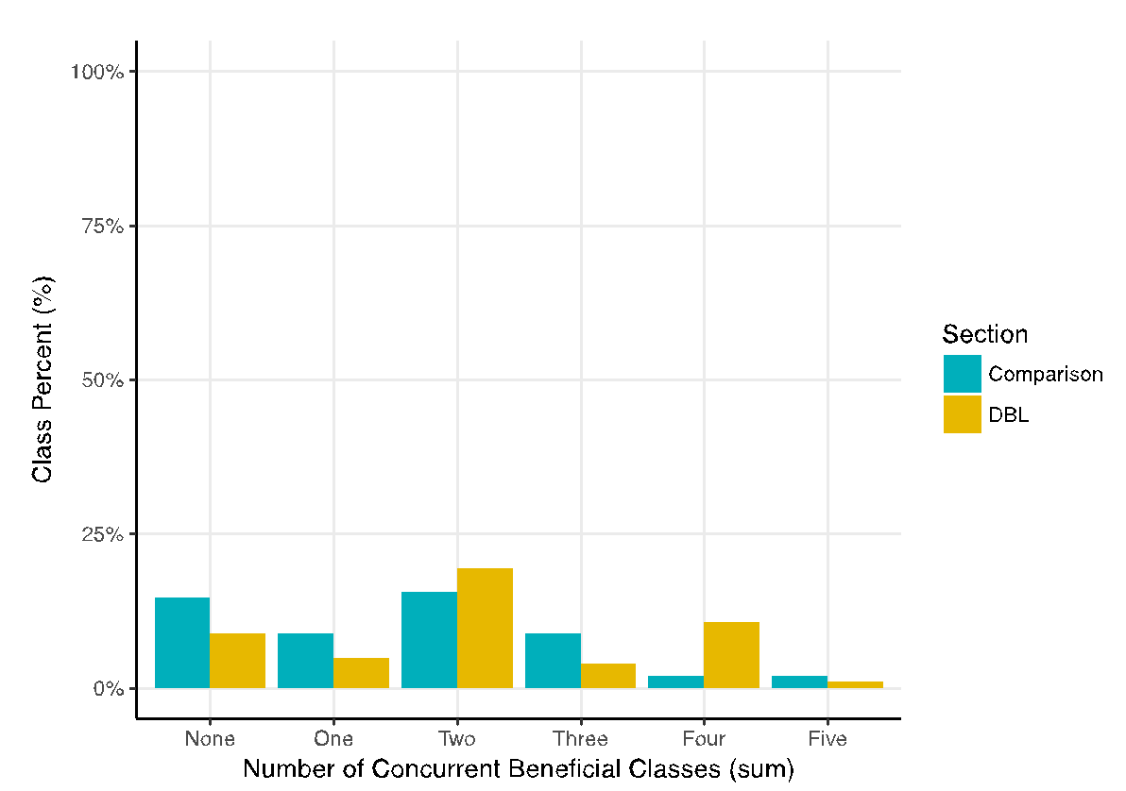
Fig E2. Percentage of students in each condition that took a certain number of transferable-knowledge course concurrently during fall 2018.

The second measure we took strived to account for non-independence of students within a section. To do this, we included ‘clique’ as a random variable in any logistic regressions we conducted. ‘Clique’ was determined by the strongest social network cluster that a student associated with and was based off of student-selected groups chosen during in-class group work throughout the semester (Hedges, 2007). By including ‘Clique’ as a random effect in the models, we attempted to account for the variance in individual student responses that was due to group thinking. While this cannot fully account for variance in individual responses due to effects of the section, it partially accounts for this by including non-independence due to group interactions within a section. Since no mixed effect model (binary logistic or ordinal logistic) had above a 10⁻² variance (approximating 0 variance) explained by the random effect of ‘Clique’, we chose to drop this effect from all final analyses (Fig C3).

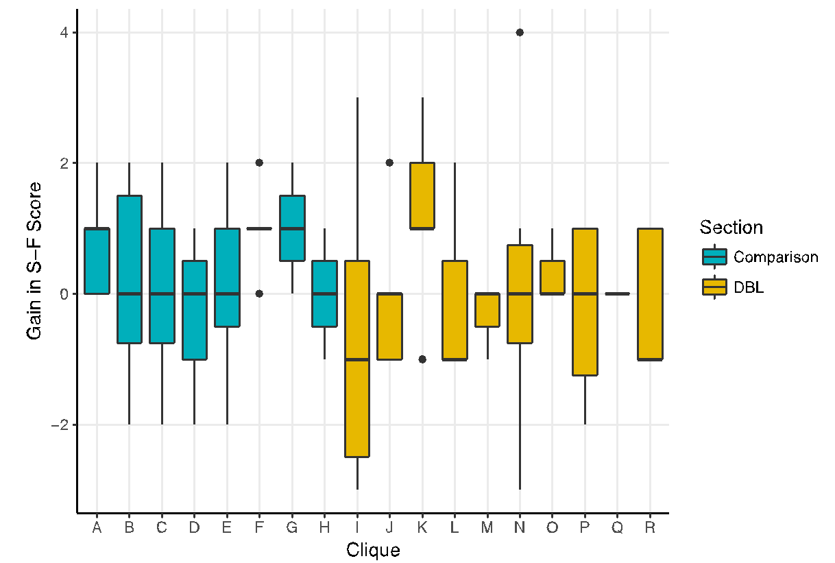

Fig. E3. Boxplot of Clique across gain in structure-function scores. Boxplot values oscillating around zero indicate no clear effect of Clique on scores.

