Additional file 3. Research design and formal model descriptions used to test the hypotheses.
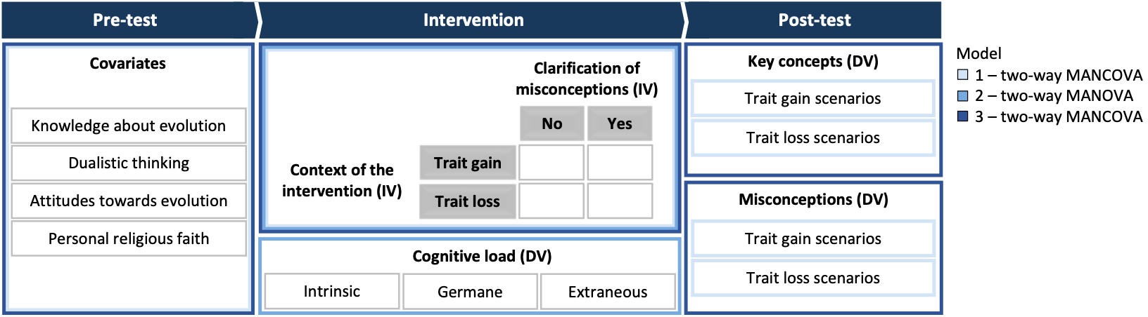
Note. DV = dependent variable, IV = independent variable.

Model 1 – two-way MANCOVA
Independent variables
- Context of the intervention (trait gain vs. trait loss)
- Clarification of misconceptions (no vs. yes)
- Interaction effect: context of the intervention (trait gain vs. trait loss) * Clarification of misconceptions (no vs. yes)
Dependent variables
- Key concepts in trait gain scenarios
- Key concepts in trait loss scenarios
- Misconceptions in trait gain scenarios
- Misconceptions in trait loss scenarios
Covariates
- Knowledge about evolution
- Dualistic thinking
- Attitudes towards evolution
- Personal religious faith
Corresponding research hypotheses
H1: Students learning in a specific evolutionary context use more key concepts and fewer misconceptions in later reasoning about the same context than students who learned in a different one before. Hence, we hypothesize that students learning in the instructional context of trait gain perform better in subsequent trait gain scenarios than in trait loss scenarios. Students learning in the instructional context of trait loss perform better in subsequent trait loss scenarios than in trait gain scenarios.

H3: Since clarifying misconceptions should promote reconstructing conceptions, we expect students who received instructions without a clarification of misconceptions to use fewer key concepts and more misconceptions in later reasoning about natural selection than students who received a clarification.

Exploratory analysis: We analyse which instructional strategy (differing in the context if instructions [trait gain vs. trait loss] and the clarification of misconceptions [no vs. yes]) effectively supports learning about natural selection and shows an increased use of key concepts and fewer misconceptions, both in trait gain and trait loss scenarios in later reasoning.

Model 2 – two-way MANOVA
Independent variables
- Context of the intervention (trait gain vs. trait loss)
- Clarification of misconceptions (no vs. yes)
- Interaction effect: context of the intervention (trait gain vs. trait loss) * clarification of misconceptions (no vs. yes)
Dependent variables
- Intrinsic cognitive load
- Germane cognitive load
- Extraneous cognitive load
Corresponding research hypotheses
H2: Given that trait gain contexts appear to be easier than trait loss contexts, we suppose students perceive lower intrinsic cognitive load when they were provided with the instructional context of trait gain than trait loss. Furthermore, supplying a clarification of misconceptions should ease conceptual development. Thus, students who receive no clarification of misconceptions should perceive a lower germane cognitive load than students who receive a clarification. Generally, we do not expect the extraneous load to differ between instructional materials. Overall, it should be noted, however, that the context of instruction and the clarification of misconceptions might interact and affect differences in the three types of loads. Based on the theoretical foundation, working memory is limited and the three loads are mutually dependent.

Model 3 – two-way MANCOVA
Independent variables
- Interaction effect: context of the intervention (trait gain vs. trait loss) * clarification of misconceptions (no vs. yes)
Dependent variables
- Key concepts
- Misconceptions
Covariates
- Knowledge about evolution
- Dualistic thinking
- Attitudes towards evolution
- Personal religious faith
Corresponding exploratory analysis
Exploratory analysis: We analyse which instructional strategy (differing in the context if instructions [trait gain vs. trait loss] and the clarification of misconceptions [no vs. yes]) effectively supports learning about natural selection and shows an increased use of key concepts and fewer misconceptions.

