Spatial-temporal distribution of human brucellosis in mainland China from 2004 to 2017 and an analysis of social and environmental factors
Cheng Peng¹, Yan-Jun Li¹, De-Sheng Huang^{1,2}, Peng Guan*
Supplementary Material

Table S1 Spatio-temporal scan analysis of high-incidence clusters between 2004 and 2017 in mainland China
Year | Spatial cluster | Locations included | Time frame | Number of cases | Expected cases | RR | LLR | P-value
2004 | Most likely cluster | Inner Mongolia, Shanxi | 2004/3/1 to 2004/8/31 | 4544 | 256.52 | 28.68 | 9723.86 | 0.001
 | Secondary likely cluster1 | Liaoning, Jilin, Heilongjiang | 2004/2/1 to 2004/7/31 | 2878 | 475.87 | 7.74 | 3061.33 | 0.001
 | Secondary likely cluster2 | Tibet | 2004/2/1 to 2004/6/30 | 206 | 1.01 | 206.79 | 891.47 | 0.001
 | Secondary likely cluster3 | Beijing, Tianjin, Hebei | 2004/4/1 to 2004/6/30 | 336 | 206.55 | 1.65 | 34.78 | 0.001
 | Secondary likely cluster4 | Shaanxi | 2004/2/1 to 2004/5/31 | 168 | 108.4 | 1.56 | 14.16 | 0.001
2005 | Most likely cluster | Inner Mongolia, Shanxi | 2005/2/1 to 2005/7/31 | 8521 | 408.88 | 37.93 | 19952.68 | 0.001
 | Secondary likely cluster1 | Heilongjiang | 2005/2/1 to 2005/7/31 | 3009 | 271.26 | 13.06 | 4720.57 | 0.001
 | Secondary likely cluster2 | Liaoning, Jilin | 2005/1/1 to 2005/6/30 | 854 | 492.6 | 1.77 | 112.17 | 0.001
 | Secondary likely cluster3 | Beijing, Tianjin, Hebei | 2005/3/1 to 2005/6/30 | 660 | 451.45 | 1.48 | 43.32 | 0.001
 | Secondary likely cluster4 | Shaanxi | 2005/3/1 to 2005/8/31 | 358 | 266.37 | 1.35 | 14.44 | 0.001
2006 | Most likely cluster | Inner Mongolia, Shanxi | 2006/2/1 to 2006/7/31 | 8387 | 421.47 | 34.82 | 19138.68 | 0.001
 | Secondary likely cluster1 | Heilongjiang | 2006/2/1 to 2006/7/31 | 2283 | 278.29 | 9.19 | 2911.37 | 0.001
 | Secondary likely cluster2 | Beijing, Tianjin, Hebei | 2006/1/1 to 2006/6/30 | 1685 | 696.92 | 2.56 | 526.67 | 0.001
 | Secondary likely cluster3 | Shaanxi | 2006/4/1 to 2006/7/31 | 386 | 181.49 | 2.15 | 87.89 | 0.001
 | Secondary likely cluster4 | Liaoning, Jilin | 2006/3/1 to 2006/7/31 | 654 | 430.36 | 1.54 | 51.40 | 0.001
2007 | Most likely cluster | Inner Mongolia, Shanxi | 2007/3/1 to 2007/8/31 | 8788 | 443.89 | 34.91 | 20036.76 | 0.001
 | Secondary likely cluster1 | Jilin, Heilongjiang | 2007/2/1 to 2007/7/31 | 2395 | 491.55 | 5.41 | 1986.70 | 0.001
 | Secondary likely cluster2 | Beijing, Tianjin, Hebei | 2007/2/1 to 2007/7/31 | 1665 | 730.05 | 2.40 | 461.19 | 0.001
 | Secondary likely cluster3 | Shaanxi | 2007/3/1 to 2007/7/31 | 492 | 235.08 | 2.12 | 108.15 | 0.001
2008 | Most likely cluster | Inner Mongolia, Shanxi | 2008/3/1 to 2008/8/31 | 11464 | 621.85 | 30.7 | 25097.12 | 0.001
 | Secondary likely cluster1 | Jilin, Heilongjiang | 2008/2/1 to 2008/7/31 | 4333 | 689.05 | 7.27 | 4580.15 | 0.001
 | Secondary likely cluster2 | Beijing, Tianjin, Hebei | 2008/3/1 to 2008/7/31 | 2056 | 877.49 | 2.45 | 598.28 | 0.001
 | Secondary likely cluster3 | Shaanxi | 2008/4/1 to 2008/7/31 | 581 | 261.82 | 2.25 | 145.79 | 0.001
2009 | Most likely cluster | Inner Mongolia, Shanxi | 2009/3/1 to 2009/8/31 | 15328 | 802.27 | 32.65 | 34237.96 | 0.001
 | Secondary likely cluster1 | Jilin, Heilongjiang | 2009/2/1 to 2009/7/31 | 6062 | 880.51 | 8.08 | 6918.68 | 0.001
 | Secondary likely cluster2 | Beijing, Tianjin, Hebei | 2009/2/1 to 2009/7/31 | 2351 | 1357.38 | 1.78 | 312.22 | 0.001
 | Secondary likely cluster3 | Shaanxi | 2009/3/1 to 2009/6/30 | 519 | 336.88 | 1.55 | 42.65 | 0.001
2010 | Most likely cluster | Inner Mongolia | 2010/3/1 to 2010/8/31 | 10959 | 315.52 | 50.94 | 30143.83 | 0.001
 | Secondary likely cluster1 | Jilin, Heilongjiang | 2010/2/1 to 2010/7/31 | 5657 | 826.15 | 8.02 | 6425.35 | 0.001
 | Secondary likely cluster2 | Shanxi | 2010/2/1 to 2010/7/31 | 2748 | 448.74 | 6.58 | 2761.86 | 0.001
 | Secondary likely cluster3 | Beijing, Tianjin, Hebei | 2010/3/1 to 2010/7/31 | 1579 | 1109.62 | 1.44 | 91.04 | 0.001
2011 | Most likely cluster | Inner Mongolia, Shanxi | 2011/2/1 to 2011/7/31 | 15763 | 857.43 | 30.62 | 34469.23 | 0.001
 | Secondary likely cluster1 | Jilin, Heilongjiang | 2011/1/1 to 2011/6/30 | 5068 | 929.13 | 6.14 | 4697.92 | 0.001
 | Secondary likely cluster2 | Beijing, Tianjin, Hebei | 2011/4/1 to 2011/6/30 | 1312 | 753.24 | 1.77 | 173.50 | 0.001
2012 | Most likely cluster | Inner Mongolia, Shanxi | 2012/2/1 to 2012/7/31 | 12682 | 889.4 | 20.53 | 23926.20 | 0.001
 | Secondary likely cluster1 | Heilongjiang | 2012/2/1 to 2012/7/31 | 5355 | 558.92 | 10.93 | 7613.19 | 0.001
 | Secondary likely cluster2 | Liaoning, Jilin | 2012/3/1 to 2012/8/31 | 2296 | 1052.16 | 2.26 | 568.12 | 0.001
 | Secondary likely cluster3 | Beijing, Tianjin, Hebei | 2012/2/1 to 2012/7/31 | 2721 | 1570.05 | 1.79 | 362.94 | 0.001
2013 | Most likely cluster | Inner Mongolia, Shanxi | 2013/2/1 to 2013/7/31 | 10161 | 975.13 | 13.29 | 15701.70 | 0.001
 | Secondary likely cluster1 | Heilongjiang | 2013/2/1 to 2013/7/31 | 5057 | 610.25 | 9.25 | 6486.07 | 0.001
 | Secondary likely cluster2 | Liaoning, Jilin | 2013/2/1 to 2013/7/31 | 2692 | 1136.33 | 2.46 | 795.06 | 0.001
 | Secondary likely cluster3 | Beijing, Tianjin, Hebei | 2013/2/1 to 2013/7/31 | 3493 | 1737.67 | 2.10 | 720.97 | 0.001
 | Secondary likely cluster4 | Gansu, Ningxia | 2013/4/1 to 2013/8/31 | 853 | 435.28 | 1.98 | 158.19 | 0.001
 | Secondary likely cluster5 | Henan, Shaanxi | 2013/4/1 to 2013/7/31 | 1973 | 1413.33 | 1.41 | 102.28 | 0.001
2014 | Most likely cluster | Inner Mongolia, Tibet, Gansu, Qinghai, Ningxia, Xinjiang | 2014/3/1 to 2014/8/31 | 14621 | 1896.39 | 10.01 | 18729.40 | 0.001
 | Secondary likely cluster1 | Hebei, Shanxi | 2014/2/1 to 2014/7/31 | 10171 | 2297.63 | 5.17 | 7851.06 | 0.001
 | Secondary likely cluster2 | Heilongjiang | 2014/2/1 to 2014/7/31 | 3925 | 798.30 | 5.21 | 3212.70 | 0.001
 | Secondary likely cluster3 | Henan, Shaanxi | 2014/3/1 to 2014/7/31 | 4131 | 2325.81 | 1.84 | 597.89 | 0.001
 | Secondary likely cluster4 | Liaoning, Jillin | 2014/2/1 to 2014/7/31 | 2884 | 1487.67 | 1.99 | 530.43 | 0.001
2015 | Most likely cluster | Inner Mongolia, Tibet, Gansu, Qinghai, Ningxia, Xinjiang | 2015/3/1 to 2015/8/31 | 14363 | 1896.76 | 9.79 | 18142.53 | 0.001
 | Secondary likely cluster1 | Hebei, Shanxi | 2015/2/1 to 2015/7/31 | 8492 | 2285.97 | 4.19 | 5304.48 | 0.001
 | Secondary likely cluster2 | Liaoning, Jilin, Heilongjiang | 2015/2/1 to 2015/7/31 | 6973 | 2256.69 | 3.38 | 3359.55 | 0.001
 | Secondary likely cluster3 | Henan, Shaanxi | 2015/3/1 to 2015/7/31 | 4136 | 2312.91 | 1.85 | 611.58 | 0.001
 | Secondary likely cluster4 | Shandong | 2015/4/1 to 2015/5/31 | 979 | 684.12 | 1.44 | 56.77 | 0.001
2016 | Most likely cluster | Inner Mongolia, Tibet, Gansu, Qinghai, Ningxia, Xinjiang | 2016/3/1 to 2016/8/31 | 12275 | 1567.53 | 10.24 | 15925.19 | 0.001
 | Secondary likely cluster1 | Liaoning, Jilin, Heilongjiang | 2016/2/1 to 2016/7/31 | 6195 | 1853.39 | 3.7 | 3349.17 | 0.001
 | Secondary likely cluster2 | Shanxi | 2016/3/1 to 2016/8/31 | 3086 | 632.37 | 5.15 | 2504.05 | 0.001
 | Secondary likely cluster3 | Henan, Shaanxi | 2016/2/1 to 2016/7/31 | 3492 | 2267.05 | 1.58 | 300.45 | 0.001
 | Secondary likely cluster4 | Shandong | 2016/3/1 to 2016/6/30 | 1874 | 1132.72 | 1.68 | 208.20 | 0.001
 | Secondary likely cluster5 | Beijing, Tianjin, Hebei | 2016/2/1 to 2016/6/30 | 2428 | 1579.28 | 1.57 | 203.51 | 0.001
2017 | Most likely cluster | Inner Mongolia, Tibet, Gansu, Qinghai, Ningxia, Xinjiang | 2017/3/1 to 2017/8/31 | 10678 | 1290.29 | 11.06 | 14474.88 | 0.001
 | Secondary likely cluster1 | Liaoning, Jilin, Heilongjiang | 2017/2/1 to 2017/7/31 | 4758 | 1497.58 | 3.48 | 2387.57 | 0.001
 | Secondary likely cluster2 | Shanxi | 2017/3/1 to 2017/8/31 | 2016 | 518.24 | 4.05 | 1270.71 | 0.001
 | Secondary likely cluster3 | Shandong | 2017/2/1 to 2017/6/30 | 1832 | 1141.91 | 1.63 | 182.31 | 0.001
 | Secondary likely cluster4 | Henan, Shaanxi | 2017/4/1 to 2017/6/30 | 1247 | 927.33 | 1.36 | 51.04 | 0.001
 | Secondary likely cluster5 | Beijing, Tianjin, Hebei | 2017/2/1 to 2017/7/31 | 1921 | 1548.94 | 1.25 | 43.36 | 0.001
2004-2017 | Most likely cluster | Inner Mongolia, Shanxi | 2008/4/1 to 2015/3/31 | 132946 | 11024.81 | 16.21 | 226236.60 | 0.001
 | Secondary likely cluster1 | Jilin, Heilongjiang | 2009/1/1 to 2015/12/31 | 56697 | 11991.59 | 5.22 | 45547.13 | 0.001
 | Secondary likely cluster2 | Gansu, Ningxia | 2014/3/1 to 2016/11/30 | 15770 | 3344.79 | 4.84 | 12190.41 | 0.001
 | Secondary likely cluster3 | Beijing, Tianjin, Hebei | 2012/1/1 to 2016/7/31 | 25673 | 13138.68 | 2.01 | 4830.73 | 0.001
 | Secondary likely cluster4 | Henan, Shaanxi | 2014/2/1 to 2016/7/31 | 16971 | 8630.78 | 2.00 | 3208.20 | 0.001
 | Secondary likely cluster5 | Shandong | 2015/1/1 to 2017/6/30 | 9694 | 6453.13 | 1.51 | 714.98 | 0.001
 | Secondary likely cluster6 | Tibet | 2004/3/1 to 2004/6/30 | 197 | 2.40 | 82.07 | 673.64 | 0.001

Table S2. VIFs of the number of cattle, the number of sheep, GDP, population density, rainfall and climate in the multivariate linear regression model
Risk factors | Coefficient | Standardized coefficient | VIF
GDP (log-transformation) | 1.0607** | 0.5908** | 2.030
Precipitation | 0.0003 | 0.0464 | 4.252
Cattle | -0.0007 | -0.1338 | 1.666
Sheep | 0.0002* | 0.4476* | 2.490
Population density(log-transformation) | 0.1364 | 0.0859 | 1.140
Climate (Tropical) | -3.2059* | -2.7829* | 1.809
Climate (Mid-temperate) | 1.5808* | 1.3722* | 9.050
Climate (Subtropical) | -4.6725** | -4.0561** | 15.479¹
Climate (Warm-temperate) | -0.7223 | -0.6270 | 12.226¹
Note: ¹Variance inflation factor (VIF) is the index to examine the multicollinearity. VIF > 10 tells a high multicollinearity in a linear regression model. In our case, Climate (Mid-temperate), Climate (Subtropical) and Climate (Warm-temperate) were dummy variables representing a categorical variable (Climate) with five categories. Thus, the high-VIF situation can be safely dismissed and these variables were still included in the multivariate regression model [1]. Still, we eliminated the factor with highest VIF value trying to improve the performance of the multivariate linear regression model, in this case Subtropical climate factor was removed. The new result of VIFs of each factor is presented in Table S3.
The climate was categorized following the previous study, northern provinces were temperate climate, among which there were Cold, Mid-temperate and Warm-temperate climate; southern provinces were subtropical climate, Hainan province was Tropical climate [2,3].

Table S3. VIF of the number of cattle, the number of sheep, GDP, population density, rainfall, Tropical climate, Mid-temperate climate and Warm-temperate climate in the multivariate linear regression model
Risk factors | Coefficient | Standardized coefficient | VIF
GDP (log-transformation) | 0761** | 0.257** | 1.793
Precipitation | -0.0004 | -0.0665 | 3.953
Cattle | -0.0007 | -0.0734 | 1.666
Sheep | 0.0003* | 0.1483* | 2.458
Population density(log-transformation) | 0.2531 | 0.0541 | 1.125
Climate (Tropical) | 1.0761 | 0.0417 | 1.175
Climate (Mid-temperate) | 4.999* | 0.7560* | 2.893
Climate (Warm-temperate) | 3.1928 | 0.5306 | 2.473

Table S4. Coefficients of the number of sheep, GDP, population density, rainfall and climate in the ridge regression model
Risk factors | Coefficient (linear regression) | Coefficient (ridge regression)
GDP (log-transformed) | 0.7605** | 0.7596**
Sheep (10⁴ heads) | 0.0003* | 0.0003*
Climate (Mid-temperate) | 4.9992* | 4.9571**
Climate (Warm-temperate) | 3.1928** | 3.1635**

Note: * P < 0.05; ** P < 0.01
From the previous linear regression, we had five significant associated factors, so in the ridge regression analysis only those five significant factors were chosen.

Table S5. Coefficients of the number of sheep, GDP, population density, rainfall and climate in the Poisson regression model
Risk factors | Coefficient (linear regression) | Coefficient (Poisson regression)
GDP (log-transformed) | 0.7605** | 0.5275**
Sheep (10⁴ heads) | 0.0003* | 0.0002**
Climate (Mid-temperate) | 4.9992* | 4.2338**
Climate (Warm-temperate) | 3.1928** | 2.8571**

Note: * P < 0.05; ** P < 0.01
From the previous linear regression, we had five significant associated factors, so in the Poisson regression analysis only those five significant factors were chosen.

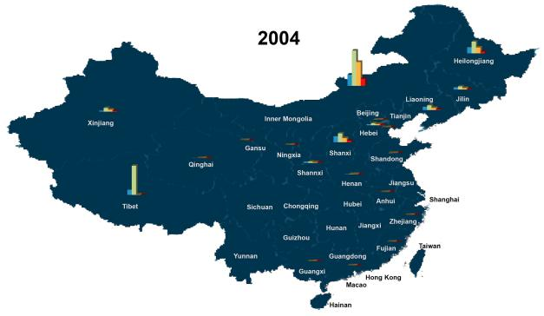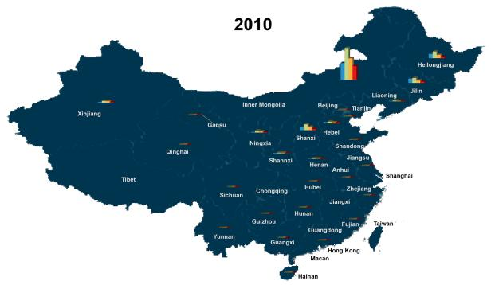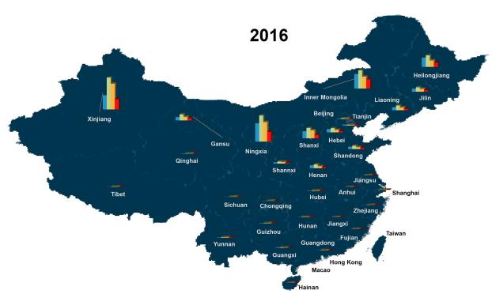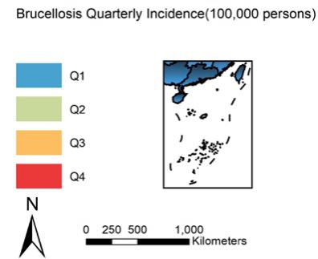
Figure S1 Spatial distribution of quarterly brucellosis incidence (100,000 persons) in 2004, 2010 and 2016 in mainland China. Overall quarterly incidence was increasing among 31 provinces. Brucellosis incidence in the second quarter (April to June) was the highest among four quarters in 2004, 2010 and 2016.

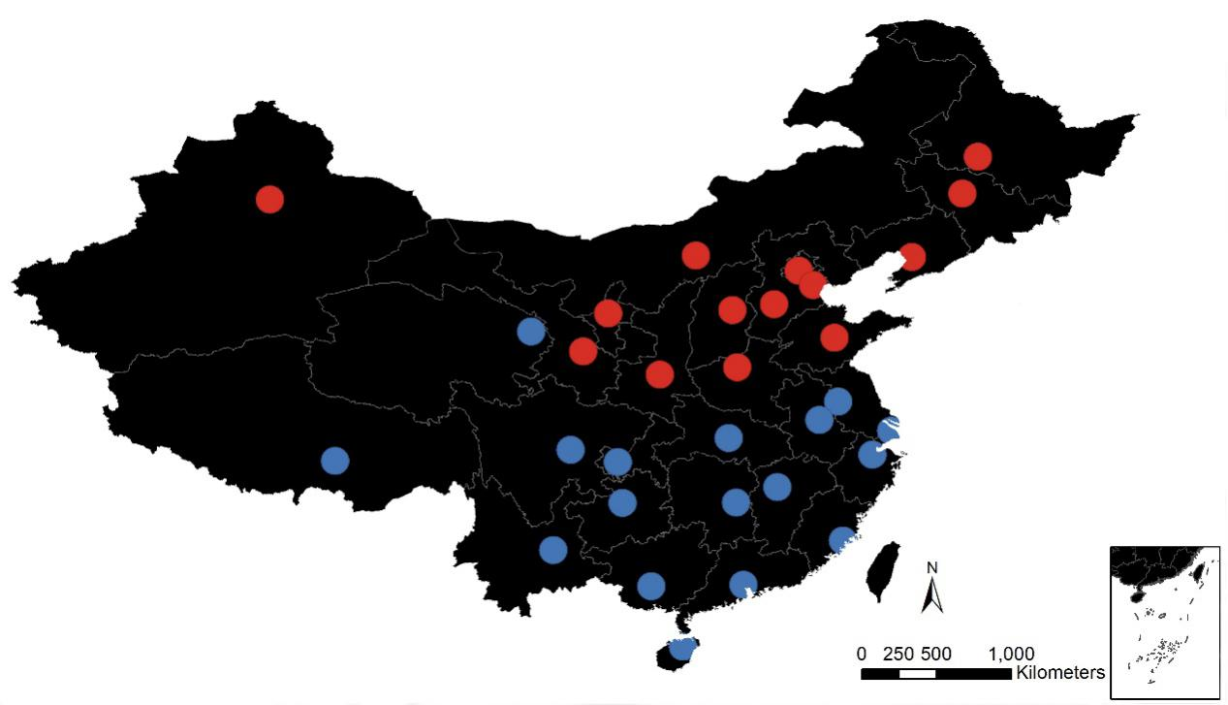
Figure S2 Hot and cold spots of brucellosis incidence between 2004 and 2017 in mainland China. Red dots represented hot spots with 99% confidence, which distributed in northern China. Blue dots represented cold spots with 99% confidence, which distributed in southern China. (Note: An element with statistically significant high value that detected as hotspot not only has high values, but also get surrounded by other elements with high values to prove that the spatial pattern is not random.)

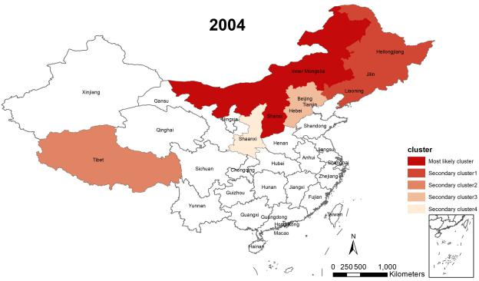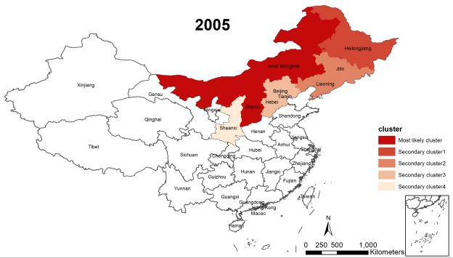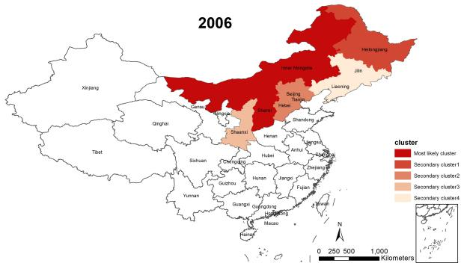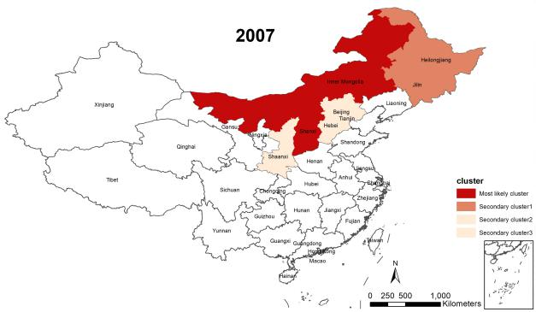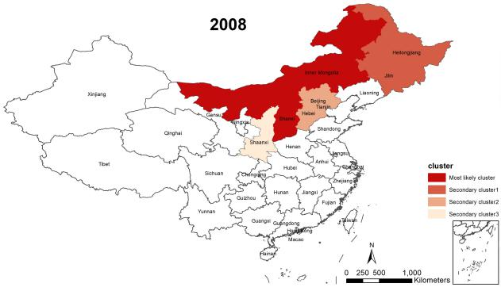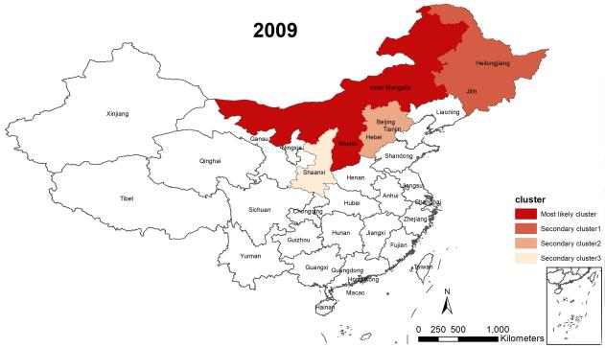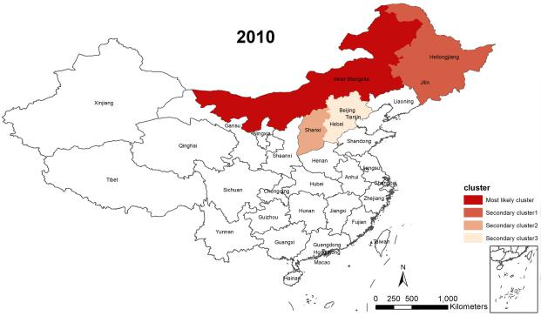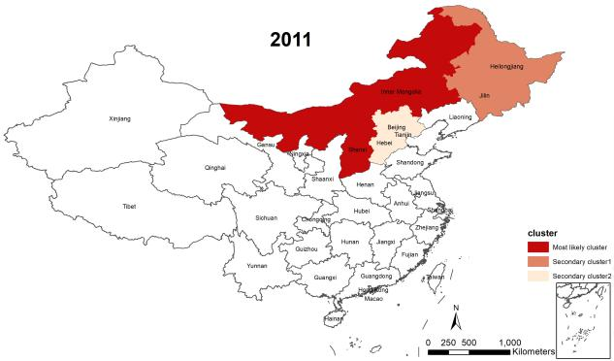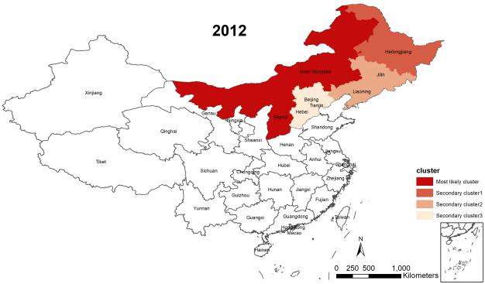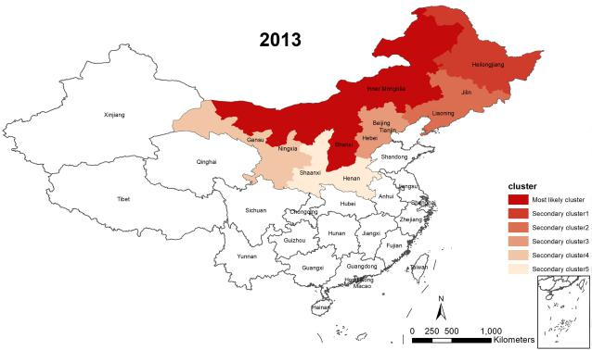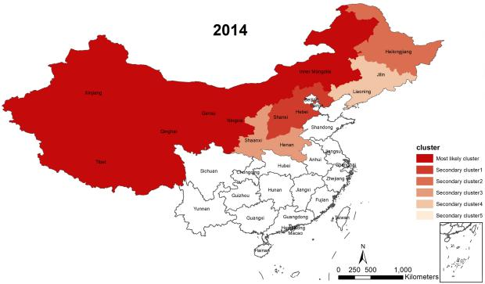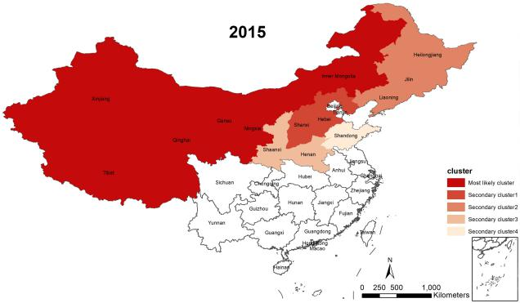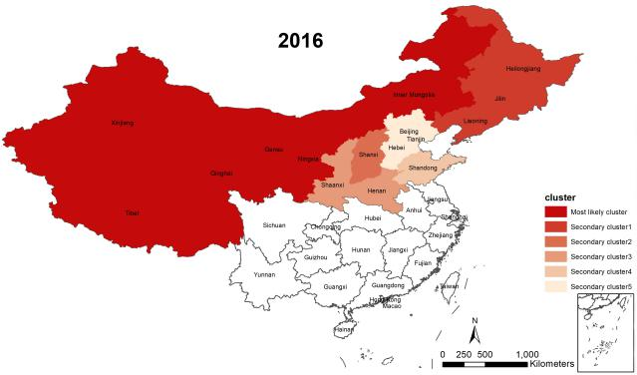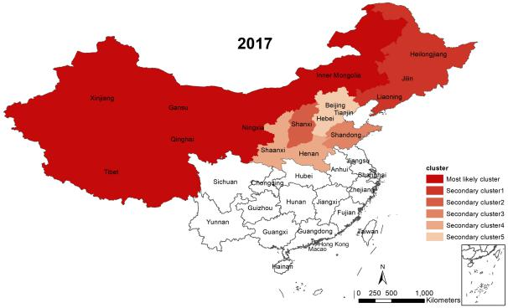
Figure S3 Spatio-temporal distribution of high-incidence clusters between 2004 and 2017 in mainland China. Most likely clusters had spread from Inner Mongolia and Shanxi province in 2004 to Inner Mongolia, Xinjiang, Tibet, Qinghai, Gansu and Ningxia in 2017. Spatial clusters of high brucellosis incidence concentrated in northern areas of mainland China.

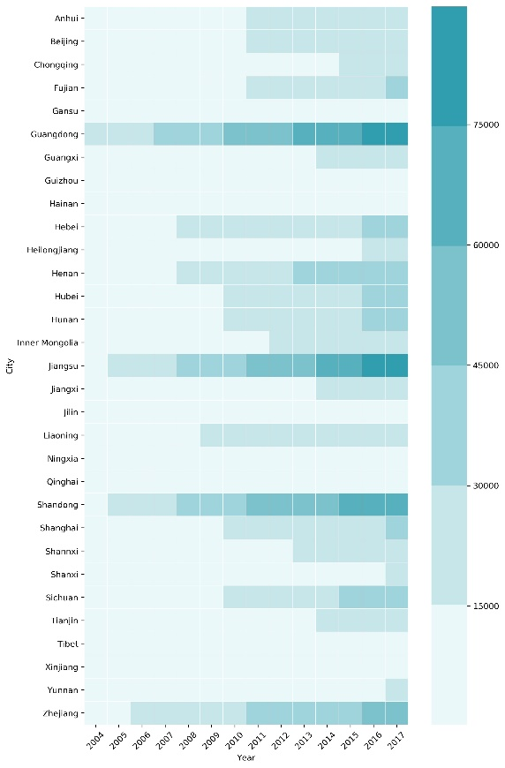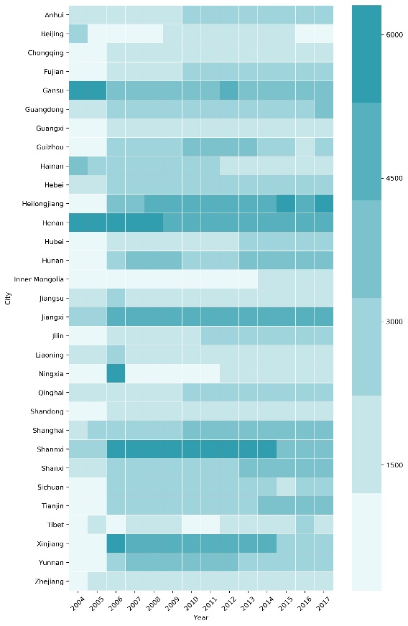
Figure S4 GDP (left) and population density (right) provincial distribution in mainland China between 2004 and 2017. GDP in Guangdong, Jiangsu and Shandong province were higher than other provinces between 2004 and 2017. Henan, Shaanxi and Jiangxi province were more populated between 2004 and 2017 than other provinces in mainland China.
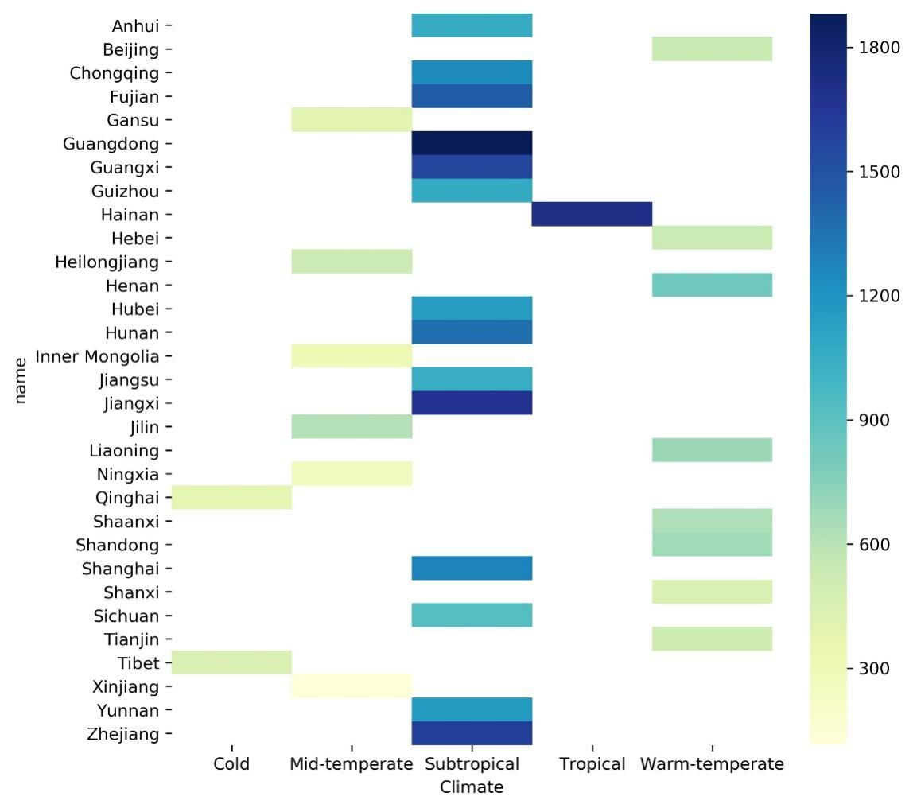
Figure S5 Climate and Precipitation distribution in provinces of mainland China between 2004 and 2017. Subtropical areas had the most precipitation, mid-temperate and warm-temperate areas rained less. The cold areas rained the least between 2004 and 2017 among other regions in mainland China.

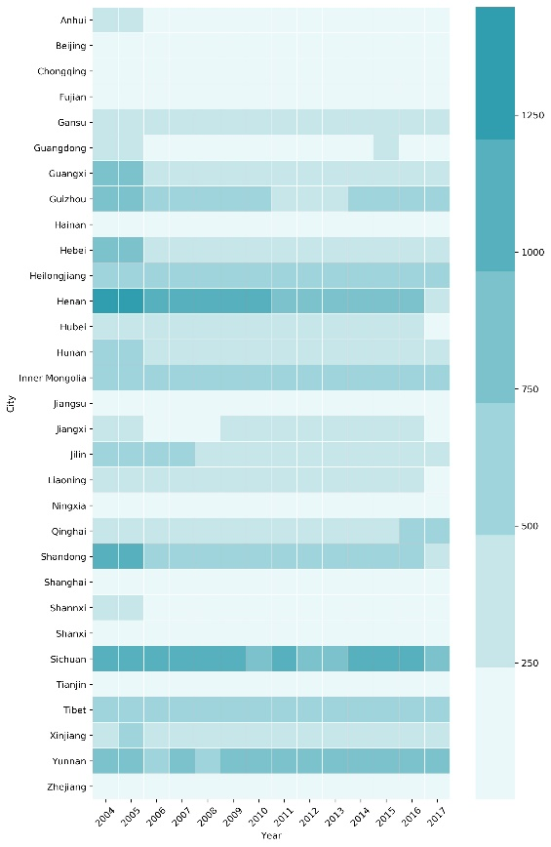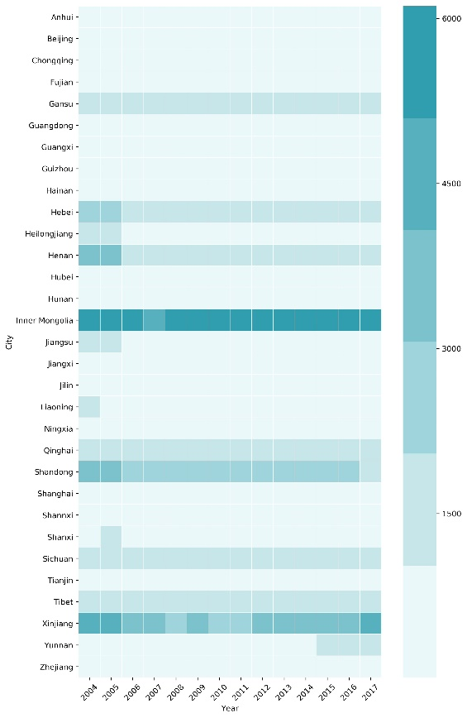
Figure S6 Cattle stocks (left) and Sheep stocks (right) provincial distribution in mainland China between 2004 and 2017. Henan had the largest number of cattle stocks, and Inner Mongolia was had the largest average stock of sheep among other provinces between 2004 and 2017.

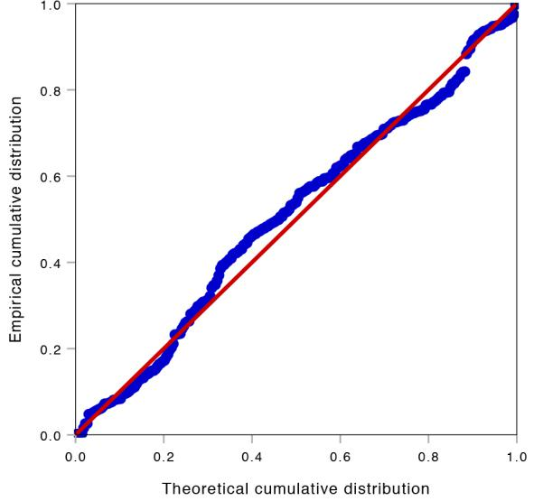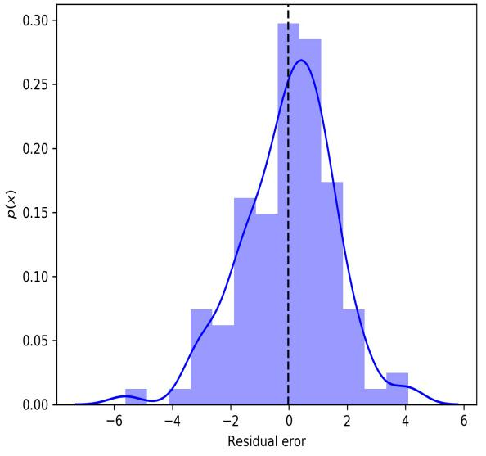
(a)
(b)
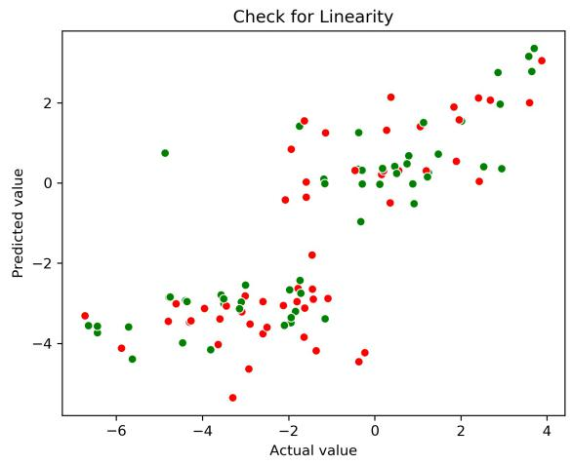
(c)

Figure S7 Validation of multivariate linear model: (a) P-P plot, (b) Residual error and (c) linearity check. Linear regression follows the basic assumptions: variables conform to multivariate normal distribution. Thus, in P-P plot, the data points should be as much in line with y=x function line to be assumed as normally distributed (a); residual errors need to be normally distributed and the mean of residual errors should be as close to zero as possible (b); the relationship between the observed and predicted values is linear (Red dot represented the observed values in testing set, and the green dots represented the predicted values) (c).
References
1. Paul A. When Can You Safely Ignore Multicollinearity? 2012. Available at: https://statisticalhorizons.com/multicollinearity (Accessed 1 September 2019).
2. Lai S, Zhou H, Xiong W, Gilbert M, Huang Z, Yu J, et al. Changing epidemiology of human brucellosis, China, 1955-2014. Emerg Infect Dis. 2017;23(2):184-94.
3. Feng L, Shay DK, Jiang Y, Zhou H, Chen X, Zheng Y, et al. Influenza-associated mortality in temperate and subtropical Chinese cities, 2003-2008. Bull World Health Organ. 2012;90(4):279–288B.

