Supplementary Material

Table S1: Countries Where Respondents Work
Country | Count | Percent
Australia | 1 | 0.12%
Bangladesh | 1 | 0.12%
Bolivia | 1 | 0.12%
Canada | 11 | 1.31%
China | 1 | 0.12%
Egypt | 1 | 0.12%
France | 2 | 0.24%
Georgia | 1 | 0.12%
Germany | 1 | 0.12%
India | 1 | 0.12%
Israel | 3 | 0.36%
Kenya | 26 | 3.10%
Kuwait | 1 | 0.12%
Lebanon | 2 | 0.24%
Netherlands | 2 | 0.24%
Nigeria | 2 | 0.24%
Portugal | 1 | 0.12%
Saudi Arabia | 1 | 0.12%
Serbia | 1 | 0.12%
South Africa | 1 | 0.12%
Sweden | 1 | 0.12%
Syria (Opposition Control) | 1 | 0.12%
Tunisia | 1 | 0.12%
Turkey | 9 | 1.07%
United Kingdom of Great Britain and Northern Ireland | 4 | 0.48%
United States of America | 760 | 90.69%
Zimbabwe | 1 | 0.12%
Grand Total | 838 | 100.00%

Table S2: Personal Health Concerns between HCWs with and without Health Risk Factors
 | Some Risk Factors | No Risk Factors | Row Total
Worried about Personal Healthª | 173 (86.5%) | 321 (68.2%) | 694
Not Worried about Personal Health^{b} | 27 (13.5%) | 150 (31.8%) | 177
Column Total | 200 (29.8%) | 471 (70.2%) | 671
Survey Question: “I feel worried about my personal health if/when providing direct in-person care to COVID-19 patients.”
ªIncludes “Strongly Agree” and “Agree” responses
^{b}Includes “Neither agree nor disagree”, “Disagree”, and “Strongly Disagree” responses

Table S3: Disease Spread Concerns between HCWs with and without Household Risk Factors
 | Some Risk Factors | No Risk Factors | Row Total
Worried about Spreadª | 200 (89.7%) | 335 (84.0%) | 535
Not Worried about Spread^{b} | 23 (10.3%) | 64 (16.0%) | 87
Column Total | 223 (35.9%) | 399 (64.1%) | 622
Survey Question: “After providing direct in-person care to COVID-19 patients I am worried about spreading COVID-19 to my family or friends.”
ªIncludes “Strongly Agree” and “Agree” responses
^{b}Includes “Neither agree nor disagree”, “Disagree”, and “Strongly Disagree” responses

Figure S1: Impact of PPE Shortages on HCW Duty to Provide Care
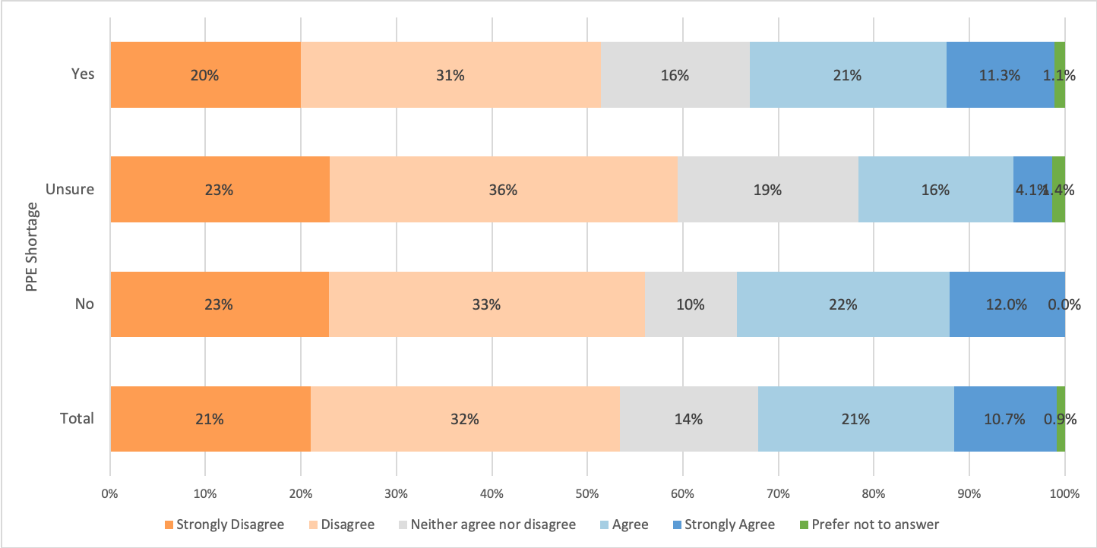
Survey Questions
Duty to Provide Care: “It is my professional duty to provide in-person care to patients with COVID-19 even if I cannot be provided with adequate personal protective equipment (PPE).”
PPE Shortage: “My place of work has faced or is facing shortages of personal equipment (PPE).”

Figure S2: HCW Experiences with Resource Limitations and Allocation
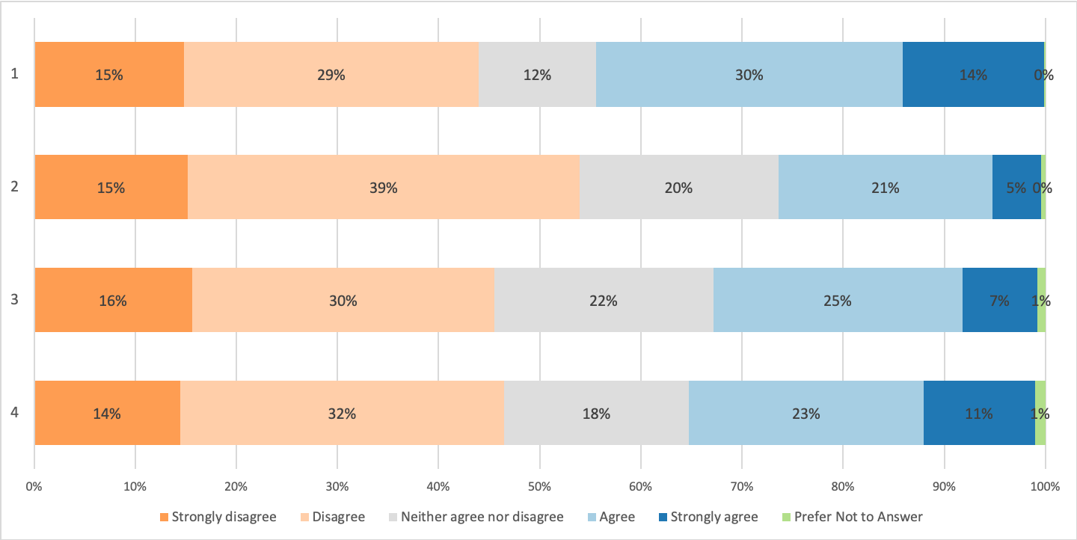
Survey Questions
1: “Before COVID-19, I was trained and/or had significant experience with priority setting with limited resources.”
2: “I have received sufficient training and preparation in how to allocate scarce resources to patients amidst the current COVID-19 pandemic.”
3: “My health care facility has given me clear information about how scarce resources will be allocated here if necessary so the burden of making decisions will not fall on the bedside team.”
4: “I am worried I will be required to personally make decisions about allocating limited resources, like which patients get ventilators or other life-saving resources, in the moment based on my own judgment.”

