Forest plot for pooled odds ratio of 30-Days survival(Study after 2010)

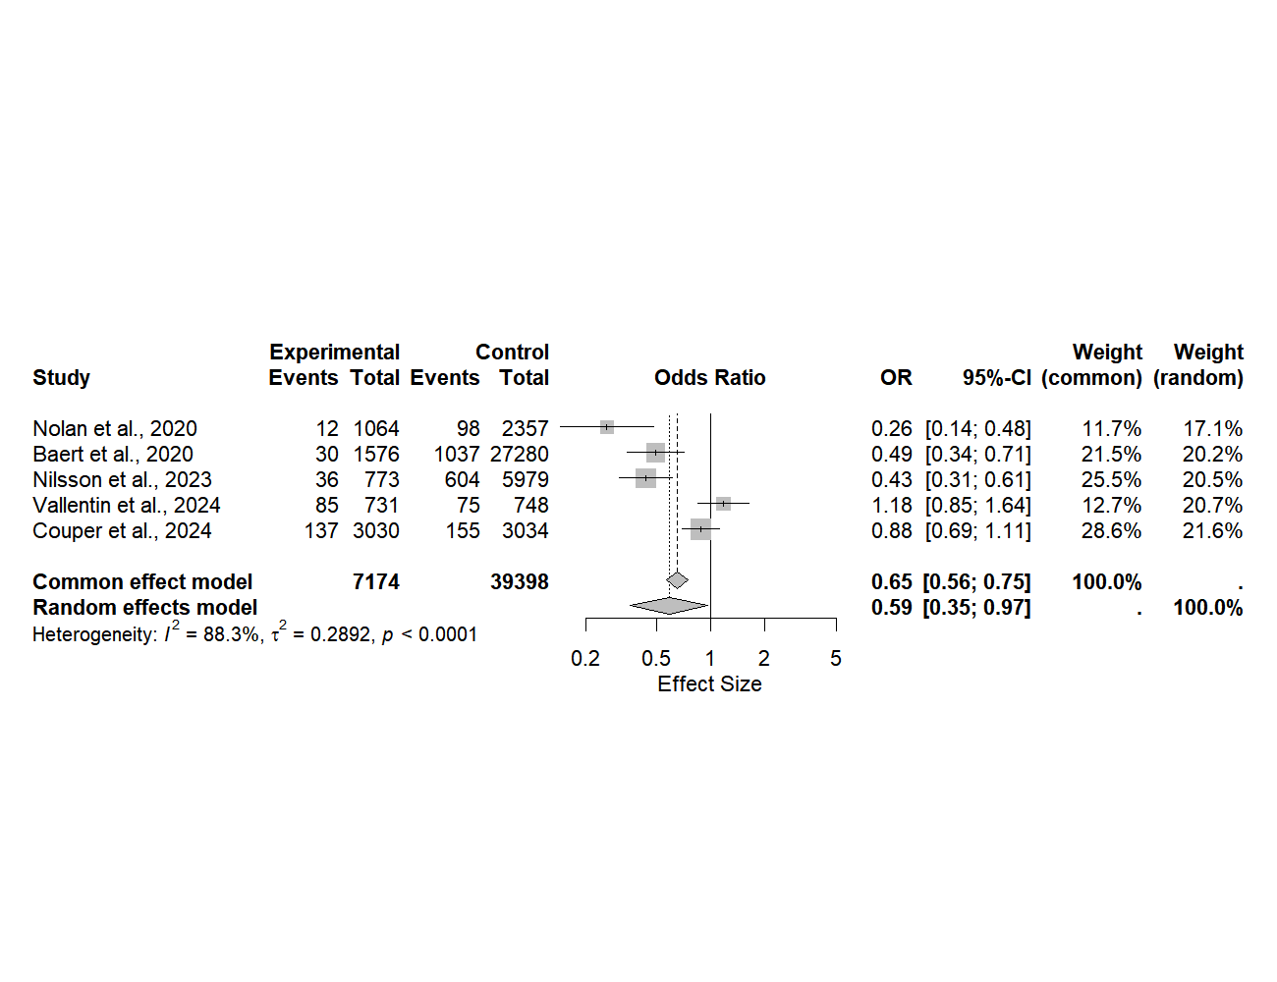

Forest plot for pooled odds ratio of 30-Days survival (Europe)

