Forest plot for pooled odds ratio of favorable neurological outcome at hospital discharge. (Shockable rhythms)

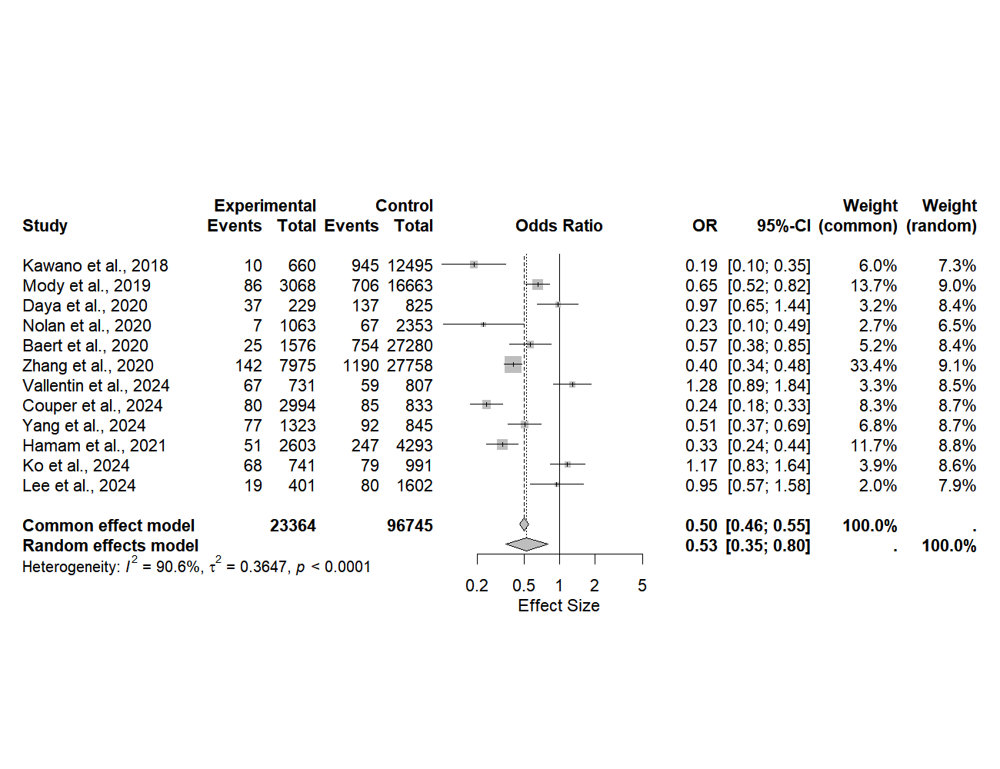

Forest plot for pooled odds ratio of favorable neurological outcome at hospital discharge. (Study Period Before 2010)

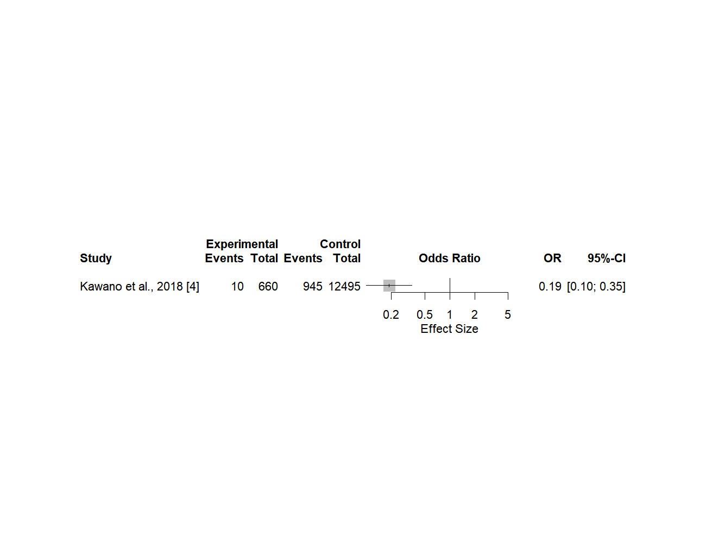

Forest plot for pooled odds ratio of favorable neurological outcome at hospital discharge. (Study Period After 2010)

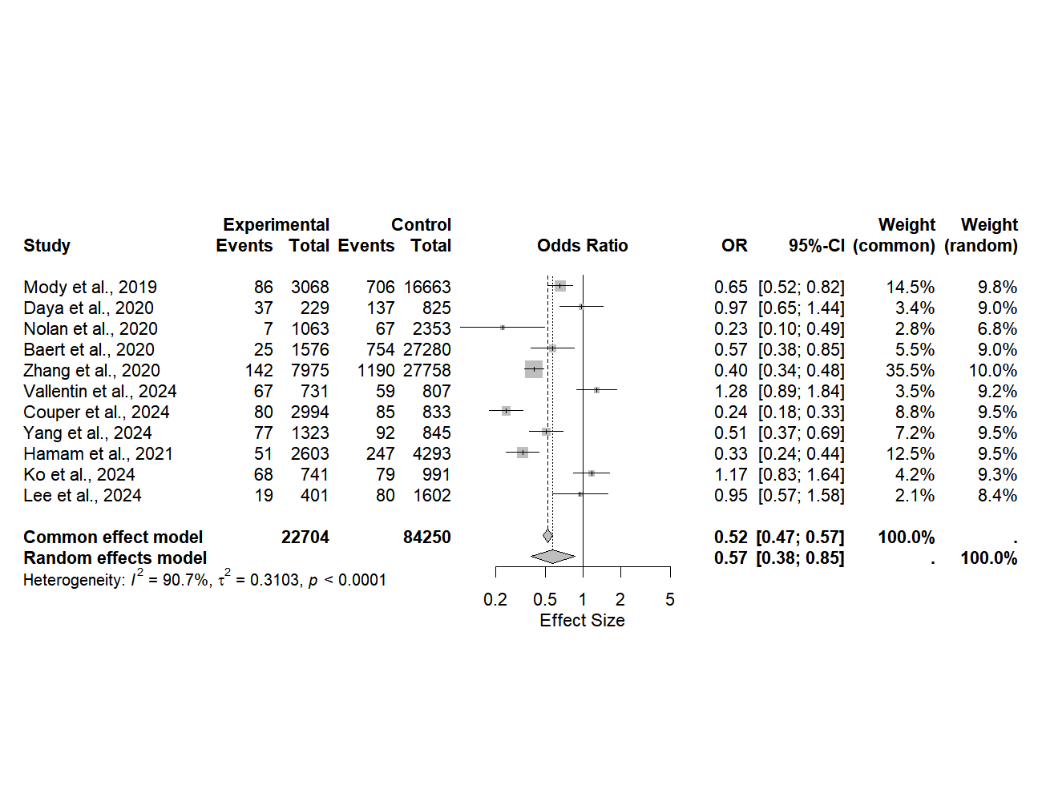

Forest plot for pooled odds ratio of favorable neurological outcome at hospital discharge. (Study Region - N/America)

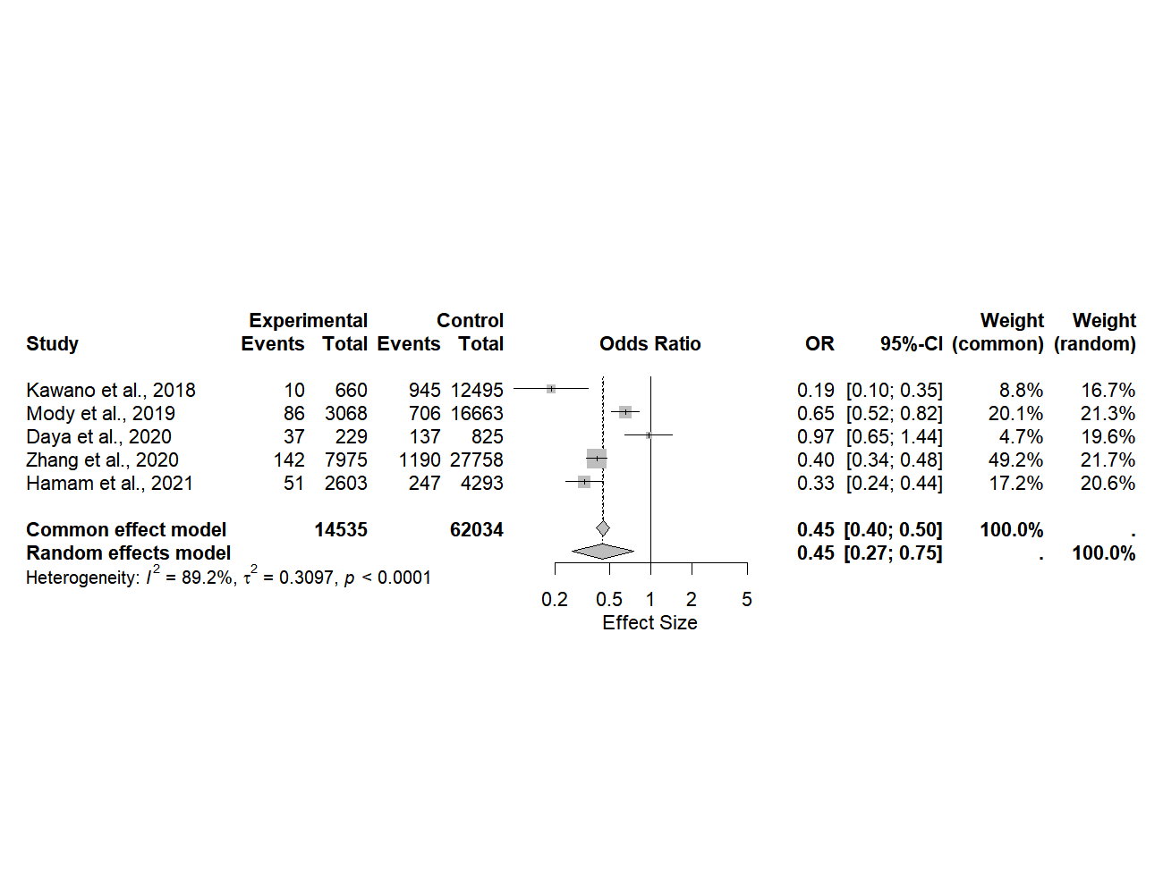

Forest plot for pooled odds ratio of favorable neurological outcome at hospital discharge. (Study Region - Europe)

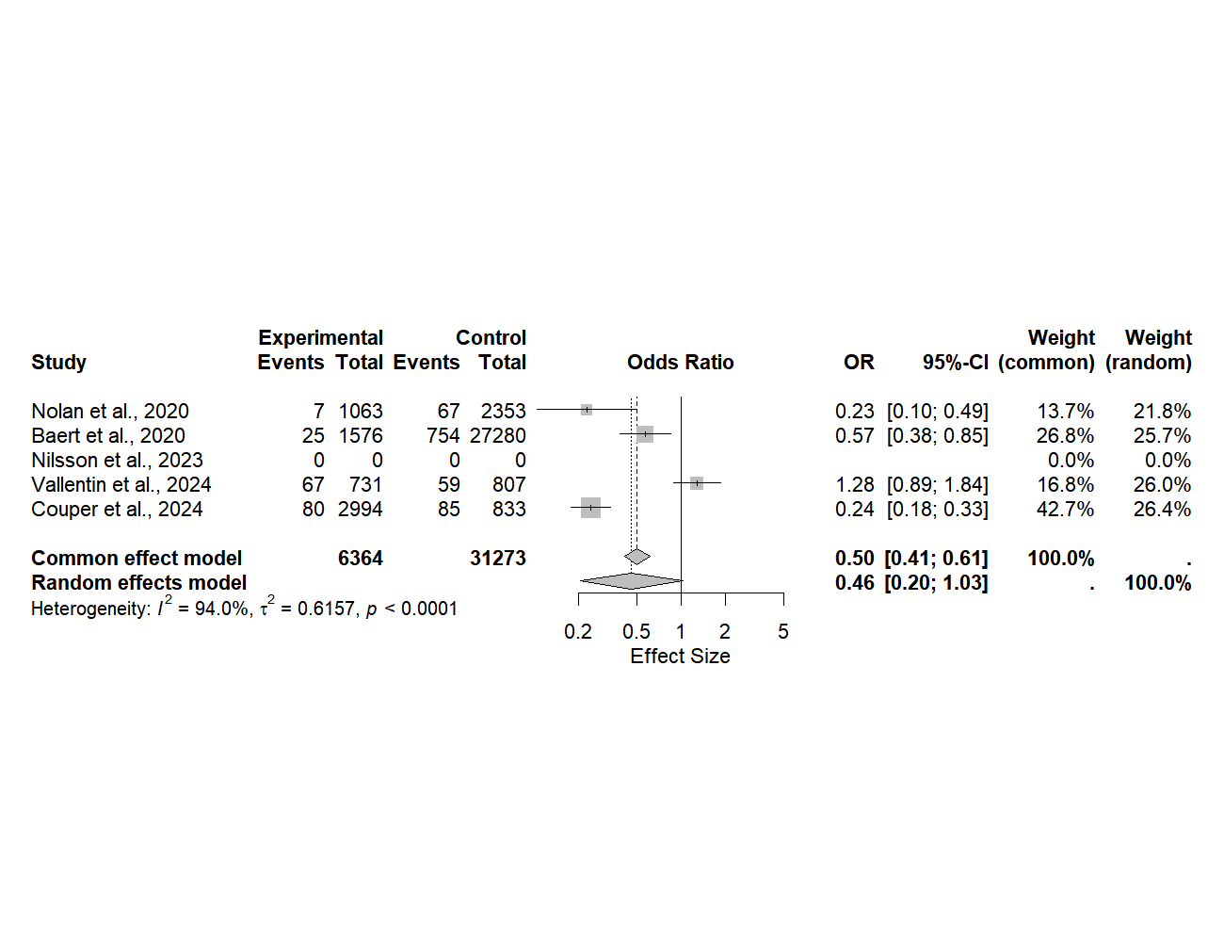

Forest plot for pooled odds ratio of favorable neurological outcome at hospital discharge. (Study Region - Asia)

