Supplementary Table 1 The comparison of eligibility criteria between the validation and development datasets
Eligible criteria | Validation dataset | Development dataset
Post-injury time | Any time | Within 8 hours
Minimum age | 15 | 16
GCS score | 3-15 | 3-14
Country | Thailand  (low-middle income country) | Both high-income and low-middle income country
CT scan | Positive ICH | Including no scan, normal and positive ICH
Abbreviations: GCS, Glasgow coma scale; CT, computed tomography; ICH, intracranial hemorrhage

Supplementary Table 2 The final equation after logistic recalibration
Final equation after logistic recalibration by adjusting intercept and slope
Basic model
- Linear predictor from the basic model = logit (probability from CRASH basic)
- Final predicted probability (Basic model) = 1.16 + 1.69 × [linear predictor from basic model + (-0.92)] *
CT model
- Linear predictor from the CT model = logit (probability from CRASH CT)
- Final predicted probability (CT model) = 1.44 + 1.86 × [linear predictor from CT model + (-1.26)] **
* 1.16 was the constant of logistic regression analysis of linear predictor, 1.69 was from the calibration slope, and 0.92 was from CITL
** 1.44 was the constant of logistic regression analysis of linear predictor, 1.86 was from the calibration slope, and 1.26 was from CITL
Abbreviations: CT, computed tomography, CITL: Calibration-in-the-large

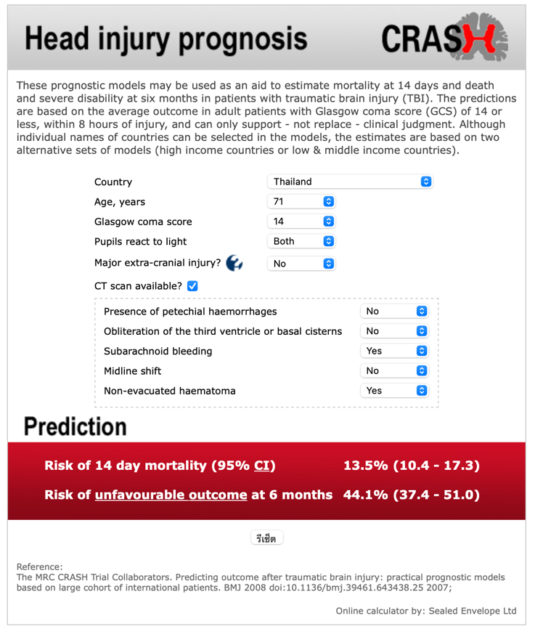

Supplementary Figure 1 Screenshot of the website version of the CRASH head injury prognosis calculator (URL: https://crash2.lshtm.ac.uk/Risk%20calculator/index.html)
a.

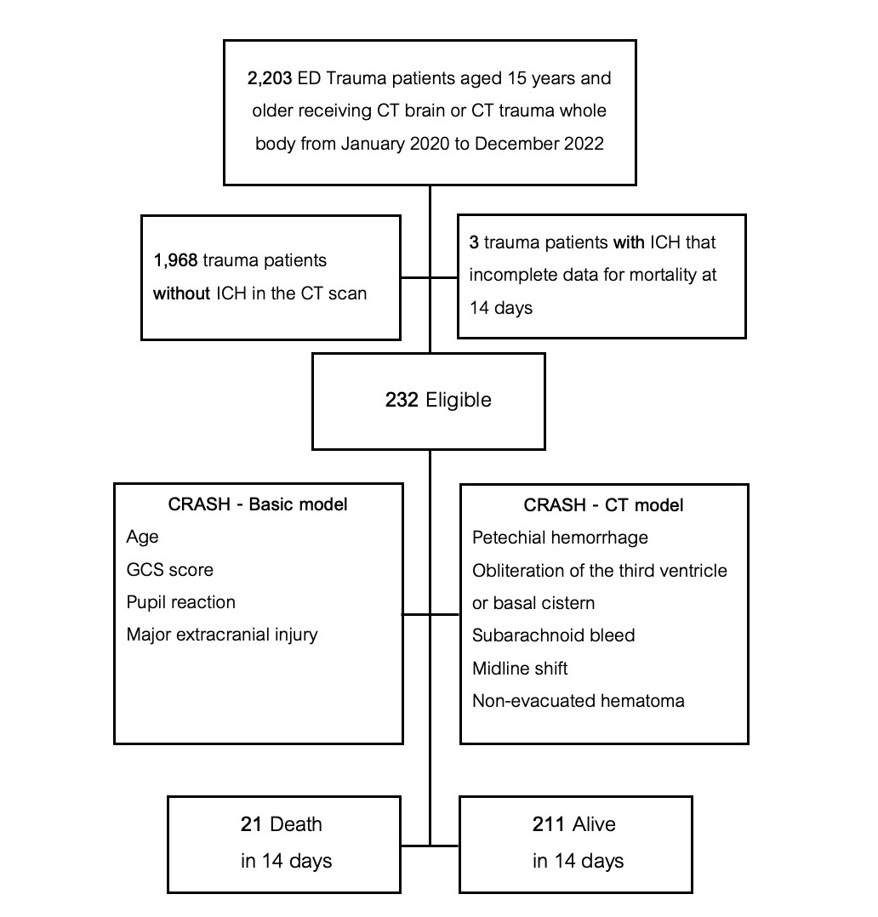
Supplementary Figure 2 Study flow of external validation study of CRASH prediction model
a.

