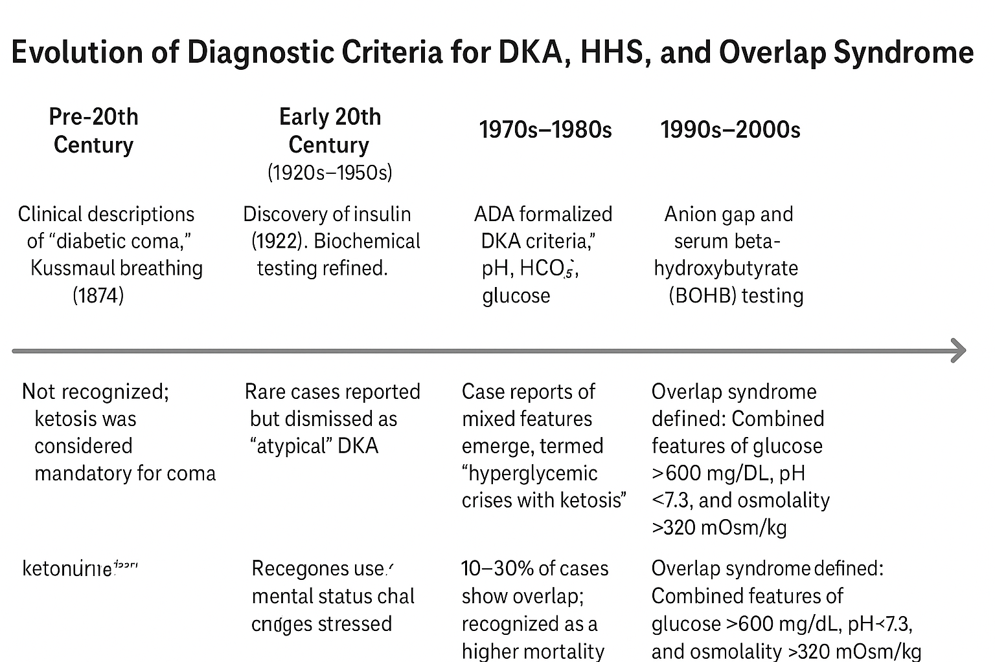

Figure 1: Timeline of Diagnostic Evolution: DKA, HHS, and Overlap Syndrome

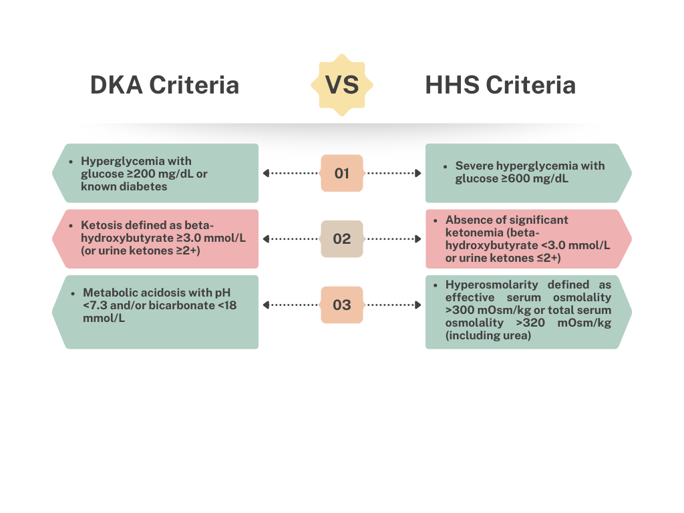

Figure 2: Diagnostic Criteria for DKA, HHS, and Overlap Syndrome
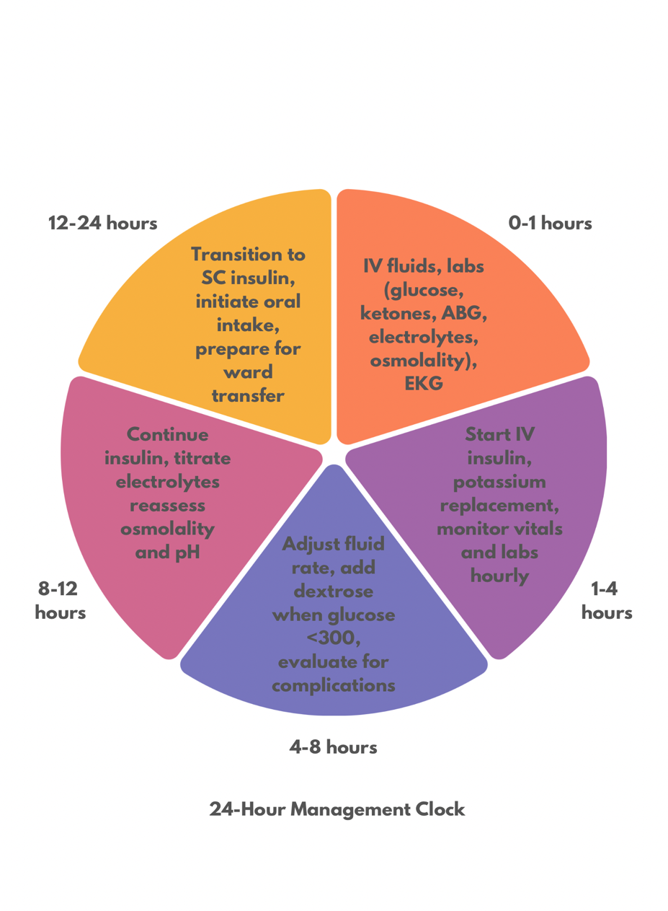

Figure 3: 24-Hour Management Clock for DKA–HHS Overlap

