Supplementary Material
Online Supplements, Appendix 1: Directed Acyclic Graph (DAG) diagram of possible mediators and confounders
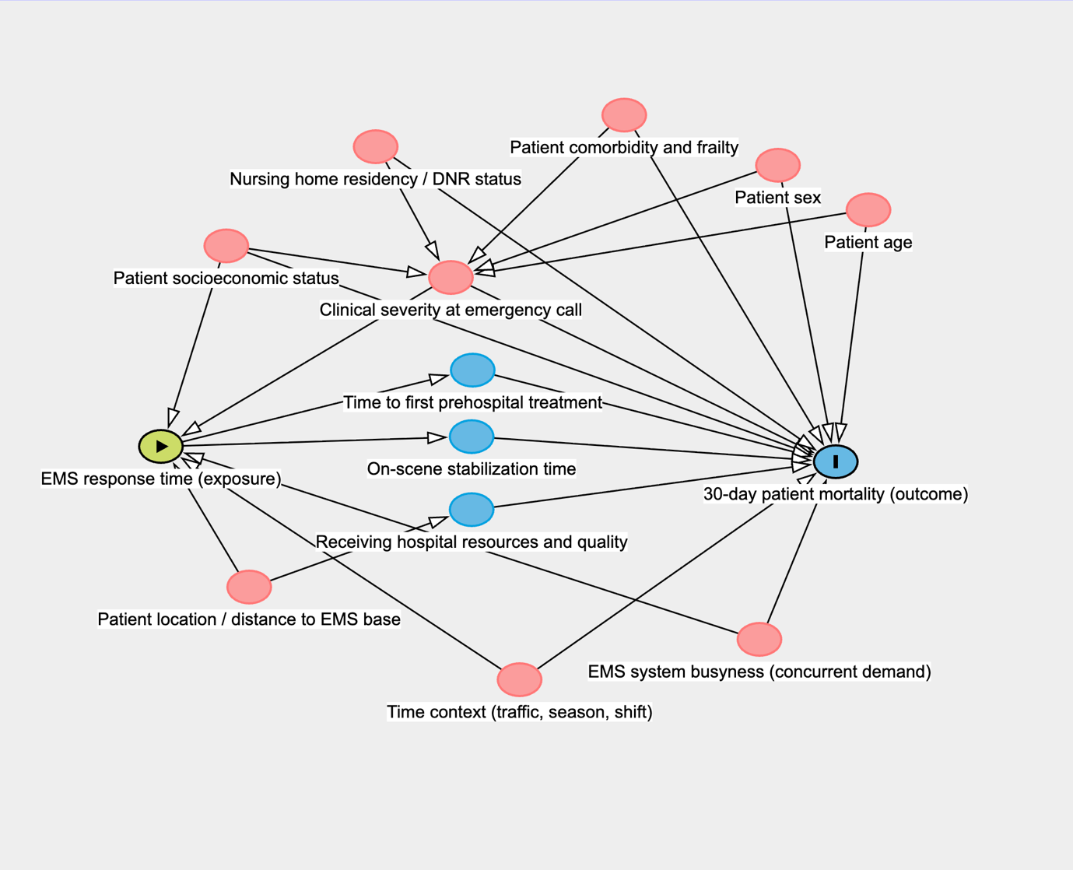
Legend: The green circle with a black triangle represents the exposure (EMS response time) and the blue circle with a black line represents the primary outcome (30-day patient mortality). The red circles represent variables that may affect both the exposure and the outcome directly or indirectly (confounders). The blue circles represent variables that affect only the outcome (mediators). It was not possible to include all the confounders in the analyses due to limited data availability. Abbreviations: DAG = Directed Acyclic Graph, DNR = Do Not Resuscitate, EMS = Emergency medical services.
Online Supplements, Appendix 2: Main dispatch categories by response time quartiles
 | ≤ 6 min 31 sec  (N=42 927) | 6 min 32 sec to 9 min 16 sec  (N=42 927) | 9 min 17 sec to 13 min 07 sec  (N=42 927) | ≥ 13 min 08 sec  (N=42 927) | Overall  (N=171 708)
Danish Index for Emergency
Care code, n (%)
01 Unconscious adult (> 8 years) | 1 300 (3.0) | 978 (2.3) | 854 (2.0) | 698 (1.6) | 3 830 (2.2)
02 Unconscious child (≤ 8 years) | 31 (0.1) | 32 (0.1) | 25 (0.1) | 11 (0.0) | 99 (0.1)
03 Foreign airway body obstruction | 163 (0.4) | 134 (0.3) | 116 (0.3) | 84 (0.2) | 497 (0.3)
04 Large scale accident | 3 (0.0) | 6 (0.0) | 3 (0.0) | 3 (0.0) | 15 (0.0)
05 Transport reservations | 153 (0.4) | 150 (0.3) | 126 (0.3) | 136 (0.3) | 565 (0.3)
06 Unclear problem | 5 529 (12.9) | 5 102 (11.9) | 4 895 (11.4) | 5 379 (12.5) | 20 905 (12.2)
07 Allergic reaction | 611 (1.4) | 727 (1.7) | 752 (1.8) | 739 (1.7) | 2 829 (1.6)
08 Bleeding – non-traumatic | 657 (1.5) | 868 (2.0) | 922 (2.1) | 941 (2.2) | 3 388 (2.0)
09 Burn, electrical injuries | 191 (0.4) | 184 (0.4) | 224 (0.5) | 216 (0.5) | 815 (0.5)
10 Chest pain, heart disease | 9 789 (22.8) | 10 501 (24.5) | 10 754 (25.1) | 10 514 (24.5) | 41 558 (24.2)
11 Diabetes | 481 (1.1) | 459 (1.1) | 400 (0.9) | 443 (1.0) | 1 783 (1.0)
12 Drowning | 18 (0.0) | 15 (0.0) | 14 (0.0) | 20 (0.0) | 67 (0.0)
13 Diving accident | 5 (0.0) | 3 (0.0) | 1 (0.0) | 1 (0.0) | 10 (0.0)
14 Animal bites, insect stings | 41 (0.1) | 56 (0.1) | 79 (0.2) | 74 (0.2) | 250 (0.1)
15 Fever | 94 (0.2) | 125 (0.3) | 145 (0.3) | 180 (0.4) | 544 (0.3)
16 Intoxication in children | 17 (0.0) | 15 (0.0) | 18 (0.0) | 16 (0.0) | 66 (0.0)
17 Childbirth | 97 (0.2) | 117 (0.3) | 83 (0.2) | 68 (0.2) | 365 (0.2)
18 Gynecology, pregnancy | 125 (0.3) | 154 (0.4) | 149 (0.3) | 172 (0.4) | 600 (0.3)
19 Headache | 201 (0.5) | 304 (0.7) | 313 (0.7) | 357 (0.8) | 1 175 (0.7)
20 Skin complaints, rashes | 3 (0.0) | 2 (0.0) | 5 (0.0) | 3 (0.0) | 13 (0.0)
21 Hypothermia, hyperthermia | 74 (0.2) | 110 (0.3) | 85 (0.2) | 92 (0.2) | 361 (0.2)
22 Chemicals, gasses | 29 (0.1) | 25 (0.1) | 34 (0.1) | 23 (0.1) | 111 (0.1)
23 Seizures, convulsions, fitting | 3 071 (7.2) | 2 437 (5.7) | 2 105 (4.9) | 1 856 (4.3) | 9 469 (5.5)
24 Abdominal pain, back pain | 415 (1.0) | 602 (1.4) | 644 (1.5) | 834 (1.9) | 2 495 (1.5)
25 Possible death, SIDS | 1 190 (2.8) | 917 (2.1) | 854 (2.0) | 701 (1.6) | 3 662 (2.1)
26 Impaired consciousness,  paralysis, dizziness | 6 819 (15.9) | 7 186 (16.7) | 7 444 (17.3) | 7 681 (17.9) | 29 130 (17.0)
27 Psychiatry, suicide | 530 (1.2) | 587 (1.4) | 561 (1.3) | 614 (1.4) | 2 292 (1.3)
28 Breathing difficulties | 4 019 (9.4) | 4 256 (9.9) | 4 201 (9.8) | 4 156 (9.7) | 16 632 (9.7)
29 Intoxication, medications,  alcohol, drugs | 862 (2.0) | 869 (2.0) | 697 (1.6) | 817 (1.9) | 3 245 (1.9)
30 Ill child | 528 (1.2) | 594 (1.4) | 615 (1.4) | 560 (1.3) | 2 297 (1.3)
31 Extremity pain, wounds,  fractures, minor injuries | 282 (0.7) | 330 (0.8) | 361 (0.8) | 560 (1.3) | 1 533 (0.9)
32 Traffic accident | 3 218 (7.5) | 2 614 (6.1) | 2 794 (6.5) | 2 270 (5.3) | 10 896 (6.3)
33 Accident (not traffic related) | 1 902 (4.4) | 1 950 (4.5) | 2 158 (5.0) | 2 184 (5.1) | 8 194 (4.8)
34 Urinary system | 7 (0.0) | 28 (0.1) | 19 (0.0) | 27 (0.1) | 81 (0.0)
35 Violence, abuse | 159 (0.4) | 148 (0.3) | 122 (0.3) | 115 (0.3) | 544 (0.3)
36 Ear, nose, throat | 103 (0.2) | 156 (0.4) | 131 (0.3) | 123 (0.3) | 513 (0.3)
37 Eyes | 16 (0.0) | 30 (0.1) | 26 (0.1) | 26 (0.1) | 98 (0.1)
Missing | 194 (0.5) | 156 (0.4) | 198 (0.5) | 233 (0.5) | 781 (0.5)
Legend: Patients with a priority level A response from Region Zealand, Denmark, 2018-2024 divided into response time quartiles (minutes: seconds). Abbreviations: SIDS: Sudden Infant Death Syndrome. Results are presented as column percentages.

