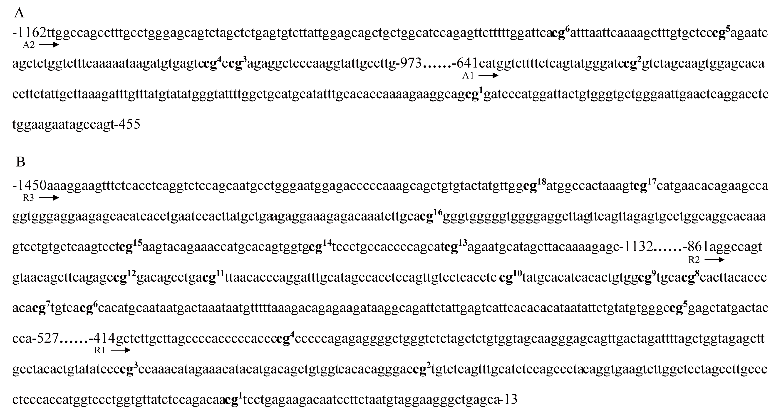
Figure S1. Regions of the mouse adiponectin and resistin promoters. The CG dinucleotides, assigned to each of the analyzed CGs, were marked and numbered on the top right. (A) The adiponectin promoter sequence with two regions spanning nucleotides -1162 to -455. (B) The resistin promoter sequence with three regions spanning nucleotides -1450 to -113

