Supplementary material

DNA methylation during human adipogenesis and the impact of fructose

Giulia Tini^{1,2}, Vijayalakshmi Varma³, Rosario Lombardo¹, Greg T. Nolen³ ,Gregory Lefebvre⁴, Patrick Descombes⁴, Sylviane Métairon⁴, Corrado Priami^{1,5}, Jim Kaput⁴, Marie-Pier Scott-Boyer¹

Supplementary figures

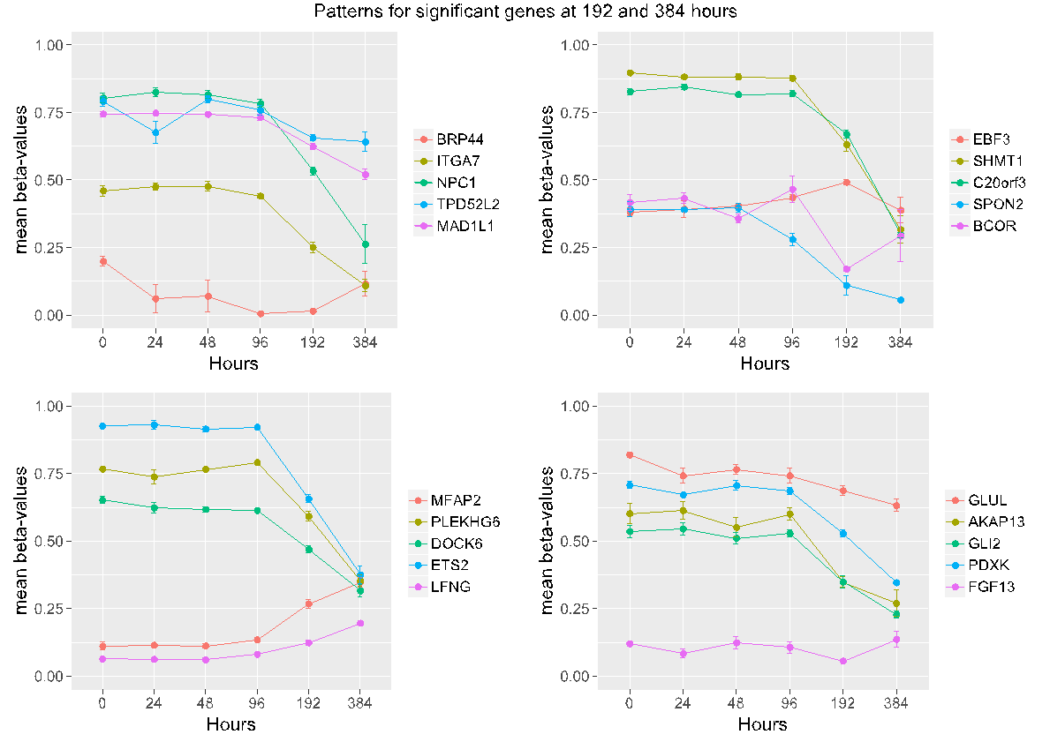

Supplementary Figure S1: Methylation patterns during differentiation for the 20 genes showing significant methylation changes both at 192 and 384 hours. To better inspect the patterns, genes are separated in four panels. Dots define averaged β-values for each time-point, while different colors represent different genes.

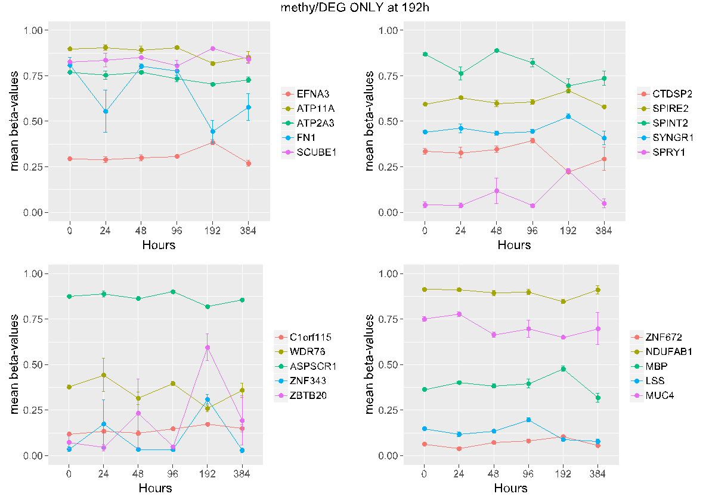

Supplementary Figure S2: methylation patterns during differentiation for the 20 genes significantly methylated/expressed at 192 hours (but not at 384 hours) which methylation levels return to the baseline at 384 hours. For each panel, mean β-values at each time point are represented by dots. Different colors represent different genes.

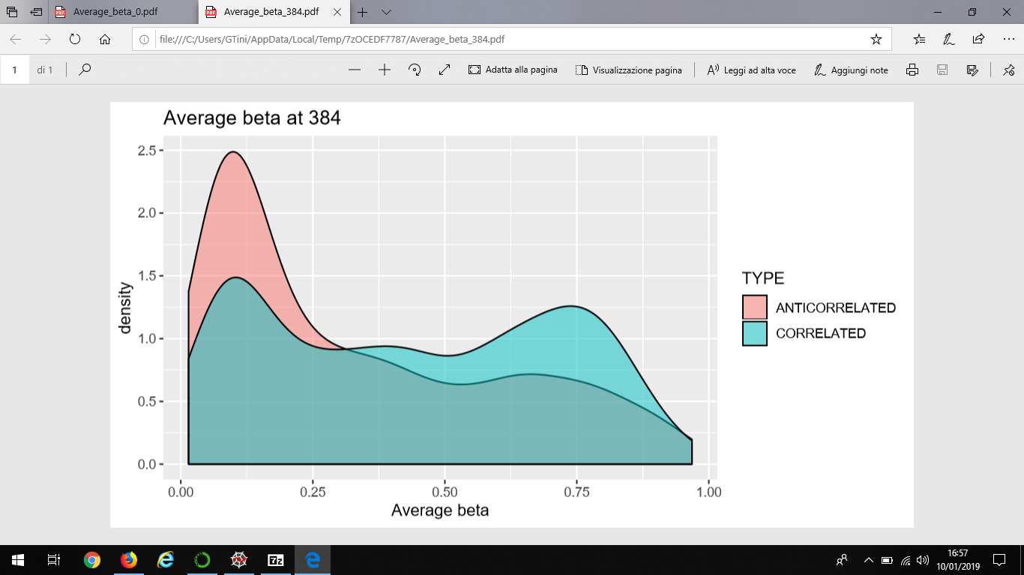
Supplementary Figure S3: Distribution of the average beta-values for the DMRs on DEGs at 384 hours. β-values of DMRs that show anti-correlated changes in methylation and gene expression are depicted in pink. The blue curve describes instead the distribution of β-values for DMRs showing the same direction of regulation in methylation and gene expression levels.

