Supplement to the manuscript titled “Effect of Gene-based vs. Standard Weight-Loss Recommendations on Anthropometry, Lipid and Glucose Markers, and Dietary Intake: A Randomized Controlled Trial (the MyGeneMyDiet® Study” by Nacis et al.

ClinicalTrials.gov:
https://clinicaltrials.gov/study/NCT05098899

Additional Table 1. Eligibility criteria
Study Inclusion Criteria:
- Overweight/obese
- 19-59 years old
- BMI equal or greater than 25 but not more than 40 kg/m²
- Normal to pre-disease state level of the following blood parameters:
  - Fasting blood glucose (4.11 – 6.05 mmol/L)
  - Lipid profile
    - Total cholesterol:
      - Desirable (<5.2 mmol/L)
      - Borderline high (5.2 – 6.2 mmol/L)
      - High (>6.2 mmol/L)
    - Triglycerides (<2.26 mmol/L)
    - HDL- cholesterol (>1.68 mmol/L)
    - VLDL (0.26 – 1.04 mmol/L)
    - LDL (0.3 – 3.37 mmol/L)
  - Cortisol (171 – 536 mmol/L)
  - Thyroid stimulating hormone (TSH) (0.270 – 4.200 nmol/L)
  - Triiodothyronine (T3) (1.3 – 3.1 nmol/L)
  - Thyroxine (T4) (66 – 181 nmol/L)
- Blood pressure (systolic: less than 120 mm Hg; diastolic: less than 80 mm Hg)
- Carrier of at least one of the risk alleles of the three target genetic polymorphisms:
  - A allele for FTO rs9939609
  - T allele for TCF7L2 rs7903146
  - G allele for UCP1 rs1800592

Study Exclusion Criteria:
- Individuals with elevated levels of fasting blood glucose, lipids, blood pressure, thyroid hormones, and cortisol
- Self-reported history of heart disease
- Participation in weight-loss program
- Adherence to a restrictive/therapeutic diet in the past 3 months
- Self-reported weight changes (greater than 3.0 kg)
- Planned or recent bariatric surgery
- Consumption of weight-altering medications and/or nutritional supplements that provide weight gain/loss in the past 6 months
- Clinical diagnosis of any mental disorder
- Current use of mental health medications
- (For females) – pregnant, nursing, or with self-declared intention to become pregnant during the study
- Current and anticipated enrollment in another research study

Additional file: Supplementary Method 1

The development of the MyGeneMyDiet® Recommendations followed three investigative phases: Explore, Develop, and Integrate (Figure 1). Each phase is built upon the findings of the previous, culminating in the implementation of genotype-based nutritional guidance through a randomized controlled trial.

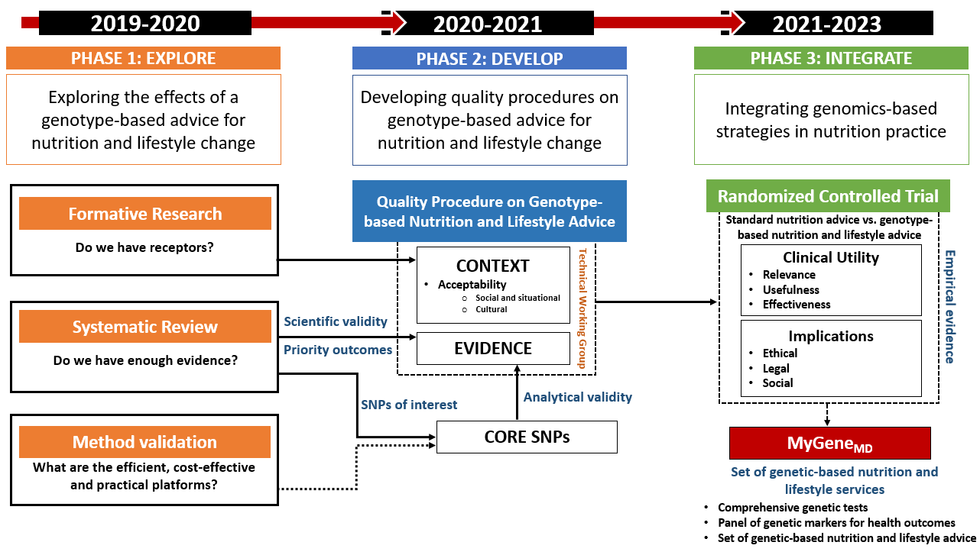
Figure 1. Development Stages of the MyGeneMyDiet® Recommendations

Phase I: Explore
This phase focused on:
- Conducting a scoping review to assess methodologies used in gene-based nutrition interventions.
- Benchmarking of existing nutrigenetic tests.
- Performing formative qualitative research to understand perceptions of nutrigenomics and gene-based nutrition recommendations among prospective end-users.
- Validating laboratory procedures for genetic analysis.

Scoping Review and SNP Identification
The scoping review (results not published) identified single nucleotide polymorphisms (SNPs) linked to obesity-related phenotypes. This review examined genetic testing, risk disclosure, and genotype-informed nutrition advice in randomized controlled trials (RCTs) targeting weight management. A total of 14 studies were identified as relevant (Figure 2).

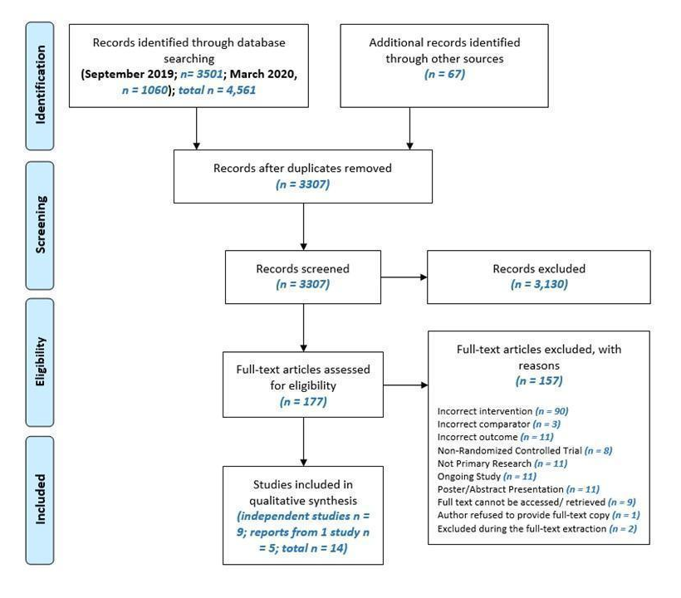

Figure 2. The flow of search, screening, and selection of studies following the PRISMA Diagram

Electronic searches were conducted in databases such as PubMed, Cochrane Library, EBSCO, MEDLINE, CINAHL, and Google Scholar using keywords related to nutrigenomics, SNPs, precision nutrition, and weight management. Benchmarking was also conducted using sample test results and recommendations from commercial nutrigenetic services.

Keywords used included: adult, nutrigenomics, nutritional genomics, nutrigenetics, nutritional genetics, personalized nutrition, nutritional epigenetics, single nucleotide polymorphisms, SNP, DNA, gene, genome, precision nutrition, nutrition counsel, nutrition advice, nutrition recommendation, dietary counsel, dietary advice, dietary recommendation, genotype-based, gene-based, DNA-based, genomics-based, genetic test, genetic information, genetic risk, diet, food, nutrition, physical activity, smoking, alcohol.

The pre-selected outcomes included BMI, waist circumference, dietary fat intake, energy intake, and physical activity. SNPs were shortlisted based on frequency of use, availability of lifestyle modifiability, and strength of evidence linking them to nutrition and obesity outcomes. The SNPs identified for further development as a MyGeneMyDiet® Recommendation are listed in Table 1.

Table 1. Single nucleotide polymorphisms (SNPs) and phenotypes
Gene | SNP | Risk Allele/Variant | Phenotype
FTO | rs99396609 | A (AA/AT) | BMI, waist circumference, physical activity levels
TCF7L2 | rs7903146 | T (TT/CT) | Dietary fat intake
UCP1* | rs1800592 | G (GG/GA) | Energy requirement
*Included based on benchmarking of existing nutrigenetic recommendations

Summary and Relevance of the Scoping Review Findings
The scoping review (unpublished) provided foundational evidence for the development of the MyGeneMyDiet® recommendations. It synthesized findings from 14 randomized trials or meta-analyses investigating gene-based versus standard nutrition interventions. While most studies reported mixed or non-significant results – particularly for changes in energy intake, macronutrients, or anthropometric outcomes – a few showed modest benefits in fat intake reduction, BMI changes, or achieving 5% weight loss. Overall, findings were limited by heterogeneity in intervention duration, outcome measures, adherence tracking, and SNP targets.

These insights underscored the need for practical and behaviorally actionable SNP targets. Hence, the following were selected:
- FTO rs9939609, consistently linked to appetite regulation and responsiveness to physical activity.
- UCP1 rs1800592, tied to thermogenesis and energy expenditure.
- TCF7L2 rs8903146, associated with glucose and fat metabolism.

All three SNPs were deemed actionable and relevant for guiding personalized dietary and physical activity recommendations.

Phase II: Develop
This phase concentrated on designing the MyGeneMyDiet® Recommendations and their supporting tools. A Technical Working Group (TWG), composed of nutritionist-dietitians and medical technologists from DOST-FNRI, led the development process. Recommendations were based on (1) findings from the scoping review, (2) evidence-based obesity management guidelines; and (3) culturally appropriate practices.

The following tools and procedures were developed:

MyGeneMyDiet® standard tools, and quality standard procedures | Purpose/Contents
Summary of Gene-based Nutrition Recommendations | Gene-based Nutrition Recommendations for risk allele carriers of FTO rs9939609, UCP1 rs1800592, and TCF7L2 rs7903146
Standard Procedures for Gene-based Nutrition Assessment and Counseling | Process, procedures, and key people involved in the gene-based nutrition assessment and counseling
Decision Trees of Recommendations | Comprises of algorithms of nutrition assessment procedures and corresponding MyGeneMyDiet® recommendations for FTO rs9939609, UCP1 rs1800592, and TCF7L2 rs7903146
Nutrigenetic Report and Personalized Meal plans | A report detailing genetic test results, MyGeneMyDiet® recommendations, and sample meal plans
Nutrition Education Modules | A collection of nutritional education lessons focused on weight management strategies. Address topics related to healthy eating, physical activity, sustaining weight loss goals, and avoiding weight relapse
Genetic Education Flipcharts | A set of genetic education flipcharts designed for use by genetic counselors to communicate genetic test results and provide psychosocial counseling.

Scientific Advisory Board (SAB)
The SAB included experts in nutrition, genetics, and lifestyle medicine. Between February and December 2021, five iterative meetings were conducted to review and finalized the intervention content and delivery protocols.

Table 2. Summary of SAB meetings
SAB Meetings | Tools and Materials Reviewed | Date
1st SAB Meeting | Overview of the MyGeneMyDiet® Recommendations and Standard Procedures for Gene-based Nutrition Assessment | February 18, 2021
2nd SAB Meeting | Nutrigenetic Report | March 18, 2021
3rd SAB Meeting | Decision Trees for Recommendations | May 25, 2021
4th SAB Meeting | Genetic Education Flipcharts | September 16, 2021
5th SAB Meeting | Nutrition Education Modules | December 9, 2021

Phase III: Integrate
This final phase tested the feasibility, relevance, and potential effectiveness of the MyGeneMyDiet® Recommendations through a 12-month randomized controlled trial. The trial’s dual-phase design – active (months 0 – 6) and inactive (months 6-12) – provided insights into both the immediate and sustained effects of genotype-informed guidance.

The final set of recommendations delivered to participants randomized to the gene-based nutrition recommendation group were as follows, with each tailored to participants carrying a specific polymorphism:
- For participants carrying FTO rs9939609 (A): Engage in ≥30–60 minutes of moderate-intensity physical activity daily.
- For participants carrying UCP1 rs1800592 (G): Reduce calorie intake by an additional 150 kcal/day beyond estimated needs.
- For participants carrying TCF7L2 rs7903146 (T): Limit fat intake to 15–20% of total daily energy.

Decision trees were developed to support delivery of these gene-specific strategies. The decision tree was structured into four domains:
- Domain A: Disclosure of genotype and explanation of risk.
- Domain B: Nutritional guidance based on genotype.
- Domain C: Tailored dietary targets based on nutritional needs.
- Domain D: Lifestyle and behavioral recommendations.

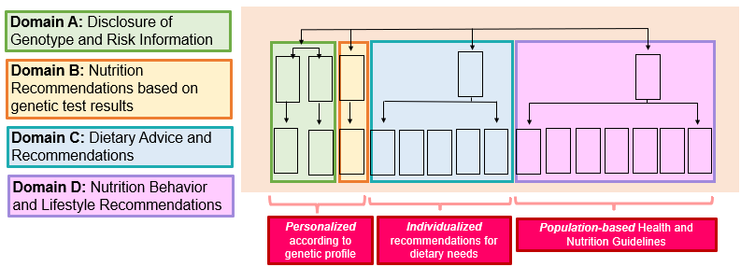
Figure 3. Personalization Domains of the MyGeneMyDiet® Recommendations

All finalized tools, recommendations, and delivery procedures were described in detail in a prior protocol paper (Nacis JS et al., 2023, Frontiers in Nutrition, https://doi.org/10.3389/fnut.2023.1238234).

Additional Table 2. Distribution of genetic polymorphisms carried by the study participants.
 |  | Genotype distribution, n (%)¹
Gene, rs number |  | Active phase |  | Inactive phase
Gene, rs number |  | Standard  Recommendation (n = 23) | MyGeneMyDiet® (n = 29) | Standard Recommendation (n = 12) | MyGeneMyDiet® (n = 15)
FTO, rs9939609 | AA | 0 (0.0) | 3 (10.3) | 0 (0.0) | 1 (6.7)
 | AT | 11 (47.8) | 8 (27.6) | 8 (66.7) | 5 (33.3)
UCP1, rs1800592 | GG | 4 (17.4) | 6 (20.7) | 2 (16.7) | 3 (20.0)
 | GA | 12 (52.2) | 18 (62.1) | 4 (33.3) | 9 (60.0)
TCF7L2, rs7903146 | CC | 21 (91.3) | 29 (100.0) | 10 (83.3) | 15 (100.0)
 | CT | 2 (8.7) | 0 (0.0) | 2 (16.7) | 0 (0.0)
¹The genotypes presented here represent those carrying the risk alleles. Participants carrying the homozygous non-risk genotypes (TT for FTO rs9939609, AA for UCP1 rs1800592, and TT for TCF7L2 rs7903146) were excluded from the study

Additional Table 3. Adherence rates to the genotype-based recommendations for total calorie intake, fat intake, and physical activity in the MyGeneMyDiet® and standard recommendation groups across four time points
Time Point (Months) | TOTAL CALORIES |  |  | FAT INTAKE |  |  | PHYSICAL ACTIVITY
Time Point (Months) | Standard  Recommendation | MyGeneMyDiet® | P-value | Standard  Recommendation | MyGeneMyDiet® | P-value | Standard  Recommendation | MyGeneMyDiet® | P-value
3 | 5 (21.73) | 3 (11.54) | 0.564 | 3 (13.04) | 5 (19.23) | 0.843 | 12 (63.16) | 8 (40.00) | 0.795
6 | 3 (13.04) | 7 (26.92) | 0.396 | 4 (17.39) | 6 (23.08) | 0.890 | 9 (56.25) | 7 (53.33) | 0.674
9 | 2 (11.76) | 4 (23.53) | 0.653 | 2 (11.76) | 4 (23.53) | 0.653 | 10 (66.67) | 3 (25.00) | 0.266
12 | 4 (33.33) | 2 (13.33) | 0.438 | 1 (8.33) | 2 (13.33) | 1.000 | 6 (66.67) | 3 (50.00) | 0.632
Values are reported as n (%) of participants who adhered to each behavioral target, as assessed using 3-day food diaries (for dietary adherence) and IPAQ-SF questionnaires (for physical activity). P-values represent between-group differences assessed at each time point.

Additional Table 4. Difference in outcomes at month 6 of intervention, with imputation methods
 | ACTIVE PHASE (Month 6)
 | Standard Recommendation | MyGeneMyDiet® | Difference [95% CI] | P – value*
Anthropometry
Weight (kg) | 75.87 + 13.48 | 74.92 + 14.62 | RAW: 0.95 [0.89, 1.09]  LOCF: 0.63 [0.91, 1.11]  IPAW: 0.95 [0.89, 1.09] | 0.754  0.940  0.763
BMI (kg/m²) | 28.96 + 3.04 | 29.35 + 4.37 | RAW: -0.39 [0.94, 1.08]  LOCF: -0.82 [0.95, 1.10]  IPAW: -0.39 [0.95, 1.09] | 0.813  0.571  0.682
Waist circumference (cm) | 88.70 + 8.85 | 88.81 + 11.27 | RAW: -0.11 [0.94, 1.06]  LOCF: -1.23 [0.95, 1.07]  IPAW: -0.11 [0.94, 1.06] | 0.957  0.739  0.971
Body fat (%) | 33.64 + 8.24 | 38.12 + 6.68 | RAW: -4.48 [1.02, 1.30]  LOCF: -4.44 [1.01, 1.30]  IPAW: -4.48 [1.04, 1.34] | 0.026  0.038  0.014
Biochemical markers
HbA1c (%) | 5.64 + 0.33 | 5.46 + 0.37 | RAW: 0.18 [0.93, 1.00]  LOCF: 0.13 [0.94, 1.01]  IPAW: 0.18 [0.94, 1.01] | 0.063  0.173  0.212
Total cholesterol (mmol/L) | 5.20 + 1.01 | 5.28 + 1.00 | RAW: -0.08 [0.91, 1.14]  LOCF: -0.08 [0.91, 1.14]  IPAW: -0.08 [0.91, 1.16] | 0.743  0.728  0.644
HDL-cholesterol (mmol/L) | 1.29 + 0.31 | 1.31 + 0.29 | RAW: -0.02 [0.89, 1.16]  LOCF: -0.02 [0.90, 1.16]  IPAW: -0.02 [0.89, 1.17] | 0.843  0.782  0.783
LDL-cholesterol (mmol/L) | 3.23 + 0.95 | 3.19 + 1.02 | RAW: 0.04 [0.81, 1.19]  LOCF: 0.01 [0.83, 1.20]  IPAW: 0.04 [0.82, 1.22] | 0.881  0.969  0.985
Triglycerides (mmol/L) | 1.53 + 0.66 | 1.71 + 1.66 | RAW: -0.18 [0.74, 1.36]  LOCF: -0.13 [0.74, 1.31]  IPAW: -0.18 [0.75, 1.39] | 0.974  0.904  0.900
Dietary intake
Total calories (kcal) | 1677.13 + 437.5 | 1515.85 + 502.2 | RAW: 161.28 [0.74, 1.05]  LOCF: 98.89 [0.77, 1.09]  IPAW: 161.28 [0.76, 1.08] | 0.157  0.312  0.254
Protein (g) | 67.30 + 18.39 | 61.0 + 20.45 | RAW: 6.30 [0.74, 1.06]  LOCF: 2.13 [0.77, 1.12]  IPAW: 6.30 [0.74, 1.06] | 0.176  0.448  0.170
Carbohydrates (g) | 196.15 + 60.74 | 170.23 + 54.81 | RAW: 25.92 [0.72, 1.05]  LOCF: 21.77 [0.73, 1.07]  IPAW: 25.92 [0.73, 1.07] | 0.146  0.208  0.209
Fat (g) | 68.65 + 27.88 | 65.54 + 27.69 | RAW: 3.11 [0.74, 1.21]  LOCF: 0.14 [0.77, 1.26]  IPAW: 3.11 [0.75, 1.23] | 0.659  0.916  0.750
Values are presented as mean ± SD. P values were obtained using t-tests. Abbreviations: HbA1c – glycated hemoglobin; HDL – high-density lipoprotein; LDL – low-density lipoprotein. RAW indicates results without imputation, LOCF denotes Last Observation Carried Forward, and IPAW refers to Inverse Probability of Attrition Weighting. This table presents results for the active phase (month 6), providing differences between groups analyzed using RAW, LOCF, and IPAW methods.

Additional Table 5. Difference in outcomes at month 12 of intervention, with imputation methods
 | INACTIVE PHASE (Month 12)
 | Standard Recommendation | MyGeneMyDiet® | Difference [95% CI] | P – value*
Anthropometry
Weight (kg) | 71.69 ± 11.4 | 71.68 ± 13.3 | RAW: 0.01 [0.87, 1.14]  LOCF: -0.67 [0.90, 1.11]  IPAW: 0.01 [0.84, 1.10] | 0.955  0.925  0.584
BMI (kg/m²) | 27.86 ± 1.86 | 28.01 ± 3.71 | RAW: -0.15 [0.92, 1.08]  LOCF: -0.87 [0.95, 1.10]  IPAW: -0.15 [0.93, 1.09] | 0.995  0.563  0.858
Waist circumference (cm) | 84.64 ± 4.61 | 84.42 ± 9.29 | RAW: 0.22 [0.93, 1.06]  LOCF: -2.07 [0.95, 1.09]  IPAW: 0.22 [0.93, 1.06] | 0.844  0.564  0.866
Body fat (%) | 32.74 ± 7.19 | 36.3 ± 7.30 | RAW: -3.56 [0.94, 1.31]  LOCF: -4.54 [1.01, 1.30]  IPAW: -3.56 [0.99, 1.39] | 0.212  0.039  0.061
Biochemical markers
HbA1c (%) | 5.48 ± 0.39 | 5.54 ± 0.59 | RAW: -0.06 [0.94, 1.08]  LOCF: 0.01 [0.96, 1.04]  IPAW: -0.06 [0.95, 1.12] | 0.815  0.915  0.433
Total cholesterol (mmol/L) | 5.52 ± 1.07 | 5.13 ± 0.87 | RAW: 0.39 [0.81, 1.07]  LOCF: 0.15 [0.88, 1.07]  IPAW: 0.39 [0.80, 1.04] | 0.343  0.567  0.143
HDL-cholesterol (mmol/L) | 1.37 ± 0.29 | 1.40 ± 0.33 | RAW: -0.04 [0.86, 1.22]  LOCF: -0.05 [0.92,1.18]  IPAW: -0.04 [0.85, 1.21] | 0.800  0.539  0.881
LDL-cholesterol (mmol/L) | 3.47 ± 0.98 | 3.19 ± 0.78 | RAW: 0.27 [0.76, 1.16]  LOCF: 0.22 [0.78, 1.09]  IPAW: 0.27 [0.73, 1.08] | 0.553  0.361  0.221
Triglycerides (mmol/L) | 1.50 ± 0.87 | 1.16 ± 0.41 | RAW: 0.34 [0.60, 1.10]  LOCF: -0.03 [0.70, 1.26]  IPAW: 0.34 [0.64, 1.15] | 0.179  0.692  0.299
Dietary intake
Total calories (kcal) | 1718.3 ± 620.2 | 1291.9 ± 466.5 | RAW: 426.40 [0.56, 0.96]  LOCF: 184.37 [0.72, 1.04]  IPAW: 426.40 [0.49, 0.90] | 0.023  0.130  0.011
Protein (g) | 79.75 ± 40.60 | 51.2 ± 16.31 | RAW: 28.55 [0.51, 0.87]  LOCF: 11.51 [0.69, 1.03]  IPAW: 28.55 [0.45, 0.88] | 0.003  0.092  0.009
Carbohydrates (g) | 199.67 ± 46.43 | 159.8 ± 63.67 | RAW: 39.87 [0.59, 0.98]  LOCF: 22.43 [0.70, 1.04]  IPAW: 39.87 [0.58, 0.94] | 0.036  0.109  0.016
Fat (g) | 67.0 ± 43.10 | 49.8 ± 22.32 | RAW: 17.20 [0.54, 1.11]  LOCF: 9.65 [0.68, 1.12]  IPAW: 17.20 [0.48, 1.10] | 0.160  0.280  0.124
Values are presented as mean ± SD. P values were obtained using t-tests. Abbreviations: HbA1c – glycated hemoglobin; HDL – high-density lipoprotein; LDL – low-density lipoprotein. RAW indicates results without imputation, LOCF denotes Last Observation Carried Forward, and IPAW refers to Inverse Probability of Attrition Weighting. This table presents results for the inactive phase (month 12), with differences between groups analyzed using RAW, LOCF, and IPAW methods.

