Supplementation files

Supplementary S1 | Literature search strategy used for each considered database
Supplementary S2 | Characteristics of Included Randomized Controlled Trials and Individual-Level Features Used to Generate Personalized Nutrition Interventions
Supplementary S3 | Characteristics of Control Diets and Personalized Nutrition Interventions Across Included Randomized Controlled Trials
Supplementary S4 | Delivery Modes, Contact Intensity, and Generators of Personalized Diets Across Included Randomized Controlled Trials
Supplementary S5 | Visualization of Sensitivity Analysis Results (Leave-one-out Method)
Supplementary S6 | Bayesian meta-regression of intervention duration on outcomes
Supplementary S7 | Funnel plot for publication bias
Supplementary S8 | GRADE rating for quality of evidence
 | References

Supplementary S1. Literature search strategy used for each considered database

Database | Syntax | Results
Pubmed | (("personalized diet"[All Fields] OR "personalized nutrition"[All Fields] OR "personalised nutrition"[All Fields] OR "individualized nutrition"[All Fields] OR "individualised nutrition"[All Fields] OR "precision nutrition"[All Fields] OR ("nutrigenomics"[MeSH Terms] OR "nutrigenomics"[All Fields] OR "nutrigenomic"[All Fields]) OR ("nutrigenetic"[All Fields] OR "nutrigenomics"[MeSH Terms] OR "nutrigenomics"[All Fields] OR "nutrigenetics"[All Fields]) OR "nutritional genomics"[All Fields] OR "gene-diet interaction"[All Fields] OR "individualized diet"[All Fields] OR "dietary personalization"[All Fields] OR "personalized dietary intervention"[All Fields]) AND ("randomized controlled trial"[All Fields] OR "clinical trial"[All Fields] OR "randomized study"[All Fields] OR "controlled trial"[All Fields] OR "randomized intervention"[All Fields] OR "interventional study"[All Fields] OR "RCT"[All Fields])) | 487
Scopus | TITLE-ABS-KEY ( ( "personalized diet" OR "personalized nutrition" OR "personalised nutrition" OR "individualized nutrition" OR "individualised nutrition" OR "precision nutrition" OR nutrigenomics OR nutrigenetics OR "nutritional genomics" OR "gene-diet interaction" OR "individualized diet" OR "dietary personalization" OR "personalized dietary intervention" ) AND ( "randomized controlled trial" OR "clinical trial" OR "randomized study" OR "controlled trial" OR "randomized intervention" OR "interventional study" OR RCT )) | 715
ClinicalTrials.gov | ("personalized diet" OR "personalized nutrition" OR "personalised nutrition" OR "individualized nutrition" OR "individualised nutrition" OR "precision nutrition" OR "nutrigenomics" OR "nutrigenetics" OR "nutriepigenetics" OR "nutriepigenetic" OR "nutritional genomics" OR "gene-diet interaction" OR "individualized diet" OR "personalized dietary intervention" OR "dietary personalization") | Completed studies | 186
Web of Science | ("personalized diet" OR "personalized nutrition" OR "personalised nutrition" OR "individualized nutrition" OR "individualised nutrition" OR "precision nutrition" OR "nutrigenomics" OR "nutrigenetics" OR "nutriepigenetics" OR "nutriepigenetic" OR "nutritional genomics" OR "gene-diet interaction" OR "individualized diet" OR "personalized dietary intervention" OR "dietary personalization")  AND ("RCT" OR "randomized controlled trial" OR "clinical trial" OR "randomized intervention" OR "controlled trial" OR "randomized study" OR "clinical investigation" OR "interventional study") | 55
 | Total | 1,443

Supplementary S2. Characteristics of Included Randomized Controlled Trials and Individual-Level Features Used to Generate Personalized Nutrition Interventions

No. | Author (Year) | Population | Country | Design | Sample Size (PN Group) | Sample Size (Control Group) | Mean Age ± SD (PN Group) | Mean Age ± SD (Control Group) | Duration (wks) | Individual-Level Features Used for Personalization | Factor Groups Used | No. of Factor Groups | Data Collection Sources
1 | Collin J. Popp (2022) (1) | Healthy overweight or obese pre-diabetic or early T2D individuals | USA | ﻿A single-center, population based, RCT | 97.0 | 102.0 | 58 ± 11 | 59 ± 11 | 24.0 | ﻿Anthropometrics, blood tests (eg, hemoglobin A1c level), lifestyle features derived from  questionnaires, and microbiome abundances | Anthropometrics, Blood biomarkers, Lifestyle data, Microbiome | 4 | Stool; fasting blood; wearables; diet app
2 | Kate M. Bermingham (2024) (2) | Overweight adults | USA | ﻿A parallel-design, RCT | 170.0 | 177.0 | 52 ± 7.8 | 52 ± 7.1 | 18.0 | Tthe macronutrients of a food items, food metadata (glycemic load, fat quality, level of processing and food group (for example meat, fruit, vegetables and fermented foods)), individual’s glucose control, postprandial TG concentration, atherosclerotic cardiovascular disease risk, health history and  microbiome composition (abundance of specific health-promoting and health-reducing microbial taxa and the associations of these taxa with food items). | Dietary composition, Blood biomarkers, Microbiome | 3 | Lifestyle questionnaire, Blood; stool; FFQ; CGM; app
3 | Celis-Morales C. A. (2016) (3) | Adults in 7 ﻿European countries ﻿with high BMI (≥ 25 kg/m2) | ﻿7 European countries (Germany, ﻿Greece, Ireland, the Netherlands, Poland, Spain, and the United Kingdom) | Web-based RCT | 171.0 | 47.0 | 42.2 ± 13.3 | 42.9 ± 12.2 | 24.0 | Anthropometric, dietary, and PA data (levels 1–3) as well as phenotypic data (levels 2 and 3) and genotypic data (level 3 only). | Anthropometrics, Dietary composition, Lifestyle data, Genetic data | 4 | FFQ, ﻿lifestyle questionnaire,Baecke physical activity questionaire, physical activity monitor, blood, and buccal swabs for DNA
4 | Justine R. Horne (2020) (4) | Adults with obesity | Canada | A parallel-group, pragmatic, RCT | 37.0 | 38.0 | 57.2 ± 11.5 | 59.4 ± 8.9 | 48.0 | 12 unique genetic variants: fat mass and obesity-associated (FTO) gene (rs9939609); uncoupling protein 1 (UCP1) gene (rs1800592); transcription factor 7–like 2 (TCF7L2) gene (rs7903146); apolipoprotein A2 (APOA2) gene (rs5082); peroxisome proliferator–activated receptor gamma 2 (PPARg2) gene (rs1801282); angiotensin I–converting enzyme (ACE) gene (rs4343); melanocortin 4 receptor (MC4R) gene (rs17782313); adrenoceptor beta 3 (ADRB3) gene (rs4994); nuclear factor, erythroid 2–like 2 (NRF2) gene (rs12594956); glutathione S-transferase P1 (GSTP1) gene (rs1695); nuclear factor I A–antisense RNA 2 (NFIA-AS2) gene (rs1572312); and actinin alpha 3 (ACNT3) gene (rs1815739) | Genetic data | 1 | Saliva DNA; questionnaires
5 | Mary S. McCarthy (2023) (5) | Active-duty service members | USA | A two-arm prospective, randomized, non-blinded controlled trial | 23.0 | 31.0 | NA ± NA | NA ± NA | 16.0 | 80 SNPs, laboratory, blood pressure, and anthropometric results | Genetic data, Blood biomarkers, Anthropometrics | 3 | Blood; questionnaires; diet and lifestyle in HealthWatch (HW) 360 phone application; anthropometrics
6 | Jooeun Kim (2025) (6) | Obese adults | South Korea | RCT | 32.0 | 35.0 | 41.7 ± 9.5 | 42.6 ± 10.7 | 12.0 | Postprandial glucose | CGM glycemic data | 1 | The flash CGM device (FreeStyle Libre Pro Sensor)
7 | Caitlin E. Martinez (2025) (7) | Adults with overweight/obesity | USA | A single-site pilot RCT | 8.0 | 27.0 | 49.22 ± 11.2 | 49.13 ± 10.74 | 24.0 | Postprandial glucose, ﻿diet, and physical activity | CGM glycemic data | 1 | CGM monitor (Abbott Freestyle Libre); Daily self-monitoring of weight (via Bluetooth scale), diet (via Fitbit app), activity (via Fitbit activity tracker); a study app (mPWR)
8 | Esmée L. Doets (2019) (8) | Older adults ≥ 60 year old | Netherlands | A parallel RCT | 29.0 | 30.0 | 68 ± 5.38 | 67.4 ± 4.25 | 9.0 | Protein intake; BMI, glucose, cholesterol, triglycerides, blood-pressure; BMI; waist circumference; physical activity; energy intake, Fat intake, Omega-3 fatty acid intake, Age; liquid intake, Blood pressure; salt intake; Vitamin D intake, short physical performance battery score, hand grip strength, SNP rs9939609 - gene FTO, SNP rs7903146 – gene TCF7L2, SNP rs174546 - gene FADS1, SNP rs731236 - gene VDR taq1, SNP rs4341 - rs4343 - gene ACE; SNP rs143383 - gene GDF5, SNP rs4341 - rs4343 - gene ACE; SNP rs143383 - gene GDF5 | Dietary composition, Blood biomarkers, Genetic data, Anthropometrics | 4 | Blood; questionnaires; FFQ
9 | Jacus S. Nacis (2025) (9) | Overweight adults | Philippines | A ﻿parallel-group, single-blinded, RCT | 23.0 | 29.0 | 32.8 ± 9.1 | 34.5 ± 11.6 | 48.0 | Genotypes (﻿FTO rs9939609 and ﻿UCP1 rs1800592), ﻿anthropometric data (BMI, waist circumference, and body fat  percentage), biochemical test results, dietary intake, and physical activity levels | Genetic data, Anthropometrics, Dietary composition, Blood biomarkers | 4 | Blood; ﻿International Physical Activity Questionnaire; ﻿﻿food record
10 | Yolanda E. Pérez-Beltrán (2023) (10) | Adults with overweight or obesity | Mexico | RCT | 36.0 | 42.0 | 34.1 ± 9.5 | 32.8 ± 8.5 | 8.0 | Genotypes (LIPC rs1800588, LPL rs13702, FABP2 rs1799883, ABCA1 rs9282541, CETP rs708272, PPARG rs1801282, APOA5 rs662799, APOC3 rs5128, APOA1 rs670, APOE rs7412, and rs429358) | Genetic data | 1 | Peripheral blood
11 | Jianheng Zheng (2022) (11) | Overweight or obese adults | China | A multicenter RCT with 2-group parallel design | 4.0 | 5.0 | 35.2 ± 9.42 | 35.5 ± 3.87 | 12.0 | Anthropometric, nutrient, blood, and genetic profiles (rs1121980 in FTO) | Anthropometrics, Dietary composition, Blood biomarkers, Genetic data | 4 | Anthropometric measurements; semiquantitative food frequency questionnaire; sport frequency questionnaire (SFQ); oral swab; serum
12 | Karen A. Frankwich (2015) (12) | ﻿Overweight and obese veterans | USA | ﻿A prospective, randomized controlled, feasibility trial | 20.0 | 26.0 | 48.4 ± 2.6 | 54.6 ± 2.7 | 24.0 | Genotypes (﻿APOA2 (rs5082), ADIPOQ (rs17300539), FTO (rs9939609), KCTD10 (rs10850219),  LIPC (rs1800588), MMAB (rs2241201), and PPARG (rs1801282)) | Genetic data | 1 | Saliva DNA
13 | Ewa Stachowska (2016) (13) | Obese adults with NAFLD | Poland | RCT | 14.0 | 19.0 | 52.8 ± 12.37 | 52.12 ± 14.74 | 24.0 | Adrenergic receptor (b3AR), Tumor necrosis factor (TNFα), Apolipoprotein C (Apo C III). Uncoupling Protein type I (UCP-1), Peroxisome proliferator activated receptor γ2 (PPAR-2) and Apolipoprotein E (APOEs). | Genetic data | 1 | Blood
14 | Mona A. Aldubayan (2022) (14) | Overweight or obese adults | Denmark | A randomized, single-center, parallel-group, double-blinded intervention study | 51.0 | 49.0 | 45.5 ± 11.8 | 45 ± 11.4 | 10.0 | Carbohydrates Cluster (Glucose, HOMA-IR, Insulin, Leptin, Adiponectin, Lactate, Glutamate, Uric acid, Propionylcarnitine, BCAA (Valine, Leucine, Isoleucine), Phenylalanine, Tyrosine, Glutamine); Lipid Cluster (LDL-cholesterol, HDL-cholesterol, Triglycerides, Total cholesterol, PUFAs (total), LPCs (total), Linoleic acid (C18:2), Oleic acid (C18:1), Leptin, Adiponectin, SFAs, 3-hydroxybutyrate, MUFAs (total), Propionylcarnitine, DHA (C20:3), Choline); Inflammation Cluster (CRP, IL-6, N-acetylglycoproteins, TNFα, MCP-1, IL-10, sICAM1, LBP, sCD14, LPCs (total), Linoleic acid (C18:2), DHA (C20:3)); Oxidative Stress Cluster (8-iso-PGF2α, 8-OHdG, LDLox, Uric acid, Allantoin, Betaine, Pseudouridine, Dimethylglycine, Glycine, Methionine); Microbiota Cluster (TMAO, TMA, DMA, Betaine, Choline, Dimethylglycine, Succinate, Lactate, LBP, Acetate) | Blood biomarkers, Metabolomics, Microbiome, Genetic data | 4 | Blood; Plasma; Urine; saliva DNA
15 | Shashank Joshi (2023) (15) | Overweight or obese adults | India | A multicenter RCT | 233 | 86 | 43.6 ± 8.6 | 51.8 ± 10.5 | 52 | Postprandial glycemic responses; daily steps, sedentary minutes, active minutes, calories burned, and resting heart rate, blood pressure | CGM glycemic data, Sensor physiology (steps, HR, energy), Blood pressure | 3 | Questionaire; continuous glucose monitor (Abbott FreeStyle Libre Pro); sensor watch (Fitbit Charge 2); smart scale (Powermax BCA-130 Bluetooth Smart Scale); and arm blood pressure meter (TAIDOC TD-3140)
16 | Maria Karvela (2024) (16) | Adults with non-diabetic hyperglycaemia | UK | Open-label pilot RCT | 51 | 50 | 60 ± 12.59 | 57 ± 14.07 | 26 | SNPs (rs10811661, rs1367117, rs1378942, rs1558902, rs2479409, rs4420638, rs6065906, rs6567160, rs699, rs762551, rs7903146, rs8050136) | Genetic data | 1 | Saliva samples
17 | Orly Ben-Yacov (2021) (17) | Adults with prediabetes | ﻿Israel | ﻿A biphasic, randomized, controlled, single-blind dietary intervention | 113.0 | 112.0 | 50 ± 7 | 50 ± 7 | 24 | ﻿anthropometrics, blood tests (FPG, HbA1c% and Hemoglobin), lifestyle features, and microbiome features (abundances of species estimated by MetaPhlAn2 and functional modules estimated with mapping to KEGG database), macro- and micronutrient composition of the meal was used and features extracted from person's CGM (percentiles of blood glucose). | Anthropometrics, Blood biomarkers, Microbiome, CGM glycemic data, Dietary composition | 5 | Questionnaires; blood; Stool; CGM

Supplementary S3. Characteristics of Control Diets and Personalized Nutrition Interventions Across Included Randomized Controlled Trials
No. | Author (Year) | Control group | Control category | Personalization Category | Detailed Description of Control and PN Intervention
1 | Collin J. Popp (2022) | Low-fat diet | Specific dietary patterns | Predicted PPGR Personalized Diet | Both groups received identical behavioral weight-loss support, consisting of social-cognitive–based counseling, Diabetes Prevention Program–derived education, 14 virtual group sessions over six months, and self-monitoring of diet, activity, and weight through the study app programmed with a 7% weight-loss target, a 500-kcal/day deficit, and 30 minutes of daily activity. The standardized group followed a traditional low-fat diet and used the app to stay within calorie, total fat (<25% of energy), and saturated fat (<7% of energy) limits. The personalized group received individualized dietary feedback generated by an algorithm predicting each participant’s postprandial glucose response using anthropometric, biochemical, lifestyle, and microbiome data. In addition to standard nutrient feedback, personalized participants saw color-coded PPGR meal scores and were guided by a dietitian to choose foods or substitutions that shifted meals toward lower predicted glucose responses.
2 | Kate M. Bermingham (2024) | USDA Dietary Guidelines for Americans (2020–2025) | Non-specific dietary patterns | Multi-Omics Personalized Nutrition (Microbiome + Metabolomics) | The control group received standard dietary guidance by e-mail, including a PDF leaflet and video based on the USDA Dietary Guidelines for Americans (2020–2025), along with access to online resources and weekly check-ins from a study nutrition coach; they were asked to follow these general recommendations throughout weeks 2–18. The personalized diet program (PDP) group initially received four weeks of generalized nutrition and lifestyle education through the ZOE app, delivered as interactive lessons on topics such as dietary variety, higher plant and fiber intake, whole-grain substitutions, and fermented foods. At week 6, PDP participants received a personalized report summarizing individual blood sugar, blood fat, and gut microbiome profiles, along with person-specific food scores generated by the ZOE 2022 algorithm, which then guided their ongoing dietary recommendations. The PDP intervention differed in contact level and intensity, as it integrated personalized scoring layered onto general nutrition lessons.
3 | Celis-Morales C. A. (2016) | Non-personalized dietary, body weight and physical activity advice based on (European) population guidelines. | Non-specific dietary patterns | Phenotype- and Genotype–Based Personalized Nutrition | Participants were randomized into three personalized-advice levels plus a nonpersonalized control: Level 0 received standard diet and physical activity guidelines; Level 1 received personalized recommendations based on weight, diet, and activity; Level 2 received additional tailoring using phenotype data such as waist circumference and cholesterol; and Level 3 received the same personalized guidance as lower levels plus genotype-based advice for five nutrition-related variants. Feedback at baseline, 3 months, and 6 months was delivered remotely using algorithm-generated reports that graded results using a green–amber–red system, with Level 3 participants also informed of their genetic risk and corresponding nutrient or weight-related targets.
4 | Justine R. Horne (2020) | Low-fat diet | Specific dietary patterns | Genotype-Based Personalized Diet | Participants in the standard GLB group completed the usual 12-month, 22-session lifestyle program focused on a calorie-controlled diet with about 25% of calories from fat and received an additional introductory session outlining general population-based nutrition and physical activity guidelines. They followed the standard materials and were given their genetic reports only after the study ended. Those in the GLB + NGx group followed the same GLB structure and calorie goals but received personalized nutrition and activity advice based on 12 genetic variants commonly used in clinical nutrigenetic testing. Their guidance translated individual genotypes into practical dietary and activity targets—for example, adjustments to protein or saturated fat intake—and was supported through tailored education and ongoing review by a registered dietitian during follow-up visits.
5 | Mary S. McCarthy (2023) | No received dietary counseling | Non-specific dietary patterns | Genotype + Clinical Biomarker–Based Personalized Nutrition (NOT multi-omics) | The intervention group completed six weekly sessions of precision nutrition counseling, delivered primarily in person by registered dietitians and tailored to each participant’s genomic profile, family history, and health markers. Counseling emphasized individualized dietary strategies alongside standard lifestyle guidance, and participants received a personalized report summarizing their genomic, biochemical, and anthropometric data. After the counseling phase, they continued self-guided weight management using tools such as the HW360 app, with follow-up assessments at week 6. The control group received general evidence-based written materials on metabolic syndrome prevention at the start of the study but did not take part in dietary counseling. They also had access to the HW360 app for automated feedback on dietary intake and received their personalized genomic and health summary report only at the final study visit.
6 | Jooeun Kim (2025) | No received dietary counseling | Non-specific dietary patterns | CGM-Guided Personalized Diet | The control group received weekly general nutrition education materials delivered face-to-face, but no individualized counseling. In contrast, the personalized nutrition (PN) group received the same education materials along with weekly 20-minute phone-based personalized counseling, plus additional in-person sessions at weeks 4 and 8. Counseling for the PN group was tailored using flash CGM data to focus on foods that kept post-meal glucose between 70–140 mg/dL, and their daily calorie intake was reduced by 500 kcal to support gradual weight loss. Each session reviewed the participant’s understanding of the materials and evaluated dietary changes using repeated 3-day food record analyses.
7 | Caitlin E. Martinez (2025) | Calorie restriction | Specific dietary patterns | CGM-Guided Personalized Diet | Both groups received a digital behavioral weight-loss program that included a study app, wearable tracking tools, self-monitoring of diet, weight, and activity, weekly coaching sessions, and calorie and activity goals. The standard Behavioral Weight Loss (BWL) group followed a conventional program with fixed daily calorie targets based on starting weight and a physical activity goal that progressed to 150 minutes per week. In contrast, the Personalized Behavioral Weight Loss (PBWL) group received individualized calorie prescriptions based on measured energy expenditure and tested three different diet and activity “prescriptions” during the first four weeks, varying in macronutrient composition (low fat or low carbohydrate), meal frequency, and activity goal structure. PBWL participants also wore a continuous glucose monitor throughout the intervention and used glucose data to explore how diet and activity influenced their responses. After experimenting with the different prescriptions, PBWL participants selected the plan that best suited their weight, hunger, and glucose patterns, guided by their study coach.
8 | Esmée L. Doets (2019) | Standard weight management advice | Non-specific dietary patterns | Genetics + Biological-Factor Personalized Nutrition | The control group received feedback on their baseline health status and was given only generic advice through a standard leaflet outlining the Dutch national dietary guidelines and general physical activity recommendations, covering food groups such as fruits and vegetables, grains, dairy and protein sources, healthy fats, and water, along with guidance for at least 30 minutes of daily activity. The intervention group received the same general leaflet but also accessed personalized advice delivered through an online portal, which provided nine tailored recommendations addressing diet (protein, energy, saturated fat, omega-3 fatty acids, salt, vitamin D, and fluid intake) and physical activity (aerobic and resistance exercise). These individualized recommendations were generated using decision trees that incorporated biological and genetic factors, each marked with a color-coded emoji to indicate the urgency for behavior change. Participants were asked to create implementation intentions for at least two personalized recommendations, selecting specific situations and actions for adopting healthier choices, and received updated personalized advice twice during the intervention to reflect changes in behavior.
9 | Jacus S. Nacis (2025) | Standard Recommendation | Non-specific dietary patterns | Genotype + Clinical Biomarker–Based Personalized Nutrition (NOT multi-omics) | The intervention group received MyGeneMyDiet®, a personalized nutrition and lifestyle program tailored to each participant’s genetic profile, anthropometrics, biochemical markers, diet, and physical activity. Recommendations were based on three key polymorphisms (FTO rs9939609, UCP1 rs1800592, and TCF7L2 rs7903146), leading to targeted advice such as daily moderate-intensity activity for FTO risk carriers, a 150-kcal reduction for UCP1 risk carriers, and limiting fat intake to 15–20% for those with the TCF7L2 risk allele, with combined guidance provided when multiple variants were present. Registered dietitians delivered online counseling at months 0, 3, 6, and 12, monitoring adherence and adjusting goals as needed. The control group received standard weight-management recommendations based on national and WHO dietary and physical activity guidelines, informed by clinical and lifestyle data but without genetic personalization, along with the same schedule of online counseling sessions.
10 | Yolanda E. Pérez-Beltrán (2023) | Low-fat diet | Specific dietary patterns | Genotype-Based Personalized Diet | The standard diet followed general obesity and dyslipidemia guidelines, providing 50% carbohydrates, 25% protein, and 25% fat (6–11% PUFA, 15% MUFA, >10% saturated fat). The nutrigenetic group received one of two personalized dietary portfolios based on lipid-related genetic profiles: Pattern 1 included 50% low-glycemic carbohydrates, 25% protein, and 25% fat (10% PUFA, 10% MUFA, 5% saturated fat), while Pattern 2 provided 45% carbohydrates, 20% protein, and 35% fat (15% PUFA, 15% MUFA, 5% saturated fat). Both groups were given four standardized weekly menus (1000–2200 kcal, five meals per day) and received personalized online nutrition consultations every 15 days, during which new menus were provided.
11 | Jianheng Zheng (2022) | Healthy eating guidelines | Non-specific dietary patterns | Genotype + Clinical Biomarker–Based Personalized Nutrition (NOT multi-omics) | The control group received standard health guidance on diet, physical activity, and supplement use based on the Dietary Guidelines for Chinese Residents and Chinese DRIs, delivered through a brochure at baseline. The personalized nutrition (PN) group received individualized recommendations on diet, physical activity, and supplements generated by registered dietitians using decision trees informed by baseline anthropometric, nutrient, blood, and genetic profiles. Each participant was assigned 3–5 tailored goals, with guidance updated biweekly based on dietary and activity assessments. Supplements were recommended when nutrient intake was below 80% of the EAR and a relevant risk allele was present.
12 | Karen A. Frankwich (2015) | ﻿Balanced diet | Non-specific dietary patterns | Genotype-Based Personalized Diet | In the GT group, both participants and researchers knew each participant’s genetically matched diet, and individuals followed one of four diet types—balanced, low-carbohydrate, low-fat, or Mediterranean—based on their nutrigenetic report, supported by personalized meal plans, food lists, and sample menus. In contrast, the ST group remained blinded to genetic information and followed a standard balanced diet. To promote consistency and adherence, both groups used Healthy Choice entrees for lunch and dinner during the first eight weeks, with costs reimbursed. The ST group received their nutrigenetic reports only after the study ended.
13 | Ewa Stachowska (2016) | Low-fat diet | Specific dietary patterns | Genotype-Based Personalized Diet | All participants received individualized diets based on measured energy needs, with weekly menus emphasizing low–medium GI carbohydrates, plant-based fats, lean protein sources, and excluding sweets and lard. They were then assigned to three genotype-based diet strategies: NIOR(+) participants received either reduced-fat (20% TDEE) or reduced-carbohydrate diets (55% TDEE, <5% sugars) based on sensitivity; Cust(+) participants followed a balanced diet of 30% fat and 55% carbohydrates (10% sugars); and NIOR(–)/Cust(–) participants received the opposite nutrient emphasis—higher fat (30%) for fat-sensitive variants or higher carbohydrates (10% sugars), with Cust(–) individuals randomly assigned to reduced-fat or reduced-carb diets.
14 | Mona A. Aldubayan (2022) | Generic recommendations | Non-specific dietary patterns | Multi-Omics Personalized Nutrition | Both groups received isocaloric, vegetarian meal boxes twice weekly, providing 12 meals per week, designed to appear identical and aligned with national dietary guidelines. Participants were encouraged to prepare similar lunches and weekend meals using app-based recipes, and dietary adherence was monitored twice weekly. Both groups also received behavioral support via app notifications. The personalized group received diet and behavior recommendations tailored to individual biological profiles and baseline habits, including specific food ingredients and targeted behavioral “Do” prompts. The control group received standard meal boxes and non-personalized, general health messages based on public dietary guidelines.
15 | Shashank Joshi (2023) | Standard Recommendation | Non-specific dietary patterns | AI-Driven Sensor-Based Personalized Diet | The Digital Twin (DT) group received a precision nutrition and lifestyle intervention combining continuous glucose monitoring, wearable devices, AI-driven dietary guidance, and remote dietitian coaching. Sensor data were integrated using machine learning to personalize food recommendations, color-code foods by predicted glucose response, and guide phased dietary adjustments (restricted, reintroduction, maintenance). Participants also received tailored goals for physical activity, resistance exercise, sleep, and stress reduction, while most diabetes medications were discontinued or tapered. The Standard Care (SC) group received guideline-based diabetes management, including physician visits every 3 months, medication titration, quarterly nutrition counseling, a calorie-restricted diet low in saturated fat, starch, and added sugars, and recommendations for aerobic and resistance exercise consistent with diabetes guidelines.
16 | Maria Karvela (2024) | General healthy eating dietary advice | Non-specific dietary patterns | Genotype-Based Personalized Diet | The control group received standard dietary advice based on NICE guidelines through routine dietitian consultations, following NHS procedures and goal-setting practices. The intervention group received personalized nutrition guidance informed by genetic testing for obesity, hypertension, T2DM, and cholesterol risk. Genetic risk scores were mapped to macronutrient sensitivities (e.g., fat, sugar, salt), and participants were given individualized genetic reports and dietitian consultations focused on tailored dietary goals aligned with their genetic profiles. The Exploratory arm received DNA-personalized dietary advice delivered entirely through a self-guided app and barcode scanner, which used genetic data to recommend healthier food alternatives without dietitian support.
17 | Orly Ben-Yacov (2021) | Mediterranean diet | Specific dietary patterns | Predicted PPGR Personalized Diet | The MED diet group received standard dietary advice based on Israeli Ministry of Health guidelines, emphasizing whole grains, legumes, low-fat dairy, fish, poultry, olive oil, fruits, and vegetables, while limiting sweets, fried foods, processed meats, and high-fat dairy. Menus followed a macronutrient composition of 45–65% carbohydrates, 15–20% protein, and <35% fat (<10% saturated fat). The Personalized PPT diet group received individualized dietary recommendations based on predicted postprandial glucose responses using a clinical and microbiome-based algorithm. Meals were selected and scored specifically for each participant according to their predicted glucose responses, rather than a uniform Mediterranean scoring system.

Supplementary S4. Delivery Modes, Contact Intensity, and Generators of Personalized Diets Across Included Randomized Controlled Trials
No. | Author (Year) | Delivery Mode – Control | Control Intensity / Contact | Delivery Mode – Intervention | Intervention Intensity / Contact | Generator of Personalized Diet
1 | Collin J. Popp (2022) | Online counseling (via WebEx) | 14 group counseling sessions over 6 months | Online counseling (via WebEx) | 14 group counseling sessions over 6 months | Algorithm-Generated Personalized Diet
2 | Kate M. Bermingham (2024) | Email | Frequency not detailed | ZOE app | Frequency not detailed | Algorithm-Generated Personalized Diet
3 | Celis-Morales C. A. (2016) | Web and email | At baseline and at month 3 of the study | Fully online | 3 personalized feedback reports over 6 months | Algorithm-Generated Personalized Diet
4 | Justine R. Horne (2020) | Group classes | 22 population-based lifestyle intervention sessions in 12 months + one information session | Group classes + genetic feedback | Same as control | Dietitian-Generated Personalized Diet
5 | Mary S. McCarthy (2023) | HealthWatch 360 phone application | Frequency not detailed | In-person counseling + HealthWatch 360 phone application | Six weekly counseling sessions lasting 30–45 minutes | Dietitian-Generated Personalized Diet
6 | Jooeun Kim (2025) | Face-to-face nutrition education materials | 12 sessions | Dietitian counseling + CGM | 20-minute weekly phone counseling over 12 weeks + 2 face-to-face counseling/education sessions | Dietitian-Generated Personalized Diet
7 | Caitlin E. Martinez (2025) | Study-specific smartphone app + digital tools (Wi-Fi smart scale, Fitbit Inspire, mPWR app) + weekly counseling/messages | Weekly sessions during first 4 weeks; one-on-one coaching + weekly feedback messages | Same tools + CGM | Same as control + glucose summary report online | Participant-Selected Personalized Diet
8 | Esmée L. Doets (2019) | Leaflet | Frequency not detailed | Online portal + leaflet | Twice-updated personalized advice contacts | Dietitian-Generated Personalized Diet
9 | Jacus S. Nacis (2025) | Online counseling | 4 sessions (months 0, 3, 6, 12) | Online personalized counseling | 4 sessions (months 0, 3, 6, 12) | Dietitian-Generated Personalized Diet
10 | Yolanda E. Pérez-Beltrán (2023) | Standard diet menus | Every 15 days | Online counseling + personalized menus | Every 15 days | Dietitian-Generated Personalized Diet
11 | Jianheng Zheng (2022) | Localized messaging and calling app (WeChat) | Biweekly | Same (WeChat) | Biweekly | Dietitian-Generated Personalized Diet
12 | Karen A. Frankwich (2015) | Face-to-face group counseling | Weekly (weeks 1–8) | Face-to-face group counseling | Weekly (weeks 1–8) | Dietitian-Generated Personalized Diet
13 | Ewa Stachowska (2016) | Provided menus and guidelines (delivery mode not specified) | Weekly | Same (delivery mode not specified) | Weekly | Dietitian-Generated Personalized Diet
14 | Mona A. Aldubayan (2022) | Meal boxes (12 meals/week) + recipes via Simple Feast App | Twice weekly | Same meal boxes + recipes | Twice weekly | Algorithm-Generated Personalized Diet
15 | Shashank Joshi (2023) | Coaching sessions for nutritional recommendations | Quarterly | App + phone calls | Health coach calls 3×/week during month 1, then weekly for 2 months | Algorithm-Generated Personalized Diet
16 | Maria Karvela (2024) | Verbal consultations with a dietitian | Frequency not detailed | DnaNudge app + hard-copy materials + dietitian consultations | Frequency not detailed | Dietitian-Generated Personalized Diet
17 | Orly Ben-Yacov (2021) | Certified dietitian consultations | Biweekly automated email feedback + monthly follow-up meetings | Counseling + CGM + algorithm | Same as control | Algorithm-Generated Personalized Diet

Supplementary S5. Visualization of Sensitivity Analysis Results (Leave-one-out Method)
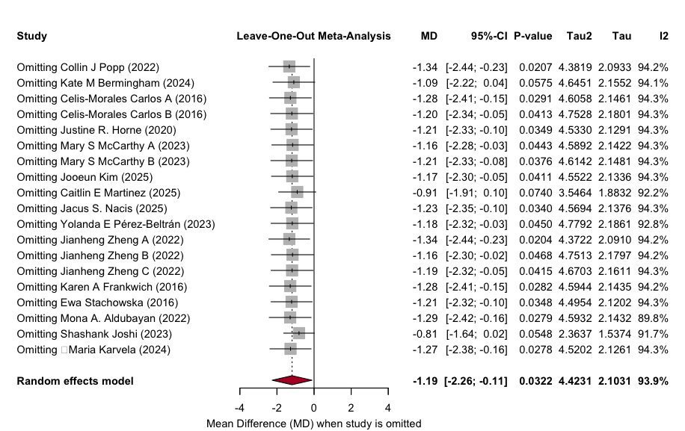
- Body weight (kg)

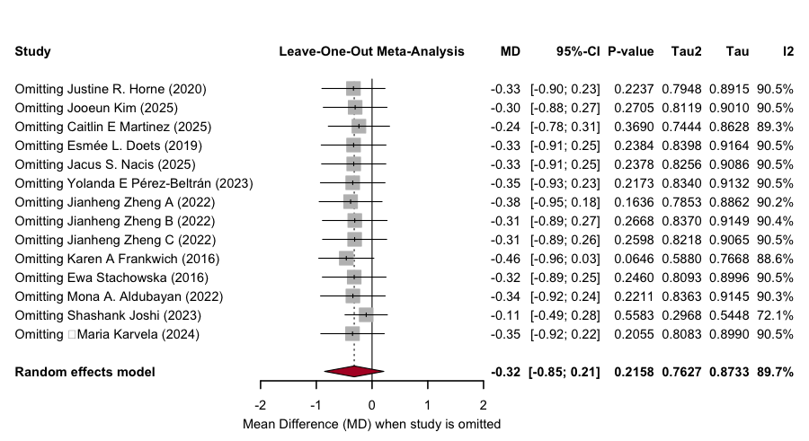
- Body mass index (kg/m²)

Supplementary S6. Bayesian meta-regression of intervention duration on anthropometrics

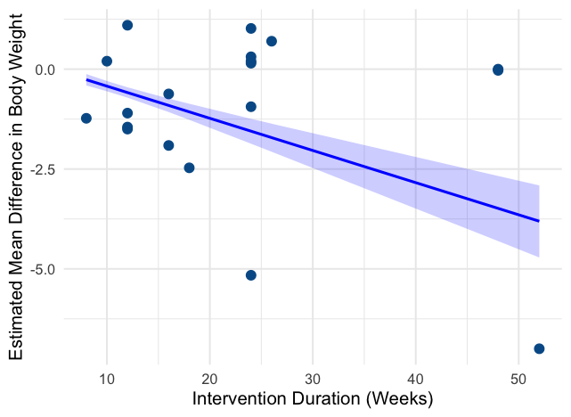
A
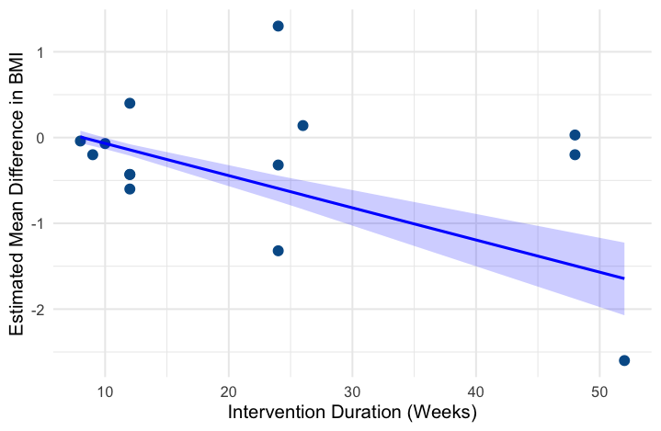
B

Bayesian meta-regression plots illustrating the association between intervention duration (weeks) and treatment effects for (A) body weight and (B) BMI. Each point represents an individual study. The solid blue line represents the posterior mean estimate, and the shaded area indicates the 95% credible interval (CrI).
Abbreviations: BMI – Body Mass Index; CrI – Credible Interval; MD – Mean Difference; kg – Kilogram; kg/m² – Kilograms per square meter

Supplementary S7. Funnel plot for publication bias

- Body weight
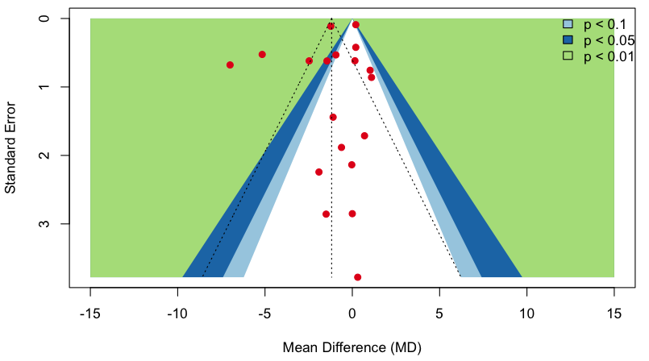
- Body Mass Index
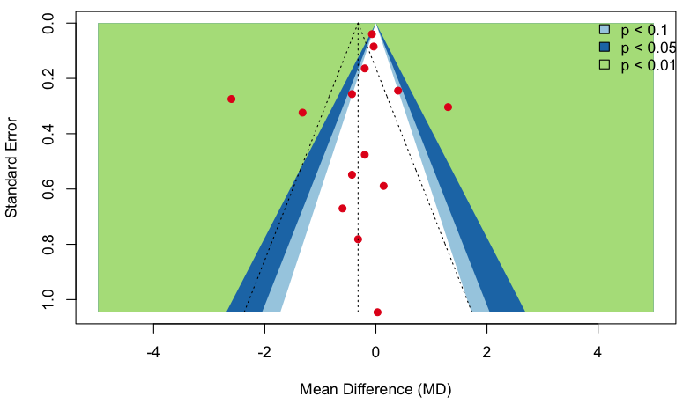

Supplementary S8. GRADE rating for quality of evidence

Outcomes | No. of Effect Sizes | No. of Participants | Initial Certainty | Risk of Bias | Inconsistency(–1 serious; –2 very serious) | Indirectness | Imprecision(–1 serious; –2 very serious) | Publication Bias | Final Certainty | Justification for Downgrading
Body weight (kg) | 19 | 2,393 | High | 0 | –2 (considerable heterogeneity;  I² = 93.9%) | 0 | –1 (sensitivity analysis shows loss of significance when 3 studies removed) | 0 (Egger’s p = 0.276) | ⨁⨁◯◯ Low | Downgraded for considerable heterogeneity and imprecision. Leave-one-out analysis revealed that removing three influential studies (Bermingham 2024, Martinez 2025, Kim 2025) shifted the pooled CI to non-significance, reducing confidence in the stability of the effect.
BMI (kg/m²) | 14 | 1,283 | High | 0 | –2 (considerable heterogeneity;  I² = 89.7%) | 0 | –1 (non-significant pooled effect; CI crosses 0) | 0 (Egger’s p = 0.426) | ⨁◯◯◯ Very Low | Downgraded for considerable heterogeneity and serious imprecision. All leave-one-out iterations remained non-significant, with wide confidence intervals and substantial between-study variability.
Abbreviations: CI = confidence interval; MD = standardised mean difference; GRADE = Grading of Recommendations, Assessment, Development, and Evaluations

References
1. Popp CJ, Hu L, Kharmats AY, Curran M, Berube L, Wang C, et al. Effect of a Personalized Diet to Reduce Postprandial Glycemic Response vs a Low-fat Diet on Weight Loss in Adults With Abnormal Glucose Metabolism and Obesity: A Randomized Clinical Trial. JAMA Network Open. 2022;5(9):e2233760–e.
2. Bermingham KM, Linenberg I, Polidori L, Asnicar F, Arrè A, Wolf J, et al. Effects of a personalized nutrition program on cardiometabolic health: a randomized controlled trial. Nature Medicine. 2024;30(7):1888–97.
3. Celis-Morales C, Marsaux CFM, Livingstone KM, Navas-Carretero S, San-Cristobal R, Fallaize R, et al. Can genetic-based advice help you lose weight? Findings from the Food4Me European randomized controlled trial1, 2, 3. The American Journal of Clinical Nutrition. 2017;105(5):1204–13.
4. Horne JR, Gilliland JA, O’Connor CP, Seabrook JA, Madill J. Change in Weight, BMI, and Body Composition in a Population-Based Intervention Versus Genetic-Based Intervention: The NOW Trial. Obesity. 2020;28(8):1419–27.
5. McCarthy MS, Colburn ZT, Yeung KY, Gillette LH, Hung L-H, Elshaw E. A Randomized Controlled Trial of Precision Nutrition Counseling for Service Members at Risk for Metabolic Syndrome. Military Medicine. 2023;188(Supplement_6):606–13.
6. Kim J, Kang M, Song k, Ahn H, Park YK. Application of personalized nutrition counseling according to glycemic response in obese adults: A randomized dietary intervention study. Nutrition. 2025;131:112641.
7. Martinez CE, Hatley KE, Polzien K, Diamond M, Tate DF. Testing a Personalized Behavioral Weight Loss Approach Using Multifactor Prescriptions and Self-Experimentation: 12-Week mHealth Pilot Randomized Controlled Trial Results. Obesity Science & Practice. 2025;11(1):e70051.
8. Doets EL, de Hoogh IM, Holthuysen N, Wopereis S, Verain MCD, van den Puttelaar J, et al. Beneficial effect of personalized lifestyle advice compared to generic advice on wellbeing among Dutch seniors – An explorative study. Physiology & Behavior. 2019;210:112642.
9. Nacis JS, Labrador JPH, Ronquillo DGD, Rementilla JC, Rodriguez MP, Madrid ML, et al. Effect of Gene-based vs. Standard Weight-Loss Recommendations on Anthropometry, Lipid and Glucose Markers, and Dietary Intake: The MyGeneMyDiet® Study. medRxiv. 2025:2025.03.02.25323063.
10. Pérez-Beltrán YE, González-Becerra K, Rivera-Iñiguez I, Martínez-López E, Ramos-Lopez O, Alcaraz-Mejía M, et al. A Nutrigenetic Strategy for Reducing Blood Lipids and Low-Grade Inflammation in Adults with Obesity and Overweight. Nutrients. 2023;15(20):4324.
11. Zheng J, Wang F, Guo H, Cheng J, Du J, Kan J. Gut microbiota modulates differential lipid metabolism outcomes associated with FTO gene polymorphisms in response to personalized nutrition intervention. Frontiers in Nutrition. 2022;Volume 9 - 2022.
12. Frankwich KA, Egnatios J, Kenyon ML, Rutledge TR, Liao PS, Gupta S, et al. Differences in Weight Loss Between Persons on Standard Balanced vs Nutrigenetic Diets in a Randomized Controlled Trial. Clinical Gastroenterology and Hepatology. 2015;13(9):1625–32.e1.
13. Stachowska E, Ryterska K, Maciejewska D, Banaszczak M, Milkiewicz P, Milkiewicz M, et al. Nutritional Strategies for the Individualized Treatment of Non-Alcoholic Fatty Liver Disease (NAFLD) Based on the Nutrient-Induced Insulin Output Ratio (NIOR). International Journal of Molecular Sciences. 2016;17(7):1192.
14. Aldubayan MA, Pigsborg K, Gormsen SMO, Serra F, Palou M, Galmés S, et al. A double-blinded, randomized, parallel intervention to evaluate biomarker-based nutrition plans for weight loss: The PREVENTOMICS study. Clinical Nutrition. 2022;41(8):1834–44.
15. Joshi S, Shamanna P, Dharmalingam M, Vadavi A, Keshavamurthy A, Shah L, et al. Digital Twin-Enabled Personalized Nutrition Improves Metabolic Dysfunction-Associated Fatty Liver Disease in Type 2 Diabetes: Results of a 1-Year Randomized Controlled Study. Endocrine Practice. 2023;29(12):960–70.
16. Karvela M, Golden CT, Bell N, Martin-Li S, Bedzo-Nutakor J, Bosnic N, et al. Assessment of the impact of a personalised nutrition intervention in impaired glucose regulation over 26 weeks: a randomised controlled trial. Scientific Reports. 2024;14(1):5428.
17. Ben-Yacov O, Godneva A, Rein M, Shilo S, Kolobkov D, Koren N, et al. Personalized Postprandial Glucose Response–Targeting Diet Versus Mediterranean Diet for Glycemic Control in Prediabetes. Diabetes Care. 2021;44(9):1980–91.

