Effects of Synbiotic Supplementation on Oxidative Stress Biomarkers in Adults: A GRADE-assessed Systematic Review and Meta-analysis of Randomized Controlled Trials
Mohammad Vesal Bideshki ^{1,2*}, Maedeh Nojoumi ³, Mehrdad Behzadi ⁴, Nasir Arefinia ^{1,2}, Hedyeh Askarpour ², Zahra Sohrabi ⁵, Mohammad Esmailian ^{1,2}, Mohammad Ali-Hassanzadeh ^{1,2}*,
¹ Bio Environmental Health Hazards Research Center, Jiroft University of Medical Sciences, Jiroft, Iran.
² Clinical Research Development Unit, Imam Khomeini Hospital, Jiroft University of Medical Sciences, Jiroft, Iran.
³ Department of Nutrition, Faculty of Medicine, Mashhad University of Medical Sciences, Mashhad, Iran.
⁴ Nutrition Research Center, School of Nutrition and Food Sciences, Shiraz University of Medical Sciences, Shiraz, Iran
⁵ Nutrition Research Center, School of Nutrition and Food Sciences, Shiraz University of Medical Sciences, Shiraz, Iran.

Corresponding authors:
* Mohammad Vesal Bideshki
Bio Environmental Health Hazards Research Center
Jiroft University of Medical Sciences
E-mail address: bm.vasal@gmail.com; ORCID ID: 0000-0002-5098-6547
* Mohammad Ali-Hassanzadeh
Department of Immunology
Jiroft University of Medical Sciences
E-mail address: smim8035@yahoo.com; ORCID ID: 0000-0001-8212-9737

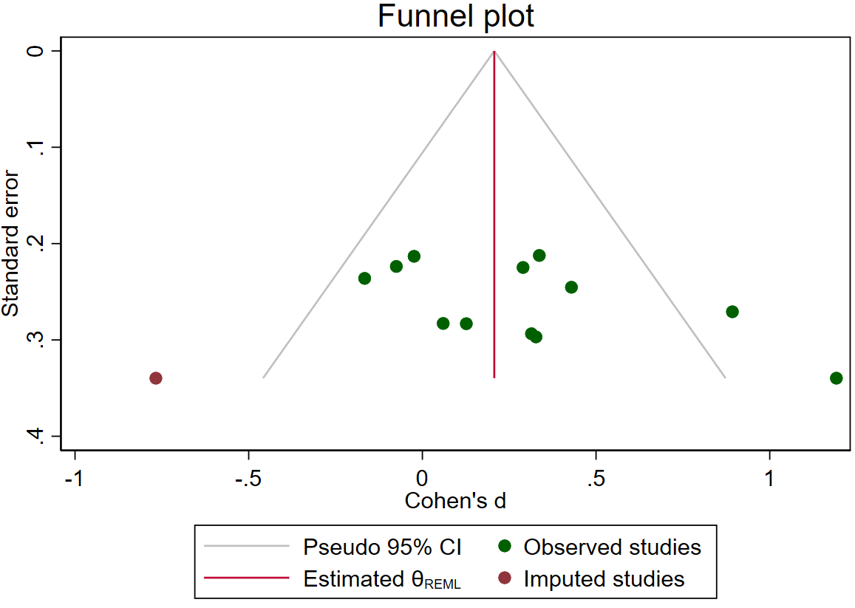
(A)

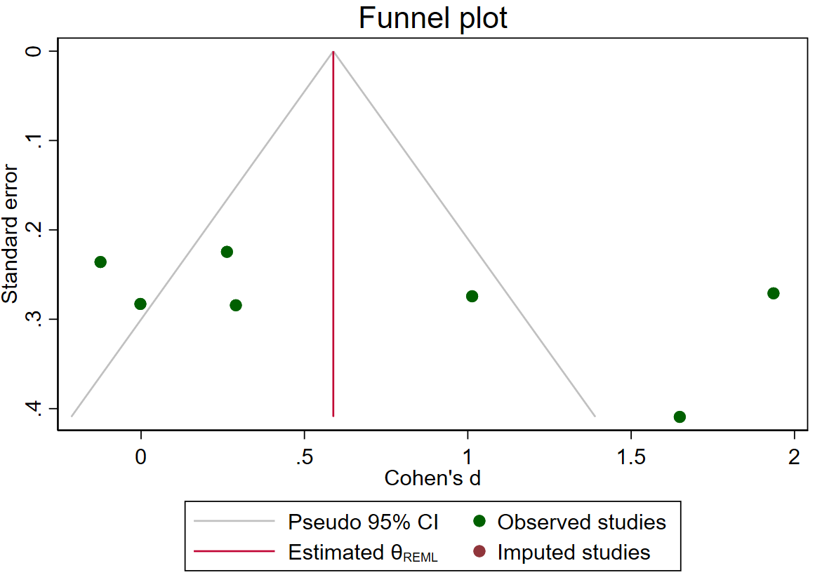
(B)
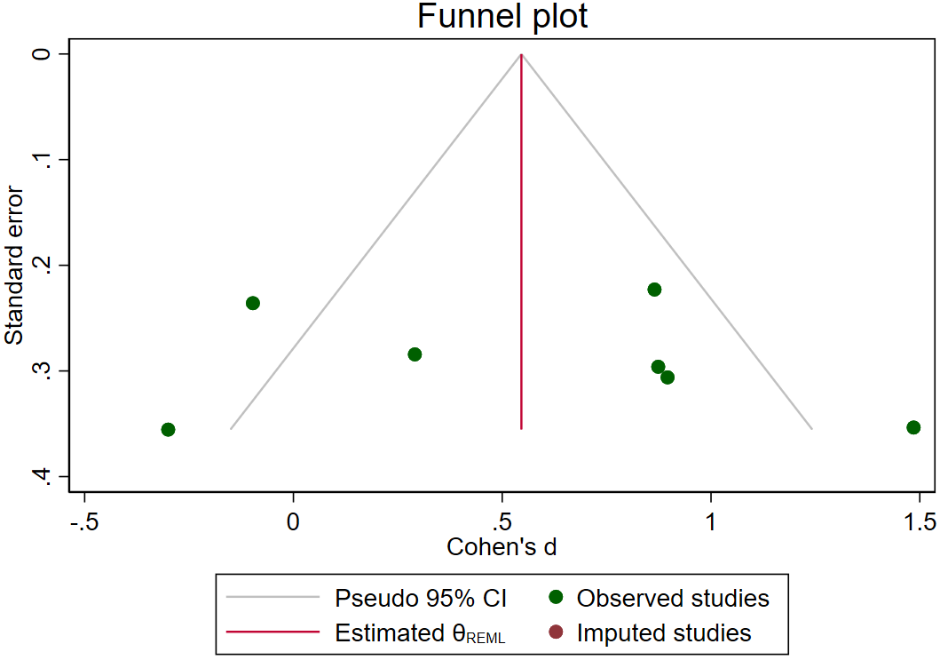
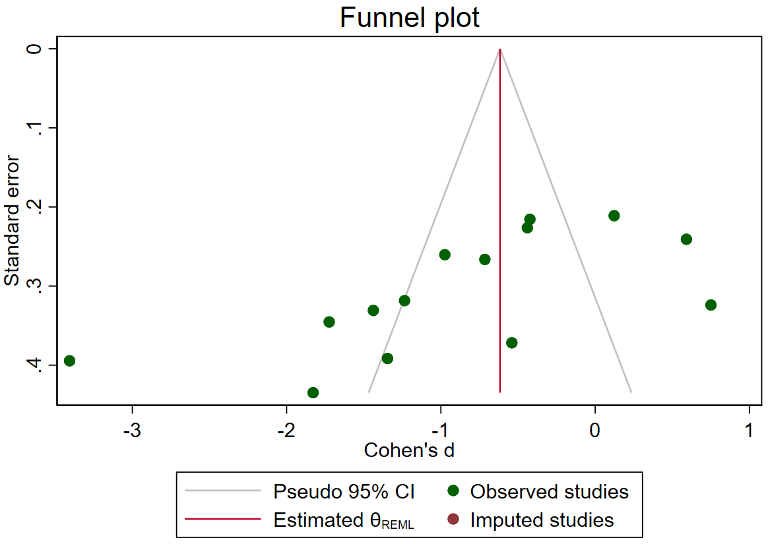
(C)
(D)

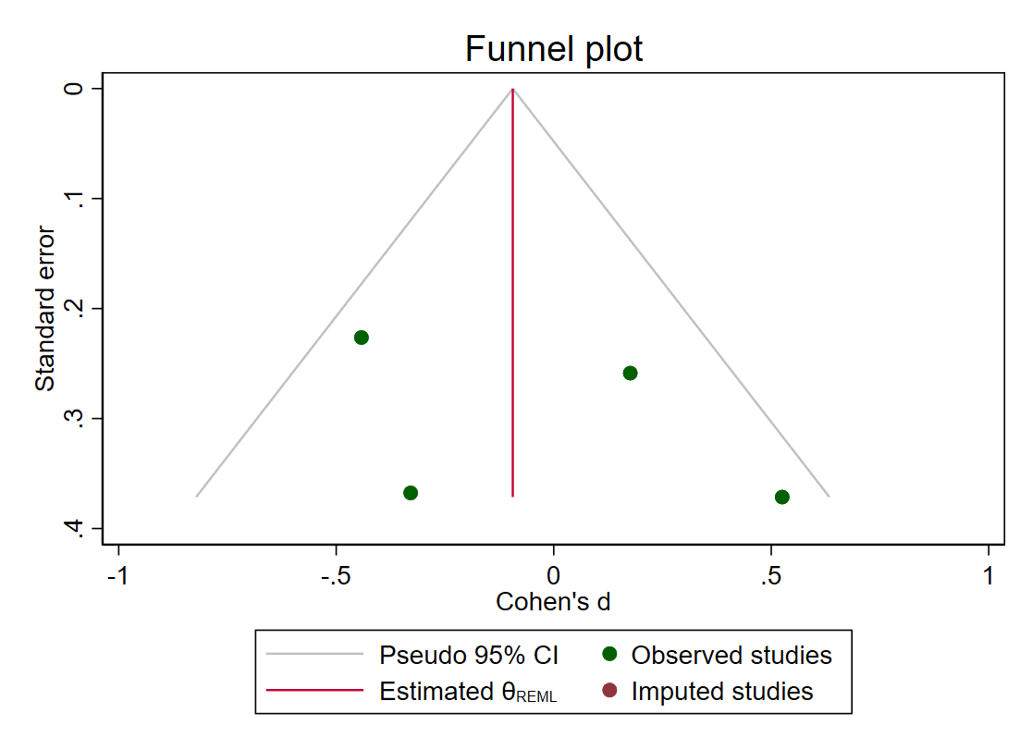
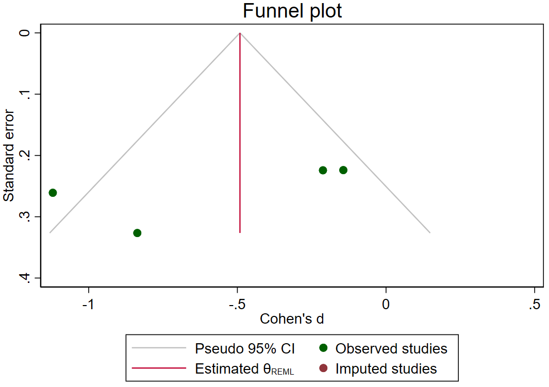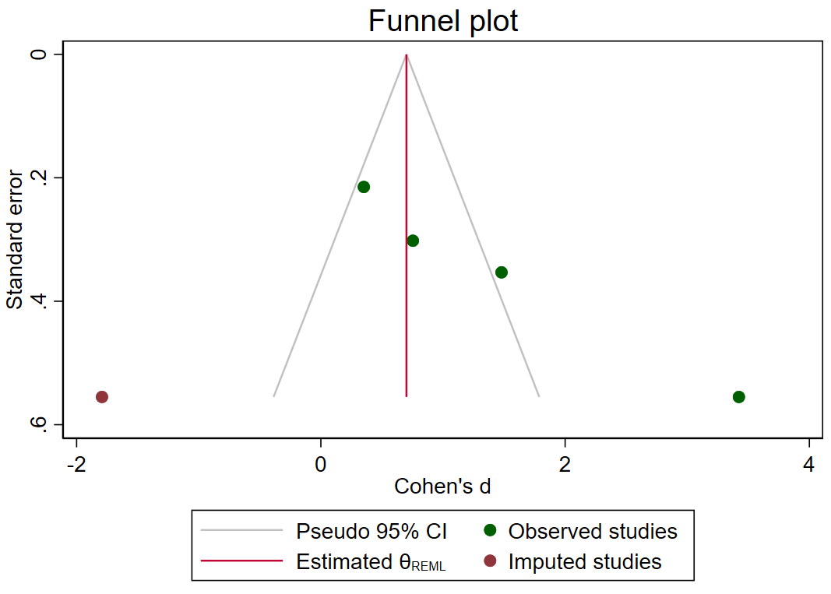
(F)
(E)
(G)
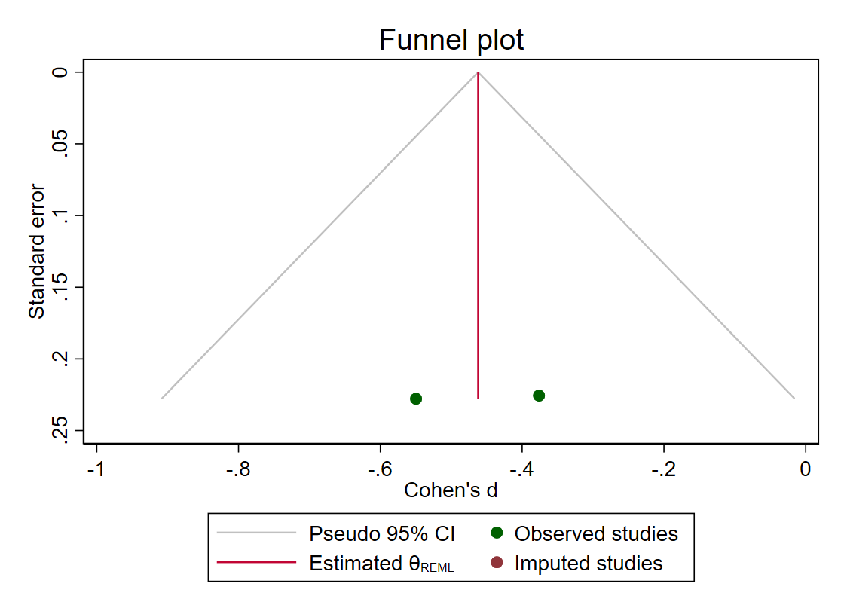
(H)
(H)

Fig. S1. A-H. Assessment of publication bias in the impact of synbiotic supplementation on A: TAC, B: GSH, C: MDA, D: SOD, E: TOS, F: NO, G: GPX, H: OSI, in adults.

Table S1. GRADE profile of synbiotic supplementation on oxidative stress biomarkers.
Certainty assessment |  |  |  |  |  |  | № of patients |  | Effect | Certainty | Importance
№ of studies | Study design | Risk of bias | Inconsistency | Indirectness | Imprecision | Other considerations | Synbiotic | Control | Absolute  (95% CI) | Certainty | Importance
TAC
11 | randomised trials | not serious | not serious | seriousª | not serious | publication bias strongly suspected^{d} | 387 | 385 | SMD 0.25 SD higher  (0.06 higher to 0.43 higher) | ⨁⨁◯◯  Low | IMPORTANT
GSH
6 | randomised trials | not serious | serious^{b} | seriousª | not serious | none | 212 | 212 | SMD 0.70 SD higher  (0.11 higher to 1.28 higher) | ⨁⨁◯◯  Low | IMPORTANT
MDA
13 | randomised trials | not serious | very serious^{c} | seriousª | not serious | publication bias strongly suspected^{d} | 397 | 394 | SMD 0.87 SD lower  (1.37 lower to 0.37 lower) | ⨁◯◯◯  Very low | IMPORTANT
SOD
6 | randomised trials | not serious | serious^{e} | seriousª | not serious | none | 191 | 189 | SMD 0.57 SD higher  (0.13 higher to 1.00 higher) | ⨁⨁◯◯  Low | IMPORTANT
TOS
4 | randomised trials | not serious | serious^{f} | seriousª | not serious | none | 136 | 133 | SMD 0.55 SD lower  (1.03 lower to 0.08 lower) | ⨁⨁◯◯  Low | IMPORTANT
NO
3 | randomised trials | not serious | not serious | seriousª | serious^{g} | none | 100 | 100 | SMD 0.05 SD lower  (0.48 lower to 0.38 higher) | ⨁⨁◯◯  Low | IMPORTANT
GP_{X}
4 | randomised trials | not serious | serious^{h} | seriousª | not serious | publication bias strongly suspected^{d} | 105 | 103 | SMD 1.40 SD higher  (0.39 higher to 2.40 higher) | ⨁◯◯◯  Very low | IMPORTANT
OSI
2 | randomised trials | not serious | not serious | seriousª | not serious | none | 80 | 80 | SMD 0.46 SD lower  (0.78 lower to 0.15 lower) | ⨁⨁⨁◯  Moderate | IMPORTANT
Abbreviations: CI: confidence interval; SMD: standardized mean difference

Note:
a. Most of studies was conducted in Iran. Downgraded.
b. Serious inconsistency since I2 = 88.0%. Downgraded.
c. Serious inconsistency since I2 = 90.6%. Downgraded.
d. Potential publication bias was detected for MDA and GPx. Downgraded.
e. Serious inconsistency since I2 = 76.4%. Downgraded.
f. Serious inconsistency since I2 = 72.4%. Downgraded.
g. Serious imprecision since combined results from the random-effects model showed a non-significant reduction in NO following Synbiotics consumption (p = 0.82). Downgraded.
h. Serious inconsistency since I2 = 89.7%. Downgraded.

