BMI
Ancestry | GWAS Dataset Composition | N | Source
EAS-like | Taiwan Biobank + Biobank Japan | 256,450 | Chen et al, 2023
EUR-like | GIANT + UKBB | ~700,000 | Yengo et al, 2018
PNS-like | Native Hawaiians | 4,148 | Multi-Ethnic Cohort Study (MEC)
T2D
Ancestry | GWAS Dataset Composition | N | Source
EAS-like | 40 GWAS encompassing China, Hong Kong, Japan, Korea, Philippines, Singapore, Taiwan, USA | 427,504 | Suzuki et al, 2024
EUR-like | 36 GWAS encompassing Denmark, Estonia, Finland, France, Germany, Greece, Iceland, Netherlands, Sweden, UK, USA, Various European countries | 1,812,017 | Suzuki et al, 2024
PNS-like | Native Hawaiians | 4,131 | Multi-Ethnic Cohort Study (MEC)

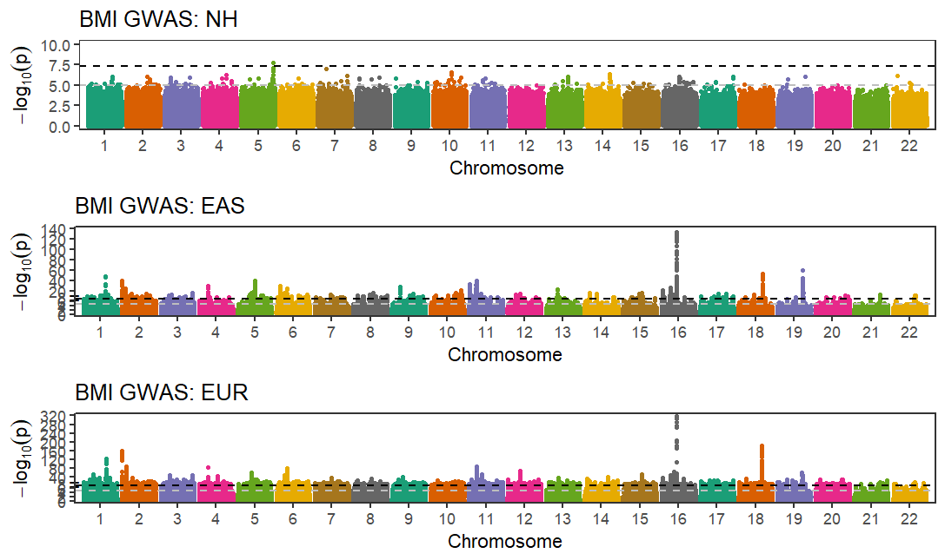

Figure S1. Summary of GWAS datasets. GWAS summary statistics that were used to train PGS models for BMI (top) and T2D (bottom) for Native Hawaiians are visualized through Manhattan plots.

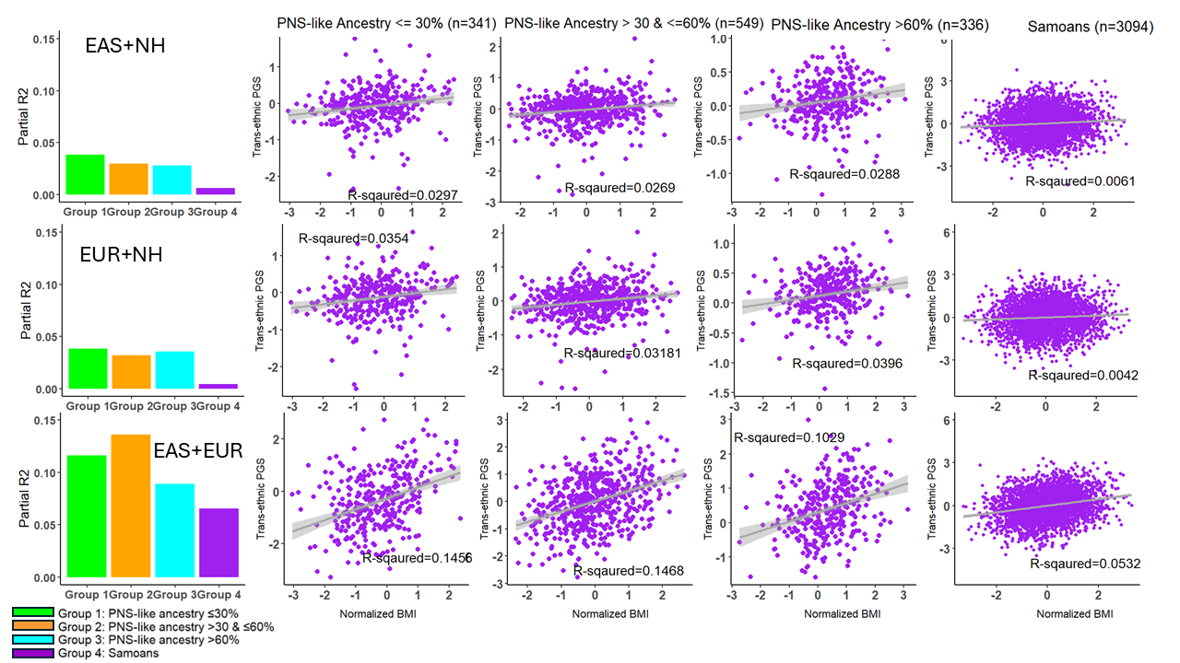

Figure S2. Performance of the cross-ancestry PGS-CSx models for BMI among the Native Hawaiian and Samoan genetic validation sets. Different approaches to combine GWAS summary statistics from multiple ethnic populations using PRS-CSx was evaluated and compared across strata by PNS-like ancestries: < 30%, between 30% to 60%, and > 60%. Global ancestry estimates were previously calculated (16) using ADMIXTURE (v.1.3.0) in unsupervised mode, in combination with other MEC ethnic groups and the 1000 Genome Project reference populations. We found MEC-NH individuals at k = 4 exhibited known components of European (EUR)-like, East-Asian (EAS)-like, and African (AFR)-like ancestries (interpreted based on 1000 Genomes reference samples), as well as a component of ancestry that is unique to the MEC-NH, presumed to be Polynesian (PNS)-like in origin. Each PGS model was also validated in Samoans, who are taken as a largely-unadmixed representative of Western Polynesian ancestry. The PGS accuracy as measured by partial R².

BMI (n_{test} =1,226 )
Model | P-value | Beta ± SE | R² [95% CI] | Partial-R² [95% CI]
EAS + EUR | 4.13×10⁻³⁵ | 0.39 ± 0.03 | 0.190 [0.160 to 0.240] | 0.119 [0.084 to 0.155]
Meta (EAS+EUR) | 3.40×10⁻²⁰ | 0.33 ± 0.03 | 0.141 [0.114 to 0.188] | 0.067 [0.067 to 0.098]
Meta (EAS+EUR) + NH | 8.03×10⁻⁹ | 0.29 ± 0.05 | 0.104 [0.081 to 0.149] | 0.027 [0.027 to 0.049]
EAS + EUR + NH | 9.51×10⁻¹¹ | 0.38 ± 0.06 | 0.113 [0.089 to 0.158] | 0.034 [0.016 to 0.057]
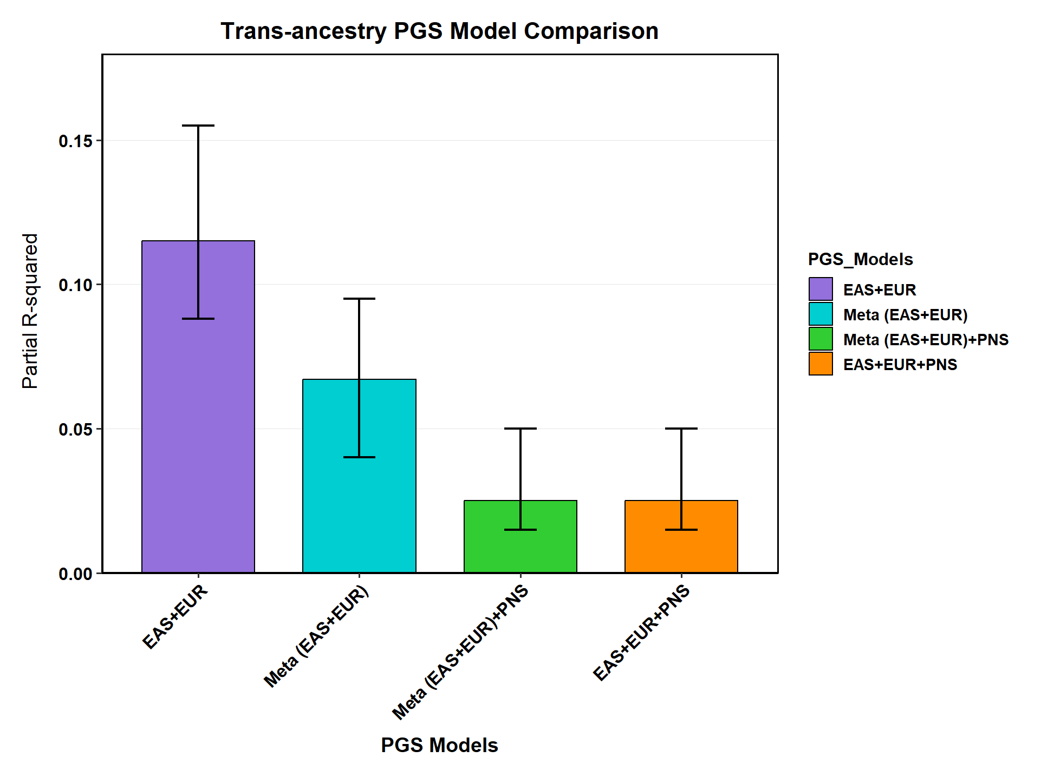 Figure S3. Comparison of cross-ancestry PGS models integrating GWAS information from two and three population groups using PRS-CSx. We applied PRS-CSx using GWAS summary statistics from two continental populations (EAS+EUR), or three populations (EAS+EUR+NH). We compared two additional approaches for constructing PGS prediction models for BMI: (1) Meta (EAS+EUR), which performs GWAS meta-analysis and then apply PRS-CS on the single GWAS summary statistics, and (2) Meta (EAS+EUR) + NH, which we combined the meta-analyzed summary statistics from (1) with that from NH-only for a cross-ancestry PGS model using PRS-CSx. The latter approach also incorporates information from three separate populations via meta-analysis. P-value and Beta denotes the effect size and associated p-value in a linear model where the PGS is the predicator. The linear model is: BMI ~ PGS + PC1+ ….+PC10, where partial R² represents the incremental variance explained by the PGS after adjusting for the first 10 genetic principal components.
Figure S4. Dietary patterns/behaviors across MEC participants by geographical location and race/ethnicity. We first applied principal components analysis (PCA) to the data after pruning the data for related variables (Supplementary Figure S6, bottom), and then projected the top 10 PCs down to two-dimensions with uniform manifold approximation and projection (UMAP). UMAP dimensionality reduction was implemented using the umap R package with default hyperparameters: 15 neighbors for local structure, Euclidean distance metric, minimum distance of 0.1 between embedded points, and effective scale of 1.0. We performed this procedure across all five ethnic groups of MEC individuals (n = 191,183), colored by recruitment area (Hawai‘i vs Los Angeles). Nearly all Native Hawaiians in MEC were recruited from Hawai‘i and most of African-American and Latinos participants in MEC were recruited in Los Angeles. Japanese and Whites are represented in both recruitment locations. There may be shared food consumption behaviors among those recruited in Los Angeles (African Americans, Latinos, and some of the Whites), as well as those recruited in Hawai‘i (Native Hawaiians, Japanese, and some of the Whites), indicating a pattern perhaps driven by food type accessibility that differed by geographical regions. A notable exception may be the Japanese in the MEC, who were more similar to each other regardless of the area they were recruited from, in contrast to, say, the Whites, consistent with a stronger influence of consistent cultural practices in food choices.

Figure S5. Correlation among dietary variables available in the Multi-Ethnic Cohort. The correlations among (top) all 520 diet variables and (bottom) pruned (n=220) diet variables in Native Hawaiians (N = 14,346). The pruned dataset removes randomly one variable among all pairs of variables correlated with R² > 0.5.

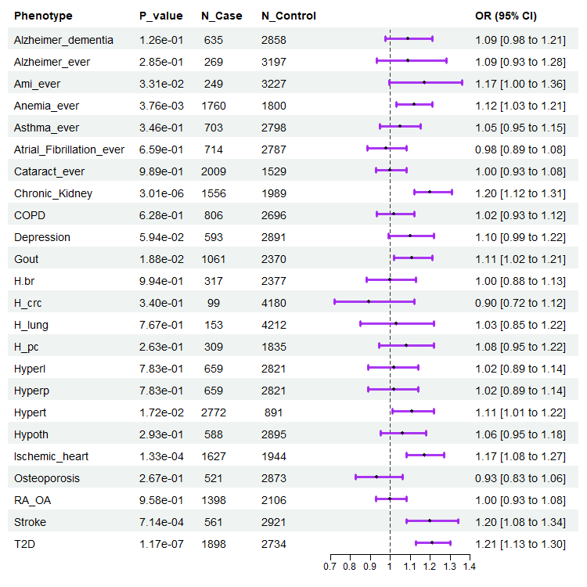
Figure S6. Association of BMI DDS with other binary disease outcome in Native Hawaiians. For each disease, cases were defined based on ICD-9 and ICD-10 codes in the Medicare claim data, following the Chronic Condition Warehouse database (Methods). The remaining individuals are assumed to be controls. The only exception is T2D, which was defined separately for this study (Methods). The associations were assessed after adjusting for age, sex, BMI, and first 10 PCs.

REFERENCES

1. Ge T, Chen CY, Ni Y, Feng YCA, Smoller JW. Polygenic prediction via Bayesian regression and continuous shrinkage priors. Nat Commun. 2019;10(1):1776. doi:10.1038/s41467-019-09718-5

2. Ruan Y, Lin YF, Feng YCA, Chen CY, Lam M, Guo Z, et al. Improving polygenic prediction in ancestrally diverse populations. Nat Genet. 2022; 54(5):573-580. doi:10.1038/s41588-022-01054-7

3. Hoggart, C.J., Choi, S.W., García-González, J. et al. BridgePRS leverages shared genetic effects across ancestries to increase polygenic risk score portability. Nat Genet 56, 180–186 (2024). https://doi.org/10.1038/s41588-023-01583-9

4. Chen CY, Chen TT, Feng YCA, Yu M, Lin SC, Longchamps RJ, Wang SH, Hsu YH, Yang HI, Kuo PH, Daly MJ, Chen WJ, Huang H, Ge T, Lin YF. Analysis across Taiwan Biobank, Biobank Japan, and UK Biobank identifies hundreds of novel loci for 36 quantitative traits. Cell Genom. 2023 Nov 16;3(12):100436. doi: 10.1016/j.xgen.2023.100436.

5. Yengo L, Sidorenko J, Kemper KE, Zheng Z, Wood AR, Weedon MN, Frayling TM, Hirschhorn J, Yang J, Visscher PM; GIANT Consortium. Meta-analysis of genome-wide association studies for height and body mass index in ∼700000 individuals of European ancestry. Hum Mol Genet. 2018 Oct 15;27(20):3641-3649. doi: 10.1093/hmg/ddy271.

6. Suzuki K, Hatzikotoulas K, Southam L, Taylor HJ, Yin X, Lorenz KM, Mandla R, et al. Genetic drivers of heterogeneity in type 2 diabetes pathophysiology. Nature. 2024;627(8003):347-357. doi:10.1038/s41586-024-07019-6

