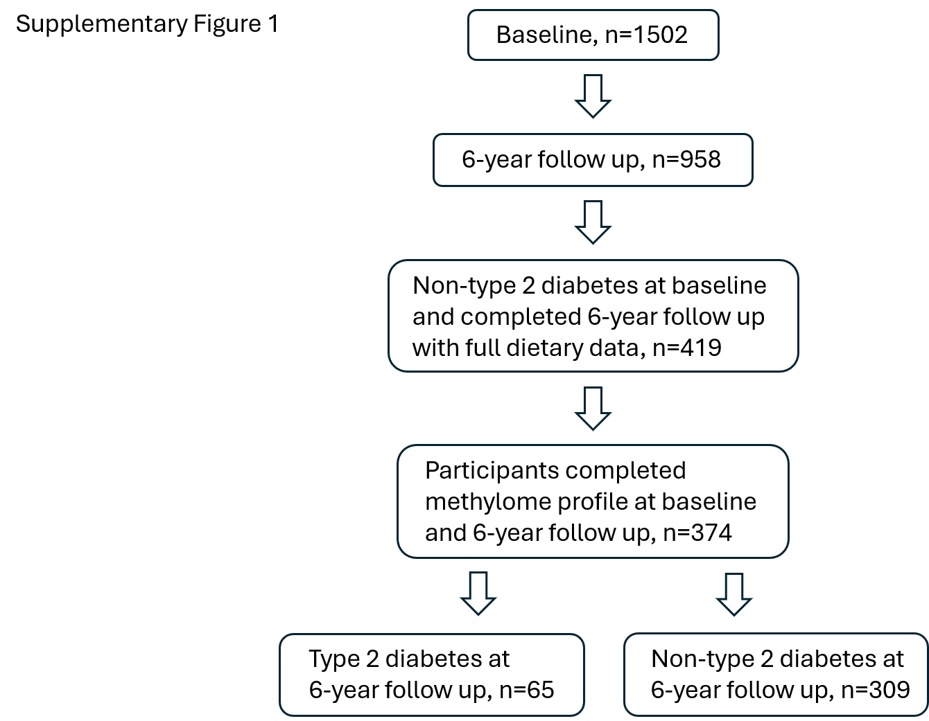

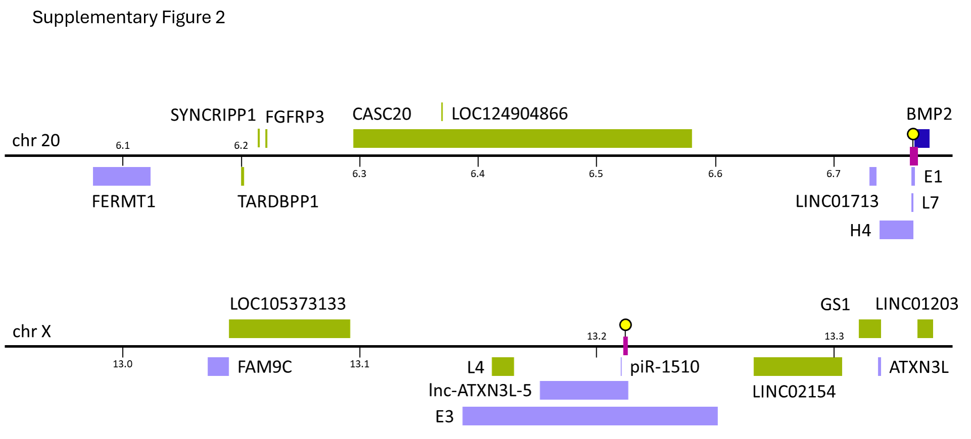

Supplementary Table 1. List of daily nutrient intake
Nutrient group | nutrient | unit
alcohol | % Calories from Alcohol | %
alcohol | Alcohol | g
amino acids | Betaine | mg
amino acids | 3-Methylhistidine | mg
amino acids | Alanine | g
amino acids | Arginine | g
amino acids | Aspartic Acid | g
amino acids | Cystine | g
amino acids | Glutamic Acid | g
amino acids | Glycine | g
amino acids | Histidine | g
amino acids | Isoleucine | g
amino acids | Leucine | g
amino acids | Lysine | g
amino acids | Methionine | g
amino acids | Phenylalanine | g
amino acids | Proline | g
amino acids | Serine | g
amino acids | Threonine | g
amino acids | Tryptophan | g
amino acids | Tyrosine | g
amino acids | Valine | g
ash | Ash | g
caffeine | Caffeine | mg
carbohydrates | % Calories from Carbohydrate | %
carbohydrates | Added Sugars (by Total Sugars) | g
carbohydrates | Added Sugars (by Available Carbohydrate) | g
carbohydrates | Available Carbohydrate | g
carbohydrates | Fructose | g
carbohydrates | Galactose | g
carbohydrates | Glucose | g
carbohydrates | Lactose | g
carbohydrates | Pectins | g
carbohydrates | Starch | g
carbohydrates | Sucrose | g
carbohydrates | Tagatose | mg
carbohydrates | Total Carbohydrate | g
carbohydrates | Total Sugars | g
carbohydrates | % calorie from total sugar
energy | Energy (kilocalories) | kcal
energy | Energy (kilojoules) | kj
Fat | % Calories from Fat | %
fat | Solid Fats | g
fat | Total Fat | g
fiber | Insoluble Dietary Fiber | g
fiber | Soluble Dietary Fiber | g
fiber | Total Dietary Fiber | g
Food | Total grams | g
food | Glycemic Index (bread reference) | ?
food | Glycemic Index (glucose reference) | ?
food | Glycemic Load (bread reference) | ?
food | Glycemic Load (glucose reference) | ?
food | Gram amount of food | ?
Grain | Refined Grains (ounce equivalents) | oz equiv
Grain | Total Grains (ounce equivalents) | oz equiv
grain | Whole Grains (ounce equivalents) | oz equiv
lignans | Pinoresinol | mcg
lignans | Secoisolariciresinol | mcg
lignans | Total Lignans | mcg
Lipid | Cholesterol | mg
Lipid | Cholesterol to Saturated Fatty Acid Index | ?
minerals | Acesulfame Potassium | mg
minerals | Calcium | mg
minerals | Copper | mg
minerals | Iron | mg
minerals | Magnesium | mg
minerals | Manganese | mg
minerals | Phosphorus | mg
minerals | Potassium | mg
minerals | Selenium | mcg
minerals | Sodium | mg
minerals | Zinc | mg
MUFA | % Calories from MUFA | %
MUFA | MUFA 14:1 (myristoleic acid) | g
MUFA | MUFA 16:1 (palmitoleic acid) | g
MUFA | MUFA 18:1 (oleic acid) | g
MUFA | MUFA 20:1 (gadoleic acid) | g
MUFA | MUFA 22:1 (erucic acid) | g
natatoc | Natural Alpha-Tocopherol (RRR-alpha-tocopherol or d-alpha-tocopherol) | mg
natural and chemical compounds | Lariciresinol | mcg
natural and chemical compounds | Matairesinol | mcg
natural and chemical compounds | Biochanin A | mg
natural and chemical compounds | Coumestrol | mg
natural and chemical compounds | Daidzein | mg
natural and chemical compounds | Formononetin | mg
natural and chemical compounds | Formononetin | mg
natural and chemical compounds | Genistein | mg
natural and chemical compounds | Glycitein | mg
natural and chemical compounds | Inositol | g
natural and chemical compounds | Mannitol | g
natural and chemical compounds | Oxalic Acid | mg
natural and chemical compounds | Phytic Acid | mg
natural and chemical compounds | Pinitol | g
natural and chemical compounds | Sucrose Polyester | g
nitrogen | Nitrogen | g
Protein | % Calories from Protein | %
protein | Gluten | g
protein | Animal Protein | g
protein | Total Protein | g
protein | Vegetable Protein | g
PUFA | % Calories from PUFA | %
PUFA | Omega-3 Fatty Acids | g
PUFA | Omega-6 Fatty Acids | g
PUFA | Polyunsaturated to Saturated Fat Ratio | ?
PUFA | PUFA 18:2 n-6 (linoleic acid [LA]) | g
PUFA | PUFA 18:3 n-3 (alpha-linolenic acid [ALA]) | g
PUFA | PUFA 18:3 n-6 (gamma-linolenic acid [GLA]) | g
PUFA | PUFA 20:4 n-6 (arachidonic acid [AA]) | g
PUFA | PUFA 18:2 (linoleic acid, undifferentiated) | g
PUFA | PUFA 18:3 (linolenic acid, undifferentiated) | g
PUFA | PUFA 18:4 (parinaric acid) | g
PUFA | PUFA 20:4 (arachidonic acid, undifferentiated) | g
PUFA | PUFA 20:5 n-3 (eicosapentaenoic acid [EPA]) | g
PUFA | PUFA 22:5 n-3 (docosapentaenoic acid [DPA]) | g
PUFA | PUFA 22:6 n-3 (docosahexaenoic acid [DHA]) | g
SFA | % Calories from SFA | %
SFA | SFA 10:0 (capric acid) | g
SFA | SFA 12:0 (lauric acid) | g
SFA | SFA 14:0 (myristic acid) | g
SFA | SFA 16:0 (palmitic acid) | g
SFA | SFA 17:0 (margaric acid) | g
SFA | SFA 18:0 (stearic acid) | g
SFA | SFA 20:0 (arachidic acid) | g
SFA | SFA 22:0 (behenic acid) | g
SFA | SFA 4:0 (butyric acid) | g
SFA | SFA 6:0 (caproic acid) | g
SFA | SFA 8:0 (caprylic acid) | g
sweeteners and food additives | Maltitol | g
sweeteners and food additives | Aspartame | mg
sweeteners and food additives | Erythritol | g
sweeteners and food additives | Isomalt | g
sweeteners and food additives | Lactitol | g
sweeteners and food additives | Maltose | g
sweeteners and food additives | Saccharin | mg
sweeteners and food additives | Sorbitol | g
sweeteners and food additives | Sucralose | mg
sweeteners and food additives | Xylitol | g
total MUFA | Total Monounsaturated Fatty Acids (MUFA) | g
total PUFA | Total Polyunsaturated Fatty Acids (PUFA) | g
total SFA | Total Saturated Fatty Acids (SFA) | g
total trans-fat | Total Trans-Fatty Acids (TRANS) | g
trans-fat | 16:1 TRANS (trans-hexadecenoic acid) | g
trans-fat | 18:1 TRANS (trans-octadecenoic acid) | g
trans-fat | 18:2 TRANS (trans-octadecadienoic acid) | g
trans-fat | CLA cis-9, trans-11 | g
trans-fat | CLA trans-10, cis-12 | g
trans-fat | Total Conjugated Linoleic Acid (CLA 18:2) | g
vitamins | Vitamin D2 (ergocalciferol) | mcg
vitamins | Vitamin D3 (cholecalciferol) | mcg
vitamins | Alpha-Carotene (provitamin A carotenoid) | mcg
vitamins | Beta-Carotene (provitamin A carotenoid) | mcg
vitamins | Beta-Carotene Equivalents (derived from provitamin A carotenoids) | mcg
vitamins | Beta-Cryptoxanthin (provitamin A carotenoid) | mcg
vitamins | Beta-Tocopherol | mg
vitamins | Choline | mg
vitamins | Delta-Tocopherol | mg
vitamins | Dietary Folate Equivalents | mcg
vitamins | Gamma-Tocopherol | mg
vitamins | Lutein + Zeaxanthin | mcg
vitamins | Lycopene | mcg
vitamins | Natural Folate (food folate) | mcg
vitamins | Niacin (vitamin B3) | mg
vitamins | Niacin Equivalents | mg
vitamins | Pantothenic Acid | mg
vitamins | Retinol | mcg
vitamins | Riboflavin (vitamin B2) | mg
vitamins | Synthetic Alpha-Tocopherol (all rac-alpha-tocopherol or dl-alpha-tocopherol) | mg
vitamins | Synthetic Folate (folic acid) | mcg
vitamins | Thiamin (vitamin B1) | mg
vitamins | Total Alpha-Tocopherol Equivalents (see columns 171-173) | mg
vitamins | Total Folate (see columns 149-151) | mcg
vitamins | Total Vitamin A Activity (International Units) | IU
vitamins | Total Vitamin A Activity (Retinol Activity Equivalents) | mcg
vitamins | Total Vitamin A Activity (Retinol Equivalents) | mcg
vitamins | Vitamin B12 (cobalamin) | mcg
vitamins | Vitamin B6 (pyridoxine, pyridoxyl, and pyridoxamine) | mg
vitamins | Vitamin C (ascorbic acid) | mg
vitamins | Vitamin D (calciferol) | mcg
vitamins | Vitamin E (International Units) | IU
vitamins | Vitamin E (Total Alpha-Tocopherol) (see columns 171-173) | mg
vitamins | Vitamin K (phylloquinone) | mcg
water | Water | g

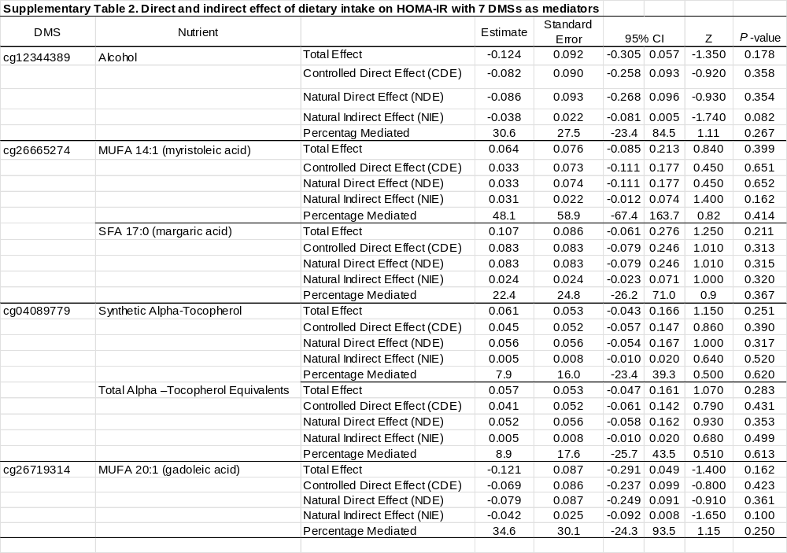

Supplemental Table 3. Transcription factors predicted to bind to enhancer elements containing selected differential methylation sites.
Transcription factor* | GH07J150372 | GH20J006764 | GH20J012950 | GH0XJ013211
AFF1 | yes | no | no | no
AHR | yes | no | no | no
ARID1B | yes | no | no | no
ARID3A | yes | no | no | no
ARID4B | yes | no | no | no
ARNT | yes | no | no | no
ATF1 | yes | no | no | no
ATF7 | yes | no | no | no
BACH1 | yes | yes | no | no
BCL11A | yes | no | no | no
BCL6 | yes | no | no | no
BCLAF1 | yes | no | no | no
BCOR | yes | no | no | no
BHLHE40 | yes | yes | no | no
BMI1 | yes | no | no | no
BRD9 | yes | no | no | no
CBFA2T3 | yes | no | no | no
CBX1 | yes | no | no | no
CBX2 | no | yes | no | no
CEBPZ | yes | no | no | no
CHD1 | yes | no | no | no
CHD2 | yes | no | no | no
CREM | yes | no | no | no
CTBP1 | yes | yes | no | no
CTCF | yes | yes | no | no
DACH1 | yes | no | no | no
DDX20 | yes | no | no | no
DMAP1 | yes | no | no | no
DNMT3B | yes | no | no | no
DPF2 | yes | yes | no | no
DRAP1 | yes | no | no | no
EBF1 | yes | no | no | no
EGR2 | yes | no | no | no
ELF1 | yes | no | no | no
ELF3 | yes | no | no | no
EP300 | yes | no | no | yes
EP400 | yes | no | no | no
ERF | yes | no | no | no
ETS1 | yes | no | no | no
ETV6 | yes | no | no | no
EZH2 | no | yes | no | yes
FOS | yes | no | no | no
FOSL2 | yes | no | no | no
FOXA1 | yes | no | no | no
FOXA2 | yes | no | no | no
FOXA3 | yes | no | no | no
FOXK2 | yes | no | no | no
FOXP1 | yes | no | no | no
GATA4 | yes | no | no | no
GATAD1 | yes | no | no | no
GATAD2A | yes | no | no | no
GATAD2B | yes | yes | no | no
GLI4 | yes | no | no | no
GLIS1 | yes | no | no | no
GLIS2 | yes | no | no | no
GMEB1 | yes | no | no | no
GTF2A2 | yes | no | no | no
GTF2F1 | yes | no | no | no
HDAC1 | yes | no | no | no
HDAC2 | yes | yes | no | no
HDGF | yes | yes | no | no
HIC1 | yes | yes | no | no
HLF | yes | yes | no | no
HMBOX1 | yes | no | no | no
HNF1A | yes | no | no | no
HNF4A | yes | yes | no | no
HNRNPH1 | yes | no | no | no
HNRNPL | yes | no | no | no
IKZF1 | yes | yes | no | no
IKZF2 | yes | yes | no | no
IKZF5 | yes | no | no | no
IRF2 | yes | no | no | no
IRF3 | yes | no | no | no
IRF4 | yes | no | no | no
JUND | no | no | no | yes
KAT7 | yes | no | no | no
KAT8 | yes | no | no | no
KDM1A | yes | no | no | no
KDM3A | yes | no | no | no
KDM6A | yes | no | no | no
KLF1 | yes | no | no | no
KLF10 | yes | no | no | no
KLF11 | yes | no | no | no
KLF5 | yes | no | no | no
KLF7 | yes | no | no | no
KMT2B | yes | no | no | no
L3MBTL2 | yes | no | no | no
LARP7 | yes | yes | no | no
MAX | yes | no | no | no
MAZ | yes | no | no | no
MBD1 | yes | no | no | no
MBD2 | yes | no | no | no
MEIS2 | yes | no | no | no
MGA | yes | no | no | no
MIER1 | yes | no | no | no
MIER3 | yes | no | no | no
MIXL1 | yes | no | no | no
MLLT1 | yes | no | no | no
MNT | yes | no | no | no
MTA1 | no | yes | no | no
MTA2 | yes | no | no | no
MTA3 | yes | no | no | no
MXD3 | yes | no | no | no
MYC | yes | no | no | no
MYNN | yes | no | no | no
MZF1 | yes | no | no | no
NANOG | yes | yes | no | no
NBN | yes | yes | no | no
NCOR1 | yes | no | no | no
NFATC1 | yes | no | no | no
NFIB | yes | yes | no | no
NFIC | yes | no | no | no
NFKBIZ | yes | no | no | no
NFRKB | yes | no | no | no
NFYC | yes | no | no | no
NKRF | yes | yes | no | no
NONO | yes | no | no | no
NR2C1 | yes | no | no | no
NR2F1 | yes | yes | no | no
NR2F2 | yes | no | no | no
NR2F6 | yes | no | no | no
NRF1 | yes | no | no | no
NUFIP1 | yes | no | no | no
OSR2 | yes | no | no | no
PBX2 | yes | no | no | no
PHF20 | yes | no | no | no
PHF21A | yes | no | no | no
PHF8 | yes | no | no | no
PKNOX1 | yes | yes | no | no
PML | yes | no | no | no
POLR2A | yes | yes | no | no
POLR2B | yes | no | no | no
POU5F1 | yes | no | no | no
PPARG | yes | no | no | no
PRDM10 | no | yes | no | no
PRDM2 | yes | no | no | no
PRDM4 | yes | no | no | no
RAD21 | yes | yes | no | no
RAD51 | yes | no | no | no
RARA | yes | no | no | no
RB1 | yes | yes | no | no
RBFOX2 | yes | no | no | no
RBM22 | yes | no | no | no
RBPJ | yes | no | no | no
RCOR1 | yes | no | no | no
RELB | yes | yes | no | no
REPIN1 | yes | no | no | no
RERE | yes | no | no | no
REST | yes | no | no | no
RFX1 | yes | no | no | no
RFX3 | yes | no | no | no
RFX5 | yes | no | no | no
RNF2 | yes | yes | no | no
RUNX1 | yes | no | no | no
RUNX3 | yes | no | no | no
RXRA | yes | no | no | no
RXRB | yes | no | no | no
SAP130 | yes | no | no | no
SIN3A | yes | yes | no | no
SIN3B | yes | no | no | no
SKI | yes | yes | no | no
SKIL | yes | no | no | no
SMAD4 | yes | no | no | no
SMAD5 | yes | no | no | no
SMARCA4 | yes | no | no | no
SMARCA5 | yes | yes | no | no
SMARCE1 | yes | no | no | no
SMC3 | yes | yes | no | no
SOX13 | yes | no | no | no
SOX5 | yes | no | no | no
SOX6 | yes | no | no | no
SP1 | yes | no | no | no
SP2 | yes | no | no | no
SP3 | yes | no | no | no
SP5 | yes | no | no | no
SP7 | yes | no | no | no
SPI1 | yes | no | no | no
SREBF1 | yes | no | no | no
STAT5A | yes | no | no | no
SUPT5H | yes | no | no | no
TAF1 | yes | no | no | no
TAF7 | yes | no | no | no
TAL1 | yes | no | no | no
TARDBP | yes | no | no | no
TBL1XR1 | yes | no | no | no
TBP | yes | no | no | no
TCF12 | yes | no | no | no
TCF7 | yes | no | no | no
TCF7L2 | yes | yes | no | no
TEAD1 | yes | no | no | no
TEAD3 | yes | no | no | no
TFAP4 | yes | yes | no | no
TGIF2 | yes | no | no | no
THAP11 | yes | no | no | no
TRIM22 | yes | yes | no | no
TRIM25 | yes | no | no | no
TRIM28 | yes | no | no | no
U2AF1 | yes | no | no | no
U2AF2 | yes | no | no | no
UBTF | yes | no | no | no
USF1 | yes | yes | no | no
USF2 | yes | no | no | no
XRCC5 | yes | no | no | no
YY1 | yes | yes | no | no
YY2 | yes | no | no | no
ZBED1 | yes | no | no | no
ZBTB10 | yes | no | no | no
ZBTB17 | yes | yes | no | no
ZBTB2 | yes | no | no | no
ZBTB20 | yes | yes | no | no
ZBTB21 | yes | no | no | no
ZBTB25 | yes | no | no | no
ZBTB26 | yes | yes | no | no
ZBTB33 | yes | no | no | no
ZBTB40 | yes | no | no | no
ZBTB48 | yes | no | no | no
ZBTB6 | yes | no | no | no
ZBTB7A | yes | no | no | no
ZBTB8A | yes | no | no | no
ZEB2 | yes | no | no | no
ZFHX2 | yes | no | no | no
ZFP36 | no | yes | no | no
ZFP37 | yes | no | no | no
ZFP64 | no | yes | no | no
ZFP69B | yes | no | no | no
ZFP91 | yes | no | no | no
ZFX | yes | no | no | no
ZGPAT | yes | no | no | no
ZHX2 | yes | no | no | no
ZIC2 | yes | no | no | no
ZKSCAN1 | yes | no | no | no
ZNF10 | yes | no | no | no
ZNF121 | yes | no | no | no
ZNF140 | yes | no | no | no
ZNF184 | yes | no | no | no
ZNF189 | yes | no | no | no
ZNF205 | yes | no | no | no
ZNF207 | yes | no | no | no
ZNF217 | yes | yes | no | no
ZNF24 | yes | yes | no | no
ZNF280C | yes | no | no | no
ZNF316 | yes | no | no | no
ZNF335 | yes | yes | no | no
ZNF341 | yes | yes | no | no
ZNF366 | yes | no | no | no
ZNF384 | no | yes | no | no
ZNF398 | yes | no | no | no
ZNF423 | yes | no | no | no
ZNF48 | yes | no | no | no
ZNF501 | yes | no | no | no
ZNF511 | yes | no | no | no
ZNF561 | yes | no | no | no
ZNF580 | yes | no | no | no
ZNF592 | yes | no | no | no
ZNF600 | yes | no | no | no
ZNF610 | yes | no | no | no
ZNF623 | yes | no | no | no
ZNF644 | yes | no | no | no
ZNF654 | no | yes | no | no
ZNF664 | yes | no | no | no
ZNF687 | yes | no | no | no
ZNF692 | yes | no | no | no
ZNF843 | yes | no | no | no
ZSCAN16 | yes | no | no | no
ZSCAN23 | yes | no | no | no
ZSCAN29 | yes | yes | no | no
ZSCAN9 | yes | no | no | no
ZXDB | yes | no | no | no
*Predictions of transcription factor binding are taken from reference 41

