SUPPLEMENTARY MATERIAL

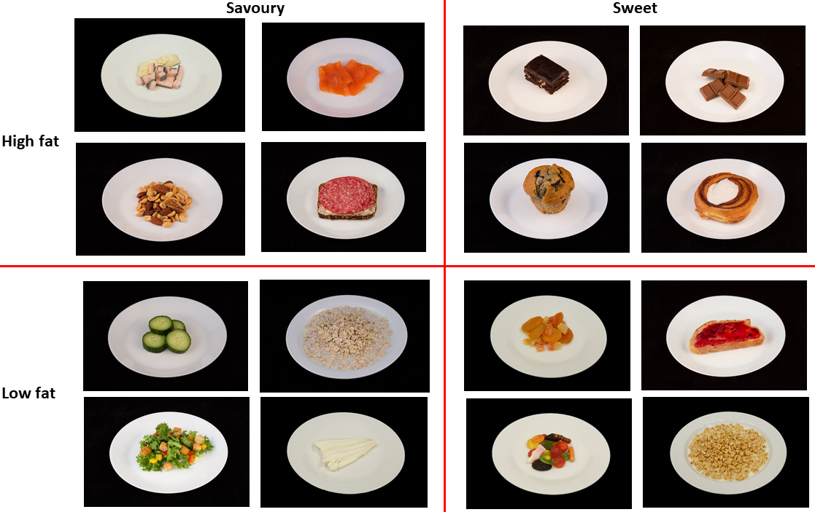
Figure 1: Images used in the Leeds Food Preference Questionnaire representing combinations of high/low fat and sweet/savoury foods. From upper left to bottom right: mattak (whale skin and blubber) with dried cod, smoked salmon, brownie, chocolate, mixed nuts, rye bread with salami, muffin, danish/pastry, cucumber, rolled oats with milk, dried fruit, bread with jam, salad with croutons, cooked cod, candy (gummies and liquorice), sweet breakfast cereal with milk (puffed wheat, Honey Monster).

A) B)
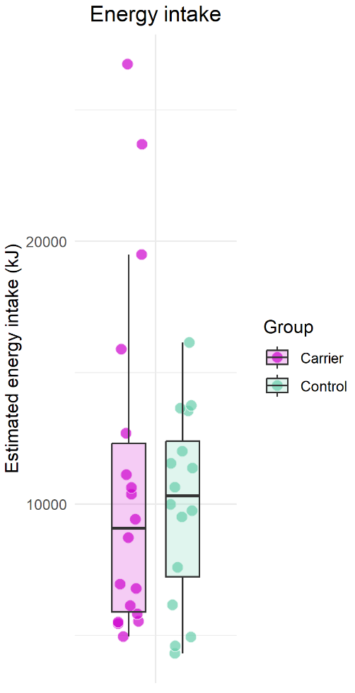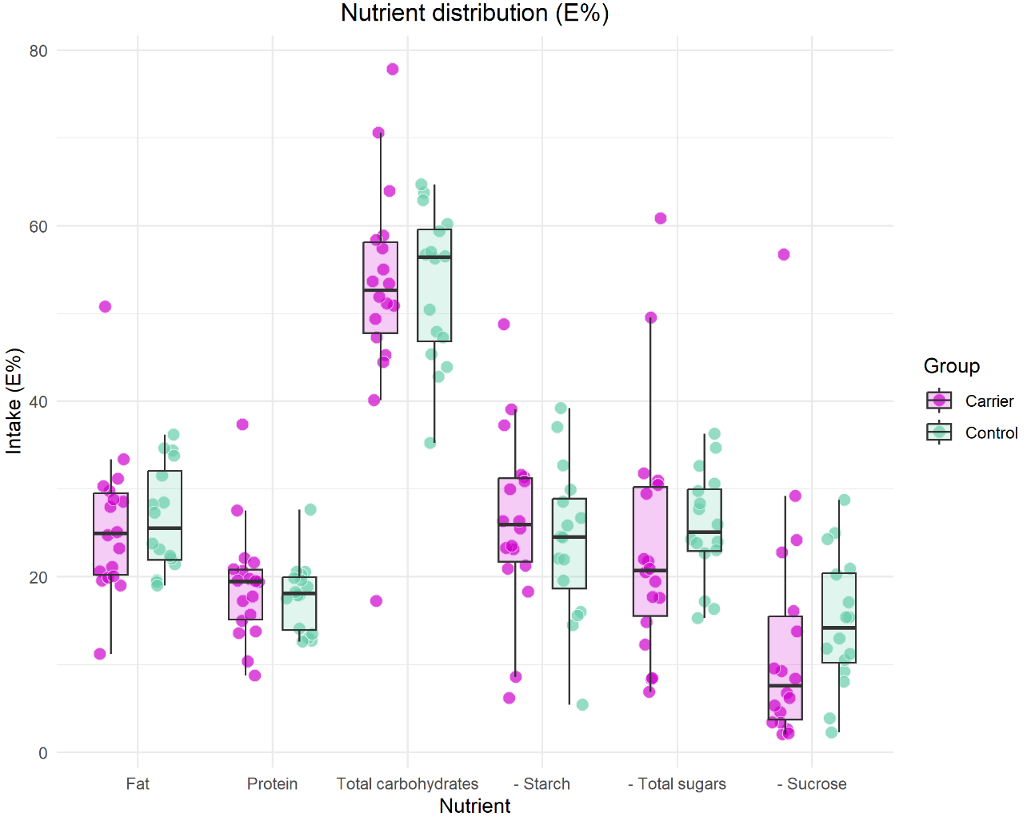
C)
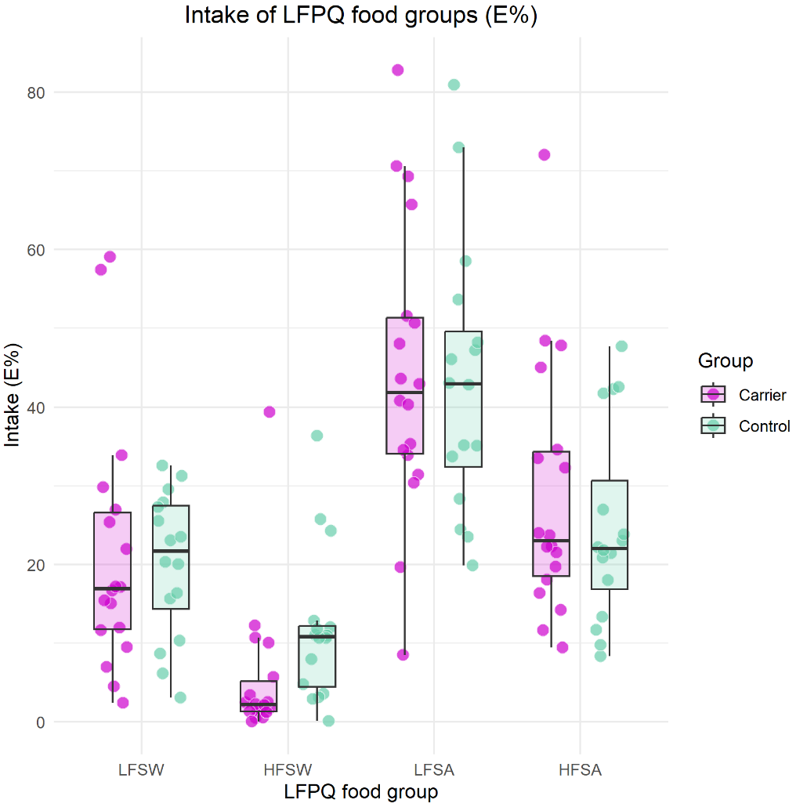
Figure 2A-C: Reported dietary intakes estimated from food frequency questionnaires in carriers and non-carriers. N(carriers)=18), N(non-carriers)=16. The dots show raw data, the box shows the median and IQR, and the whiskers shows the smallest and largest values within 1·5*IQR from the hinges. HFSA, high-fat savoury; HFSW, high-fat sweet; LFPQ, Leeds Food Preferences Questionnaire; LFSA, low-fat savoury; LFSW, low-fat sweet.
A) B)

C)
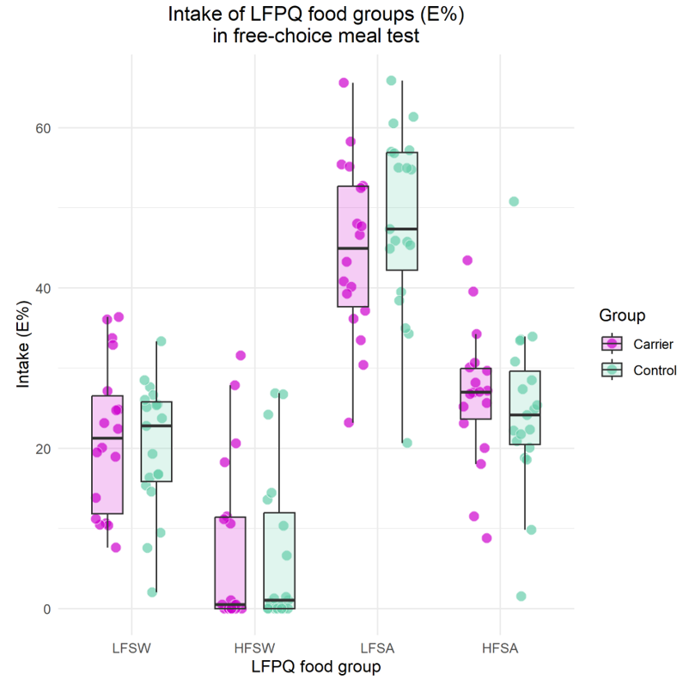
Figure 3A-C: Dietary intakes in the free-choice ad libitum meal test in carriers and non-carriers. N(carriers)=18, N(non-carriers)=19. The dots show raw data, the box shows the median and IQR, and the whiskers shows the smallest and largest values within 1·5*IQR from the hinges. HFSA, high-fat savoury; HFSW, high-fat sweet; LFPQ, Leeds Food Preferences Questionnaire; LFSA, low-fat savoury; LFSW, low-fat sweet.
Figure 4: Sweet appeal bias and fat appeal bias for implicit wanting, explicit liking, and explicit wanting in carriers and non-carriers. N(carriers)=18, N(non-carriers)=16. The dots show raw data, the box shows the median and IQR, and the whiskers shows the smallest and largest values within 1·5*IQR from the hinges.

A)
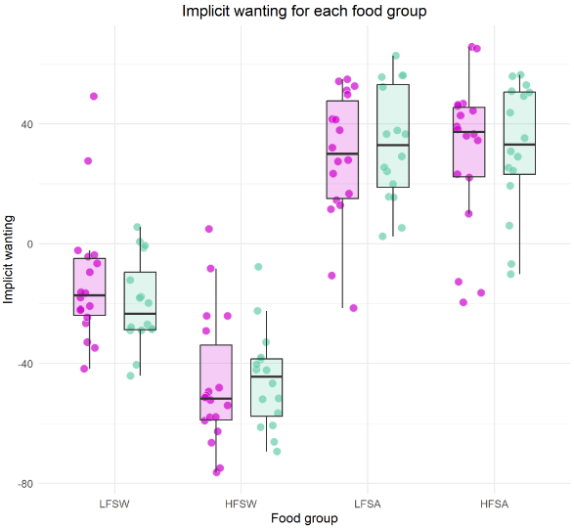
B)
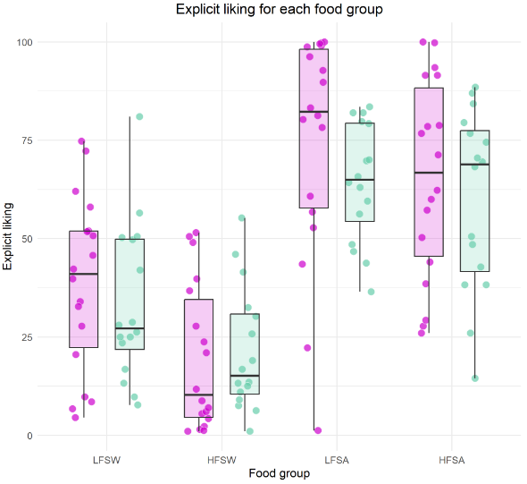
C)
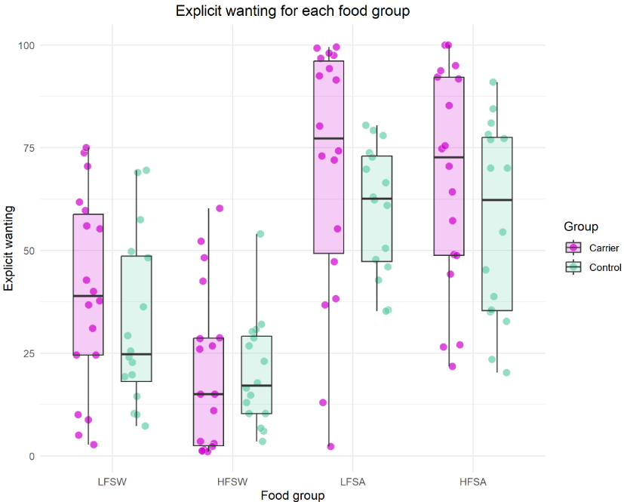
Figure 5: Implicit wanting, explicit liking, and explicit wanting for the four food categories estimated from the Leeds Food Preferences Questionnaire. N(carriers)=18, N(non-carriers)=16. The dots show raw data, the box shows the median and IQR, and the whiskers shows the smallest and largest values within 1·5*IQR from the hinges. HFSA, high-fat savoury; HFSW, high-fat sweet; LFSA, low-fat savoury; LFSW, low-fat sweet.
A)

B)

Figure 6: Hedonic and sweetness rating of four samples of sugar solutions: sucrose, fructose+glucose, fructose, and glucose. Samples were rated on a 100 mm visual analogue scale for A) liking (“not at all” to “neutral” to “like it a lot”) and B) sweetness (“not sweet at all” to “very sweet”). N(carriers)=18*, N(non-carriers)=20. *Number of missing observations for carriers: liking rating, sucrose and fructose+glucose: 2, fructose and glucose: 3; sweetness rating, fructose+glucose: 1. The dots show raw data, the box shows the median and IQR, and the whiskers shows the smallest and largest values within 1·5*IQR from the hinges. VAS, visual analogue scale.

Table 1: Overview of when the food frequency questionnaire was completed.
Timing of the FFQ during the cross-over dietary intervention | Carriers | Non-carriers
At baseline | 10 | 15
After 1) Western diet | 5 | 0
After 1) Greenlandic diet | 2 | 0
After 1) Western and 2) Greenlandic diet | 1 | 1
After 1) Greenlandic and 2) Western diet | 0 | 0
Number of carriers and non-carriers completing the food frequency questionnaire interview at baseline, after the Western or the Greenlandic intervention diet (after the first dietary intervention period), or after both dietary interventions. FFQ, food frequency questionnaire.

Table 2: Number of participants completing each test and number excluded from analyses.
Assessment | Carriers (N = 18) | Controls (N = 20) | Total (N = 38) | Carriers not in analysis | Non-carriers not in analysis
Food frequency questionnaire | 18 | 16 | 34 | 0 | 0
Test meal | 18 | 20 | 38 | 0 | 4  (Two food items not weighed by personnel: 1  Missing covariate (dropped out before measured): 3)
Sensory rating | 18 | 20 | 38 | Sweetness  - S: 0  - F+G: 1  - F: 0  - G: 0  Hedonic  - S: 2  - F+G: 2  - F: 3  - G: 3  (Missing questionnaire responses) | 3  (Missing covariate (dropped out before measured))
Two-alternative forced choice: number of responses (2×N) | 36 | 40 | 76 | - Most sweet: 2  - Most liked: 3  (Missing questionnaire responses) | 0
Leeds Food Preference Questionnaire | 18 | 16 | 34 | 0 | 0
Number of participants completing each test and the number excluded from the analyses and reason for it. For the sensory rating: none of the carriers with missing data skipped both questions for a sample, hence, they tasted and evaluated all samples. For the two-alternative forced choice test, the number of responses is given (up to two per participant) instead of the number of participants.

Table 3: Foods and beverages included in the ad libitum test meal with brand names.
Digestive biscuit: Coop, ‘Digestive’
Maria biscuit: Coop, ‘Mariekiks’
Wrispbread: Wasa, ‘Delikatess sesam’
Salty crackers: Tuc, Original
Hardtack: Brugseni, ‘Skibskiks’
Strawberry jam: Den Gamle Fabrik
Sweet hazelnut cocoa spread: Nutella
Butter: Kærgården, ‘Smørbar’
Raisins: Coop
Dried apricots: Urtekram (organic)
Small cinnamon rolls: Pågen, ‘Kanel Gifflar’
Ham (lean): Tulip, ‘Hamburgerryg’
Salami: Coop, ‘Sønderjysk Spegepølse i Skiver’
Dried whale meat
Chocolate, dark: Toms, ‘Guldbar’
Mixed gummies and licorice: Haribo, ‘Matador mix’
Pears: Conference
Oranges
Coffee
Tea: Earl grey, camomile, Lemon, and mixed fruit tea.
Sugar: 100% sucrose
Honey: Jacobsens, ‘Hverdagshonning’ (liquid)
Orange juice: Coop Xtra
Milk: Arla, ’Minimælk’ (ultra high temperature treated, 0.5% fat)
Bread rolls: Schulstad, ‘Multikerne boller’

Table 4: Grouping of food items from the food frequency questionnaire.
Low-fat sweet | High-fat sweet | Low-fat savoury | High-fat savoury
Apples | Sweet biscuits/crackers, e.g. Maria biscuit, Digestive, Lyons’ Fig Rolls. | Seal meat | Halibut
Pears | Hazelnut cocoa spread (Nutella) | Whale meat | Mattak (whale skin and blubber)
Bananas | Chocolate for bread topping (‘pålægschokolade’) | Cod | Arctic charr, salmon
Citrus fruits | Cakes, pastries | Ammasat (capelin) | Dried fish and meat
Plums | Cookies | Other fish | Seal blubber
Other fruits | Chocolate, chocolate bars | Caribou meat, muskox meat | Beef
Berries | Chocolate candies and caramels, e.g. nuts with chocolate. | Game birds | Pork
Canned fruits | Ice cream | Poultry | Lamb
Raisins, dried figs | Pancakes, waffles | Mixed vegetables | Pizza
Dates, dried apricots, other dried fruits | Muesli bar | Potatoes | Burger
Fruit juice (100% fruit) |  | Root vegetables | Fries
Fruit yogurt |  | Cabbage, e.g. cauliflower, broccoli, red cabbage. | Pigs in a blanket, hot dog
Sugar-free fruit yogurt |  | Milk | Convenience meals
Jam |  | Sugar-free yogurt | Cold meat cuts, liver paté
Sugar-free jam |  | Toast bread | Fish for bread topping, e.g. pickled herring, canned fish
Sweet breakfast cereals, e.g. Kellogs frosties, Cheerios, Coco pops |  | Sandwich bread | Cheese
Gummies, liquorice, hard candy |  | Bread rolls, bagels | Eggs
Soda, energy drinks |  | Rye bread | Lasagna
Light soda or energy drinks |  | Crispbread | Tacos
Lemonade |  | Non-sweet biscuits/crackers | Potato chips
Light Lemonade |  | Oatmeal | Nuts
Chocolate milk, milkshake |  | Oatmeal porridge
Sugar in coffee/tea |  | Non-sweet breakfast cereals, e.g. bran flakes, regular corn flakes, müsli without sugar.
 |  | Rice
 |  | Noodles
 |  | Tortilla pancakes
 |  | Pasta
Grouping of food items from the food frequency questionnaire into the four groups of the Leeds Food Preference Questionnaire.

Table 5: Grouping of food items from the ad libitum meal test.
Low-fat sweet | High-fat sweet | Low-fat savoury | High-fat savoury
Raisins | Digestive biscuits | Crispbread | Salty crackers (Tuc)
Pears | Maria biscuits | Hardtack (“Skibskiks”) | Butter
Jam | Hazelnut cocoa spread (Nutella) | Ham, lean (cold cut) | Salami (cold cut)
Gummies and liquorice | Mini cinnamon rolls (Paagen) | Dried whale meat
Sugar | Chocolate | Milk (0.5% fat, lactose free)
Dried apricots |  | Bread rolls
Oranges
Orange juice
Honey
Grouping of food items from the ad libitum meal test into the four groups of the Leeds Food Preference Questionnaire.

Table 6: Baseline characteristics of enrolled participants.
 | Non-carriers  (N=20) | Carrier  (N=18) | Overall  (N=38)
Age (y) | 54.2 [45.6, 59.0] | 53.7 [36.7, 58.6] | 54.2 [42.3, 59.0]
Females, N (%) | 14 (70.0%) | 13 (72.2%) | 27 (71.1%)
Location
Nuuk | 12 (60.0%) | 12 (66.7%) | 24 (63.2%)
Maniitsoq | 8 (40.0%) | 6 (33.3%) | 14 (36.8%)
BMI (kg/m^2) | 24.7 [21.2, 27.7] | 24.0 [21.4, 25.9] | 24.2 [21.3, 27.3]
Inuit ancestry (%) | 73.3 [67.7, 80.8] | 74.1 [58.1, 81.3] | 73.8 [65.9, 81.2]
Data is presented as medians and interquartile ranges for continuous outcomes and as number and percentage for categorical outcomes.

Table 7: Intake of different nutrients and LFPQ food groups

Nutrient/food group intake | Habitual diet (N = 34, N(carriers)=18, N(non-carriers)=16) |  |  |  | Ad libitum meal test (N = 34, N(carriers)=18, N(non-carriers)=16)
Nutrient/food group intake | Beta, carriers vs. non-carriers (95% CI) | p (carriers/non-carriers) | -Sugar vs. +sugar (95% CI) | p (+/- sugar) | Beta, carriers vs. non-carriers (95% CI) | p (carriers/non-carriers) | -Sugar vs. +sugar (95% CI) | p (+/-sugar)
Total energy (kJ) | 5623.5 (-685.42,11932.42) | 0.08 | -7089.97 (-14972.25,792.32) | 0.08 | 896.27 (357.09,1435.44) | 0 | 157.32 (-423.5,738.14) | 0.6
Fat (E%) | -3.04 (-9.89,3.81) | 0.38 | 0.78 (-5.74,7.3) | 0.81 | 3.45 (-5.09,11.99) | 0.43 | -4.23 (-14.37,5.91) | 0.41
Protein (E%) | 1.72 (-3.8,7.24) | 0.54 | 0.26 (-6.7,7.22) | 0.94 | -4.65 (-8.12,-1.19) | 0.01 | 3.28 (-1.35,7.91) | 0.16
Carbohydrates (E%) | 0.61 (-8.98,10.21) | 0.9 | -6.2 (-15.61,3.2) | 0.2 | -1.4 (-5.42,2.63) | 0.5 | 4.16 (-4.22,12.54) | 0.33
Sucrose (E%) | -1.79 (-11.68,8.1) | 0.72 | -0.8 (-10.84,9.24) | 0.88 | 1.97 (-3.08,7.03) | 0.44 | -0.63 (-7.52,6.26) | 0.86
Total sugars (E%) | -2.29 (-16.2,11.63) | 0.75 | -4.71 (-19.91,10.48) | 0.54 | 10.05 (-0.96,21.07) | 0.07 | -9.63 (-23.28,4.01) | 0.17
Starch (E%) | -0.94 (-10.97,9.08) | 0.85 | 4.58 (-8.48,17.64) | 0.49 | -5.04 (-10.37,0.29) | 0.06 | 1.75 (-6.41,9.91) | 0.67
LFPQ food groups
LFSW (E%) | 3.01 (-17.78,23.79) | 0.78 | -8.33 (-30.56,13.9) | 0.46 | 2.57 (-10.06,15.19) | 0.69 | -5.76 (-17.8,6.28) | 0.35
HFSW (E%) | -7.49 (-14.01,-0.97) | 0.02 | -0.04 (-6.12,6.04) | 0.99 | 1.37 (-7.13,9.88) | 0.75 | -0.45 (-11.74,10.85) | 0.94
LFSA (E%) | -0.28 (-26.95,26.4) | 0.98 | 2.76 (-24.77,30.3) | 0.84 | -8.12 (-15.07,-1.17) | 0.02 | 4.48 (-4.05,13.01) | 0.3
HFSA (E%) | 2.05 (-9.38,13.47) | 0.73 | -2.09 (-16.84,12.66) | 0.78 | 3.56 (-8.15,15.28) | 0.55 | -3.88 (-18.33,10.56) | 0.6
Intake of different nutrients and LFPQ food groups in carriers compared to non-carriers and in individuals reporting to avoid foods high in sugar (-sugar) on their habitual diet compared to individuals not avoiding these foods (+sugar). Results are based on quantile regression analysis adjusted for age, sex, BMI, study site, and Inuit genetic ancestry. HFSA, high-fat savoury; HFSW, high-fat sweet; LFPQ, Leeds Food Preferences Questionnaire; LFSA, low-fat savoury; LFSW, low-fat sweet.

Table 8: Food reward.
 | Beta, carriers vs. non-carriers (95% CI) | p (carriers/non-carriers) | -Sugar vs. +sugar (95% CI) | p (+/-sugar)
Implicit wanting
LFSW | 11.44 (-3.62,26.5) | 0.14 | -21.34 (-36.94,-5.74) | 0.01
HFSW | 5.53 (-10.84,21.89) | 0.51 | -17.11 (-34.33,0.12) | 0.05
LFSA | -16.53 (-35.43,2.37) | 0.09 | 33.34 (11.51,55.16) | 0
HFSA | 0.59 (-28.77,29.95) | 0.97 | 7.52 (-32.59,47.63) | 0.71
Sweet appeal bias | 13.1 (-17.57,43.77) | 0.4 | -33.47 (-69.61,2.68) | 0.07
Fat appeal bias | -4.66 (-21.15,11.83) | 0.58 | -1.89 (-26.37,22.59) | 0.88
Explicit liking
LFSW | 8.92 (-18.01,35.85) | 0.52 | -7.39 (-34.91,20.14) | 0.6
HFSW | 16.1 (-7.34,39.53) | 0.18 | -25.88 (-48.52,-3.23) | 0.03
LFSA | 4.44 (-28.91,37.79) | 0.79 | 13.79 (-25.65,53.24) | 0.49
HFSA | -2.03 (-26.6,22.55) | 0.87 | 10.28 (-16.26,36.81) | 0.45
Sweet appeal bias | 8.6 (-16.53,33.73) | 0.5 | -32.72 (-64.69,-0.76) | 0.04
Fat appeal bias | -7 (-17.02,3.01) | 0.17 | -5.87 (-18.04,6.31) | 0.35
Explicit wanting
LFSW | 10.9 (-19.38,41.18) | 0.48 | -13.76 (-42.51,14.99) | 0.35
HFSW | 7.44 (-18.24,33.13) | 0.57 | -14.14 (-42.49,14.21) | 0.33
LFSA | 0.84 (-40.76,42.44) | 0.97 | 23.19 (-26.83,73.21) | 0.36
HFSA | -4.61 (-39.43,30.21) | 0.8 | 12.97 (-27.7,53.64) | 0.53
Sweet appeal bias | 1.07 (-34.15,36.29) | 0.95 | -34.21 (-75.21,6.79) | 0.1
Fat appeal bias | 2.82 (-10.91,16.56) | 0.69 | -6.56 (-23.28,10.17) | 0.44
Food reward in carriers compared to non-carriers and in individuals reporting to avoid foods high in sugar (-sugar) on their habitual diet compared to individuals not avoiding these foods (+sugar). Results are based on quantile regression analysis adjusted for age, sex, BMI, study site, and Inuit genetic ancestry. N = 33 (carriers=18, non-carriers=15). HFSA, high-fat savoury; HFSW, high-fat sweet; LFPQ, Leeds Food Preferences Questionnaire; LFSA, low-fat savoury; LFSW, low-fat sweet.
Table 9: consistency of choice in the 2AFC test.
Choice in 2AFC test | Most sweet |  | Most liked
 | Carriers | Non-carriers | Carriers | Non-carriers
2x S | 9 | 10 | 6 | 2
2x FG | 3 | 1 | 5 | 8
S / FG | 4 | 9 | 4 | 10
S / NA | 1 | 0 | 1 | 0
FG / NA | 1 | 0 | 2 | 0
Total | 18 | 20 | 18 | 20
Overview of how many carriers and non-carriers chose the same sugar or different sugars in the repeated evaluation of sucrose and fructose+glucose samples in the 2AFC test. 2AFC, two-alternative forced choice; FG, fructose+glucose; S, sucrose.

Table 10: Ratings of four samples of sugar solutions.
 | Beta, carriers vs. non-carriers (95% CI) | p (carriers/ non-carriers) | -Sugar vs. +sugar (95% CI) | p (+/-sugar)
Sweetness
Sucrose | -10.26 (-28.71,8.19) | 0.28 | 9.9 (-10.39,30.18) | 0.34
Fructose+glucose | 5.84 (-24.67,36.34) | 0.71 | 0.55 (-31.31,32.42) | 0.97
Fructose | -2.66 (-29.94,24.62) | 0.85 | 9.53 (-29.02,48.08) | 0.63
Glucose | -1.45 (-27.09,24.2) | 0.91 | 14.7 (-22.78,52.19) | 0.44
Hedonic
Sucrose | -31.1 (-50.99,-11.21) | 0.002 | 12.01 (-13.49,37.5) | 0.36
Fructose+glucose | -3.88 (-46.43,38.68) | 0.86 | 3.14 (-50.89,57.17) | 0.91
Fructose | -11.93 (-49.64,25.79) | 0.54 | 1.23 (-41.6,44.05) | 0.96
Glucose | -12.52 (-50.45,25.4) | 0.52 | 10.99 (-24.54,46.52) | 0.54
Ratings of four samples of sugar solutions in carriers (N=18*) vs. non-carriers (N=16) and in individuals reporting to avoid foods high in sugar (-sugar) on their habitual diet compared to individuals not avoiding these foods (+sugar): sucrose, fructose+glucose, fructose, and glucose. Samples were rated on a 100 mm visual analogue scale for liking (left panel) from “not at all” to “neutral” to “like it a lot” and sweetness (right panel) from “not sweet at all” to “very sweet”. Results are based on quantile regression analysis adjusted for age, sex, BMI, study site, and Inuit genetic ancestry. *Number of missing observations for carriers: liking rating, sucrose and fructose+glucose: 2, fructose and glucose: 3; sweetness rating, fructose+glucose: 1.

