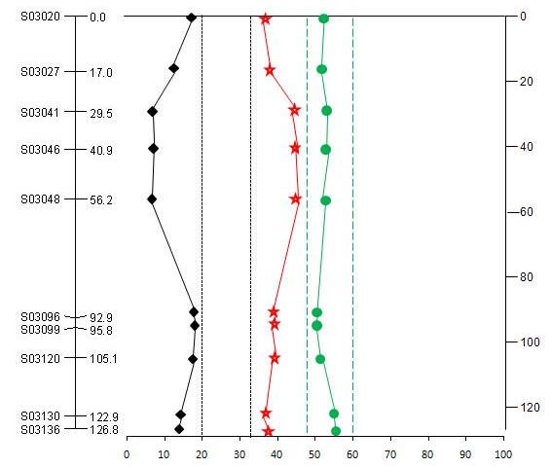
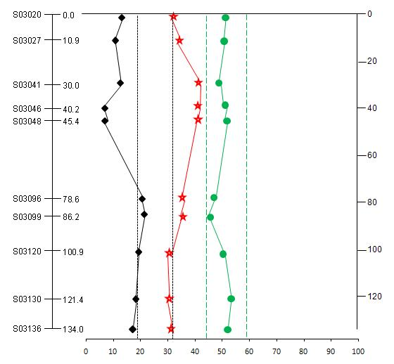
A
DI population
ID population

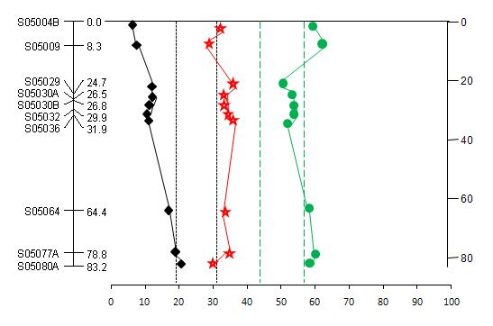
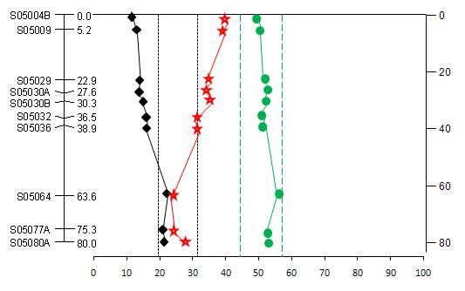
B
DI population
ID population

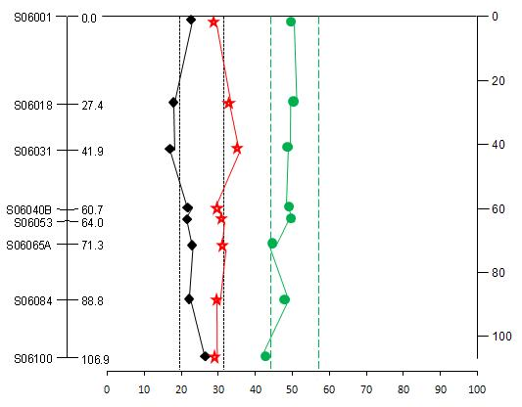
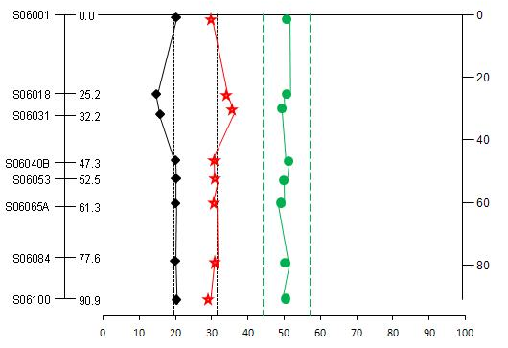
ID population
C
DI population

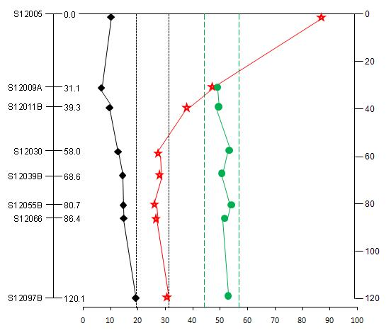
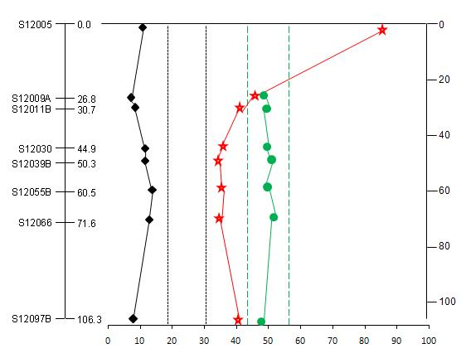
DI population
ID population
D
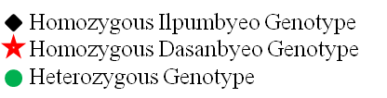

Figure S1. Genotype frequencies of STS markers along chromosome 3 (a), 5 (b), 6 (c), and 12 (d) in two reciprocal F₂ populations generated from the parents, Ilpumbyeo and Dasanbyeo. The x-axis corresponds to the genotype percentages observed for each marker and the y-axis indicates the genetic linkage map. In normal segregation, the heterozygous and homozygous genotypes account for 50 and 25%, respectively. The 0.95 confidence limits are 43%<y<57% indicated by round dotted lines and 19%<y<31% indicated by square dotted lines for heterozygous and homozygous genotypes, respectively.

