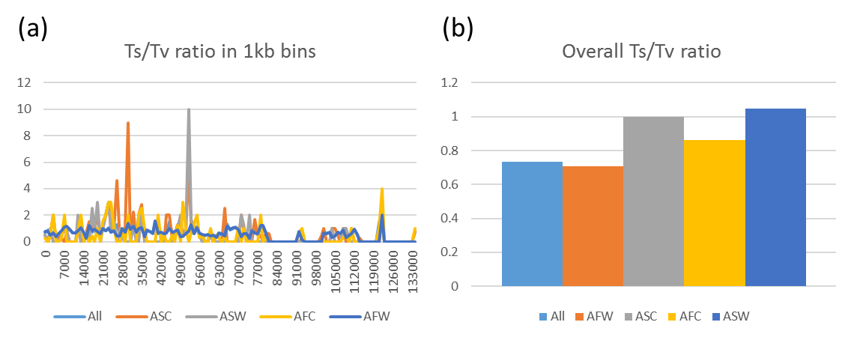
Figure S1. Overall Ts/Tv (Transition/ Transversion ratio) in 1kb bins of the whole collection and different groups. ASW: Asian wild rice, ASC: Asian cultivated rice, AFW: African wild rice, AFC: African cultivated rice.

