Table S2. Primers used for the qRT-PCR analysis of various genes
Gene | Locus name | Primers
OsActin1 | LOC_Os03g50890 | F: ACAGGTATTGTGTTGGACTCTGG  R: AGTAACCACGCTCCGTCAGG
OsRACK1A | LOC_Os01g49290 | F: AGGGATCTGTTTTGCACCAT  R: GAGAGAAGCACCATGGATCG
OsRAB16A | LOC_Os11g26790 | F: CATGGACAAGATCAAGGAGAAGC  R: CTTATTATTCAGGAAGGTGACGTGG
OsLEA3 | LOC_Os05g46480 | F: GCCGTGAATGATTTCCCTTTG  R: CACACCCGTCAGAAATCCTCC
OsLIP9 | LOC_Os02g44870 | F: TGGAATTTGGAAGTGTTTGGC  R: CCCACACGAAACACAAACTTC
OsNCED4  OsNCED5  OsAP59  OsSIK1  OsTPS1  OsMAPK5  SNAC1  OsTCP19  OsCPK4  OsMYB2  OsRMC | LOC_Os07g05940  LOC_Os12g42280  LOC_Os02g43790  LOC_Os06g03970  LOC_Os08g34580  LOC_Os03g17700  LOC_Os03g60080  LOC_Os06g12230  LOC_Os02g03410  LOC_Os03g20090  LOC_Os04g56430 | F: ATCTCCTTCTCCCTCCTCCCA  R: TCGCACCCTGCTTGATCTTGC  F: TCCGAGCTCCTCGTCGTGAA  R: AGGTGTTTTGGAATGAACCA  F: GGTGATTTAGCCATCTTGTGCG  R: TCGTCACATTTCTTGGAGCAG  F: TCTGGTAGTCTGCCCGAGGAA  R: TATGTACTGGTTGCAATCAG  F: ACCAAGCATACCGCCAGAC  R: ACCATTCAGCCAGTTCATCCT  F: CGACTTCGAGCAGAAGGCTCTA  R: GTTCATCTCGATCGCTTCGTT  F: TGGGAGAAGATGCAGCAGG  R: GAGTGCGACTGCGACGTAAC  F: TTTTCTCCGTTTTTGTTTGAGTTG  R: CATGAATATATGATGGGTCGAGGAA  F: CGTGTGCAGCATGCAGATAA  R: TGCGATGAATACGTGCAATCA  F: GGGCTGAAACGCACAGGCAAGA  R: CTGCTTGGCGTGCTTCTGC  F: TCGGAGGTGTACCCGTTCTACA  R: ACTCTTAATTTGTGCCATTTTATTCTA

Table S2. Continued.
Gene | Locus name | Primers
OsDREB1A  OsDREB1B | LOC_Os09g35030  LOC_Os09g35010 | F: CCACACTCGAGCAGAGCAAAT  R: GCTTGATCCCGCACATCTTC  F: TCTCCGGCGGAGACCTTC  R: CCGGCAACACGTCCTTGT
OsDREB1C | LOC_Os06g03670 | F: CAAAGCTTATCAGCAGTAGC  R: GGTTAGTAGCAGAAAGACTTG
OsDREB1E | LOC_Os04g48350 | F: GAATTCGAAATGCAGGGGTA  R: CTCGCAGTCGTAGTCCTCCT
OsDREB1G | LOC_Os02g45450 | F: CCCGTACTACGAGGTCATGG  R: GCTACCTACGGCAGGATCAC
OsDREB1H  OsDREB2A | LOC_Os09g35020  LOC_Os01g07120 | F: TGCCTCAACTTCCAGGACTC  R: GCCGTTCGTGGTCTTGTTG  F: GGAATCTCCTCCTTTCATCGTG  R: TTCCGCTCCTGACAAACACG

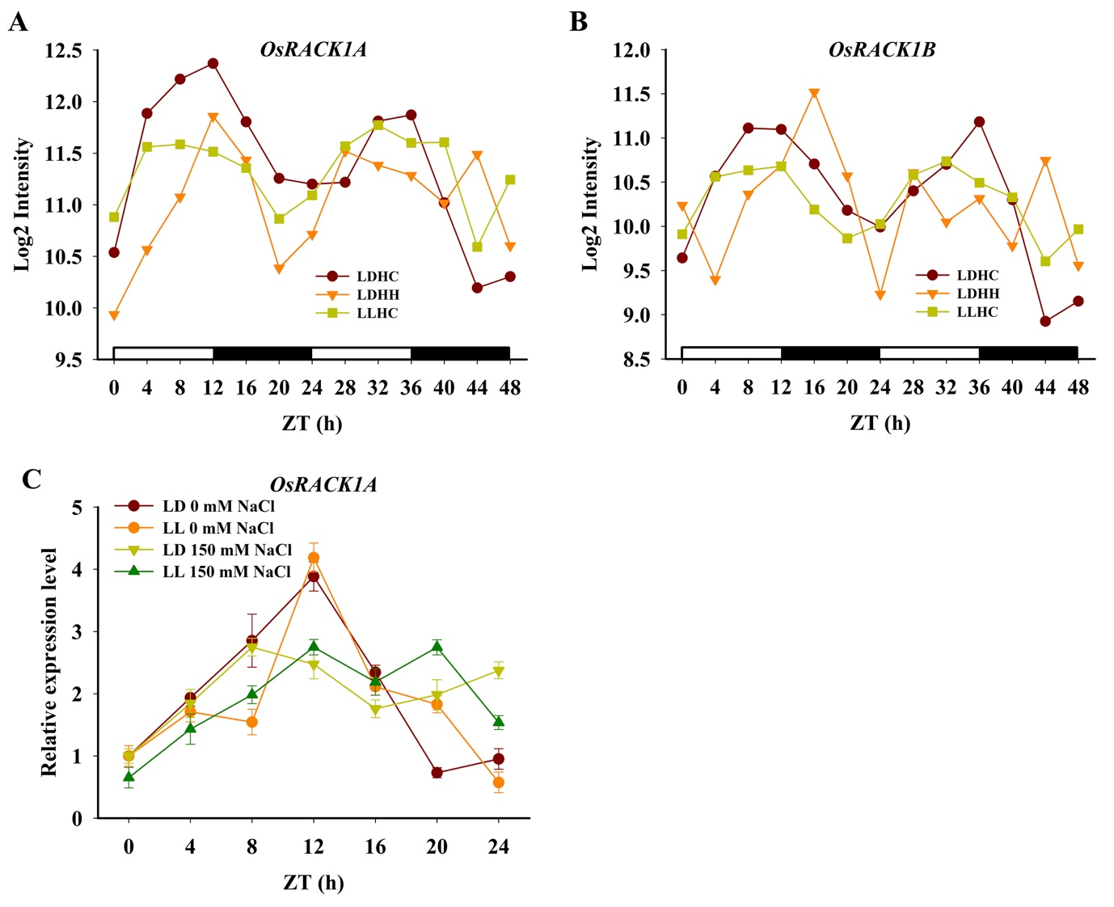

Figure S1. Public microarray data showing OsRACK1A (A) and OsRACK1B (B) expression is controlled by a circadian clock (http://www.ebi.ac.uk/arrayexpress/experiments/E-MTAB-275/). OsRACK1A expression in rice leaves under 16 h light/ 8 h dark (LD) or constant light (LL) conditions and under NaCl treatment (C).

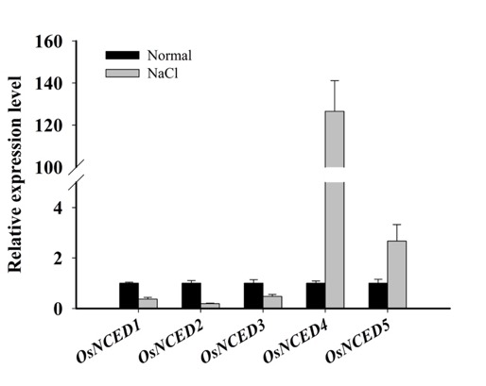
Figure S2. OsNCED gene expression in rice leaves under 150 mM NaCl treatment for 12 h.

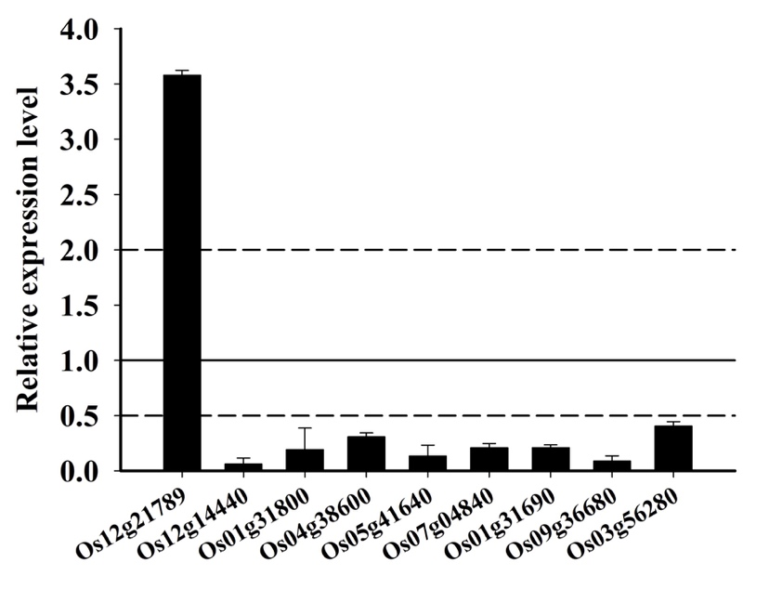
Figure S3. Quantitative RT-PCR analysis of the expression of OsRACK1 interactors in response to salt stress.

