Additional file 1
Table S1 Performance of BC₁F_{2:3} mapping populations of Kalarata/NSIC Rc238 and Kalarata/NSIC Rc222 along with respective parents for seedling height
 | KALARATA/NSIC Rc238 POPULATION |  |  |  |  |  | KALARATA/NSIC Rc222 POPULATION
 | Seedling height 14DAS |  |  | Seedling height 21DAS |  |  | Seedling height 14DAS |  |  | Seedling height 21DAS
 | Control | Screen house | Tray-on-table | Control | Screen house | Tray-on-table | Control | Screen house | Tray-on-table | Control | Screen house | Tray-on-table
Kalarata | 24.3 | 16.7 | 16.5 | 36.2 | 31.3 | 23.2 | 24.7 | 21 | 11.5 | 34.3 | 25.9 | 27.1
NSIC Rc238/  NSIC Rc222 | 19.1 | 14.3 | 15.4 | 29.4 | 22.0 | 22.0 | 20.5 | 14.1 | 12.4 | 30.8 | 18.9 | 23.9
Mean | 22.8 | 16.5 | 15.6 | 35.5 | 29.7 | 23.7 | 24.0 | 20.2 | 12.9 | 34.3 | 25.3 | 27.4
Range | 16.2-27.8 | 9.1-26.8 | 11.9-19.2 | 28.4-42.8 | 14.1-40.5 | 10.5-36.0 | 13.6-29.8 | 11.6-29.5 | 9.7-18.4 | 20.5-39.9 | 10.0-38.1 | 21.8-35.7
SED | 2.42 | 2.84 | 2.45 | 2.95 | 2.95 | 3.20 | 2.01 | 2.78 | 1.95 | 2.52 | 2.73 | 2.60
P value | **** | **** | **** | **** | **** | **** | **** | **** | **** | **** | **** | ****
Heritability | 0.48 | 0.66 | 0.63 | 0.65 | 0.89 | 0.60 | 0.70 | 0.81 | 0.45 | 0.72 | 0.90 | 0.58

**** = significant at 0.0001% P levels

Table S2 List of QTLs detected for seedling height in the BC₁F_{2:3} population of Kalarata and NSIC Rc238

QTL NAME | CHR | PEAK MARKER | POSITION (cM) | CONFIDENCE INTERVAL (cM) | LOD | PVE | ADD
Seedling height at 14DAS
Screenhouse conditions
qSH3-1_{Rc238-SCR-14} | 3 | SWRm_00256 | 238 | 216-238 | 3.7 | 10.1 | 0.84
Seedling height at 21DAS
Screenhouse conditions
qSH1-1_{Rc238-SCR-21} | 1 | SWRm_00052 | 200 | 192-206 | 5.4 | 12.5 | 3.34
qSH3-1_{Rc238-SCR-21} | 3 | SWRm_00276 | 198 | 192-204 | 4.3 | 10.1 | 5.17
qSH7-1_{Rc238-SCR-21} | 7 | SWRm_00554 | 80 | 74-84 | 4.6 | 10.7 | 4.57
Tray-on-table conditions
qSH1-1_{Rc238-TAB-21} | 1 | SWRm_00052 | 198 | 194-200 | 9.4 | 22.1 | 2.26
qSH3-1_{Rc238-TAB-21} | 3 | SWRm_00276 | 210 | 202-222 | 5.8 | 14.4 | 3.42
Control conditions
qSH1-2_{Rc238-CON-21} | 1 | SWRm_01359 | 32 | 28-36 | 6.1 | 14.1 | 2.00
q indicates QTL, SH indicates seedling height, LOD=logarithm of odds, PVE = percent phenotypic variation explained, ADD=additive effects of the peak marker.

Table S3 List of QTLs detected for seedling height in the BC₁F_{2:3} population of Kalarata and NSIC Rc222.
QTL NAME | CHR | PEAK MARKER | POSITION (cM) | INTERVAL (cM) | LOD | PVE | ADD
Seedling height at 14DAS
Screenhouse conditions
qSH1-1_{Rc222-SCR-14} | 1 | SWRm_00052 | 134 | 128-138 | 7.17 | 18.5 | 2.7
qSH3-2_{Rc222-SCR-14} | 3 | SWRm_00252 | 48 | 42-82 | 3.78 | 10.2 | 1.8
Seedling height at 21DAS
Screenhouse conditions
qSH1-1_{Rc222-SCR-21} | 1 | SWRm_00052 | 134 | 126-142 | 5.71 | 13.5 | 3.4
qSH3-2_{Rc222-SCR-21} | 3 | SWRm_00252 | 58 | 46-82 | 4.87 | 11.7 | 2.7
Tray-on-table conditions
qSH1-1_{Rc222-TAB-21} | 1 | SWRm_00052 | 129.63 | 126-138 | 5.18 | 13.5 | 1.3
Control conditions
qSH1-2_{Rc222-CON-21} | 1 | SWRm_01359 | 238 | 237.9-240.0 | 10.16 | 21.9 | 2.3
q indicates QTL, SH indicates seedling height, LOD=logarithm of odds, PVE = percent phenotypic variation explained, ADD=additive effects of the peak marker.

Table S4: List of QTLs detected for pericarp color in the BC₁F_{2:3} mapping populations of Kalarata/NSIC Rc238 and Kalarata/NSIC Rc222
POPULATION | CHR | PEAK MARKER | POSITION (cM) | INTERVAL (cM) | LOD | PVE | ADD
Kalaratta/NSIC Rc222 | 7 | SWRm_01153 | 52.72 | 52.00-54.00 | 52.84 | 72.4 | 3.866
Kalaratta/NSIC Rc238 | 7 | SWRm_01153 | 59.06 | 59.06-60.00 | 78.32 | 85.77 | 3.886
LOD=logarithm of odds, PVE = percent phenotypic variation explained, ADD=additive effects of the peak marker.

Supplementary Figures

Figure S1 Line graph showing the average daily water temperature profile during the experiment period in screen house and on tray conditions.

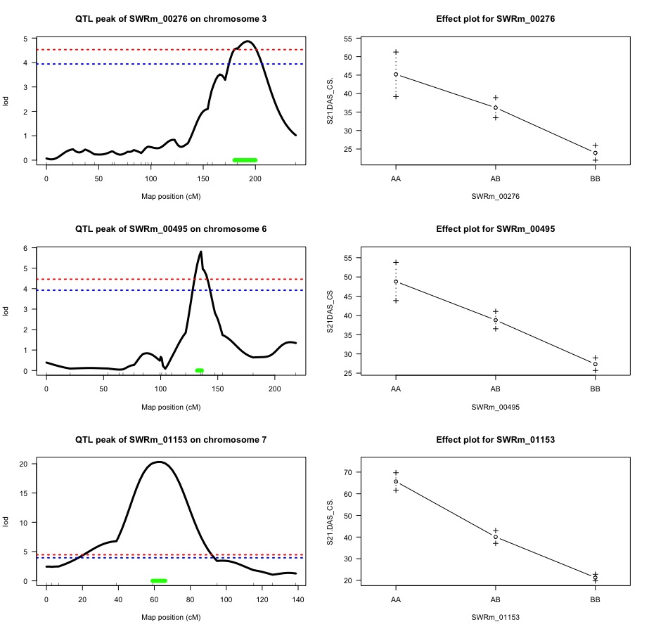

Figure S2 The QTL likelihood curve of LOD score showing peak marker and confidence interval for the trait 21 DAS survivability in Kalarata/NSIC Rc238 population in screenhouse screening conditions. The green line indicates confidence interval while horizontal lines indicate the significant logarithm of odds threshold at 95% and 99% confidence levels (from the bottom to the top) based on 10000 permutations. The figures on the right show the effect of each of the peak markers. All QTLs are contributed by tolerant parent, Kalarata.
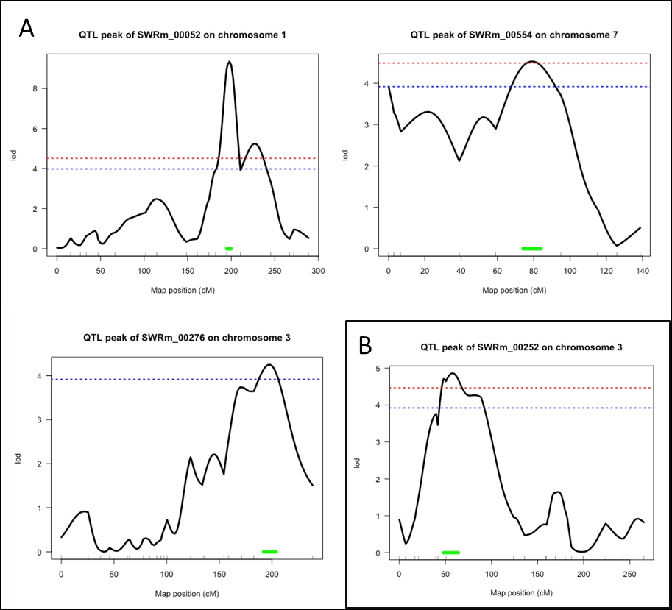

Figure S3 The QTL likelihood curves of LOD score showing peak marker and confidence interval for the trait 21 DAS seedling height for (A) Kalarata/NSIC Rc238 and (B) Kalarata/NSIC Rc222 in screenhouse screening conditions. The green line indicates confidence interval while horizontal lines indicate the significant logarithm of odds threshold at 95% and 99% confidence levels (from the bottom to the top) based on 10000 permutations. All QTLs are contributed by tolerant parent, Kalarata.

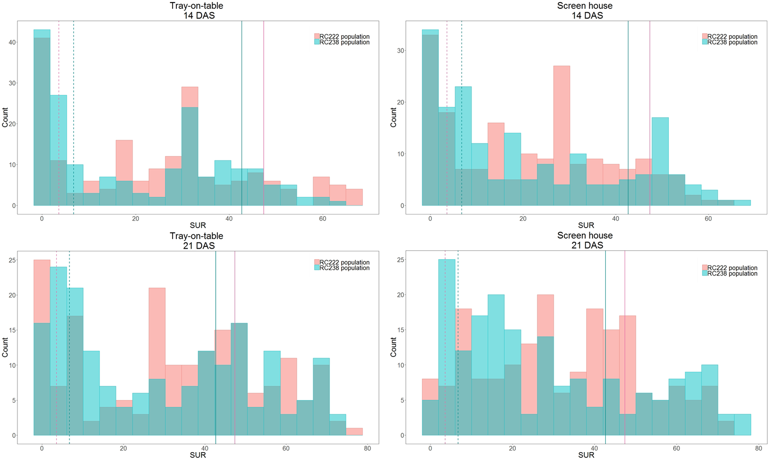
Figure S4 Frequency distribution of the survival (SUR) trait for Kalarata/NSIC Rc238 and Kalarata/NSIC Rc222 populations under different screening conditions (screenhouse and tray-on-table) and data collection periods (14 DAS and 21 DAS). Dotted lines refer to the susceptible parent (NSIC Rc 238/NSIC Rc 222) while solid lines refer to the tolerant parent (Kalarata).

Figure S5 Relation between grain pericarp color and survival under anaerobic condition.

