Additional file 2: Figures and Tables: 1k-RiCA (1k-Rice Custom Amplicon) a novel genotyping amplicon-base SNP assay for genetics and breeding applications in rice

Juan David Arbelaez. International Rice Research Institute, Los Baños, Philippines, DAPO Box 7777 Metro Manila 1301.Email: j.arbelaezvelez@irri.org
Maria Stefanie Dwiyanti. Research Faculty of Agriculture, Hokkaido University, Sapporo, Hokkaido 060-8589, Japan. Email: dwiyanti@abs.agr.hokudai.ac.jp
Erwin Tandayu. International Rice Research Institute, Los Baños, Philippines, DAPO Box 7777 Metro Manila 1301.Email: e.tandayu@irri.org
Krizzel Llantada. International Rice Research Institute, Los Baños, Philippines, DAPO Box 7777 Metro Manila 1301.Email: k.llantada@irri.org
Annalhea Jarana. International Rice Research Institute, Los Baños, Philippines, DAPO Box 7777 Metro Manila 1301.Email: a.jarana@irri.org
John Carlos Ignacio. International Rice Research Institute, Los Baños, Philippines, DAPO Box 7777 Metro Manila 1301.Email: j.ignacio@irri.org
John Damien Platten. International Rice Research Institute, Los Baños, Philippines, DAPO Box 7777 Metro Manila 1301.Email: J.Platten@irri.org
Joshua Cobb. International Rice Research Institute, Los Baños, Philippines, DAPO Box 7777 Metro Manila 1301.Email: j.cobb@irri.org
Jessica Elaine Rutkoski. International Rice Research Institute, Los Baños, Philippines, DAPO Box 7777 Metro Manila 1301.Email: j.rutkoski@irri.org
Mike Thomson. Department of Soil and Crop Sciences, Texas A&M University, College Station, Houston, TX 77843, ISA. Email: m.thomson@tamu.edu
Tobias Kretzschmar. Southern Cross Plant Sciences, Southern Cross University, PO Box 157, Lismore NSW 2480, Australia. Tobias.Kretzschmar@scu.edu.au

Figure S1. Distribution of physical distance gaps between adjacent SNPs in the 1k-RiCA. SNP-distance distribution between adjacent SNPs in the 1k-RiCA expressed in a 1,000 bp (1 Kbp) scale. The mean SNP distance between adjacent SNPs, ~372 kb, is indicated by a dotted line.

Figure S2. 1k-RiCA SNP minor allele frequency (MAF) estimated on 431 indica lines. Distribution of the 1k-RiCA MAF on 995 SNPs using 431 indica inbred lines. The median SNP MAF value of 0.355 estimated is defined by a dotted line.

Figure S3. 1k-RiCA SNP call rate distribution. Distribution of the 1k-RiCA SNP call rate estimated on 995 SNPs using 700 independent DNA samples. The mean SNP CR value of 0.95 (or 95% CR) estimated is defined by a dotted line.

Figure S4. 1k-RiCA SNP heterozygosity distribution. Distribution of the 1k-RiCA SNP heterozygosity estimated on 995 SNPs using 700 independent DNA samples. The mean SNP heterozygosity value of 0.015 (or 1.5%) estimated is defined by a dotted line.

Figure S5. Hierarchical cluster analysis estimated in 38 highly replicated accessions using the 1k-RiCA set. Replicates were extracted using the Kingfisher kit and a modified CTAB protocol. Samples extracted with CTAB are names with the suffix “.ct.” after their ‘SW’ identity code. Labels with the same color belong to the replicates of the same accession.

Figure S6. 1k-RiCA average SNP repeatability. Distribution of repeatability estimated in 38 highly replicated accessions using the 1k-RiCA-assay. The SNP repeatability distributions before and after removing miscalled heterozygous calls are indicated in red and blue respectively. Their corresponding means are indicated dotted (0.99 or 99%) and dashed lines (0.997 or 99.7%).

Figure S7. 1k-RiCA SNP concordance rate distribution between CTAB and King-Fisher DNA extracted samples. Distribution of the 1k-RiCA SNP concordance rate estimated between same samples extracted using CTAB and King-Fisher Kit. The mean SNP SNP concordance rate value of 0.99.51 (or 99.51%) estimated is defined by a dotted line.

A)
B)

Figure S8. 1k-RiCA Oryza sativa PCA optimal clustering and Silhouette width test. 8A) Optimal number of clusters visually determined by the ‘Average silhouette width. 8B) Classification of 283 accessions implementing the PCA coordinates using clusters generated using k-mean of 3 estimated to be the optimal number of cluster using the Silhouette method.

Figure S9. 1k-RiCA Oryza sativa PCA classification. Classification of ‘undetermined’ accessions implementing the PCA coordinates using clusters generated using 65 accessions that are known to be from the subpopulation indica (IND), aus (AUS), and japonicas (made up from temperate japonica, tropical japonica, and aromatic - JAPONICA). ‘Black rice’ indica and japonica accessions were identified with the ‘brc’ prefix.

Table S1. Cross-reference identification for 12 ‘undetermined’ rice accessions classified using PC coordinates. Manual cross-reference of 12 ‘un-determined’ accessions classified into 3 subpopulations using the PC coordinates from the 1k-RiCA diversity analysis.

Accession | Subpopulation | Description | Reference | Predicted population
BORUBI::IRGC25181-1 | tropical japonica | Diversity | McCouch et al 2016, Wang et al. 2017 | japonica
BLACK GORA S.N 109 | indica | India | Yan et al. 2011 | indica
BASTMATI | indica | Fragrance | Kovach et al. 2009 | indica
DPRK 036S 474 | temperate japonica | DPRK | Kim et al. 2014 | japonica
DPRK 036M 10515 | temperate japonica | DPRK | Kim et al. 2014 | japonica
DPRK 036S 9917 | temperate japonica | DPRK | Kim et al. 2014 | japonica
DPRK 036S 7220 | temperate japonica | DPRK | Kim et al. 2014 | japonica
Hei Mi Chan | indica | NA | Li et al. 2004 | indica
PIKTO MAMAS | tropical japonica | NA | Alexandrov et al. 2017 | japonica
BR11 | indica | NA | Fujita et al. 2013 | indica
IR74 | indica | NA | Lepitan et al. 2007 | indica
BR29 | indica | NA | Datta 2006 | indica

Table S2. Grouping analysis using PC coordinates between indica lines. Accessions from the indica subpopulation that cluster together with the ‘Black-rice’ lines genotyped with the 1k-RiCA.

Accession | Subgroup cluster | Designation | PC1 | PC2
HB2120 | Black rice | KHAO DAWK MALI 105 | -22.4216236 | 7.796715943
HB2137 | Black rice | SAMBHA MAHSURI | -16.90539817 | 4.06043655
QMp03 | Black rice | Birain 360 | -21.05959218 | 8.465602172
QMp07 | Black rice | Birain 360 | -21.26630577 | 8.439611855
SW108 | Black rice | IR 84649-97-3-1-B-B | -20.87644391 | 4.853705157
SW112 | Black rice | ADR52 | -18.50421528 | 10.85843889
SW130 | Black rice | Tadukan | -18.38149871 | 8.532461147
SW165 | Black rice | BR11 | -23.5933901 | -0.317880888
SW191 | Black rice | A 69-1 | -19.8083939 | -0.385602509
SW211 | Black rice | Ashi Binni | -19.74753357 | 9.05212594
SW236 | Black rice | POKKALI | -22.36954214 | 7.159561487
SW237 | Black rice | SADU CHO | -21.49011261 | 7.475529874
SW241 | Black rice | ZHENSHAN 97 B | -19.1458832 | 4.956531651
SW242 | Black rice | ASWINA | -19.8401169 | 7.347433687
SW251 | Black rice | MANAW THUKHA | -21.64006458 | 3.400897709
SW264 | Black rice | BR 29 | -20.5146175 | -3.904192842
SW266 | Black rice | IR 64680-81-2-2-1-3 | -20.79642326 | -0.650956341
SW282 | Black rice | TETEP | -17.45662357 | 8.842468136
SW291 | Black rice | Utri Merah IRGC 16682 | -23.45072245 | 7.009314534
SW314 | Black rice | BRRI DHAN54 | -21.57019704 | 1.107270377
SW321 | Black rice | IR 66946-3R-178-1-1 | -16.11874696 | -1.916090656
SW350 | Black rice | JUMBO JET | -18.06171717 | 5.712257661
SW352 | Black rice | CAPSULE | -20.27054761 | 8.501741355
SW361 | Black rice | NONA BOKRA | -21.66435158 | 8.746726403
SW363 | Black rice | SUPA | -22.21844476 | 9.573561571
SW371 | Black rice | TKM6 | -15.57743275 | 5.770844922
SW42 | Black rice | IR05F102 | -21.24373309 | 2.821051612
HB2040 | Bi-parental | IRRI175 | 0.412580145 | -12.65065717
HB2041 | Bi-parental | IRRI179 | 6.702205952 | -4.035194311
HB2042 | Bi-parental | IRRI180 | 9.61331785 | -0.770119311
HB2110 | Bi-parental | IRRI 104 | 7.962845049 | 0.604329164
QMp01 | Bi-parental | IR36ae | 4.988906779 | -11.21331514
SW103 | Bi-parental | NSIC Rc 342SR | 0.45527379 | -9.951786327
SW142 | Bi-parental | IR03A262 | 3.069949619 | -2.928799249
SW145 | Bi-parental | IRRI 149 (NSIC Rc 194) | 0.177181319 | -24.43838657
SW146 | Bi-parental | PSB Rc 82 (IRRI 123) | 9.329657705 | -4.961634307
SW16 | Bi-parental | IR10N112 | 0.203893536 | -17.57353826
SW161 | Bi-parental | IR09F153 | 0.831732777 | -4.062617899
SW18 | Bi-parental | IR09F154 | 6.694568584 | 3.82427151
SW184 | Bi-parental | MTU 1010 | 1.263401683 | -11.48499906
SW20 | Bi-parental | IR09F437 (PSB-Rc18-SUB1) | 8.221538344 | 4.829853322
SW213 | Bi-parental | NSIC Rc 358 | 4.00353612 | -6.027681405
SW222 | Bi-parental | NSIC Rc 308 | 3.553328343 | -13.94724575
SW229 | Bi-parental | IR64-21 | 0.747691202 | -25.83314203
SW24 | Bi-parental | IR74 | 1.021090933 | -0.940684958
SW244 | Bi-parental | IR42 | 0.973807238 | -4.520028958
SW250 | Bi-parental | IR11A293 | 13.94676064 | 5.381880217
SW253 | Bi-parental | IR 50::C1 | 1.314752243 | -4.829462338
SW257 | Bi-parental | IR00A107 | 0.935538238 | 0.647779122
SW258 | Bi-parental | IRRI 105 (PSB Rc18) | 10.84494987 | 9.92223704
SW262 | Bi-parental | IRRI 143 | 3.440094745 | -23.01357698
SW265 | Bi-parental | IR 04A427 | 12.13684995 | 4.57856436
SW268 | Bi-parental | IR 65620-192-3-3-3-2 | 4.997562506 | -2.189285546
SW269 | Bi-parental | IR 68058-71-2-1 | 10.84547309 | 9.738023296
SW270 | Bi-parental | IR 68544-29-2-1-3-1-2 | 14.4092718 | 5.587133544
SW275 | Bi-parental | IRRI 148 (Sahod Ulan 1) | 6.627781797 | -4.695731697
SW277 | Bi-parental | IR28 | 7.129189025 | -12.75931358
SW279 | Bi-parental | IR05N229 | 0.62327474 | -7.648549977
SW298 | Bi-parental | Matatag 3 | 0.654991939 | -9.343967372
SW322 | Bi-parental | IR08N210 | 5.01947077 | -3.589694455
SW368 | Bi-parental | PSB Rc18-Sub1 | 9.472602023 | 5.926370867
SW372 | Bi-parental | IR64 | 1.35176608 | -25.66979085
SW39 | Bi-parental | IR02A127 | 3.108983857 | -2.710307786
SW41 | Bi-parental | IR04A115 | 2.119667884 | -2.210226143
SW43 | Bi-parental | IR05N412 | 9.415261859 | -5.362770266
SW44 | Bi-parental | IR06A150 | 3.063263767 | -3.157807835
SW45 | Bi-parental | IR06N209 | 9.559212219 | -4.747314259
SW46 | Bi-parental | IR07A234 | 6.19267307 | -10.45557893
SW48 | Bi-parental | IR08A172 | 7.480797776 | -3.451501712
SW49 | Bi-parental | IR08A176 | 3.193102841 | -15.75281627
SW50 | Bi-parental | IR08N194 | 9.539138338 | -5.023997344
SW51 | Bi-parental | IR09A136 | 9.321294522 | -9.984108975
SW52 | Bi-parental | IR09A138 | 0.708268261 | -9.821268416
SW53 | Bi-parental | IR09A220 | 6.915307457 | -8.637246054
SW55 | Bi-parental | IR09N190 | 16.37885038 | 9.496371422
SW56 | Bi-parental | IR09N496 | 5.592731008 | -5.186235148
SW57 | Bi-parental | IR09N514 | 1.488936276 | -8.221962948
SW59 | Bi-parental | IR09N531 | 2.009463615 | -10.13594062
SW60 | Bi-parental | IR09N538 | 4.735814566 | -0.562788105
SW61 | Bi-parental | Vandana | 6.393176984 | -8.526430346
SW63 | Bi-parental | IR10N108 | 8.473171374 | 1.292716481
SW69 | Bi-parental | IRRI168 (NSIC Rc 302) | 4.344282462 | -6.863199154
SW70 | Bi-parental | IRRI181 (NSIC 2014 Rc 360) | 3.081119561 | -2.077129851
SW98 | Bi-parental | IRBLta2-RE | 6.162545433 | 2.896190883

Figure S10. 1k-RiCA distribution of F₁ percentage of similarity between true F₁ and predicted F₁. Percentage of concordance calls between ‘predicted’ F₁ and F₁ genotypes generated with the 1k-RiCA in 51 different F₁ plants. The average concordance estimated value (0.987, or 98.7%) is determined by a dotted line.

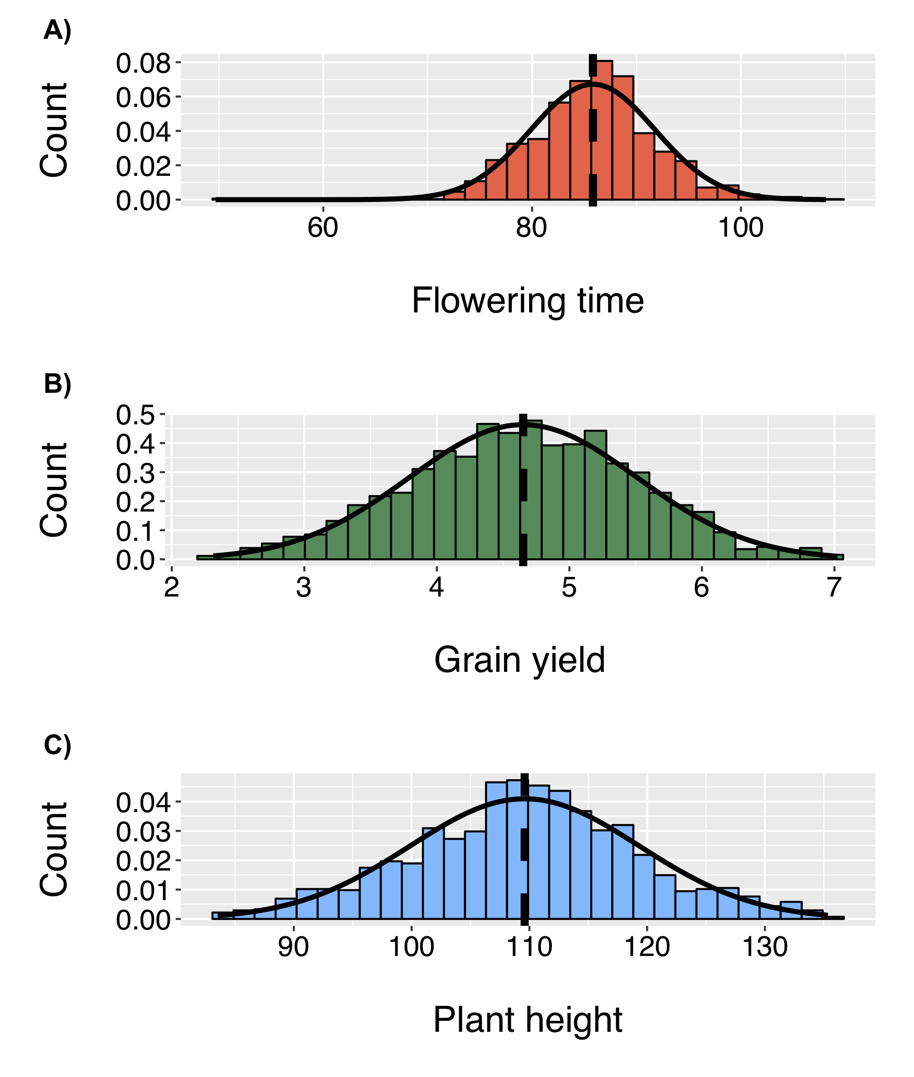

Figure S11. Phenotypic distribution for flowering time (FLW), grain yield (GY), and plant height (PH). Phenotypic distribution for A) FLW, B) GY, and C) PH evaluated in the genomic selection cross validation analysis estimated in 353 elite breeding lines from IRRI’s Favorable Environments Breeding Program.

