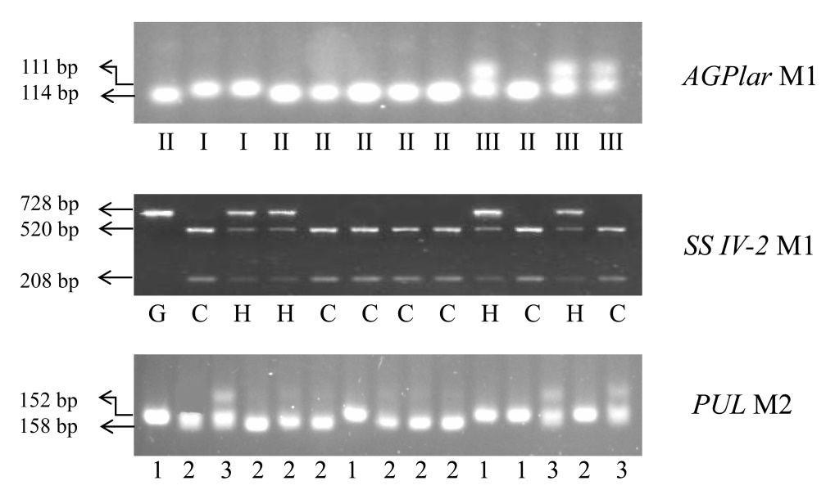
Figure S1. Segregation of three target genes among partial tested materials. Type I, G, 1; II, C, 2; and III, H, 3 indicate homozygous for GZ63S, CG173R and heterozygote in AGPlar, SSIV-2, PUL loci, respectively

