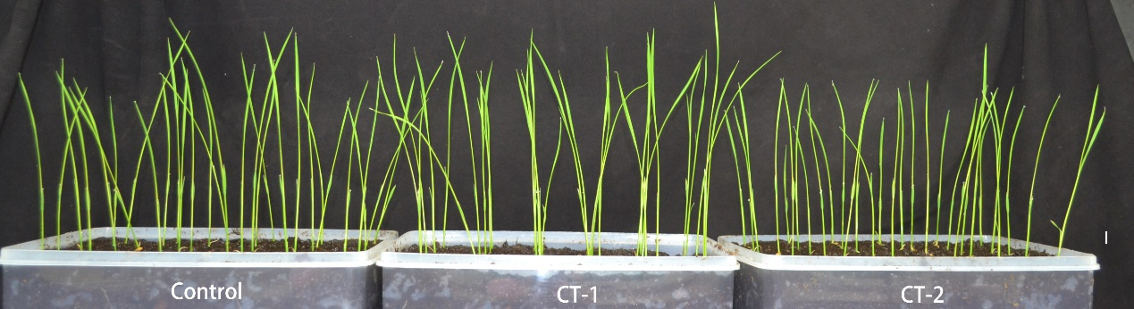
Supplemental Figure 1 Growth analysis of rice seedlings after X-ray scanning. CT-1 and CT-2 represented the X-ray scanned sample.

